Facilitator Preparation
If you are a facilitator, there is a couple of things we need to prepare before the workshop - otherwise you can skip this section and go straight to Introduction to Microcontollers

USB Battery Charger
The most essential preparation is soldering the battery and charger. This is the weakest part of the assembly and you can expect some breakage during the workshop so have spares ready, or the soldering iron warmed up.
- Cut two female Jumper wires and tin the cut ends
- Solder the Jumper wires to the battery charger
- Solder the RED battery lead to the + connector on the charger
- Solder the Black battery lead to the - connector on the charger

Lasercut Cases
The cases can be cut beforehand, or as part of the workshop to demonstrate the laser cutter in use.

Using the 12 sheet layout
- takes about 20 minutes to cut 12 sets of case parts from an A2 6mm sheet.

Trim Arduino Pins
To make the assembly as easy as possible - we can trim the un-needed pins from the nano. This takes a couple of minutes per Arduino.

Flip your Nano so the pins are facing up and the USB port is on the left.
The ONLY pins we need to leave are
- D10,D9,D8 and Ground on the bottom
- and 3v3, 5v and Ground on the top
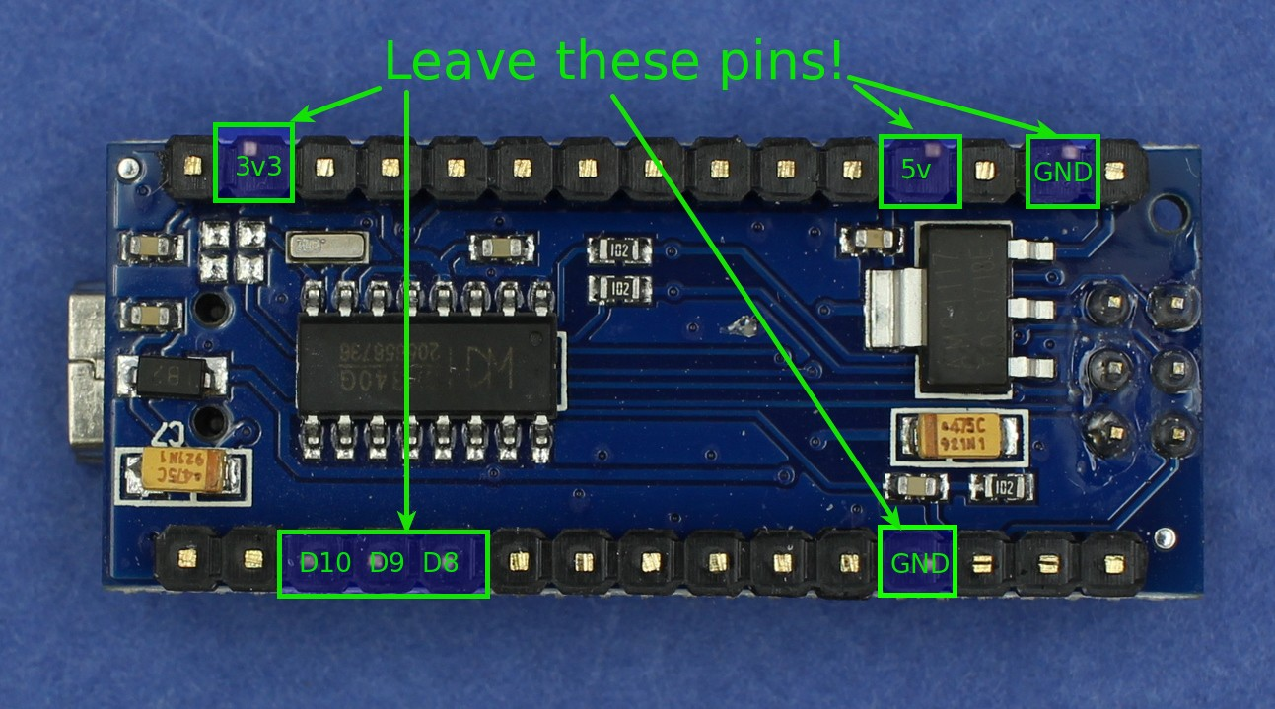

Examine the labeled side carefully.
- note the labels on the pins
- double check before cutting
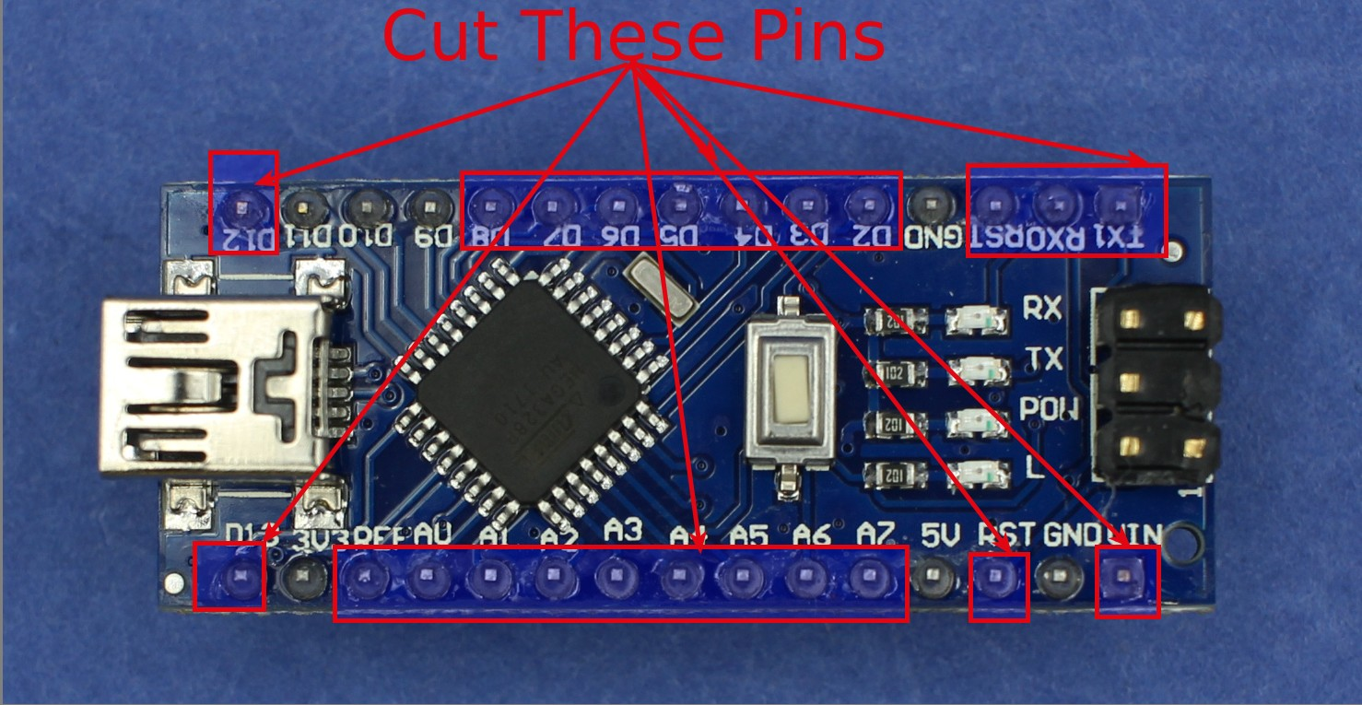

Flip the nano back over then cut off the pins with your side-cutters.
- Watch out for the offcuts! They will fly about!
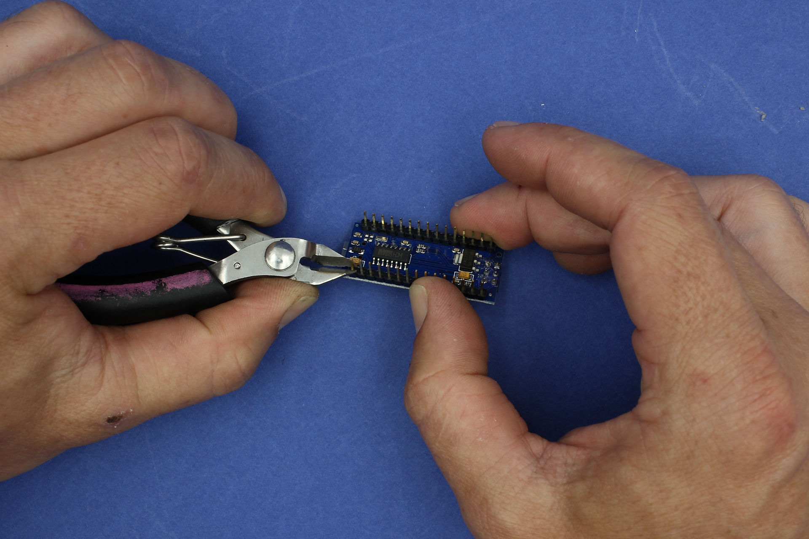

Half-way there - this is pins D10,D9,D8 and Ground
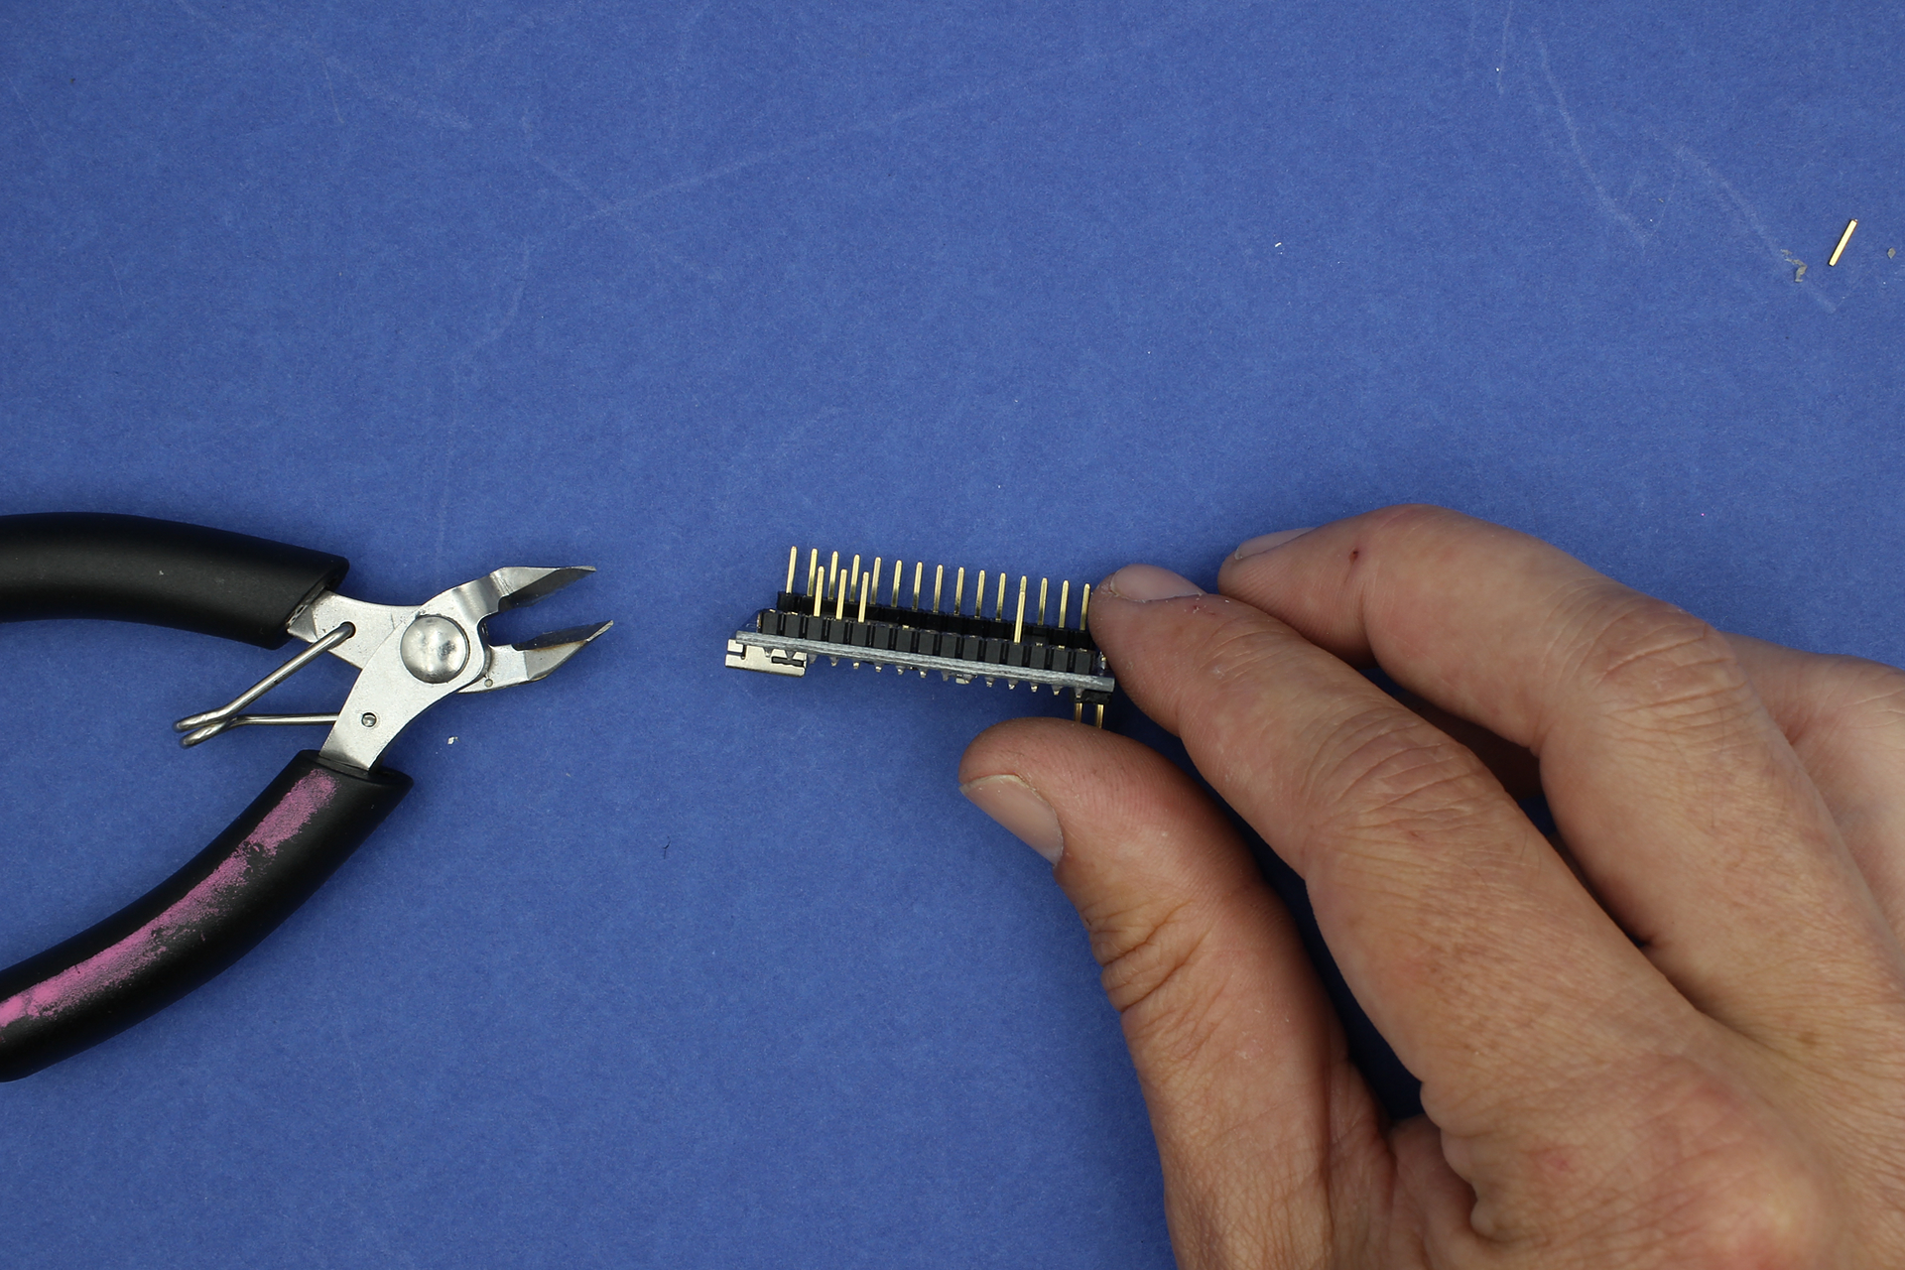

Now on the other side - GND, 5V and 3V3
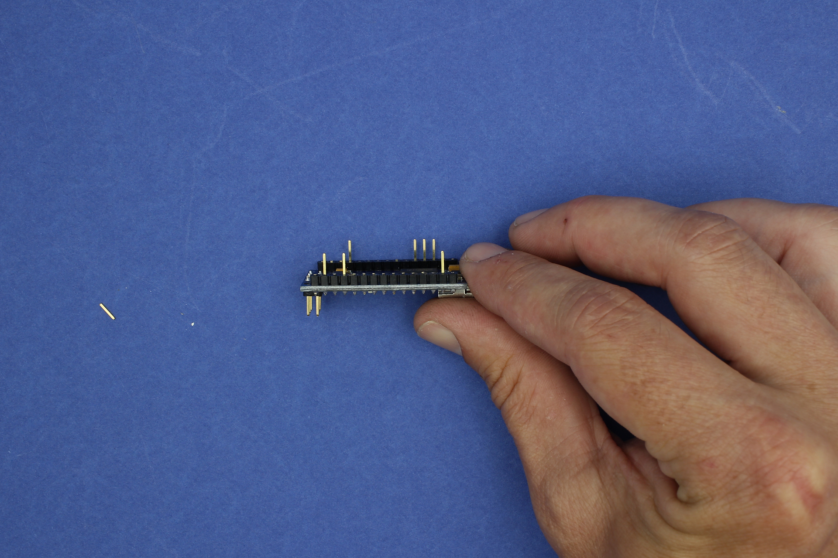

Finally, cut off the 6 pins on the top of the Nano
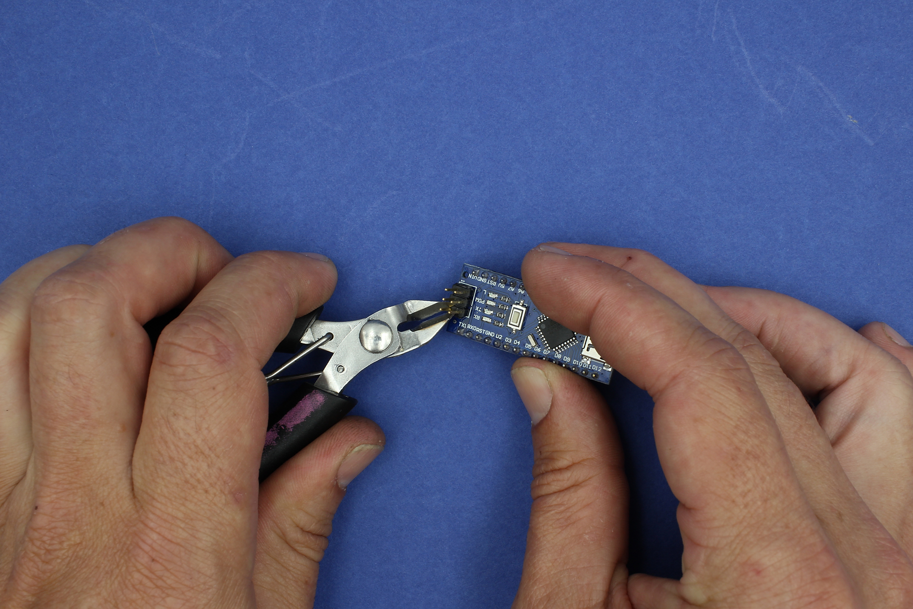

Prepare milk bottles - Optional
Each participant will need at least two milk bottles for vacuum forming.

These can be cut as part of the workshop or beforehand.

