Virtual Reality
Resource developed by Michelle Brown in 2018, current as of 2020.

History of XR (VR, AR, MR)
The first actual VR head-mounted display (HMD) was created in 1968 by computer scientist Ivan Sutherland. Sutherland was one of the most important figures in the history of computer graphics, having developed the revolutionary “Sketchpad” software that paves the way for tools like Computer-Aided Design (CAD).

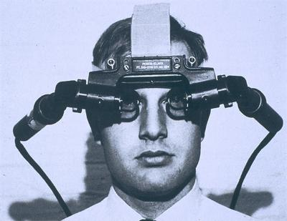
https://youtu.be/NtwZXGprxag

XR is a recent term that captures a variety of new technologies mainly focused around, VR, AR and MR. MR is the abbreviation for Mixed Reality, where usually a person is included in the environment, for example videos capturing someone painting in virtual reality.
More info on the history of XR via these links;
https://www.vrs.org.uk/virtual-reality/history.html
https://www.digitaltrends.com/cool-tech/history-of-virtual-reality/
https://en.wikipedia.org/wiki/Virtual_reality

Virtual Reality

What do we mean by Virtual Reality?
In basic terms Virtual Reality (VR) is the computer-generated simulation of a three-dimensional image or environment that we can interact with in a seemingly real or physical way by using specific equipment, such as a headset or mobile device inside another component. A person becomes part of a virtual world or is immersed within this environment and whilst there, is able to manipulate objects or perform a series of actions.

We learn about the 5 main senses; taste, touch, smell, sight and hearing; however these are the most broadly discussed senses, there are others such as balance and kinesthetic sense.
Everything that we know about our reality comes by way of our senses. In other words, our entire experience of reality is simply a combination of sensory information and our brains sense-making mechanisms for that information. When you present your senses with made-up information, your perception of reality can also change in response to it.
So basically VR can be a version of reality that isn’t really there, but from your perspective it can be perceived as real.

What can Libraries use VR for?
VR is not just for gaming and the technical savvy; from 2015 until now there has been a massive boom in creating experiences that not only help train and educate people, but also to deliver creative multimedia opportunities in arts and film practice.
Libraries these days are not just about books and information, they are community centres featuring digital learning and experiences, hands on workshops and access to equipment like 3D printers.
Some examples being used at libraries across the globe include library tours (virtual!), training and education programs, workshops and access to virtual reality labs and equipment.

Avenues that VR can be used for
- Digital Storytelling; Short films, documentaries etc. An example of a local Aboriginal and Torres Strait Islander owned and operated organisation using VR technology for storytelling of culture is Virtual Songlines

https://www.virtualsonglines.org
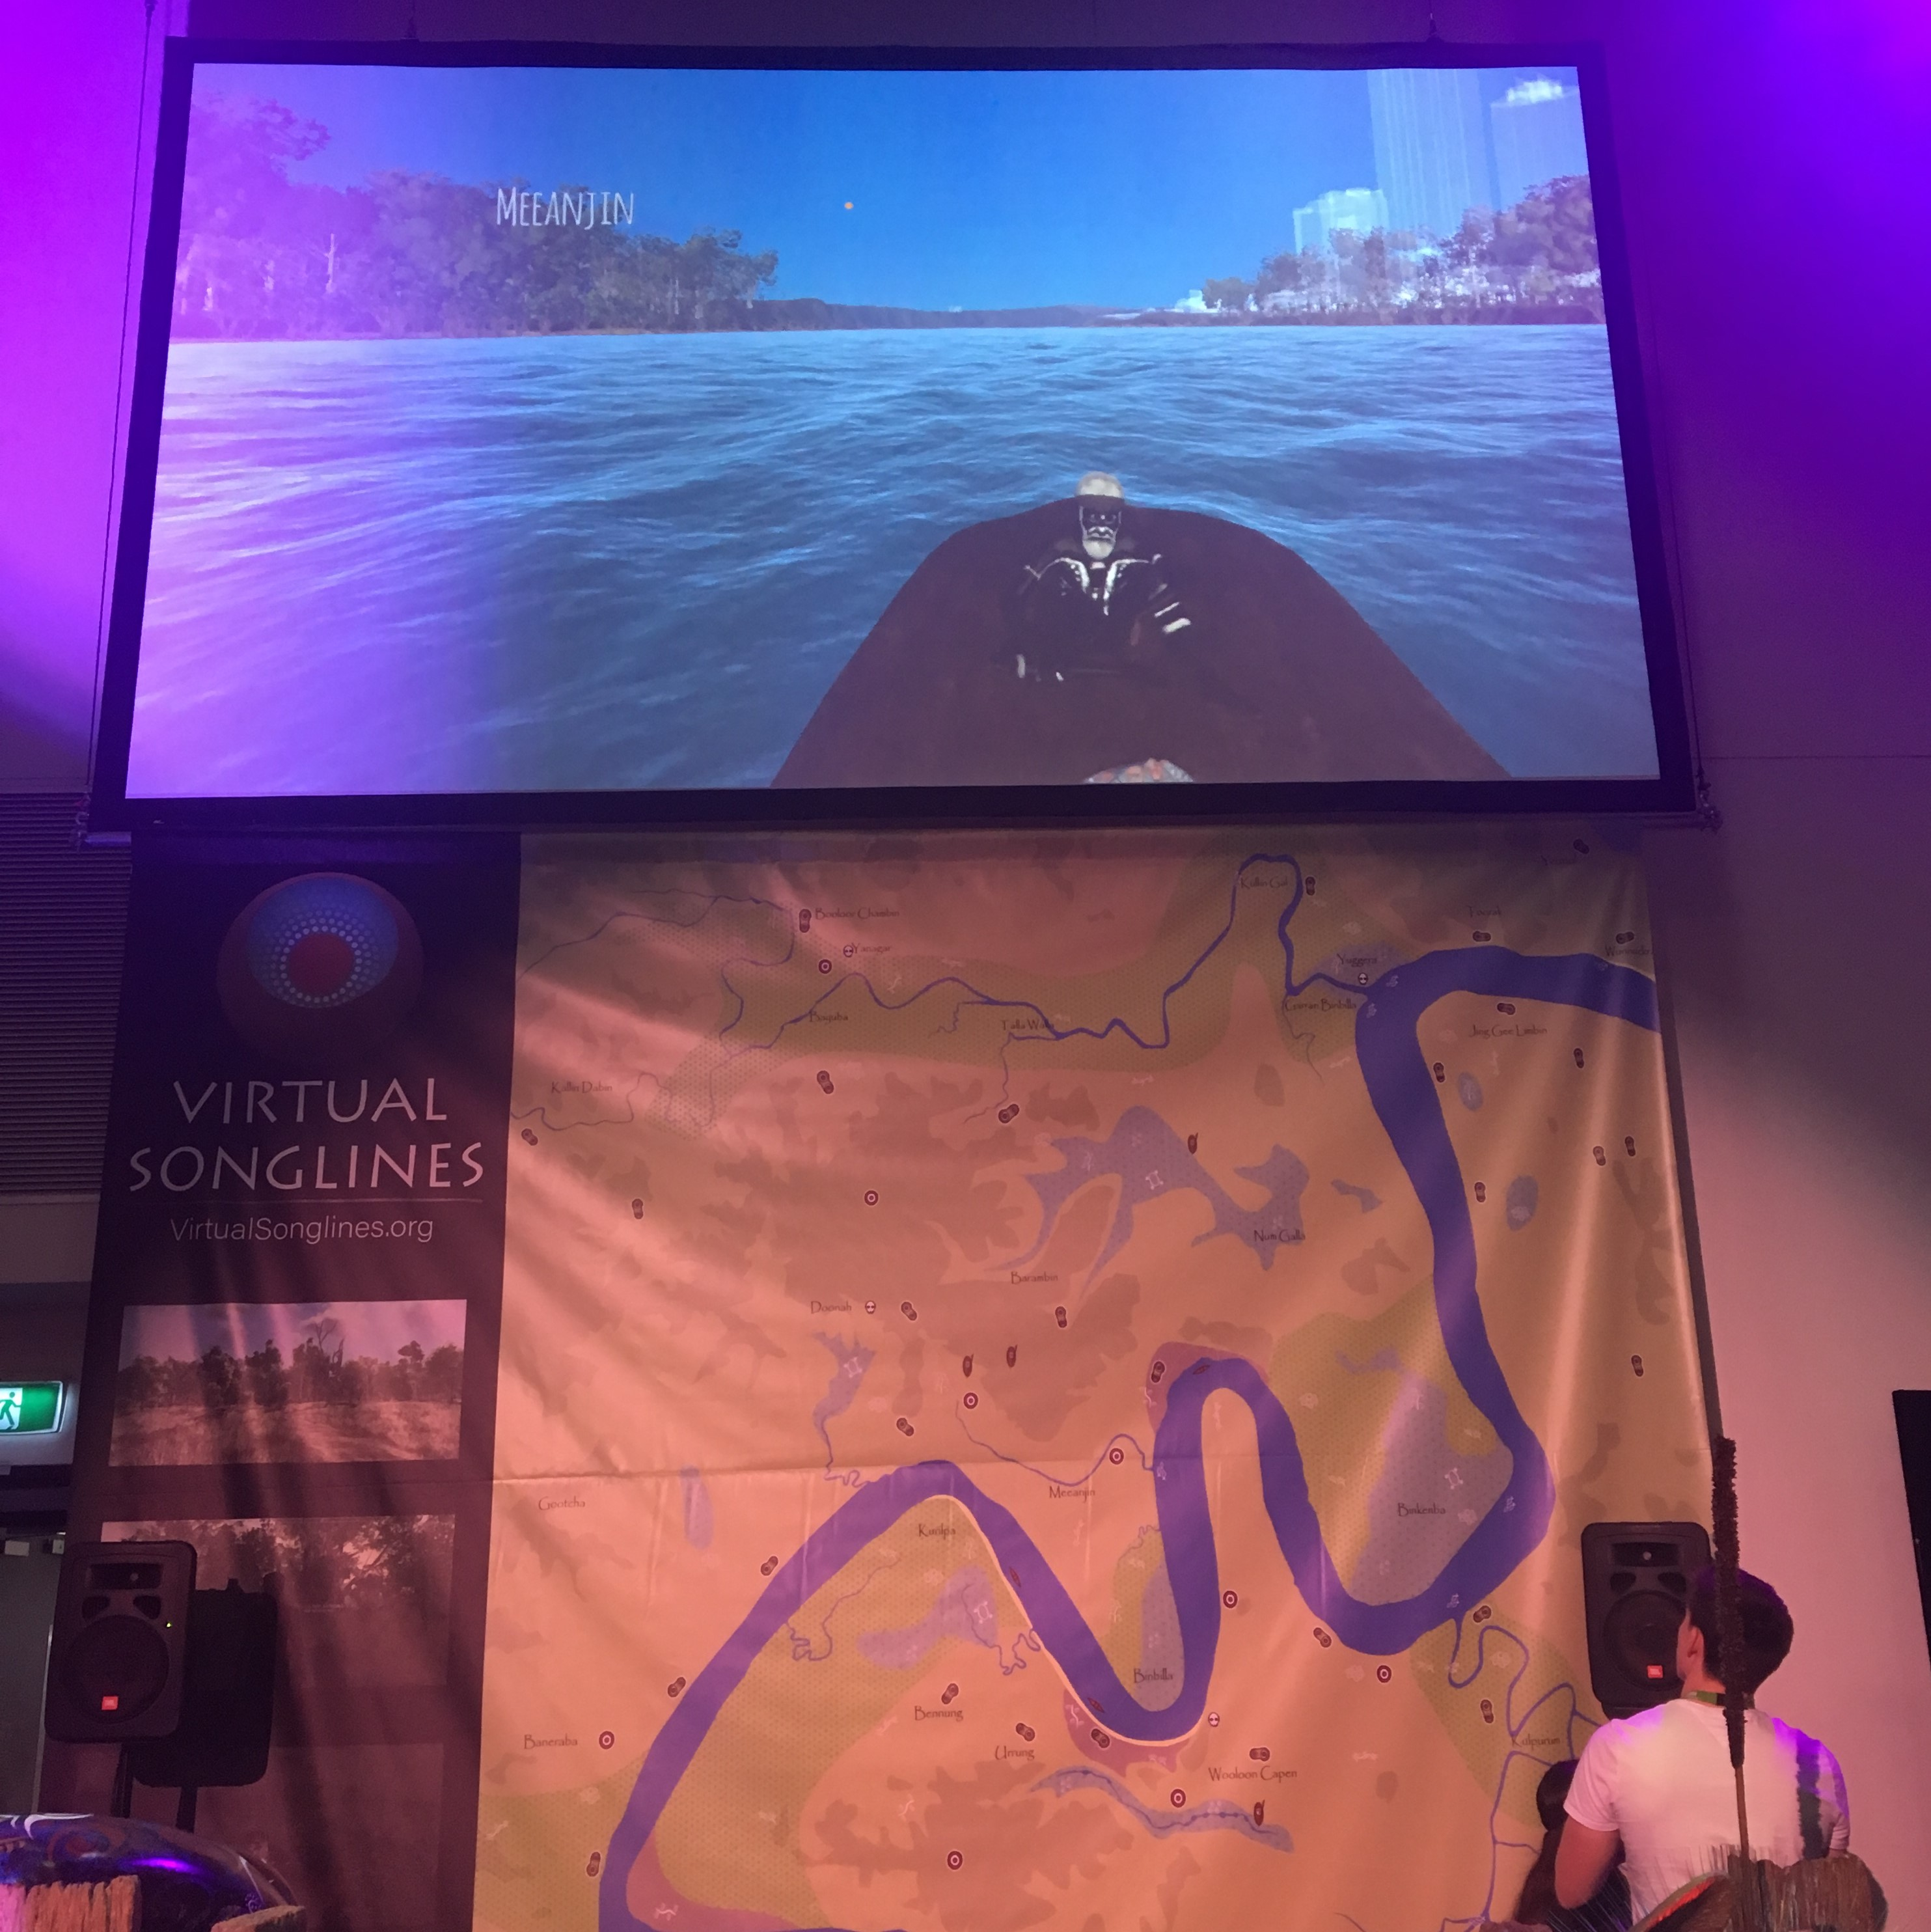

- Education and training; Flight simulation and Medical VR are common examples but more recently companies like Brisbane based Equal Reality are using VR to immerse workers in equality training. Including; leadership, gender diversity, disability inclusion, cultural inclusion, sexual harassment & bullying.

https://equalreality.com
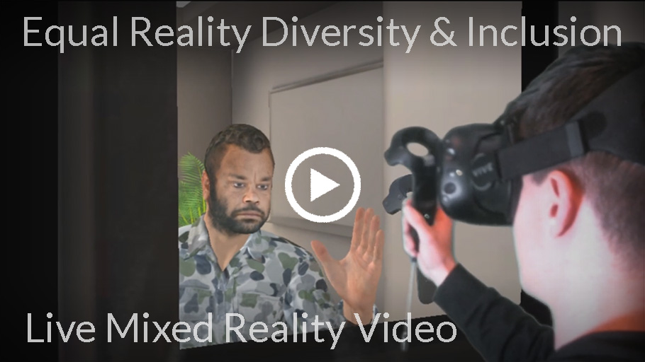

- Art and new media; there are several VR apps where you can create in the virtual environment, for example, Google’s Tilt Brush and an animation program called Quill. These programs have been used by artists to create immersive installation pieces, short films and many more creative experiences.

https://www.tiltbrush.com/
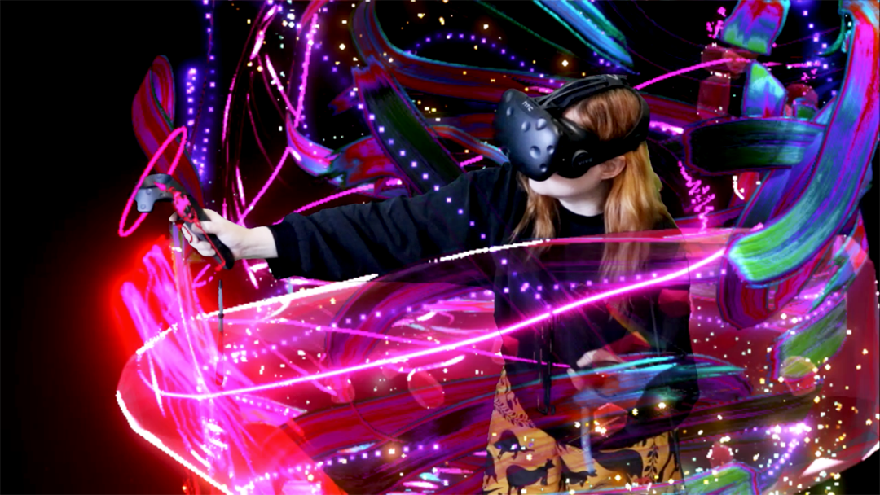

- Architecture, Engineering and 3D modelling; many architects and real estate organisations are using virtual reality to model works and display them for clients etc.

- Gaming; VR gaming is on the rise and even the general public can learn to make games for VR platforms

- Social interaction; Facebook spaces, VR Chatrooms etc. Next wave of social media

https://www.facebook.com/spaces
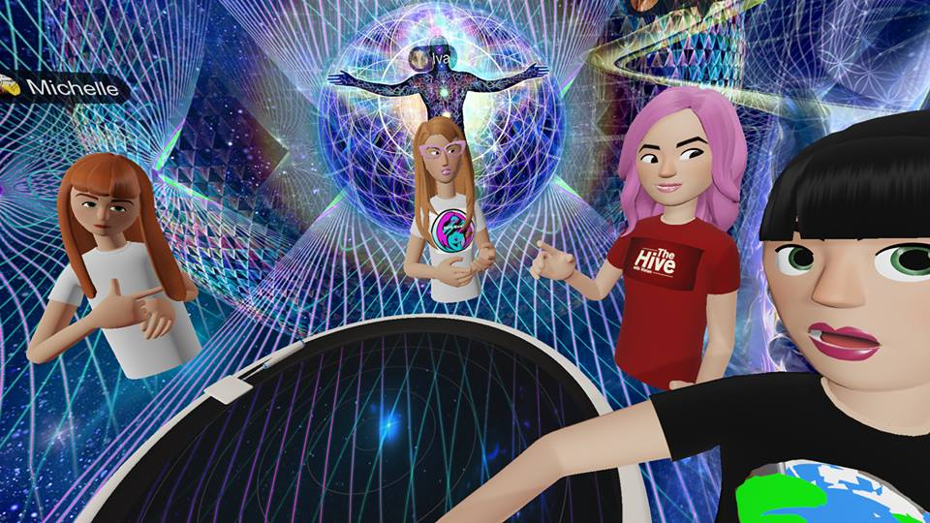

- Spatial Audio; or ambisonics, is a full sphere surround-sound technique that uses a dimensional approach to audio to mimic the way we hear in real life (360 sound)

Differentiation between VR headsets
6DOF VR (six degrees of freedom, as in walk around a virtual space) The six degrees of freedom: forward/back, up/down, left/right, yaw, pitch, roll

6DOF headsets will track orientation and position, the headsets knows where you are looking and also where you are in space. This is also referred to as roomscale or positional tracking. Minimum room specs – 2m x 2m cleared space (room to move around in the headset), trackers for the headset need to be wall mounted or on portable stands. The two main devices of 6DOF are the HTC VIVE and OCULUS RIFT.
There is also Playstation VR, but this requires a Playstation console rather than a PC to connect.

3DOF VR (three degrees of freedom) Stationary experience, can move head and see 360 degrees and standalone VR. 3DOF can track your head orientation, i.e., it knows where you are looking. The 3 axis are roll, yaw and pitch. Oculus Go is an example of this as an all-in-one virtual reality headset, no mobile phone or PC required to connect.

Mobile & Gear VR These are basically googles that hold a smart phone (like the Google Cardboard or Google Daydream) and have varying degrees of functions and controls.

More info: http://publiclibrariesonline.org/2016/02/virtual-reality-in-the-library-creating-a-new-experience/

