Queensland Architecture in Miniature 2023
~~HERO-SUBTITLE Laser-cut book nooks, miniatures and other delights! ~~
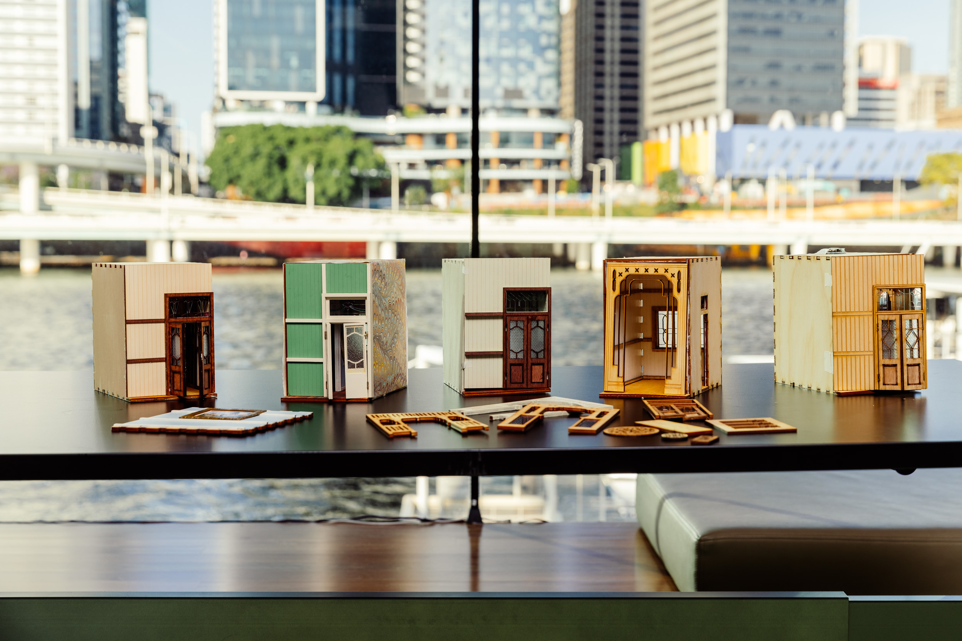
- Prototype developed by Billie Reuben 2021
- 2022 development and delivery by Michelle Brown and Rozina Suliman
- 2023 development and delivery by Michelle Brown

Workshop presentation
The Queensland Architecture in Miniature workshop has been created into a slide show for presentation and documentation purposes. Please feel free to download and use the guide and files as per our CC license in the footnote.
Some pages may link to other online workshops, tutorials or guides created at The Edge, you may require internet to connect and view links.
Public view - Slides
Admin view - Slides

Design File Templates

Basic nook with archway design
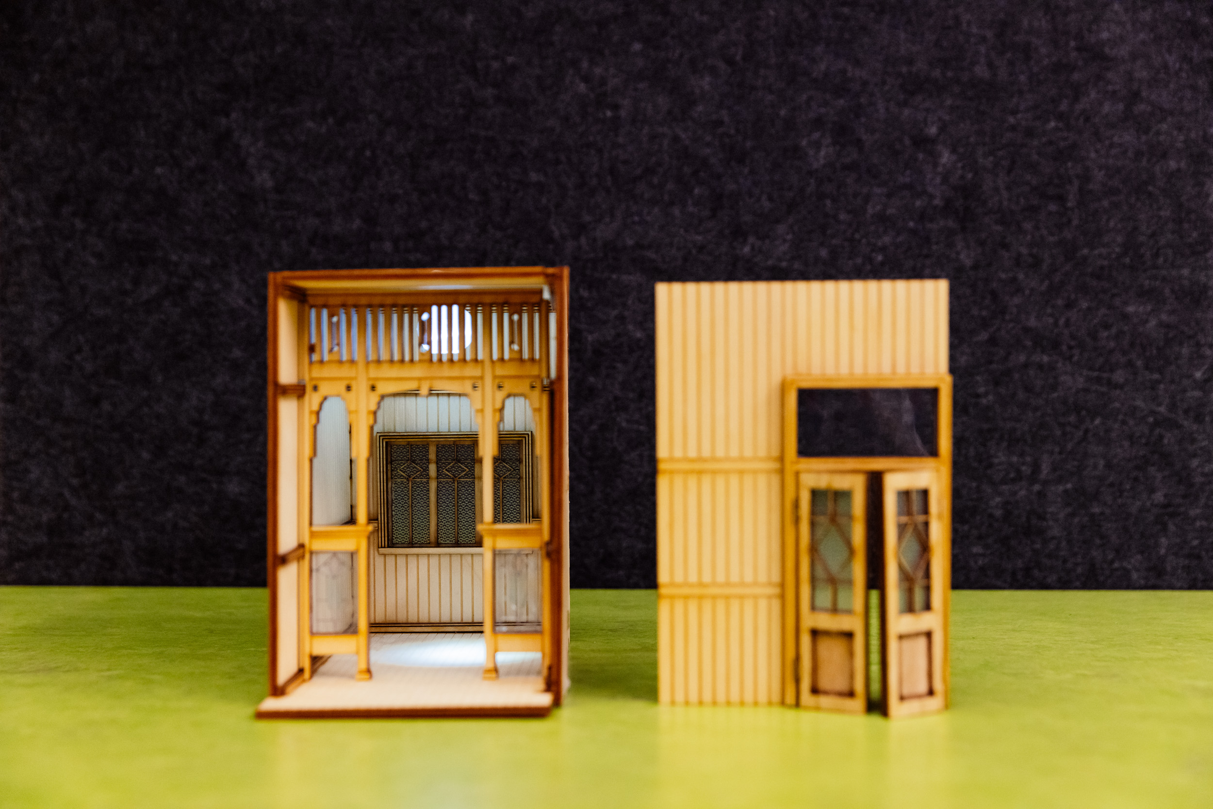
Our nook dimensions file - nookdimensions.pdf
Template | Material | File
Base (Closed) nook design | 4mm ply | Nook design file
Base (Closed) nook design - Magnet cuts | 4mm ply | Nook design file magnet cuts
Reverse nook front piece - Magnet engrave | 4mm ply - pre-cut piece | Front piece magnet engrave
Base nook with patio design | 4mm ply | Nook with pation design file
Front Nook rail door surround | 1.7mm to 4mm works | Front door surround
Rails and door surrounds | 1.5 mm to 3mm ply or boxboard | Internal rails and door surround
Accents template; casements, doors, breezeway & stain glass | 1.5 mm to 2mm wood | Accents template
Mottled glass design for windows | 1.5mm acrylic or 0.75mm PETG | Mottled glass
Stained glass window designs | 0.75mm PETG | stained_glass_designs.pdf
Nook roof | 4mm ply | Pitched roof design
Front veranda idea | 4mm ply | Front add on veranda
Fences | 4mm ply | Fences file
Material cutting notes
Current working file for windows with engraving (clear acrylic or PETG), tested with 1.5mm acrylic and .75mm PETG, both look fine but the PETG works best since it's thinner, but be mindful of warping, quick single cuts that are separated by a good distance are best, and remove any plastic covering before cutting.

Additional Design Files
Vector designs | Material | File | Image
Arch 1 | 4mm ply | Arch1 design file | 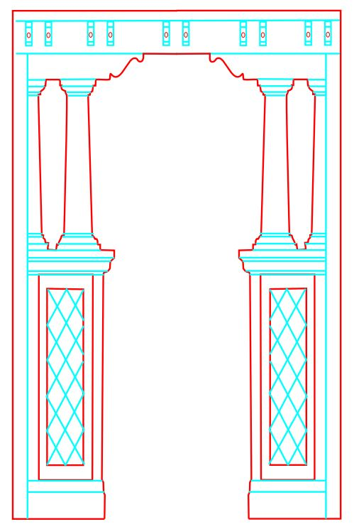
Arch 2 | 4mm ply | Arch2 design file | 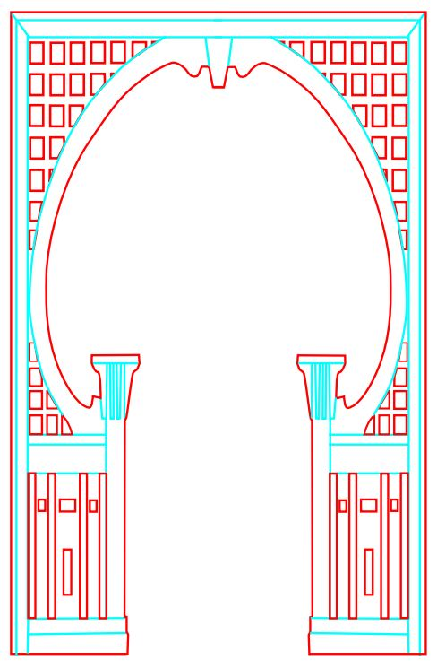
Arch 3 | 4mm ply | Arch3 design file | 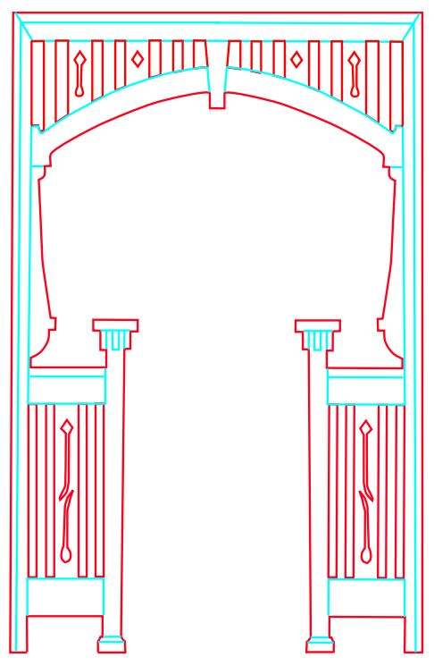
Arch 4 | 4mm ply | Arch4 design file | 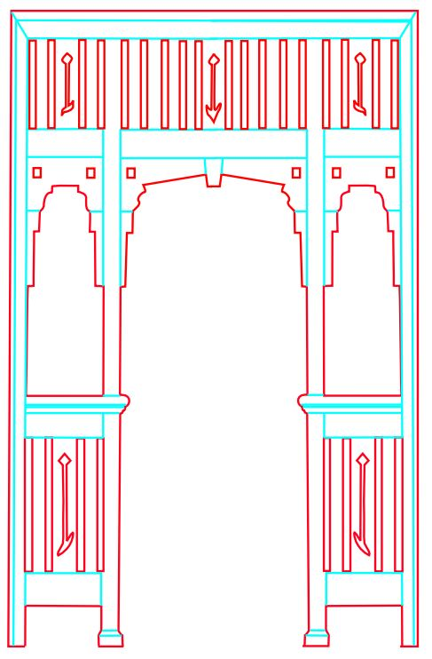
Arch 5 | 4mm ply | Arch5 design file | 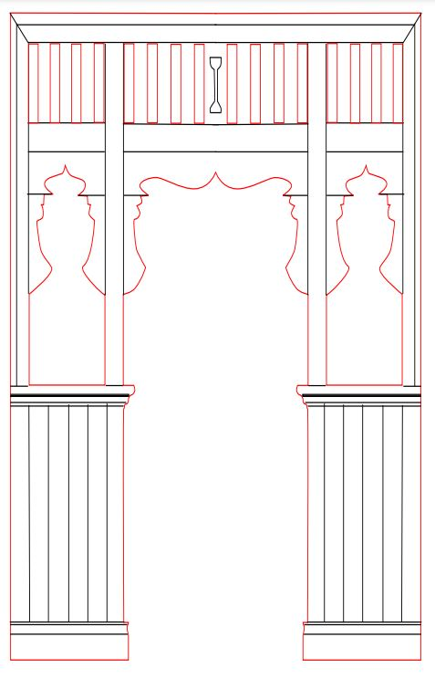
Arch 6 | 4mm ply | Arch6 design file | 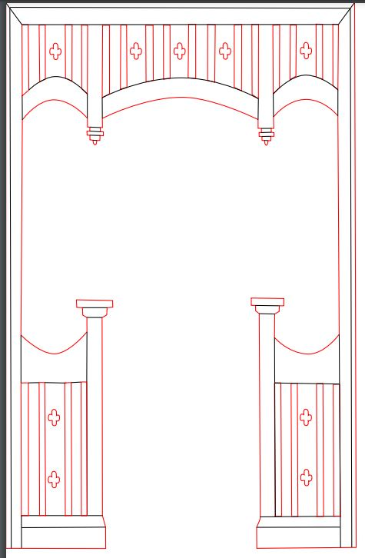
Arch 7 | 4mm ply | Arch7 design file | 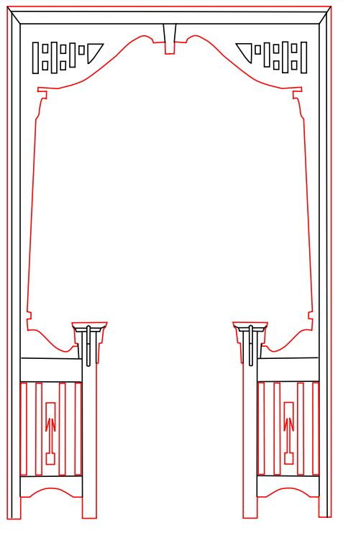
Arch 8 | 4mm ply | Arch8 design file | 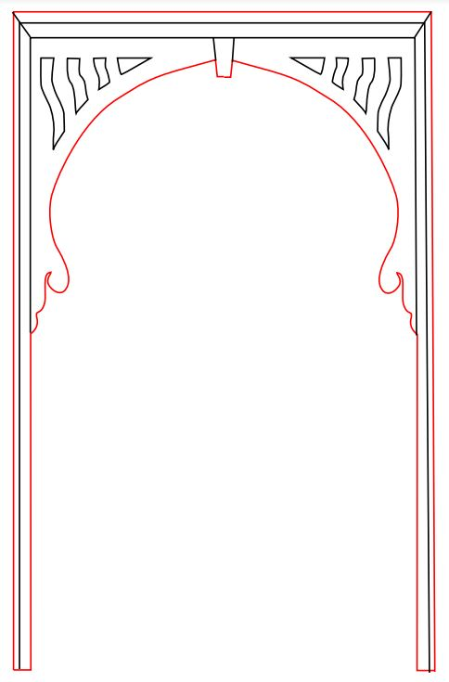
Multiple options | 1.5mm to 2mm | Casement windows and doors | 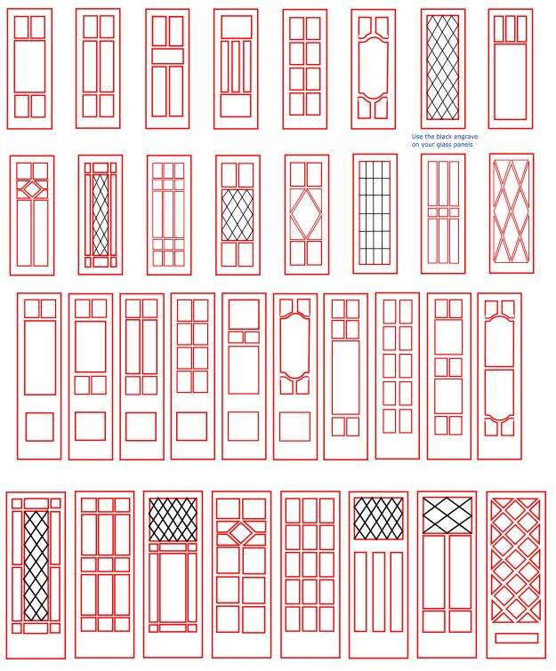
Back window casements | 1.5mm to 2mm | back_window_casements.pdf
More side door options | 1.5mm to 2mm | More side door options | 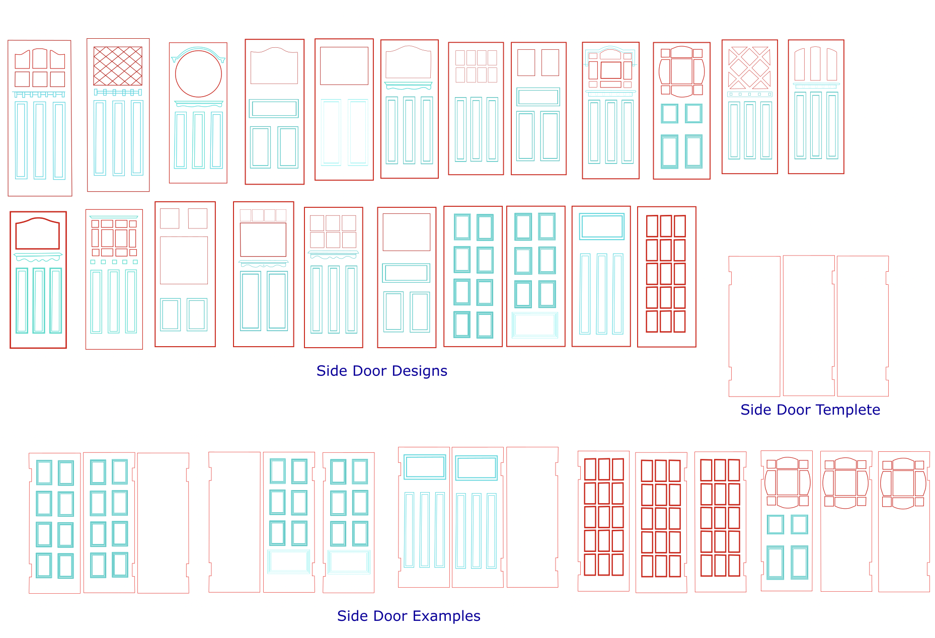
Breezeways | 1.5 mm to 4mm | breezeways.pdf | 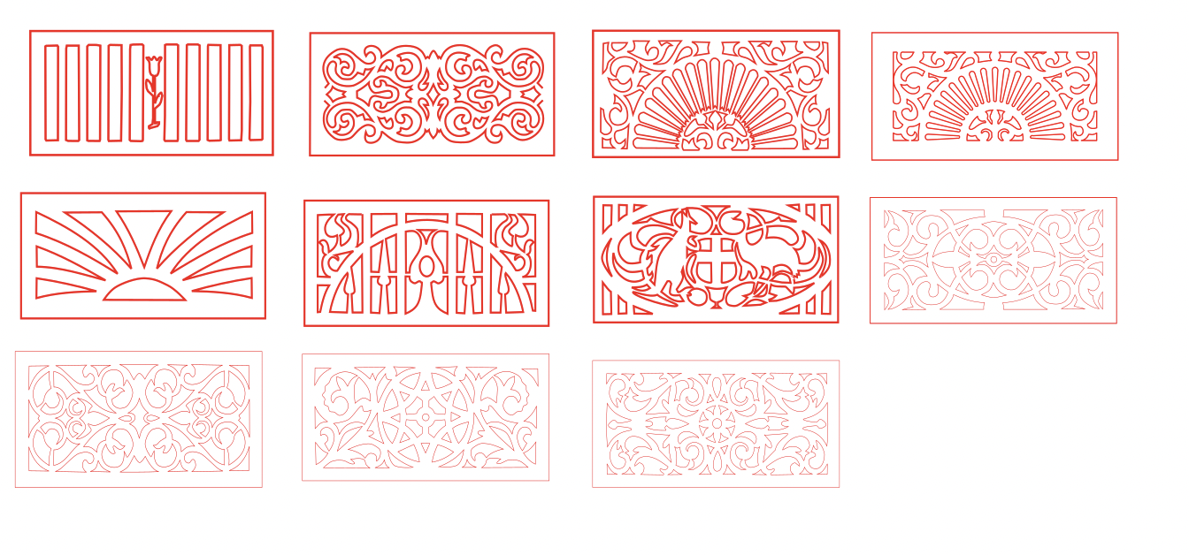

Furniture Design Files
Vector designs | Material | File | Image
Mini frames | 1.5mm - 4mm | frame_design.pdf | 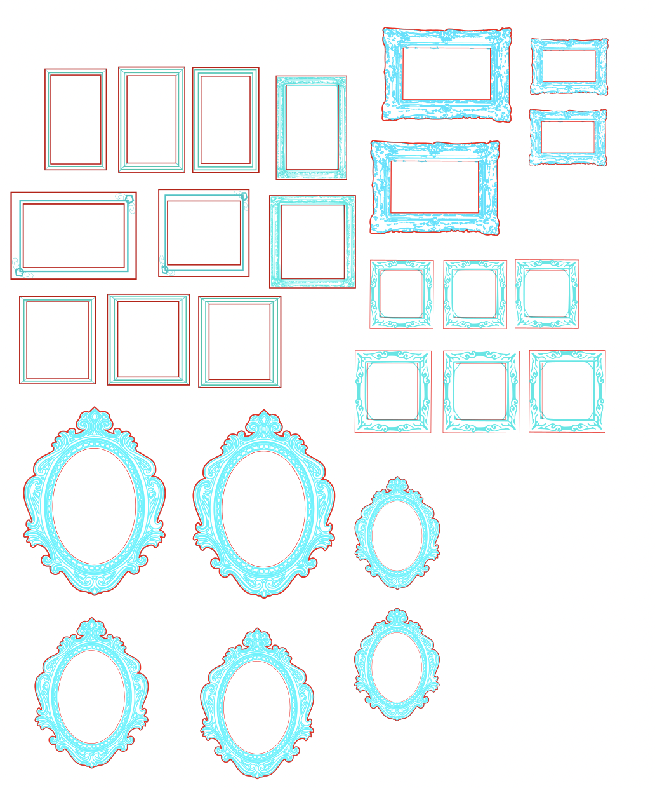
More frames (unsized) | 1.5mm - 4mm | pictureframes.pdf | 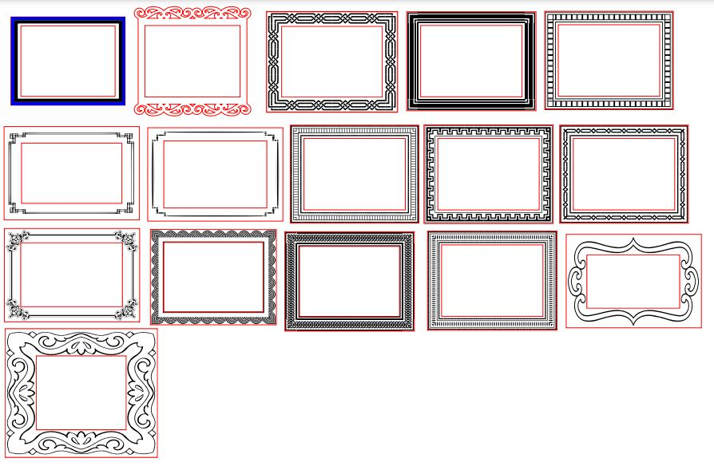
Some furniture | 1.5mm - 2mm | some_furniture.pdf | 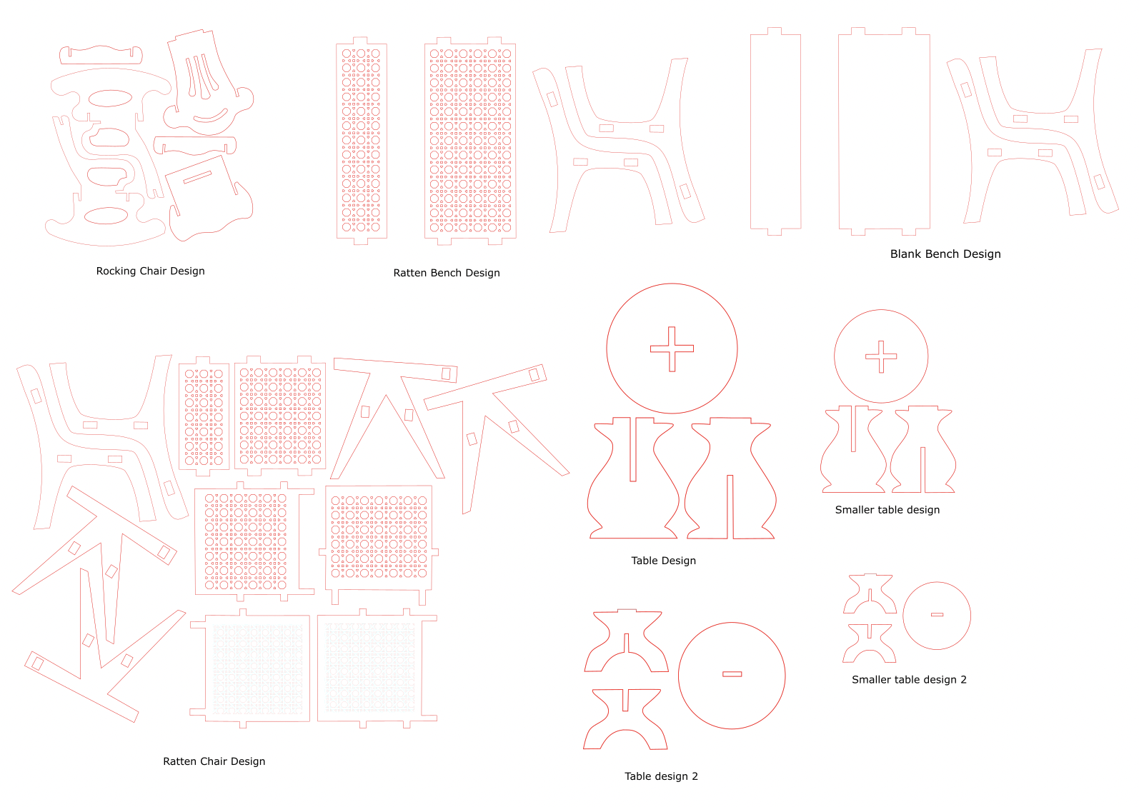
Different Roof designs | 4mm
MidMod Designs July 2025 | 4mm + 1.5mm


