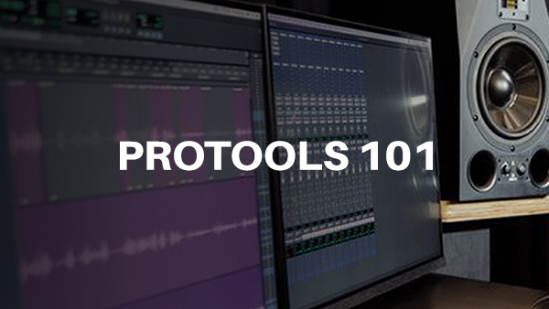

101 - Intro to ProTools
Developed by Marius Wyllie, 2023

Acknowledgement
We acknowledge Aboriginal and Torres Strait Islander peoples and their continuing connection to the land and as custodians of stories for millennia. We respectfully acknowledge the land on which we all meet today, and pay our respects to elders past, present, and emerging.

Summary
Learn the basics of ProTools, an industry-standard music production software. Together we will get an overview of some of the tools available in ProTools to enable you to record audio, MIDI, edit, and export audio.

Skills Introduced
- Create a new session
- Overview of Sample Rate and Bit Depth
- Setting the Playback Engine and Buffer Size
- Navigate the Edit and Mix Windows
- Create Audio and Instrument Midi Tracks
- Basic tools (Selection Tool, Trim, Grabber, Smart Tool)
- Creating Click Tracks and setting Tempo
- Creating Markers
- Recording Audio and Midi
- Importing Audio and Exporting Audio
- Bouncing session to stereo WAV or MP3 files

Hardware and Software
Software required
- ProTools.
Hardware required
- MIDI Keyboard
- USB microphone

Health & Safety
Running this workshop at The Edge?.. You should familiarise yourself and your participants with:
- DML Risk Assessment

Preparation
Ensure your computer is equipped with Headphones, MIDI Keyboard, and a USB Microphone.

References
protools_101.pdf
shaking_through_eliza_hardy_jones_441_16_raw_tracks.zip

