101 - Intro to Podcasting
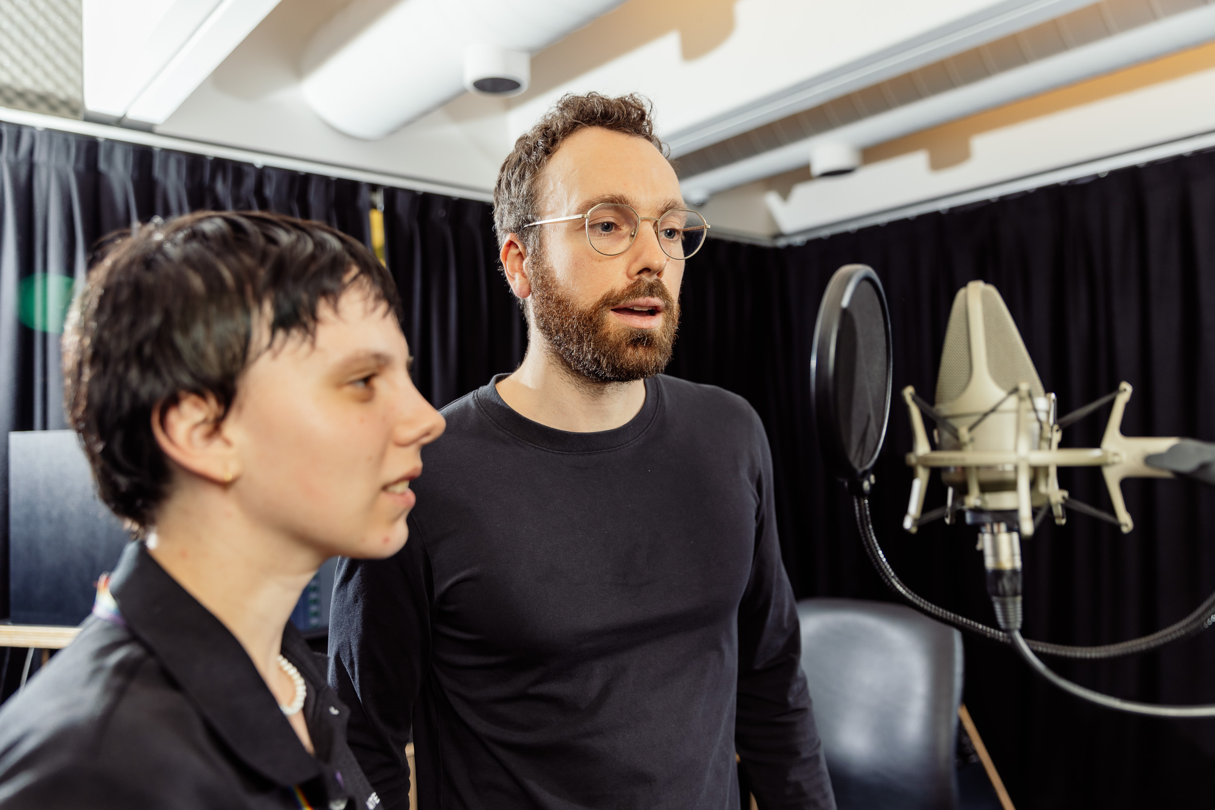
Stephanie Dower, November 2022.

Acknowledgement
We acknowledge Aboriginal and Torres Strait Islander peoples and their continuing connection to land and as custodians of stories for millennia. We respectfully acknowledge the land on which we all meet today, and pay our respects to elders past, present and emerging.

Workshop presentation
The 101 - Intro to Podcasting workshop has been created into a slide show for presentation and documentation purposes. Please feel free to download and use the guide and files as per our CC license in the footnote.
Some pages may link to other online workshops, tutorials or guides created at The Edge, you may require internet to connect and view links.
Admin view
Public view

Summary
Podcasting is relatively new media format that has taken the world by storm. From true crime podcasts uncovering new evidence in homicide cases to movie review podcasts giving us ideas of what to watch this weekend; Podcasts can entertain us, inform us, and inspire us. Stemming from the terms, “iPod” and “Broadcast”, Podcasts are characterised by their episodic nature and using RSS feed technology to allow audiences to subscribe and automatically receive new episodes as they're released.
Podcasting can be as expensive or inexpensive as desired by the creator, making it an accessible form of media that almost anyone can produce and share with a wide-reaching audience; if they know the basic skills needed.
Tonight's session will give participants are “quick start” guide to podcasting, giving them the basic technical skills for recording and editing a podcast, as well as some inspiration to get their creative ideas flowing.

Skills Introduced
- Brainstorming and Scripting
- Recording and Editing
- Finding an Audience

Health & Safety
Running this workshop at The Edge?.. You should familiarise yourself and your participants with:
- DML Risk Assessment

Styles of Podcasts
- Storytelling - could be historical content or fictional, can include one host or more.
Examples: Serial, Teacher's Pet, Last Night on the Titanic
- Audio Drama - similar to old-fashioned radio plays featuring sound design, multiple characters etc.
Examples: 36 Questions, The Candyman, Elf Control
- Solo - run by one person and possible covering specific topics.
Examples: Rachel Corbett's Podschool, Creative Peptalk
- Interview - usually featuring regular guests and interviews and may include a few hosts.
Examples: Wilosophy, How Others Dads Dad
- Panel - a group of hosts discussing different topics relating to the podcasts main focus.
Examples: Smartless, ReFramed

Basic Requirements
Like any artistic or creative product, the quality of your podcast will depend on how much time and effort you put into it but to get started, you need only a few things.
- A recording device - this may be a microphone, smartphone, audio recorder
- Editing software - this is where you will join the pieces of your audio together into a seamless (and hopefully engaging) episode
- Host server - this is where you will upload your podcast and get an RSS feed for distributing your podcast
- A great idea that people will want to listen to!

Brainstorming and Scripting
You may have heard the expression that Content is King; this is truer than ever in podcasting. If you want audiences to hit that all important 'subscribe' button, you need to know or understand what will appeal to and engage your audience. One of the simplest ways to figure this out is to ask yourself, “What would I want to listen to?”
Some questions to ask when brainstorming your podcast are:
- What kind of podcast do you want to create?
- How long? How often?
- Who is your target audience (Lay audience or industry specific? Vocab and level of explanation will be important for how you communicate based on the level of expertise you expect listeners to have)
- Tone: serious or light-hearted?
- How will you record it and edit it? (don't worry if you haven't thought about that yet, we'll go into this later)
- How will you promote it?
It's also important to be familiar with the podcasting landscape i.e. what other podcasts are already out in the world. Think about these key things when developing your podcast:
- Is this for fun or will you be looking to monetize?
- Are there other podcasts that cover similar (or identical!) topics, how will yours be different?
- How long will an episode of your podcast run for (will each week be the same or will you
- intersperse with extras or ‘minisode’ eps)
- Have you thought of a name that will stand out from the crowd? (Making sure to check if it’s already been used before you get too attached!)
- How often will your podcast run, weekly, monthly, intermittently? Will it be seasonal or continuous etc.

Preparing to Record
Preparation is key when it comes to the recording phase of your podcast. There are often many moving parts to recording a podcast and you want to make sure you've nailed these down so you can ensure you'll get the desired result from your recording session and go into it feeling confident.
A few key things to include in your preparation for recording include:
- Finding a quiet location to record in
- Researching which microphone will deliver the best audio for you
- Sourcing intro and outro music or audio stings
- Testing platforms for remote interviews with guests, etc.
- Making sure you have the correct permissions to use the audio you want or need
As Podcasting becomes more and more popular, recording equipment is becoming more accessible but it's still important to which microphones or audio recorders are going to work best for your podcast and then decide whether it's appropriate to invest in purchasing this equipment or perhaps look into what resources are available for hiring.
There are a range of tools for recording audio nowadays, including portable audio recorders (e.g. Zoom H4 recorders), smartphones, and more traditional microphones (e.g. RODE Podcaster and Broadcaster) which arguably will give you the best chance of recording high quality audio. It's important to remember a few things when deciding which microphone is best for your podcast.
- Dynamic or Condenser - these are the two types of microphones and each have their own pros and cons but Dynamic microphones are generally more adaptable across various conditions.
- Audio interface - if using a microphone connected to your computer or tablet, you'll most likely need a piece of software or application that can be used as an audio interface. This may be audio editing software like Audacity or the Voice Memo app on an iPad.
- Pop filters - this is usually a piece of mesh material that sits between the microphone and the presenter's mouth and works to soften any pops or clicks that come from the pronunciation of some letters e.g. 'P' or 'C'.
If you are needing to record remotely, whether its with a co-host or interview guest, it's important you test the equipment or software you'll be using but also have the other person check things on their end too. There's nothing worse that listening back to a recording and hearing an echo or one person's voice being considerably louder than the others. There are a number of platforms available for remote recording, two of which are:
- Zoom
- Squadcast

Editing a Podcast
Once you've recorded or sourced all of the audio elements you want to include in your podcast, it's time to edit! This is the step in the podcasting process you'll bring all of your assets together and edit them into a seamless audio sequence that will be exported as an episode of your podcast. For this, you'll need to use audio editing software on a computer and there are a few options available, most popularly:
- ProTools (Mac & PC)
- Logic Pro X (Mac)
- Adobe Audition (Mac & PC)
- GarageBand (Mac)
- Audacity (Mac & PC)
The first pieces of audio you'll want to bring onto the timeline are most likely an intro, chosen music and/or audio sting which are used to help transition from once piece of audio or conversation topic to another. There are many sources for free music online that fall under Creative Commons licenses.
- http://ccmixter.org/
- http://wiki.creativecommons.org/Content_Curators
- http://www.freesound.org/
Free Music Archive explains in more detail what is licensing and copyright, plus it allows you to search for music and soundtrack audio. http://freemusicarchive.org/License_Guide
For today's session, we'll go through the basics of Audacity which is an open source piece of audio editing software that can be downloaded at this link https://www.audacityteam.org/download/
Some things you'll need to understand or learn about before diving too deep into the editing phase are:
- Decibels - this is the volume of audio, otherwise known as loudness output and generally when editing your podcast, you want your audio to sit around -16 LUfs so as to not have any audio peak and become distorted
- Mono or Stereo - there are usually two options for setting up your project channels. If you set up your project as Mono, you will be working with just one audio channel (not to be confused with clips) whereas Stereo you will have two audio channels, usually Left and Right so when you export your finished podcast episode from Audacity, audiences will hear your audio coming through both their left and right speakers as opposed to just one side.
Now it's time to have some fun playing around and experimenting with the tools in Audacity. To get started, let's go through a basic Audacity software induction which will help us understand some of the basic tools available in the program. https://wiki.slq.qld.gov.au/doku.php?id=facilities:fablab:software:audacity
We have some audio available for you to download here to use as a prototype as you find your way around Audacity.

Finding an Audience
You've recorded, you've edited and now you have a finished podcast episode ready to be shared with the world! But how do you do that?
In order to distribute your podcast to platforms such as Apple Podcasts, Spotify, Stitcher or Google Podcasts, you'll need two things - an RSS Feed and Host Server.
RSS stands for “rich site summary” and is a simple way of automatically staying up to date with the delivery of content, for example, tracking episodes of podcast releases. This is what connects audience platforms like Apple Podcasts and Spotify to your host server which is where you will actually upload your podcast to and input Metadata. Note that Metadata can also be added to your audio files when exporting from Audacity.
There are a number of Host Servers available, ranging in cost and ease of use. Some popular servers are:
- Podbean
- Buzzsprout
- Libsyn
- Soundcloud
- Podomatic
Do your research to see what is best suited to your skills and budget for your podcast.
Once your podcast is available to audiences, the next step is attracting and building an audience which is arguably the most difficult part of podcasting. When thinking about how to reach and connect with your audience, consider the following:
- Who do you think would benefit from listening to your podcast or who do you want to reach?
- What are their habits?
- Do they already listen to podcasts? If so, which ones?
- What is their occupation?
- How do they get information? Social media or traditional media?
By thinking about your audience on a personal level, you can start to strategise different ways of engaging them e.g. throughs social media channels, website, cross-promotion, etc.

References

Podcasting - General
- https://www.buzzsprout.com/blog/how-to-start-a-podcast
- https://rss.com/blog/how-to-create-an-rss-feed/
- https://podcastingwithaaron.com

Audacity
- https://manual.audacityteam.org/man/audacity_tour_guide.html

Music/Sound Effects
- https://artlist.io (Paid Subscription)
- https://www.epidemicsound.com (Paid Subscription)
- https://freesound.org/browse/ (No Cost)
- https://soundbible.com/free-sound-effects-1.html (Free SFX)

RSS Feed
- https://rss.com/pricing/ (Paid)
- https://megaphone.spotify.com/tools#publish (Paid)
- https://libsyn.com/start-podcasting-with-libsyn-aus/?gclid=Cj0KCQiAsdKbBhDHARIsANJ6-jdjXytDBaVO6GFo22kj3EH3eUD3FqGXRaLJ27szzGA--gDl1xm-ZU4aAluvEALw_wcB (Paid)
If you'd like to learn more on Podcasting or check out other workshops happening at The Edge, sign up to The Edge eNews through SLQ https://www.slq.qld.gov.au/about-us/contact-us/stay-in-touch

Downloads
https://www.audacityteam.org/

Further References
Our full Podcasting workshop
Our full Podcasting workshop - online version
Audacity workshop

