Photoshop
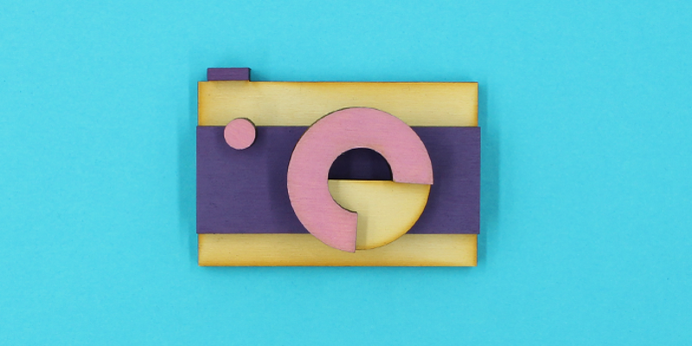
Redeveloped by Chris Eichberger in Aug 2017.

Summary
Adobe Photoshop for beginners
Get started with the basics of photo editing in this free Photoshop course for beginners.
In this 1.5 hour taster course we’ll step you through:
- The basic tools and functionality of Photoshop
- An overview of Photoshop’s capabilities
- Practical skills to help you experiment further
- By the end of the session you’ll have a digital postcard ready to send to your family and friends
*Please bring along a USB to save your work.
Editing photos with Adobe Photoshop
Build your photo editing skills in this intermediate Adobe Photoshop course.
In this 4 hour Adobe Photoshop course we’ll cover:
- Photo editing techniques using masks
- Colour & brightness corrections
- Touching up portraits
- Photograph combinations, blending and layering
Requirements and prerequisites:
This is an intermediate course, and requires a solid understanding of Photoshop, its common tools and terminology. If you are new to Photoshop, please attend Adobe Photoshop for beginners first. Intro to Mac class or proficiency with the Mac operating system.

Materials
- Photoshop 1 Workshop Plan
- Photoshop 1 Handout
- Photoshop 1 Supplied Assets
- Photoshop SHERPA

