Kombucha: Making with Microbes

Developed by Pahia Cooper in collaboration with Dr. Peter Musk in Aug 2017.

Summary
Kombucha is produced by fermenting sweet tea using a symbiotic colony bacteria and yeast (or SCOBY). It is a lightly effervescent drink regarded by many as a functional food that assists in digestive health and liver detoxification. But The Edge is growing kombucha tea for an entirely different reason. Researchers, the most prominent of these being Suzanne Lee, have suggested the microbial cellulose pellicle produced by a kombucha culture can also be used as a clothing textile. Over the last several years, The Edge has been experimenting in growing kombucha and harvesting the cellulose pellicle as artificial or vegan leather. The following instructions will take you through brewing the tea for your kombucha (its food), ongoing maintenance for your kombucha and harvesting and drying your samples.
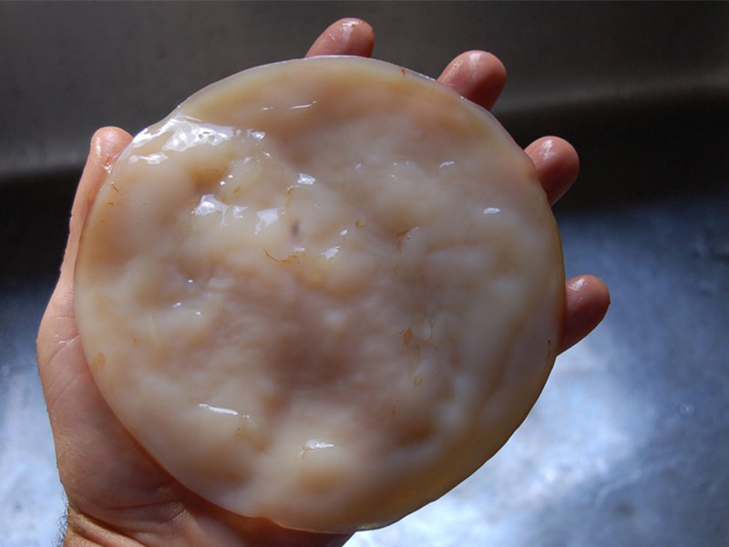

Materials
The following recipe makes a 1L of Kombucha Tea. Scale up your quantities to make more.
Equipment
- Tub or tray with a lid you can cut a small breather hole in (~30mm diameter hole), able to hold 1L. The shallower the liquid the better the pellicle grows (so a bigger tray is better)
- Measuring jug, 500mL
- Stirring spoon
- Muslin bag or other open weave material (Chux works well)
- Kettle or urn
- Spray bottle
- Scissors
- Washing tub
- Flat, smooth drying board – we use laminated table top/ kitchen cupboard melamine boards
- Scraper
- Storage container
- Washing up gloves (optional)
Consumables
- 6g of tea or 6 tabags
- 1L of tap water
- 100ml of soured (fermented) kombucha tea
- OPTIONAL a small cutting of scoby pellicle or mother (the culture will still grow without this)
- white vinegar
- coconut oil (optional)
- vaseline
- 1 cup of dry rice or sodium bicarbonate (for storage of dried material)
Commercial Kombucha drinks may have been pasteurised before sale to extend shelf life. This will kill the SCOBY organisms, and mean the product will not be a good starter for your culture.
The best source will be someone who is growing Kombucha at home, and therefore has a live culture they can share.

Instructions

Making your Kombucha
- Wash your hands… properly- not just a social wash
- Thoroughly clean all utensils and receptacles using mild detergent and rinse
- Boil water and measure 500mL into your tub or tray
- Add 85g sugar stir til dissolved
- Measure out 6gm of tea and place in muslin (or organza) bag
- Add muslin bag of tea (or 6 teabags)
- Wash your hands again
- Cover tray/ tub with lid.
- Allow tea to steep until the brew cools to room temperature (leaving it overnight is OK).
- Yep… wash those hands again
- Remove muslin bag (or teabags) and add 400ml of cold water to the brew
- OPTIONAL Add a piece of the scoby or pellicle (40mm x 40mm you have cut from the larger mass with clean scissors).
- Add at least 100ml of the starter sample of fermented kombucha tea.
- Replace the lid
- Keep your kombucha in a place where it won’t get disturbed and out of direct light.
Kombucha does not require light to grow, but it does need oxygen (from the air).
If your container has a tight fitting lid, it may be necessary to cut an air hole in the top (cover it with some of the open weave fabric to reduce the potential for contamination by passing spores, though).

Caring for your Kombucha
Before doing anything with your brew, always wash your hands. All going well, an opaque, jelly-like white pellicle or skin of microbial cellulose should start to form on the surface of your tea within 3-7 days. This will continue to thicken over 2-3 weeks until it takes on the texture and appearance of fresh, cleaned calamari tube. The thicker the pellicle, the more robust the dried product, and best results are with a pellicle 8 - 10mm thick (which takes about 3 - 4 weeks to grow).
The key to caring for your kombucha is making sure it doesn’t get infected with common mould. The brew is most susceptible to infection in the first week as the tea sours. Once your tea has soured and the pH has dropped to between 4 and 4.5 it’s difficult for an infection to take hold in your brew. If you do observe a mould infection (furry grey, grey green or even orange patches growing on top of the brew) you can combat this by spraying infected patches with a 1:1 mixture of white vinegar and water.

Harvesting, preparing and drying your pellicle
After two to three weeks a good Kombucha brew will grow a pellicle that is about 1cm thick. This is the point at which we harvest our pellicles. Sometimes you will have a slow brew that will take a little longer. You might want to wear your washing up gloves for this part.
- Without spilling any of your precious brew, remove the pellicle from the container and place it in another tub for washing.
- Wash your pellicle in a mild detergent and rinse in clean water. Repeat this cycle until the pellicle has lost its sweet smell.
- Dyeing: Because the pellicle is composed of cellulose (the same as cotton), many fabric dyes will be effective in colouring your creation. Dyeing is best done after washing, and before oiling – just follow the instructions for the dye.
- Rubbing coconut oil into the pellicle at this stage (before it dries) will produce a more supple and leather-like product. For best results, spread the wet pellicle on a flat surface, and rub all over (both sides) with fingers dipped in coconut oil.
- Lightly grease your drying board (or mould) with Vaseline to prevent the pellicle from sticking as it dries.
- Spread the pellicle over the greased board or shaped mould and allow it to dry for 4 -7 days.
- The 1cm pellicle will shrink to a 1-2mm thickness as the water evaporates. The length and breadth of the drying sheet will not change appreciably.
- When you are satisfied that your pellicle has dried completely carefully remove it from the board or mould. You can use a scraper to help you remove a smooth sheet, or simply start at a corner and gently pick away until it lifts up, so you can grab it between your fingers, and pull gently.
- If the dry product is too sticky give your next batch a more thorough wash. If it’s too papery for your purpose try washing the next batch less. Thinner pellicles will tend to give a more brittle, papery product.
- Store your dry sheets of finished cellulose in an airtight container with a cup of dry rice to act as a desiccant. You can also put in an open container of bicarbonate of soda to absorb any lingering smells.

Workshop Accessories
- Slides
- Workshop Handout
- Workshop Outline

