101 - Adobe InDesign
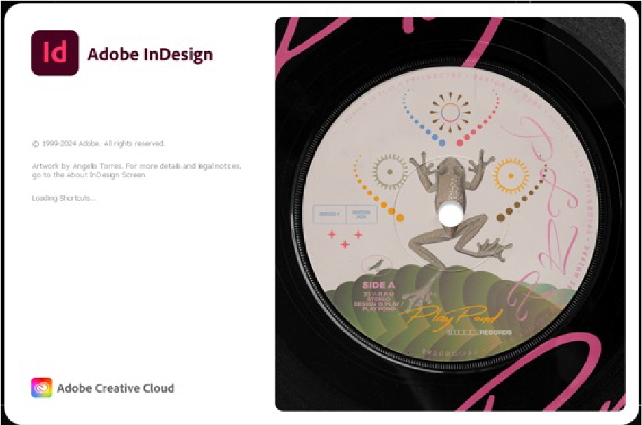
Developed by Kat Johnston, 2025

Workshop presentation
This workshop has been created into a slide show for presentation and documentation purposes. Please feel free to download and use the guide and files as per our CC license in the footnote.
Some pages may link to other online workshops, tutorials or guides created at The Edge, you may require internet to connect and view links.
Admin slide View
Public slide view
101_-_indesign_with_resource_notes.pdf - this includes the full step-by-step in granular detail with more extensive notes than are presented on the slides alone.

Workshop Resources
indesign_workshop_resources.zip
my-zine_-_export_booklet_example.pdf
my-zine_-_print_to_booklet_example.pdf

