Early Animation Technology
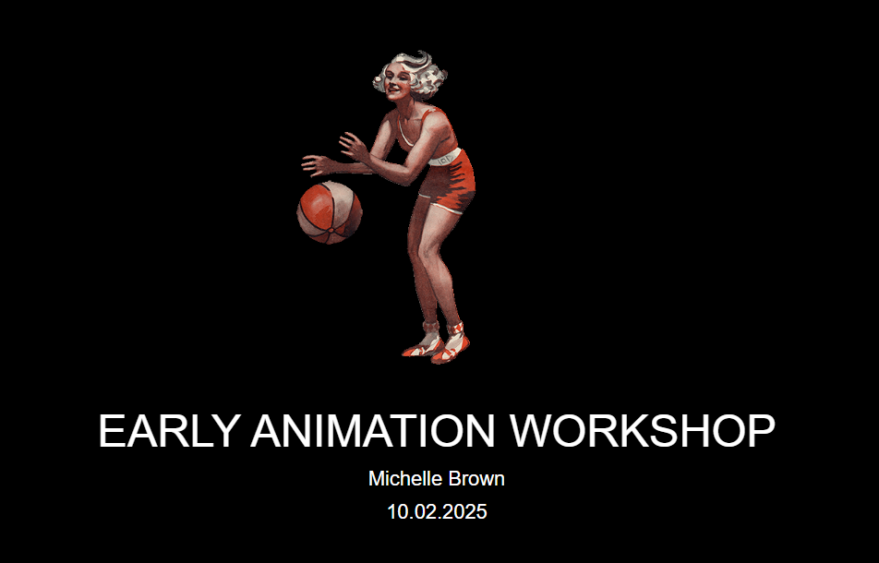

Workshop presentation
This workshop has been created into a slide show for presentation and documentation purposes. Please feel free to download and use the guide and files as per our CC license in the footnote.
Some pages may link to other online workshops, tutorials or guides created at The Edge, you may require internet to connect and view links.
Public view - Powerpoint Slides
Public view - PDF Slides
Admin view - Slides
Admin view - Session plan

Animation templates and examples
During the workshop to show the basic frame by frame animation process, we have created an example using one of the State Library's collection resources. We have chosen one of The Queenslander illustrated cover images as it is a good example of how to remove a basic background and manipulate the image to separate the ball from the person and make it bounce across the 16 frames.
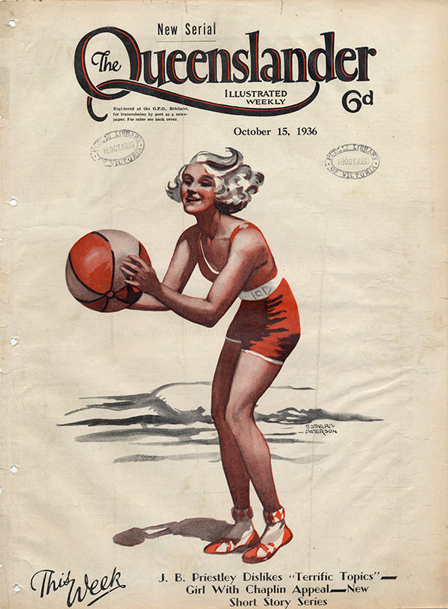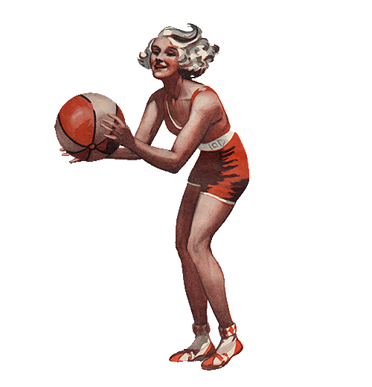
Link to the Illustrated front cover from The Queenslander, October 15, 1936
Download the medium quality JPEG version (about 5MB)

GIF Animation Template
Basketball Photoshop GIF layers PSD file
Horse and Rider Photoshop GIF layers PSD file
Unzip to open file with Photoshop.

Zoetrope Animation Templates
Our Zoetrope inner ring circumference is about 40cm in length, this fits to an A3 printed piece of paper and the templates below sized for The Edge's 3D printed model;
16 Frame Zoetrope blank template A3
16 Frame Zoetrope Basketball Girl A3 PDF
16 Frame Zoetrope Basketball Girl PSD file
Unzip to open file with Photoshop.

Phenakistiscope Animation Templates
Current working template size A4 print
PDF Basketball Girl A4 print
PDF Basketball Girl A4 Print no border
PDF Horse Gallop A4 print
Unzip to open file with Photoshop.

Zoetrope 3D print files

Original small version of Zoetrope
zoetrope_01c_inner.stl
zoetrope_01c_main.stl

SLQ version of Zoetrope
Inner ring - Zoetrope inner ring
Outer ring (body) - Zoetrope outer ring

