Digital Design & Prototyping
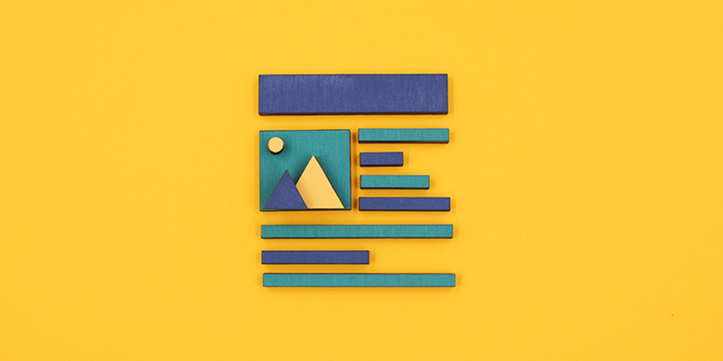
Designing the Digital
Use Design Thinking principles and processes to research, design, mock-up, and test an app (or website) using Marvel. First in a series of 3 workshop sessions.
Prototyping the Digital
Learn some of the key principles and processes you can use when getting a new digital product off the ground. Second in a series of 3 workshop sessions.
Prototyping the Physical
Learn some of the key principles and processes you can use when getting a new digital product off the ground. Third in a series of 3 workshop sessions.

