Designing the Digital

Developed by Greg Le Sueur in Nov 2017.

Summary
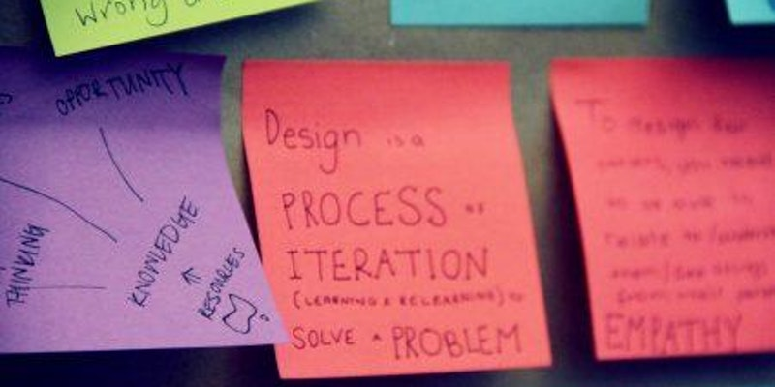
In this ideation and prototyping session we’ll use Design Thinking principles and processes to research, design, mock-up, and test an app (or website) using Marvel. Through the process we’ll cover:
- User research
- Defining the problem/opportunity
- Ideating a solution
- Prototyping the solution using Marvel
- Testing the solution with other participants to validate if it solves the problem
At the end of the workshop, you’ll leave with a tested prototype and the knowledge of how to recognise opportunities, ideate solutions, and validate them using Design thinking, which you can apply to future endeavours.
If you attended Prototyping the Digital, this Design Thinking workshop would be your next step, although it’s not a prerequisite.

Materials
- Slides (pdf)

