Augmented Reality 101

Augmented Reality 101
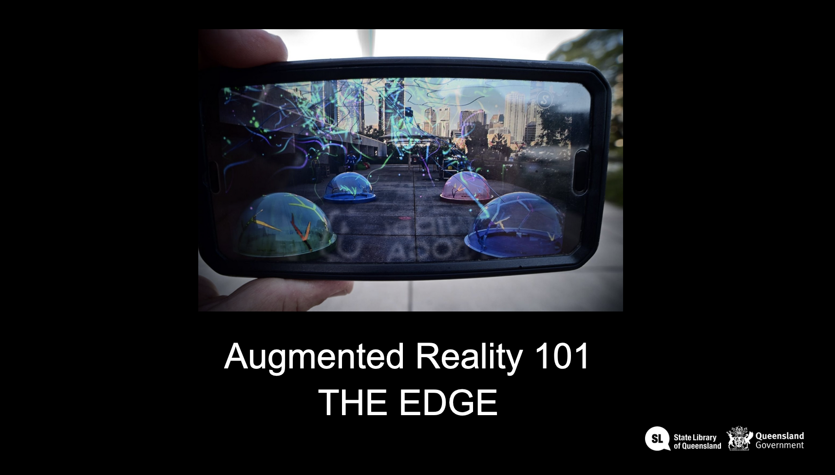

Acknowledgement
We acknowledge Aboriginal and Torres Strait Islander peoples and their continuing connection to land and as custodians of stories for millennia. We respectfully acknowledge the land on which we all meet today, and pay our respects to elders past, present and emerging.

Workshop presentation
The Augmented Reality 101 workshop has been created into a slide show for presentation and documentation purposes. Please feel free to download and use the guide and files as per our CC license in the footnote.
Some pages may link to other online workshops, tutorials or guides created at The Edge, you may require the internet to connect and view links.
101_-_intro_to_augmented_reality.pdf |Public view - Slides}}
Admin view - Slides

Workshop resources
For our poster animation we are going to use one of The Queenslander magazine covers from the State Library collection.
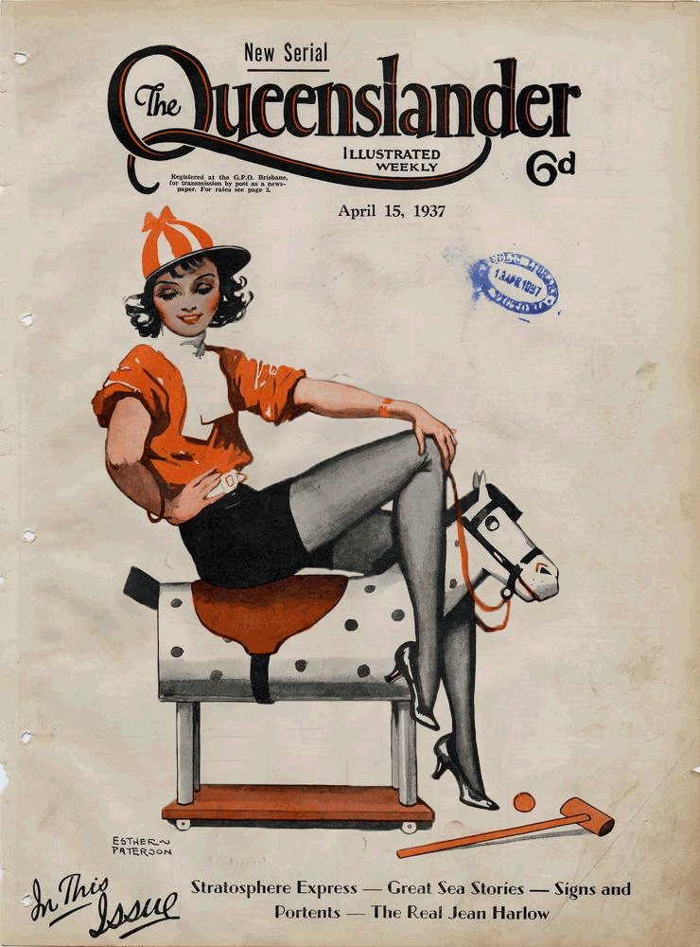
queenslanderanimated_april1937.psd.zip

Resources
https://www.pinterest.com.au/Thebadlament/augmented-reality-art/
https://wiki.slq.qld.gov.au/doku.php?id=workshops:prototypes:facefilters
https://wiki.slq.qld.gov.au/doku.php?id=workshops:public:augmentedreality:start
https://wiki.slq.qld.gov.au/doku.php?id=engagement:flyingarts:artiz2021:arfilters

