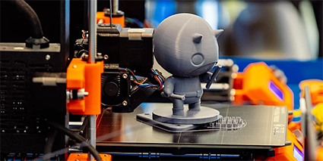

101 - Intro to 3D Printing
In this workshop, we will guide you through the process of preparing 3D models for printing using Fused Filament Fabrication (FFF). After running through this session, you should have a better understanding of the various issues that influence printing success, print speed, strength, and surface quality.
This workshop follows a similar format with different content outcomes, our most recent is focused on cards to coincide with the Driven exhibition.

Acknowledgement
We acknowledge Aboriginal and Torres Strait Islander peoples and their continuing connection to land and as custodians of stories for millennia. We respectfully acknowledge the land on which we all meet today, and pay our respects to elders past, present and emerging.

Workshop presentation
The Introduction to 3D printing workshop has been created into a slide show for presentation and documentation purposes. Please feel free to download and use the guide and files as per our CC license in the footnote.
Some pages may link to other online workshops, tutorials or guides created at The Edge, you may require the internet to connect and view links.
Admin view
Public view

Further workshops
Explore our other 101 - 3D printing workshops that teach you how to create different outcomes.
- 101 - 3D Printing - 3D Car model keychain
- 101 - 3D Printing - Keepsakes and Talismans

