SKATE or D.I.Y
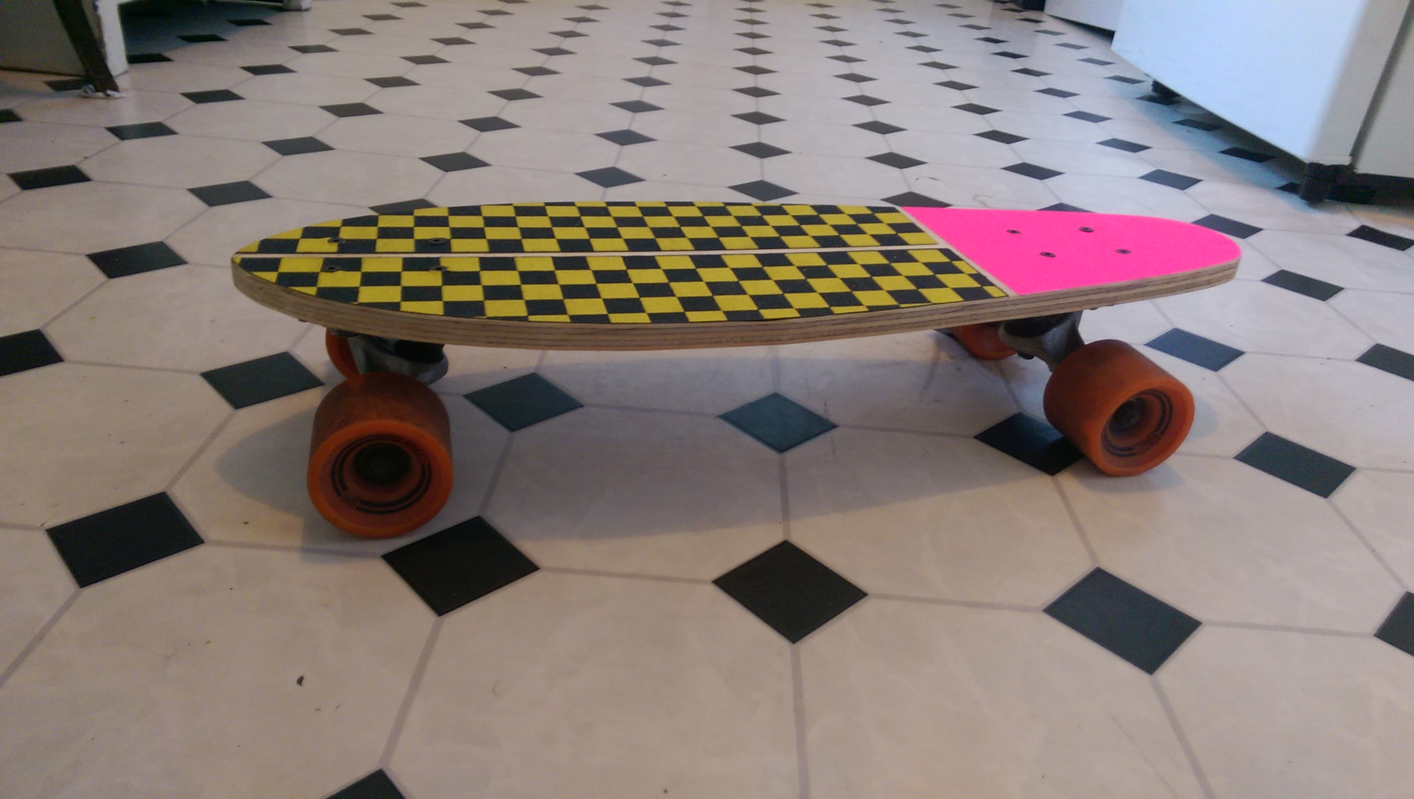
Developed by Michael Doherty

Summary
Participants will be able to design there own skateboard deck from a few basic designs(Penny, Cruiser or Long board) as well as complete a CNC induction.

Activity Summary
The workshop is not limited to people who ride skateboards but those who embrace the DIY attitude and culture of skateboarding and designs could also be used as wall mount piece(Maybe a clock or laser etched artwork).The idea is to use offcuts and salvaged parts to create something unique and personalized as well as engaging with a younger audience and there parents.
The skills gained include
- Designing a tool path for a board using Enroute
- CNC induction
- Creating graphics for stencils or laser etching in Adobe Illustrator
(The initial version of this workshop will be using offcuts for creating flat “cruiser style” boards but I have also designed a mold in Fusion 360 for pressing “blanks” with concave and kicks which can also be made of offcuts and cut on the CNC...WATCH THIS SPACE!!!)

Materials
Varied lengths of Plywood Depending of size of board
1xPair of Trucks
1xSet of Wheels
1x Set of Bearings
1x set(8) of Nuts and bolts
Griptape

Tools
CNC Machine
Sandpaper

Instructions

Step Zero:
Hand out CNC Induction paperwork to particpants.
- Safety
- Machine components
- CNC Start Up
- Tool paths
- Moving Designs to Machine-Output
- Loading a Tool

Step One:

Step Two:

Step Three:

Step Four:

Step Five: Troubleshooting

Step Six: References

Production notes

Critical Success Factors
Which of the critical success factors does this Prototype target? For more details see SLQ-Strategic-Plan-2016-20

Enable Access

Engage Community

Build Capability

Delivering of The Edge Promises
Aside from the SLQ Strategic Plan, there is The Edge's commitments to the community and the lens we look at it through. Here are a few more check boxes for you to answer

This empowers creative experimentation across...

It will inspire...

Feedback
1. Feedback:
Solution:
2. Feedback:
Solution:
3. Feedback:
Solution:
4. Other observations:

References
This were you put external links like LED generator

Files
This is where you put files for laser cutting etc..

