Plant UR Cup
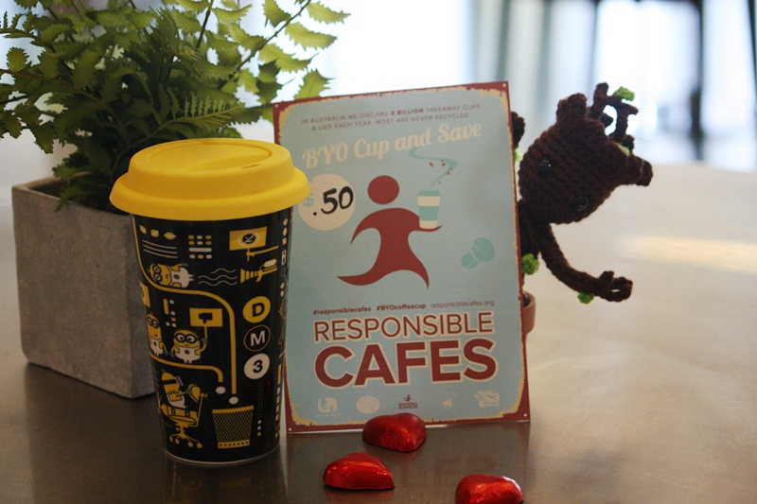

Summary
I saw this workshops:prototypes:2022-23delivery-lasercutcovers:planturcup:img_7414.jpg one day at my local and asked what they did with the cups? They used them to grow seedlings. i thought that this could be a thing we did in the Coffee Stop. Set up a station on Level 1 of the Edge, somewhere by the coffee stop, where patrons could plant a seed or seedling into their empty coffee cup and take it home with them. It could be something productive (ediblehttp://www.prettyproduce.com.au/about, attract pollinatorsworkshops:prototypes:2022-23delivery-lasercutcovers:planturcup:img_7812.jpg, air filteringhttps://en.wikipedia.org/wiki/NASA_Clean_Air_Study)
This could
- be a brief 3min activity that patrons could engage with upstairs
- a way getting people to think about their rubbish
- a hands on way of recycling/ upcycling
- an opportunity for people to learn the rarely* practiced technique of planting a seed (Urban people don't plant stuff)
- something to take home and talk about
- there could be a didactic about the productive nature of the plant

Activity Summary
Describe the activity being proposed and the engagement, skills and knowledge development value of this type of activity.

Materials
Cups seeds/ seedlings soil water

Instructions

Step Zero:
- The Edge organises seed/ seedlings from a productive plant partner ( pretty produce, woodford butterfly people, Bee one third, community gardens types)
- find a source of soil ( wandering cooks' composting machine)
- establish a stock of seedlings
- we build a booth to install upstairs. write a blogpost

Step One:
rinse your cup and lid

Step Two:
select seed/ seedling (comes with an info tag)

Step Three:
pour in measure of soil

Step Four:
plant according to instructions on tag

Step Five:
water and replace lid

Step Six:
share on social using our hash tag

Step Seven:
take home and care for me according to instructions on tag

Production notes

Critical Success Factors
Which of the critical success factors does this Prototype target? For more details see SLQ-Strategic-Plan-2016-20

Enable Access

Engage Community

Build Capability

Delivering of The Edge Promises
Aside from the SLQ Strategic Plan, there is The Edge's commitments to the community and the lens we look at it through. Here are a few more check boxes for you to answer

This empowers creative experimentation across...

It will inspire...

Feedback
1. Feedback:
Solution:
2. Feedback:
Solution:
3. Feedback:
Solution:
4. Other observations:

References
This were you put external links like LED generator

Files
This is where you put files for laser cutting etc..

