Make a Light up Cube
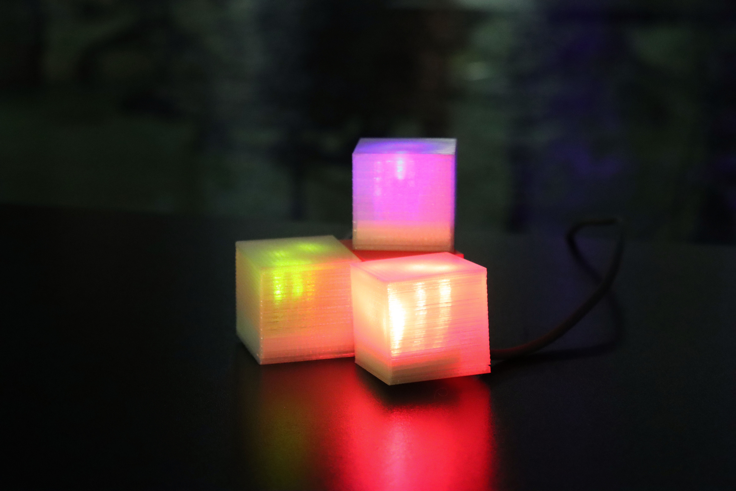
ANYONE SEEKING TO ADAPT THIS WORKSHOP SHOULD CONSIDER THE FOLLOWING INFORMATION.
WARNING - This workshop makes use of small coin cell/ button batteries.

In December 2020, the Australian Government made mandatory safety and information standards for button/coin batteries and consumer goods that contain button/coin batteries (the standards). The standards included an 18 month transition period and became mandatory from 22 June 2022. From 22 June 2022 manufacturers, importers, wholesalers and retailers of button/coin batteries or consumer goods that contain button/coin batteries supplied to Australia, must comply with the applicable Australian mandatory safety and information standards. Supplying or selling non-compliant products to consumers in Australia is illegal. The four mandatory standards are as follows:
• Consumer Goods (Products Containing Button/Coin Batteries) Safety Standard
• Consumer Goods (Products Containing Button/Coin Batteries) Information Standard
• Consumer Goods (Button/Coin Batteries) Safety Standard
• Consumer Goods (Button/Coin Batteries) Information Standard

Summary
Lightup Box is a short - 10-15 minute - community engagement activity designed to accompany basic explanation of electronics like the Electronics 101.

Materials
These materials are per participant if not specified otherwise.
- 1 x CR2032 Battery (See warning above)
- 4 x LED (in one colour)
- 3d printed box (see below)
- Mini breadboard.
- 2x resistor ( 75 Ohms)
- jumper wires

Tools
Multimeter Hot Glue gun

Instructions

Step Zero: Prep
cut off B end of usb cable and terminate positive (red) and ground (black) conductors with a male jumper cable lead as pictured below. (secure other conductors against short circuits with heat shrink). one for each participant.

Step One:
Use LED Calculator to get a circuit diagram
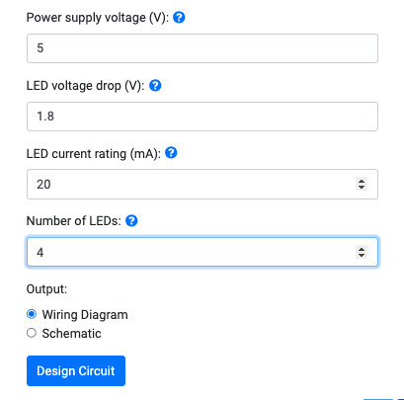
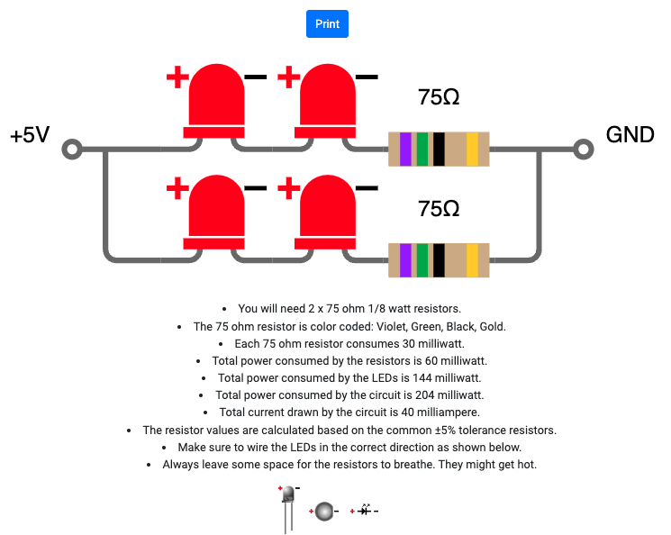

Step Two:
Review how a multimeter and breadboard works. Familiarise /Test LEDs with CR2032 Battery
use the multimeter on the Continuity setting to demo how the bread boards work
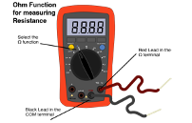
Select the continuety setting by • selecting Ohm on the Dial  • And use the blue button in the image above to select the continuity setting 
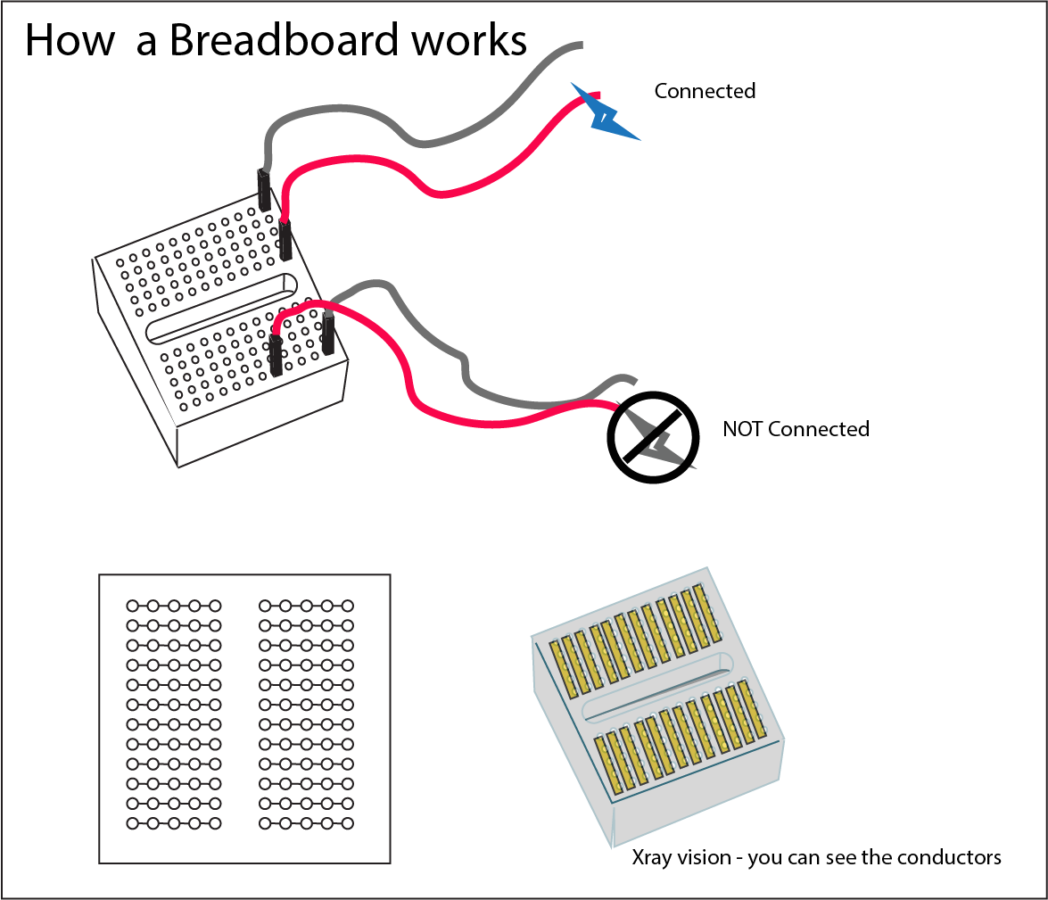

Step Three:
Work out how you are going to use the bread board to connect your circuit.
Here's how i did it
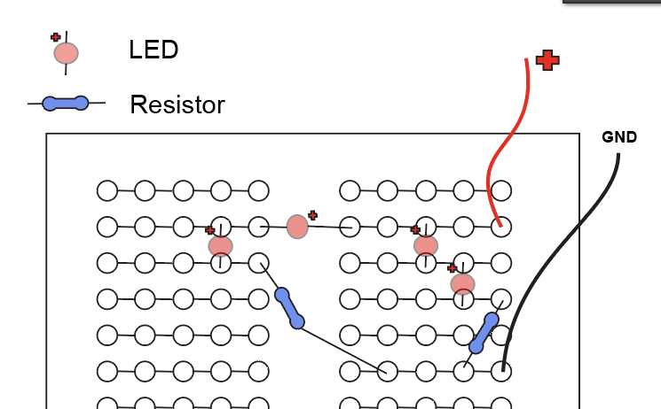

Step Four:
Assemble you circuit on you bread board and test it with the power source.

Step Five:
if it works hot glue you're components in place and install the circuit into you 3d printed box
Extension Activity

Activity Extensions
Work out how you could use lithophanemaker to add an image to the 3D printed box

Files
lightbox.stl

Acknowledgement
We acknowledge Aboriginal and Torres Strait Islander peoples and their continuing connection to land and as custodians of stories for millennia. We respectfully acknowledge the land on which we all meet today, and pay our respects to elders past, present and emerging.

