Neon Acrylic Lamps

Neon Acrylic Lamps
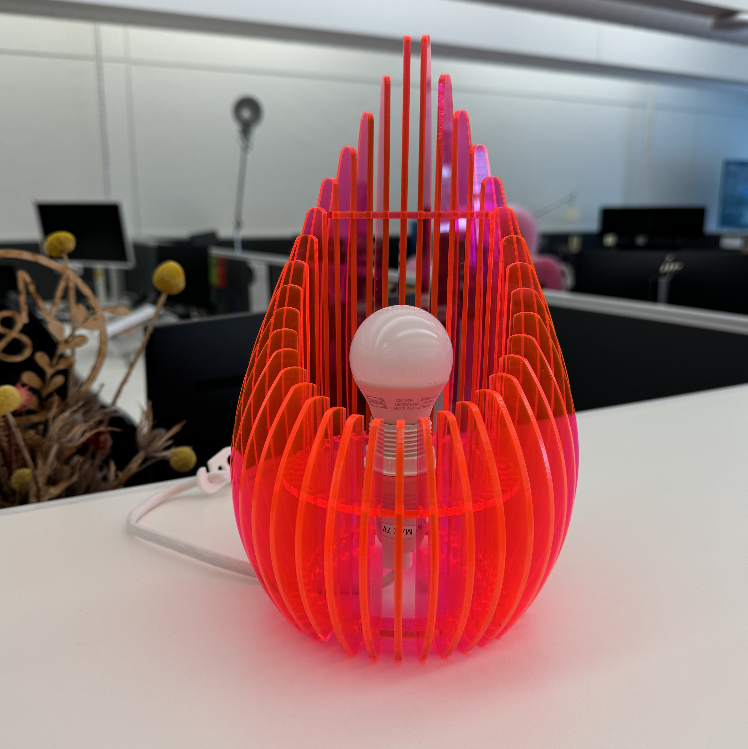

Workshop Slides
https://statelibraryqld.sharepoint.com/:p:/t/AppliedCreativityTeam/EeJhs92q0rJBnDB9JsXWrbUBDdapN1RMKoYitgdVvBkbbQ?e=0DbwFD

Designing your lamp
Make your base notched (finger joint) ring using the Path Effects>Rotate copies method, watch the video for the quick guide.
inkscape_rotatecopies_guide.mp4
You can design any type of shape you like as long as it fits into one piece of acrylic and follows similar principals to distribute weight, bulb height etc.
NOTE: Something important to remember is to not merge your notches with your circle until you are happy with how many you have and the sizes, as once you choose 'Difference' you won't be able to edit. Making copies of the files and saving as Working Stage and Laser ready is a good way you can organise your files.
If you are using a simple geometric shape, you can use the Create Tiled Clones tool to create an array, this will create a copy of the original so make sure to delete one of them, video guide here.
inkscape_createtiledclones_guide.mp4

Dimensions to note
- Inner circle for light fitting ring (Ikea type) 28mm
- Height to fit light fitting ring 75-80mm
- Height to fit light fitting with bulb coverage ??
- Ring diameter 90 - 120mm (ours are 110mm)
- Amount of panels will vary on shape and how many you can fit on a sheet or the aesthetic you're going for

Design Files
Design | Notes | Material width | Slots | Sheet size | File
Palm |  | 3mm | 12 | 590×375 | palmtreex12_lamp_editable.pdf
Basic Rectangle panels | Editable slot sizes (cloned parts) | 3mm | 25 | 600×300 | panelx25_lamp.pdf
Geometric style panels - overlapping top | Laser ready file | 3mm | 10 | 600×300 | geometric_style_lamp.pdf
Round tiered panels | Laser ready file | 3mm | 36 | A2 | round-tiered-lamp-36panels.pdf

