Electronics 101
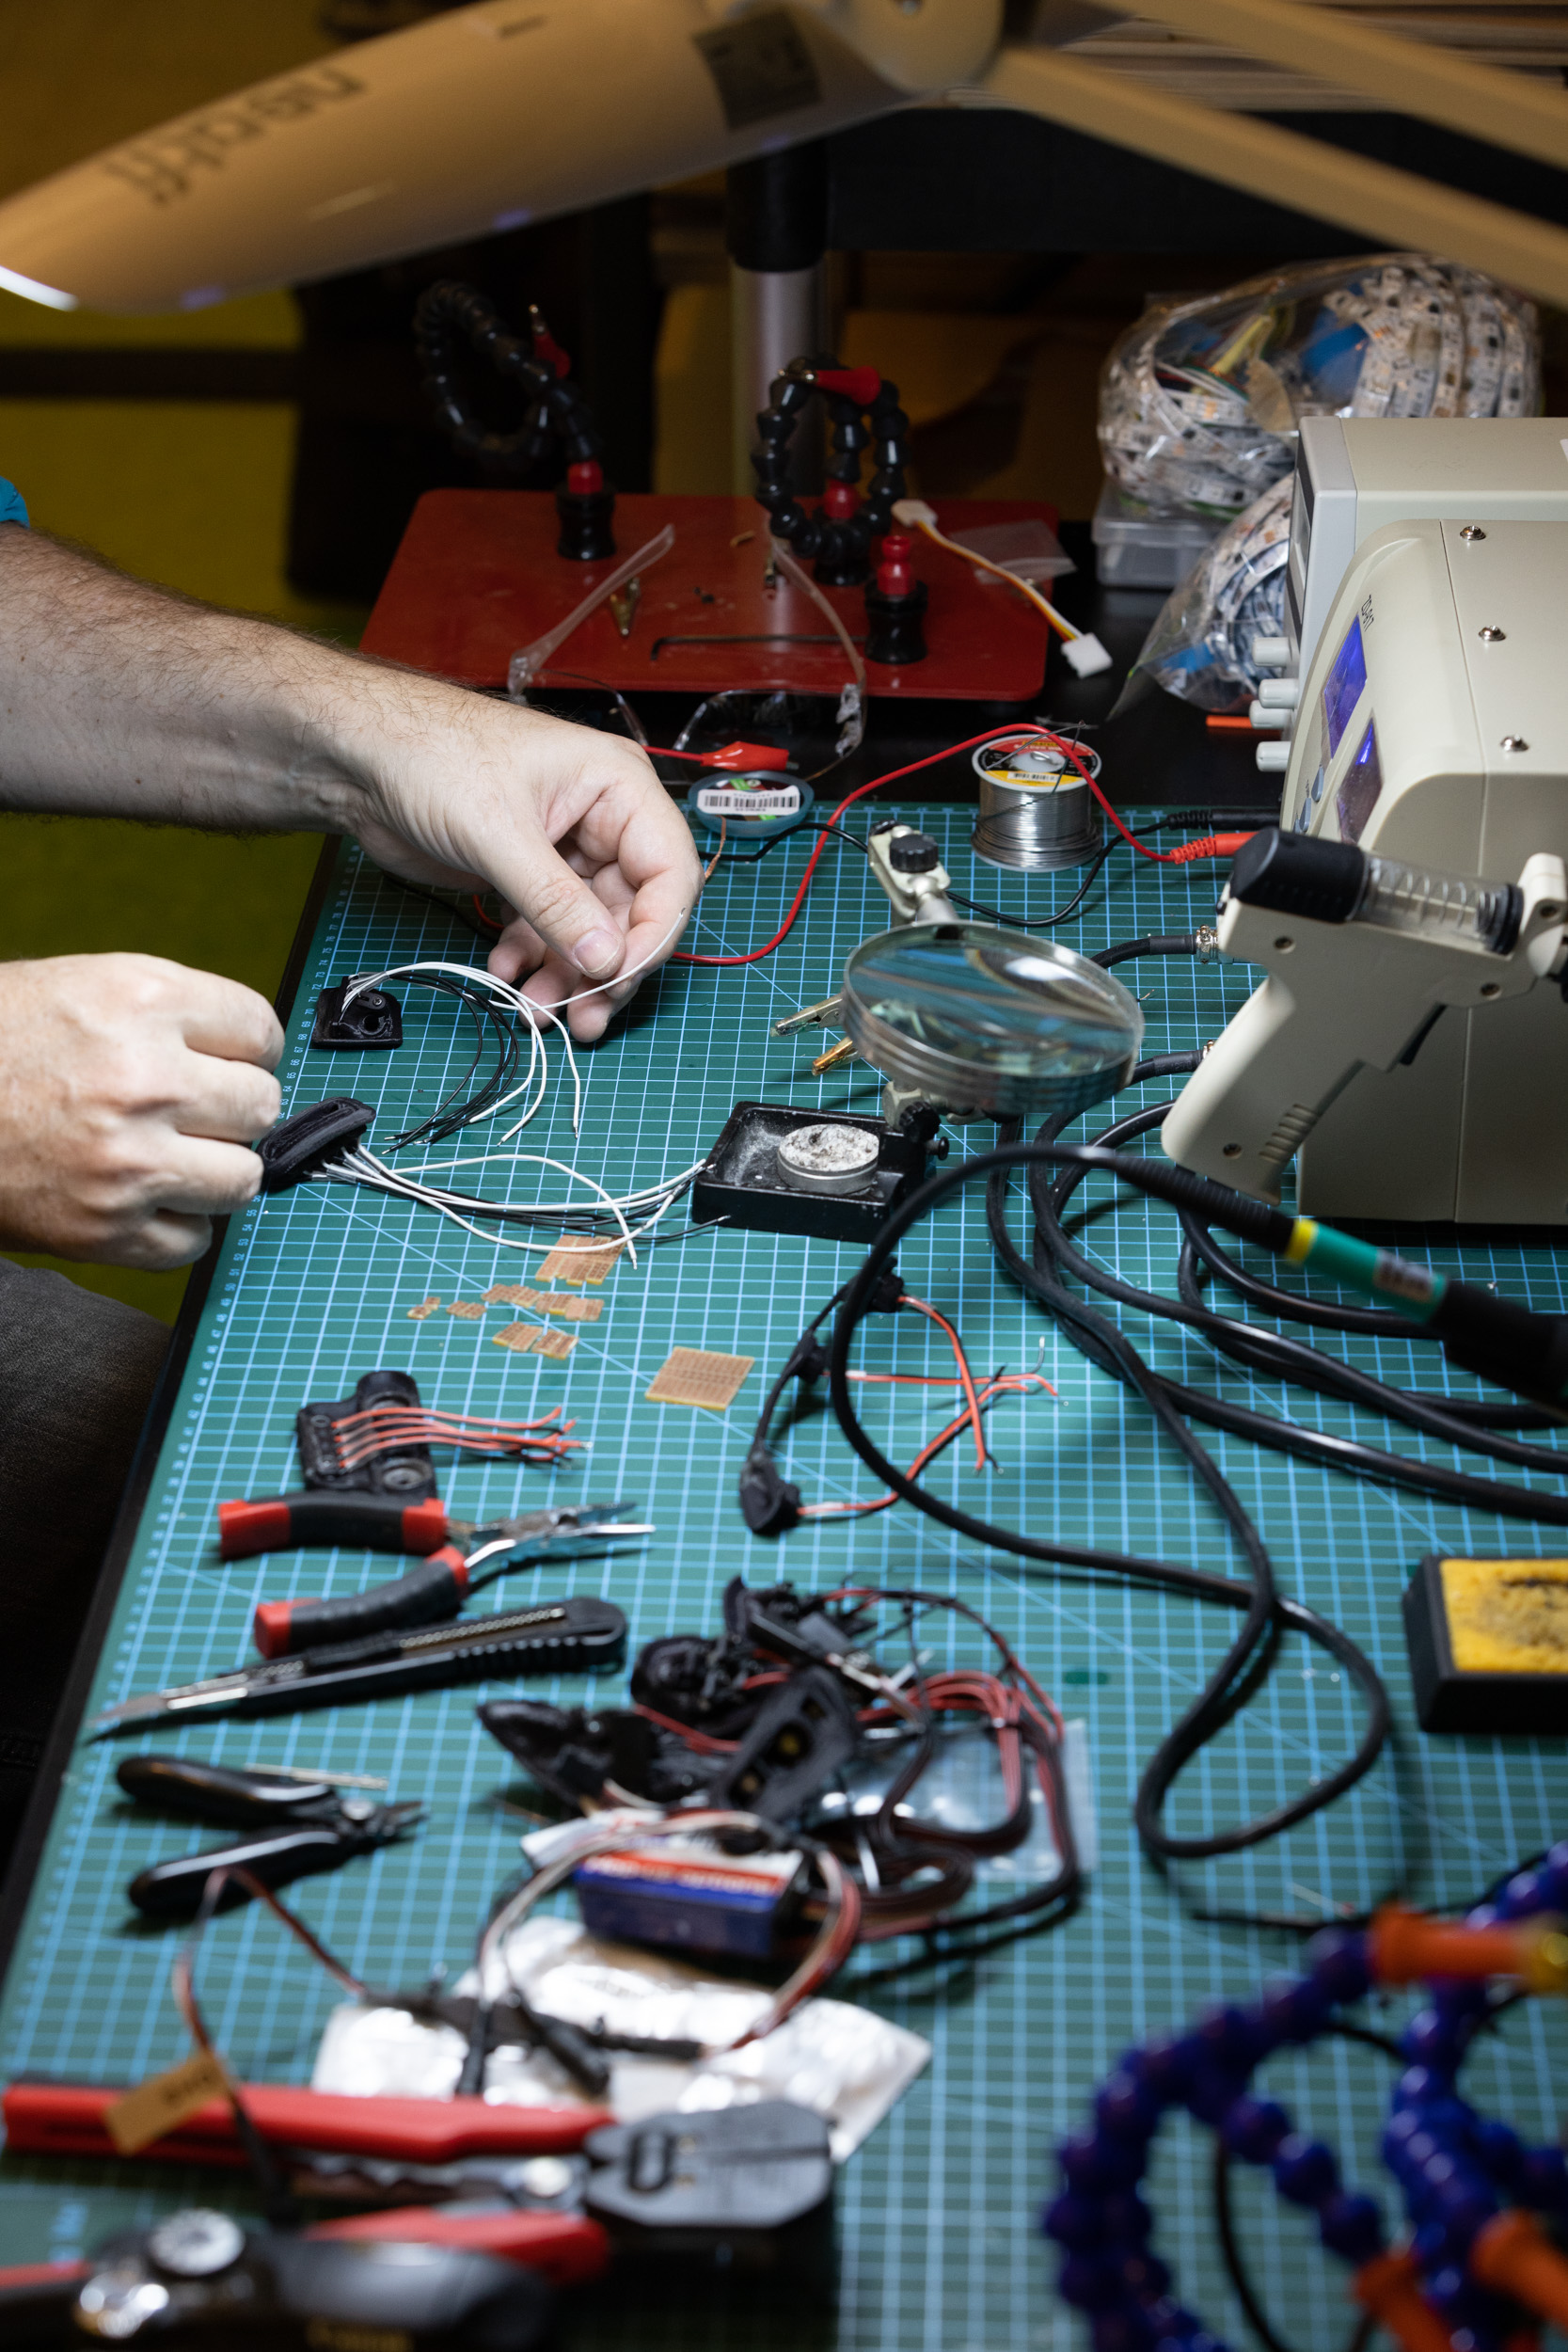Electronics bench, 2022, Joe Ruckli, State Library of Queensland
ANYONE SEEKING TO ADAPT THIS WORKSHOP SHOULD CONSIDER THE FOLLOWING INFORMATION.
This is an adaptation of the basics circuits component of the 2022Christmas Tree works and also covers some content that could be covered in an Electronics bench induction.
WARNING - This workshop makes use of small coin cell/ button batteries.
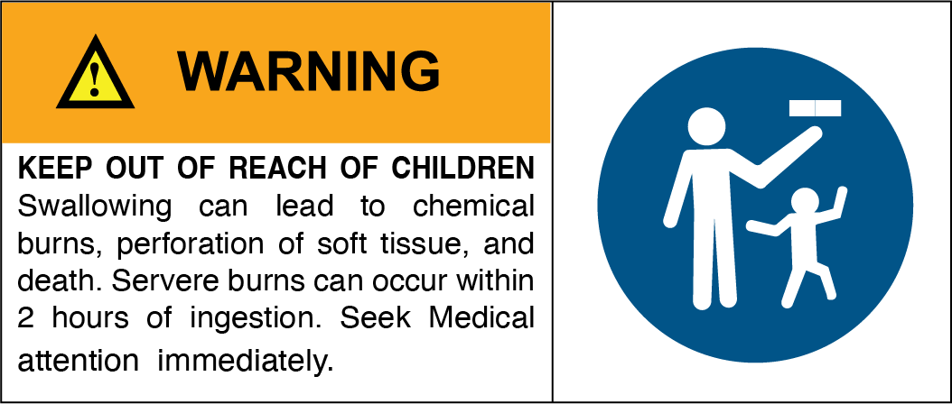
In December 2020, the Australian Government made mandatory safety and information standards for button/coin batteries and consumer goods that contain button/coin batteries (the standards). The standards included an 18 month transition period and became mandatory from 22 June 2022. From 22 June 2022 manufacturers, importers, wholesalers and retailers of button/coin batteries or consumer goods that contain button/coin batteries supplied to Australia, must comply with the applicable Australian mandatory safety and information standards. Supplying or selling non-compliant products to consumers in Australia is illegal. The four mandatory standards are as follows:
• Consumer Goods (Products Containing Button/Coin Batteries) Safety Standard
• Consumer Goods (Products Containing Button/Coin Batteries) Information Standard
• Consumer Goods (Button/Coin Batteries) Safety Standard
• Consumer Goods (Button/Coin Batteries) Information Standard
Developed by Mick, March 2023.

Promotional Copy
Simple circuitry 101 Keen to learn the basics of how electronics work? Join us for an introduction to how circuits flow and what basics components do. Learn how to use breadboards to create solderless circuits.
About 101 workshops 101 skills development workshops give you the basic skills you need to start your new creative journey. Each workshop is delivered by an experienced facilitator and no prior experience required, just basic computer skills, a willingness to learn and a bit of patience.

Acknowledgement
We acknowledge Aboriginal and Torres Strait Islander peoples and their continuing connection to land and as custodians of stories for millennia. We respectfully acknowledge the land on which we all meet today, and pay our respects to elders past, present and emerging.

Summary

Skills and Understandings Introduced
As such, the workshop will focus on the following basic skills and understanding:
- Feeling confident we know how to be safe around electricity
- Key concepts of Current flow and Voltage in a circuit, Resistance and the basic application of Ohms Law
- How to use a breadboard to test a circuit
- how to identify basic components and how to use them
- how to read a basic circuit diagram
- How to use a multimeter to test a circuit
- understanding of the use of a transistor in a basic circuit
- where to find more information

Materials
If your workshop does not require any materials (maybe digital only) delete this section or change to something more appropriate.

Material/ equipment | Quantity per kit | equip to share | Cost | Supplier | SOP/SDS
Electric Circuits 101 kits
2032 Coin Cell |  | 10 |  |  | SOP
2032 Coin Cell carrier |  | 10
breadboard |  | 10
LED |  | 20
Resistor 330R |  | 10
9 Volt Battery |  | 10
9V battery clip |  | 10
BC547b NPN Bipolar Transistor |  | 10
AA Battery |  | 20
2xAA Battery holder |  | 10
Jumper Leads (m-m) |  | 50
Capacitor |  | 5
Equipment Required
PC laptop/desktop with IDE |  | 5
Soldering iron |  | 2 |  |  | SOP
Wire strippers |  | 2
Helping Hands |  | 2
Magnifier |  | 2
Light |  | 2
Multimeter |  | 2
Laser Cutter |  | 1 |  |  | SOP
Laser Computer (Ruby machine) |  | 1
Solder |  |  |  |  | SDS
USB Microscope |  | Projector | Soldering Iron & Bench Tools

Workshop Session Plan
Detailed Powerpoint and facilitation notes are linked below
Zipped powerpoint file
Powerpoint including facilitator notes
zipped Fritzing file for Tranistor contolled LED project

References

Electricity
Physics Videos by Eugene Khutoryansky's animated visualisations of "Electric Circuit Components"
Steve Mould's video on Spintronics "Mechanical circuits: electronics without electricity"
youtube.com/ElectroBOOM on youtube
Electricity Basics, youtube.com/@EngineeringMindset
Engineering Mindset's tutorial for using a multimeter properly
Engineering Mindset's Ohms Law Calculator
Electronics Turtorials - Bipolar Transistors

Downloads
3-easy-transistor-projects-for-beginners.pdf

