Digital Fabric Design

Digital Fabric Design
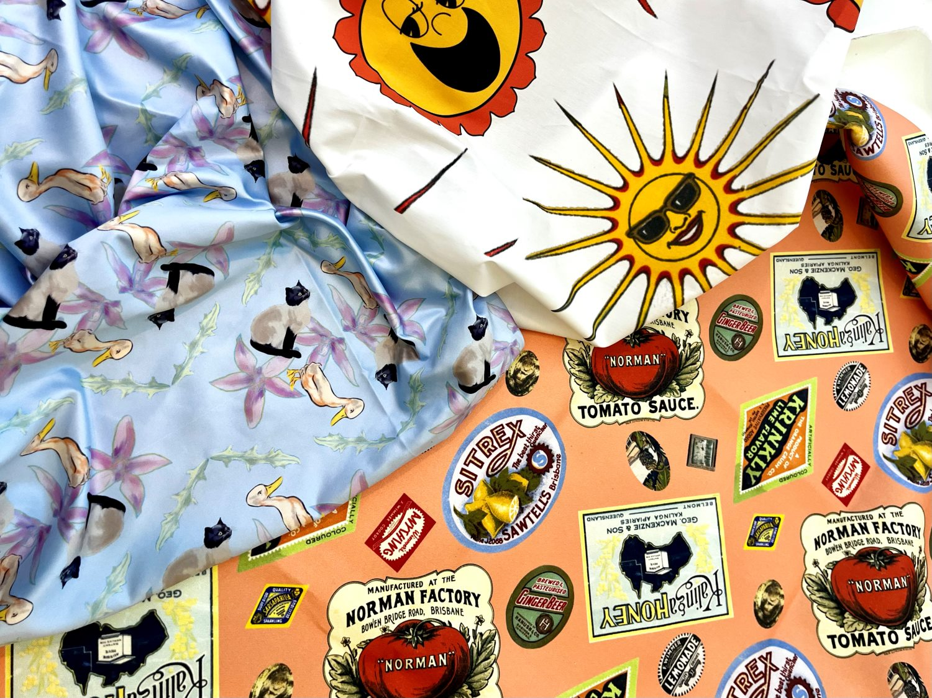
Developed by Jimmy Eng, following on from the work of Ellie Dumigan, 2025

Acknowledgement
We acknowledge Aboriginal and Torres Strait Islander peoples and their continuing connection to land and as custodians of stories for millennia. We respectfully acknowledge the land on which we all meet today, and pay our respects to elders past, present and emerging.

Workshop presentation
The Procreate 101 workshop has been created into a slide show for presentation and documentation purposes. Please feel free to download and use the guide and files as per our CC license in the footnote.
Some pages may link to other online workshops, tutorials or guides created at The Edge, you may require the internet to connect and view links.
Public View - Slides
Admin view - Slides
Workshop runsheet

Workshop Overview
SESSION ONE​
- Welcome and introductions​
- Overview of The Edge (Getting Started)​
- Overview of the day's agenda and key things participants need to decide;​
- What type of design; own illustration or a composite of copyright free images​
- Whether they want to submit something before next session or wait till the end​
- Exploring the SLQ Collection​
- Intro to Procreate; learn the basic interface & tools​
- Illustrating in Procreate; using collection images for practice​
- Pattern design; repeating designs, mirroring​
- Time to design​
- Setting up for printing; understanding the file requirements for printers​
SESSION TWO​
- Welcome back and check in​
- Decide on any sewing toiles or patterns​
- Work on finalising designs​
- Sewing and making​
FINAL STEPS​
- Pick up your fabric after session two if you don't get it printed before then.​
- Come back to The Edge and Open lab to work on finalising any of your items.​
- Come back and use The Edge iPads to make your next master piece! ​

Tools
- iPad and pencil​
- Apple/Drawing pencil/pen​
- Procreate App (no account required)​
- Photoshop (you will need an account, The Edge hosts the software for free)​
- Sewing equipment; sewing machine, overlocker or hand sewing items​
After this workshop, you can also borrow out the iPads and Apple Pencils from The Edge to use during Open Lab hours after completing a general induction.​
Learn More

Image Sourcing
The State Library Collections have a large range of copyright free images that we can use for inspiration when creating our artwork.​ Later in the session we are going to be getting a feel for procreate by tracing and redrawing different botanical illustrations found via One Search. ​
You can use any out of copyright images to trace or use in your design.​
Use One Search
Flickr is a great way to look at curated albums of items that have a digital image in the State Library’s collection, including:
- Queenslander Covers​
- Labels​
- Entwined​
Use the State Library Flickr

Printing Requirements
Keep these printing requirements in mind as you set up your document. These have been supplied by our fabric supplier, Emerald Dreams.
- Artwork should be supplied at the correct, or intended print size. Eg, if the print should be 150x100cm, the file should reflect this.​
- If printing a repeated pattern, ensure the file is set to the full width of the fabric with no repeat lines. A repeat tile of 1 – 5 metres is preferred.​
- Vector is best or Image files at 150dpi to 300dpi resolution at scale of print.​
- EPS, TIFF, PDF or JPEG files in either RGB or CMYK colour profile accepted.​
- The quality of our printing is determined by the quality of the artwork that you provide.​
- Art with layers to be saved as Hi-Res flat images.​
- If you are printing repeat print meterage, ensure your file is set-up in full repeat, to the width of the fabric with no repeat lines.​
Artwork colours can differ significantly from what is viewed on a computer/device screen to what translates onto printed fabrics. It is recommended to produce a sample before printing a large batch.

Procreate Overview

Creating a Canvas
- To create a new canvas press on the ‘+’ in the gallery view​
- Choose which size, either the default or create a custom size​
- Canvas sizes can be in mms, cms, inches or pixels.​
- DPI or dot per inch can also be selected for the new canvas from this view. ​
- The colour profile can also be selected, it will default to RGB but CMYK is the preferred option for designs that will be printed. ​
- Canvas properties – background colour can be selected or made transparent, this can also be done later on. ​
- Once all these settings have been decided on, hit ‘Create’ to open our new canvas. ​
For our project we'll set the pixels to 3000 x 3000 and DPI to 150. This will give us a working space of 50.8cm x 50.8cm in HQ detail.​

Interface Overview
There are three sections of the Procreate interface. ​These three sections can be broken down into;​
- Painting Tools (Top right)​
- Sidebar (left side)​
- Editing Tools (top left)​
Each section has its own set of tools.
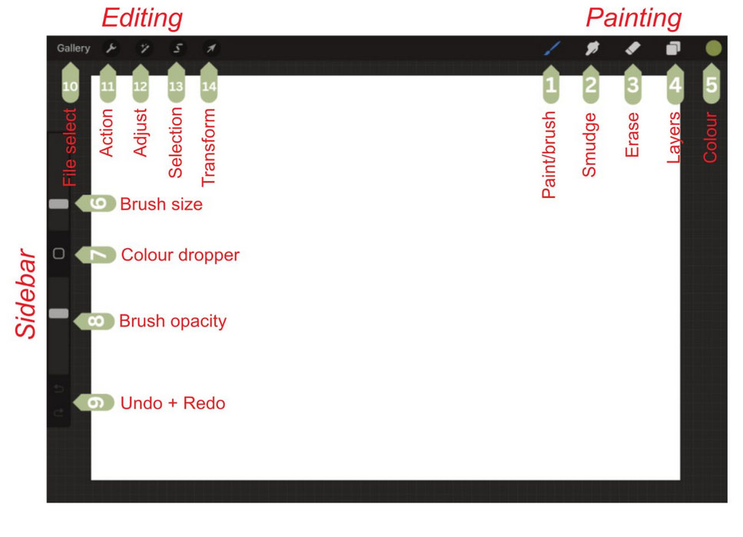

Hand Gestures/Shortcuts
- Pinch to Zoom - using two fingers place them on the canvas and move them together to zoom out or apart to zoom in.​
- Pinch-Twist to Rotate - pinch the canvas and twist your fingers in a circular motion to rotate the canvas. ​
- Quick Pinch to Fit to Screen - Same gesture as Pinch to Zoom but done at a faster rate. Do the same gesture in revere to return to the previous view. ​
- Two-Finger Tap to Undo - Tapping two fingers together on the canvas to undo. Rapidly undo a bunch of actions by holding two fingers. ​
- Three-Finger Tap to Redo - Tap three fingers together on the canvas to redo. Rapidly redo a bunch of actions by holding three fingers. ​
- Three-finger Swipe to Cut/Copy/Paste - Swipe three fingers down on the canvas to bring up the Cut/Copy/Paste option menu. ​
- Three-finger Swipe to erase selection – Swipe left and right repeatedly to erase a selected object or entire layer if empty​
- Four-Finger Tap for Full Screen - tapping four fingers on the screen will enter Full-Screen mode with the interface disappearing. To bring the interface back, four-finger tap again or tap the full-screen button in the top left corner.

Brush Options
With Procreate you can create using an apple pencil or even your finger (you can turn this function off also). Painting options:​
- Paint/brush​
- Smudge​
- Erase ​
- Layers​
- Colour select

Using Layers
Layers are super helpful in separating elements of your artwork, allowing you to make changes to one layer on the artwork without affecting the others. ​Layers can be grouped into a folder, copied, pinned and hidden. ​
The bottom of the layer menu is the background layer with a colour. This is where the colour for the background can be selected or turned off completely for exporting transparent PNG files. ​

Use images to create a design object​
- Find and save some images onto the iPad photo album​
- ​In your canvas tap the action tab (wrench), select insert a file/image and then select the image. OR From main/file select page tap import or photo in the top right corner. Copy the image (three fingers swipe down select copy). Go to your working file and paste into your canvas (three fingers swipe down select paste)​
- To 'clean up' the edges of an image tap selection, in submenu select automatic, tap the area you want removed, adjust the tolerance by sliding the pencil to the right to view what's being picked up and erase (three fingers swipe left and right repeatedly). Use the erase tool to clean the edge and missing artifacts.​ To cut a shape out of an image tap selection icon, in submenu select shape you prefer, highlight that area, drag three fingers down on screen and click copy and paste​
- ​You can manipulate all your images however you like using the adjustment and selection tools​
- Repeat for every object you wish to use on your final design​

Draw your design​
- Find and save some images onto the iPad photo album​
- ​In your canvas tap the action tab (wrench), select insert a file/image and then select the image. OR From main/file select page tap import or photo in the top right corner. Copy the image (three fingers swipe down select copy). Go to your working file and paste into your canvas (three fingers swipe down select paste)​
- ​Lower your image layer opacity (click N on layer name to bring up submenu) and either set it as a reference layer (tap layer name then reference) or then lock the layer (swipe layer name to left and tap lock)​
- ​Make three new layers (recommended to call them lines, details and fill) and use your brushes and colour wheel to copy your image. Use more layers if you prefer​
- ​Repeat for every object you wish to use on your final design​
​ Helpful tips​
- Brushes will behave similarly to real life materials. Pastels will blend better than watercolours, pencils will be more solid etc... The Apple pencil is also pressure sensitive and angle sensitive!​
- Stop and start when you erase as when you undo it will erase everything you've done in one action​
- Figure out a good practise of how you want to add shadows or colours. One technique is to do the fill first and colour in your majority colour, then the darkest shadows, then the mid shadows and repeat. Then create your outline and clean up the outer edges​

Entwined: Plants Practice Drawing​
Past exhibition focused on botanical illustrations within the collection. ​ Pick an illustration and start drawing!​ Start with the linework and then try adding some colour.
Pick an image from the collection

Colour Harmony​
Deciding on your colour scheme can affect how its perceived through its mood and how people feel about it. The colour wheel can be divided into primary, secondary and tertiary colours.​
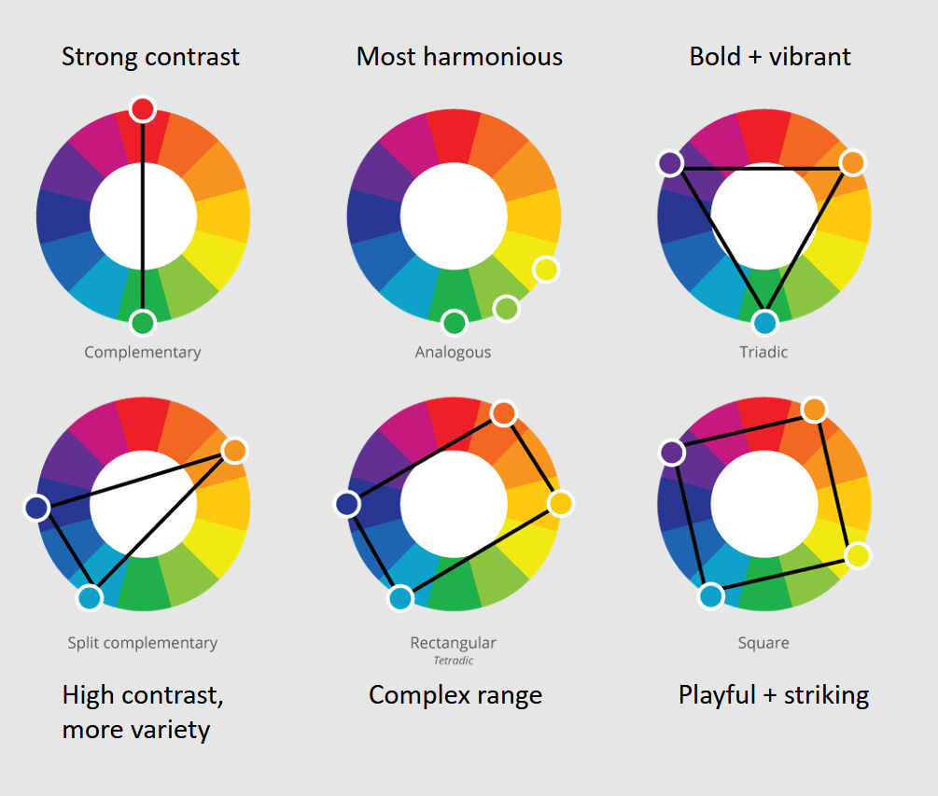
Colour comprises of four key elements/qualities:​
- Hue (the position on the wheel, brightest version of that colour)​
- Saturation (vibrancy of the colour)​
- Value (lightness and darkness)​
- Tempertaure (warmth or coolness)​
Monochromatic colour scheme​: One base colour/hue. Looks simple, cohesive and organized.​

Create a seamless pattern in Procreate
You can easily create a seamless pattern in Procreate, with a number of methods outlined in our Creating a Seamless Pattern in Procreate deep-dive.

Export for fabric printing
Saving files:​ New canvases are always automatically saved into the Procreate gallery. Within this gallery, you can create stacks to help organise your artwork. ​
Sharing your work:​ Procreate has a pretty easy way of sharing your artwork with friends, family or the world. You can share the artwork via the Gallery or the actual project file itself.​
To export your pattern for fabric printing:
- Navigate to the 'Actions' icon and select 'Share'​
- Choose 'PDF' and select 'Best' quality'​
- You will see the blue check-mark as it is exporting​
- Select your save location, and click 'Save'​

Internal Resources
101 Workshop - Procreate - https://wiki.slq.qld.gov.au/doku.php?id=workshops:public:procreate
Create a Seamless Pattern in Procreate - https://wiki.slq.qld.gov.au/doku.php?id=facilities:slq_wiki:seamless_patterning_in_procreate
Animating in Procreate - https://wiki.slq.qld.gov.au/doku.php?id=facilities:slq_wiki:procreateactivties

External Resources
Handbook to Procreate tools and UI - https://help.procreate.com/procreate/handbook/introduction
Intro to Procreate - The Basics for Beginners in 10 Minutes (Luma_Llama) - https://www.youtube.com/watch?v=oo8_NODWjbw
27+ Procreate Tips You Have to Know (Alanna Flowers – Paperlike) - https://paperlike.com/blogs/paperlikers-insights/procreate-tips
10 Common Procreate Problems and How to Solve Them (UMA Technology) - https://umatechnology.org/10-common-procreate-problems-and-how-to-solve-them/
Color Theory for beginners (Sarah Renae Clark) - https://sarahrenaeclark.com/color-theory-basics/
Color schemes (Copic markers)
https://copicmarkers.com/blogs/educational/analogous-complimentary-and-split-complementary-color-schemes?_pos=4&_sid=8f783561e&_ss=r
https://copicmarkers.com/blogs/educational/color-schemes-2?_pos=6&_sid=8f783561e&_ss=r
Let’s draw a tessellation! - in Procreate (Yaplaw’s comics) - https://www.youtube.com/watch?v=lmfCjBD9WeY
Easy repeating patterns in Procreate (Dawn Nicole)
https://www.youtube.com/watch?v=-r3BRXSbXLA
https://artignition.com/color-temperature-in-art/

FAQs
- Always check your image size, PPI including pixels and conversion to mms
- Check you don't have any white lines on the sides of your artwork before you start tiling
- Opening files across different creative apps can create changes or loss of quality, be mindful of how you are saving out your files and check dimensions including DPI and measurements regularly

