Art of Projection
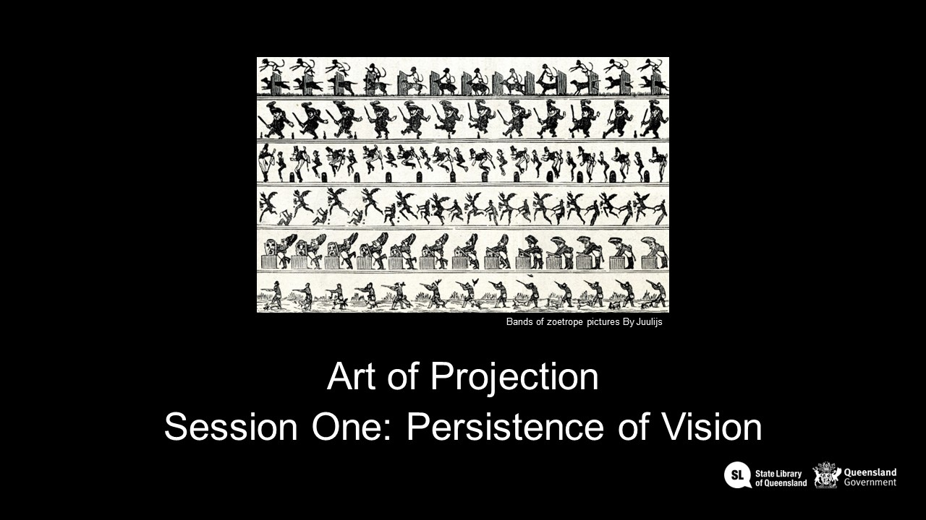
Developed by Waldemar Janek, supported by Michelle Brown, 2024

Workshop slides
Workshop 1 session slides
Workshop 2 session slides
Workshop 3 session slides

Templates and Downloads

Session 1 - Persistence of Vision

Animation templates and examples
During the workshop to show the basic frame by frame animation process, we have created an example using one of the State Library's collection resources. We have chosen one of The Queenslander illustrated cover images as it is a good example of how to remove a basic background and manipulate the image to separate the ball from the person and make it bounce across the 16 frames.
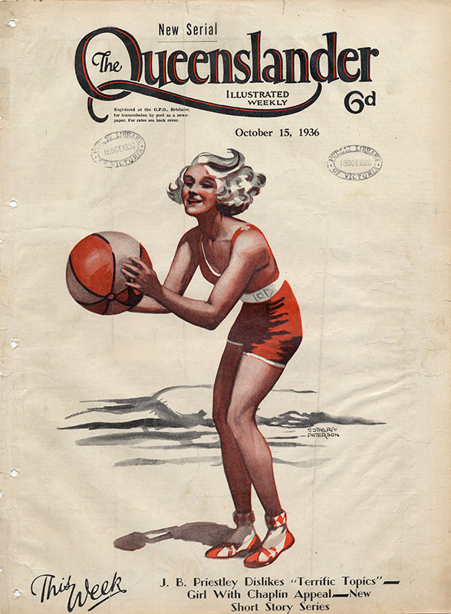
Link to the Illustrated front cover from The Queenslander, October 15, 1936
Our Zoetrope inner ring circumference is about 40cm in length, this fits to an A3 printed piece of paper and the templates below sized for the 3D model;
16 frame Photoshop PSD template with basketball girl 40cm circumference
16 frame Photoshop PDF blank 40cm template

Old versions
Moon phases photoshop file

Phenakistiscope files
Current working 16 image file
Current working template size
Different frame sizes;
Final 16 Frame Phenakistascope file
16 Frame template V2
12 Frame template V1
8 Frame template V1

Zoetrope files

Original small version of Zoetrope
zoetrope_01c_inner.stl
zoetrope_01c_main.stl

SLQ version of Zoetrope
Inner ring - Zoetrope inner ring
Outer ring (body) - Zoetrope outer ring

Session 2 - Holograms

Hologram files
Original peppers ghost iPad viewer file
Modified iPad viewer 3mm file
iPad viewer 1.3mm card file
1.3mm card file longer tabs
cardboard design adapted to 3D printed corners
Pyramid viewer (petg)
For our 3D hologram, we have captured video of the Greta Towner Bronze maquette in the State Library collection, which has been 3d scanned.
3D printed corners to make assembly easy
card_corner2.stl_use_7_of_these
cardboardlastcorner.stl_and_one_of_these
cardboard design adapted to 3d printed corners
hologramviewerblkcard_plasticcorners.pdf
hologramtriangletabv2025.pdf

Session 3 - Projection Mapping
Please download the Zipped file, which contains the files you will need to use for the workshop.
zipped folder
The Touchdesigner file to open is called 'camshapper box.1.toe'

Gallery

