Laser cut covers, hand sewn spines - Participant resource page
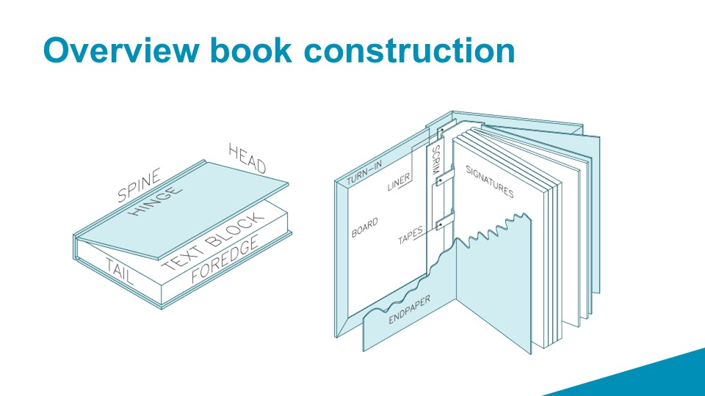

Software we've used
In the workshop we have used Adobe Illustrator. You can download a free 7 day trial here: https://www.adobe.com/au/products/illustrator/free-trial-download.html or you can use the DML at the Edge to access the software free at any time.
Other options:
Download Inkscape online for free inkscape.org
Download Gimp online for free gimp.org
checkout the more detailed info about Inkscape on this wiki (including a detailed tutorial) Inkscape for beginners
Create 5x Text Prompt to Image conversions a day for free with night cafe studio

Hand sewing spines

Inspiration & Sources of royalty free artwork
//Stencil Catalogue for the use of practical men//
Excelsior Fresco Stencils
250 Stencil Designs From India
Our colleague Billie Ruben's book covers pintrest board
The Public Domain Review The Public Domain Review is dedicated to the exploration of curious and compelling works from the history of art, literature, and ideas – focusing on works now fallen into the public domain, the vast commons of out-of-copyright material that everyone is free to enjoy, share, and build upon without restrictions.
https://publicdomainreview.org/collection/the-art-of-book-covers-1820-1914

Colour Pallet
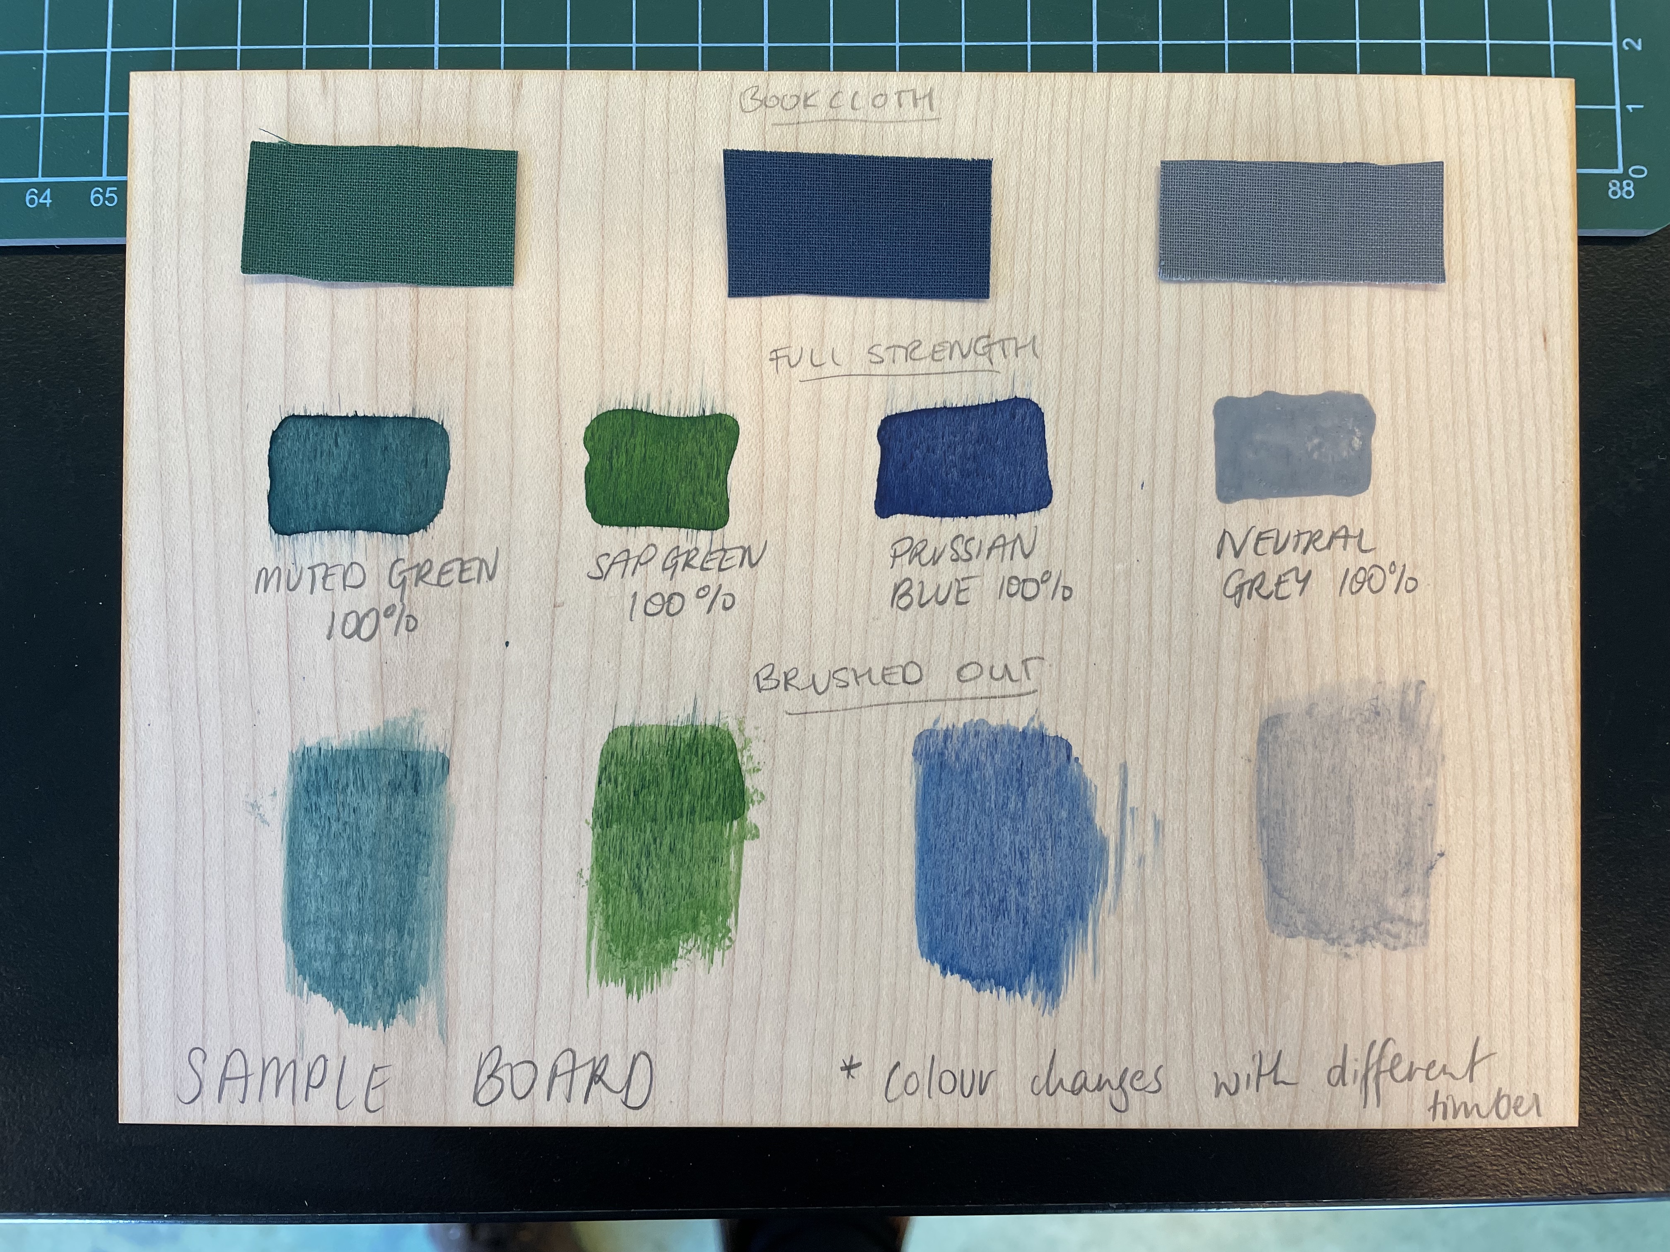

Where we bought stuff
book cloth & other supplies
inks

Where we learnt stuff
https://www.youtube.com/c/DASBookbinding

Files
{{}}
Cover Template
a5_awlguide_v3.ai
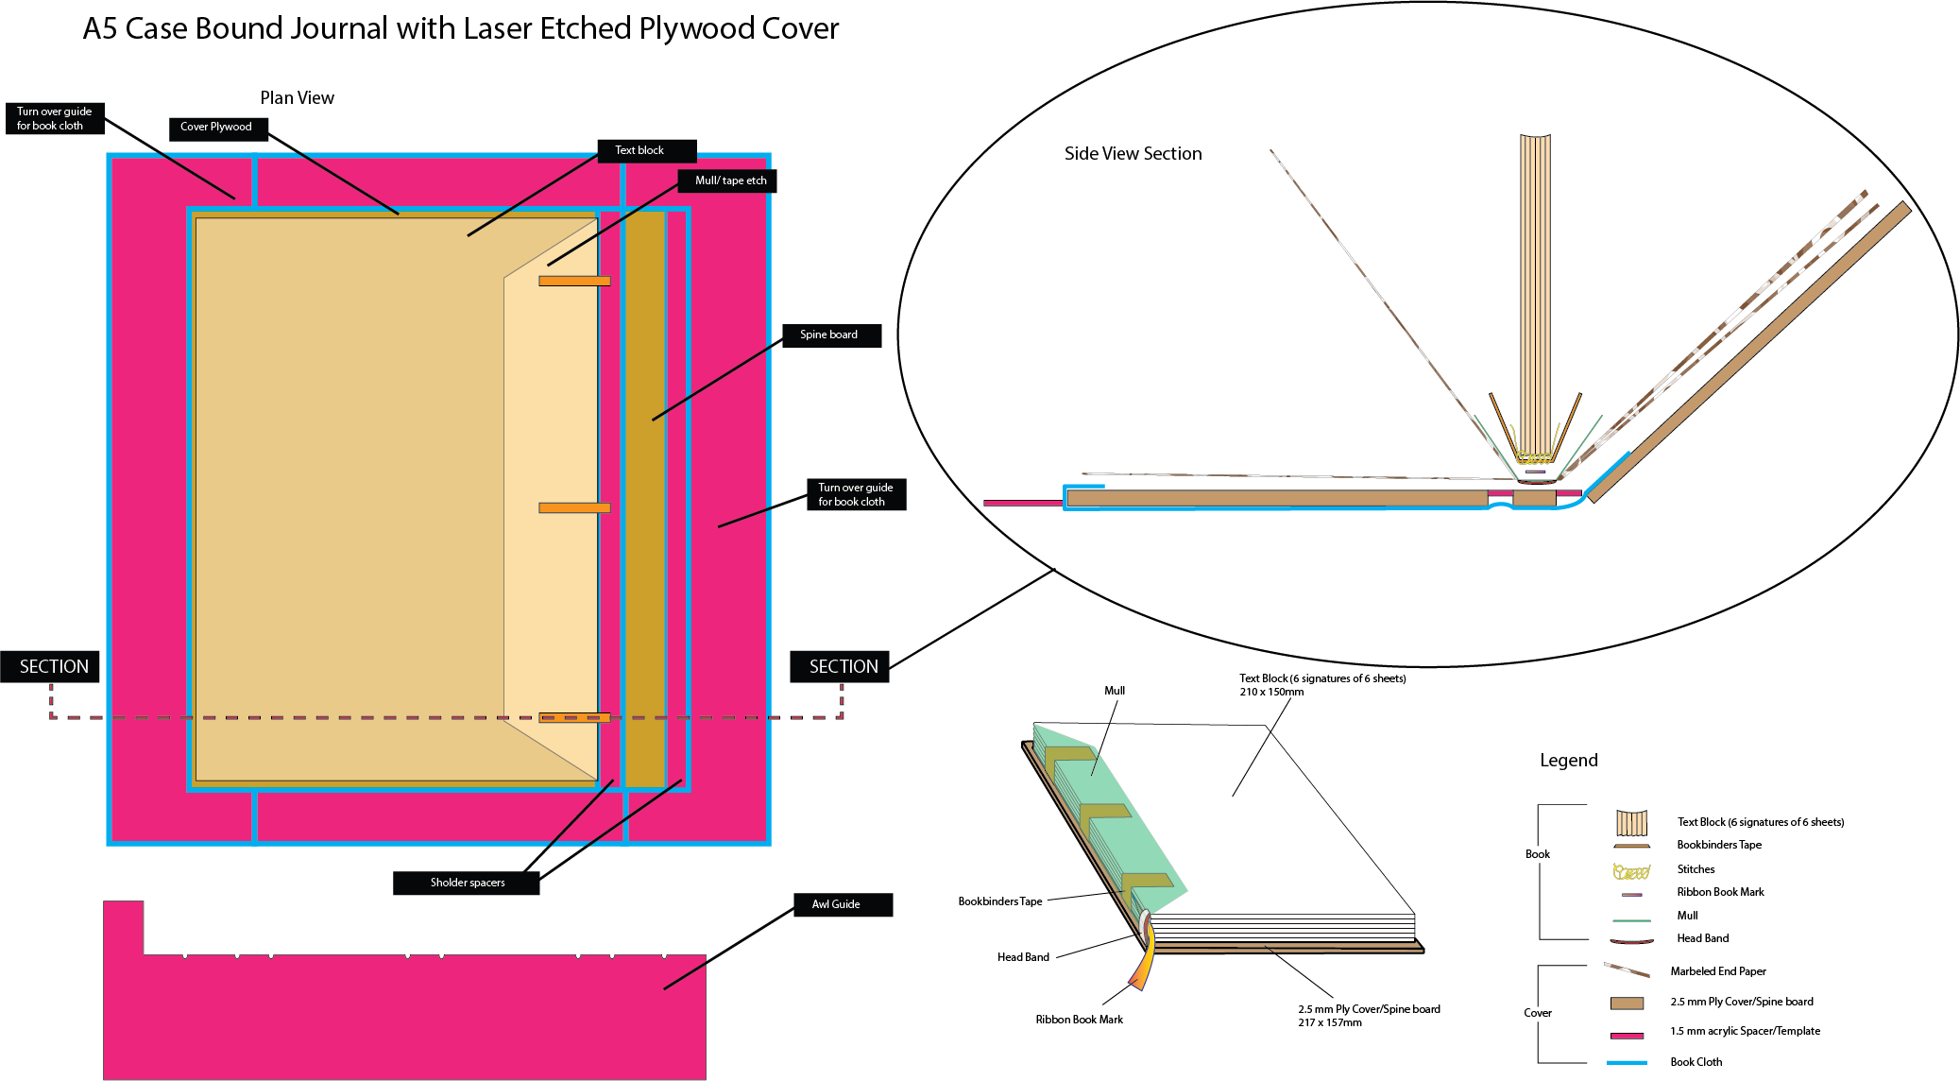
a diagram showing how it all fits together
scaled_assembly_diagrama5journal.ai

Documentation from the previous workshop
And here's the link to Billie's workshop from last year.

