Recording studio Induction
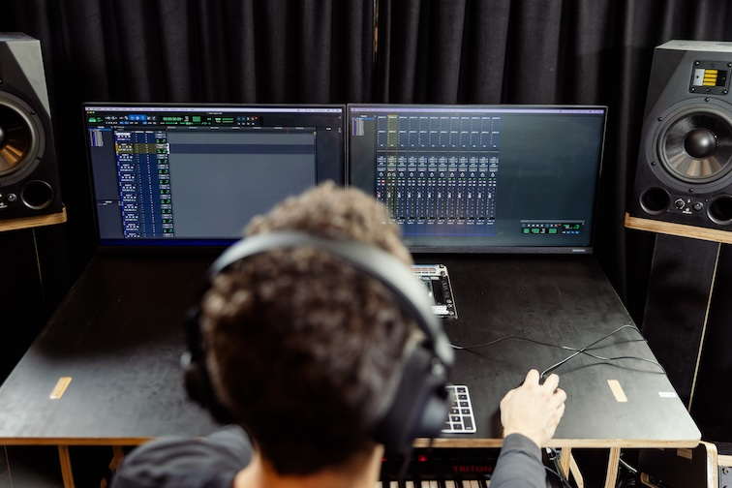

Recording studio Induction

Induction presentation
Our Inductions have been created as slide shows for presentation and documentation purposes to support you in using the studio.
Admin view
Our Recording Studio induction resource guide
This wiki page is a supplement to the induction and can serve as a reminder of the basic operation of the studio and assist with troubleshooting issues.

Outcomes
- Booking a session
- Safety
- Overview of recording studio hardware
- Power on/off procedure
- Microphone selection and positioning
- Overview of microphone Pre-Amp
- Setting gain on Pre-Amp
- Analog to digital audio signal path
- Recording audio
- Exporting audio

Equipment Used
- RODE Broadcaster Microphone (mic)
- Mic lead
- Mic stand
- Pop-Filter
- Behringer ADA8200 Microphone/Line Pre-Amplifier (8 Channels)
- 500 series JLM Microphone Pre-Amplifier (3 Channels)
- MOTU 16A Audio Interface
- Apple Mac Pro
- Audient Nero Monitor Controller
- Adam A8X Studio Monitors

Making a booking
Once you have completed your induction with the facilitator, you can make a booking here. You can book 2 sessions per week. Sessions are 2 or 4 hours long.

On Arrival
When you arrive for your booking, check in at reception and one of the friendly Visitor Service Officers (VSO) will open the studio, and supply you with your requested microphones.

Acorn Online Component
Acorn is our database that holds your induction access details. Please enrol into the specific induction you are completing with the SLQ Acorn website. NOTE: This website is only available onsite at State Library of Queensland.
https://inductions.slq.qld.gov.au/user_login

START UP PROCESS
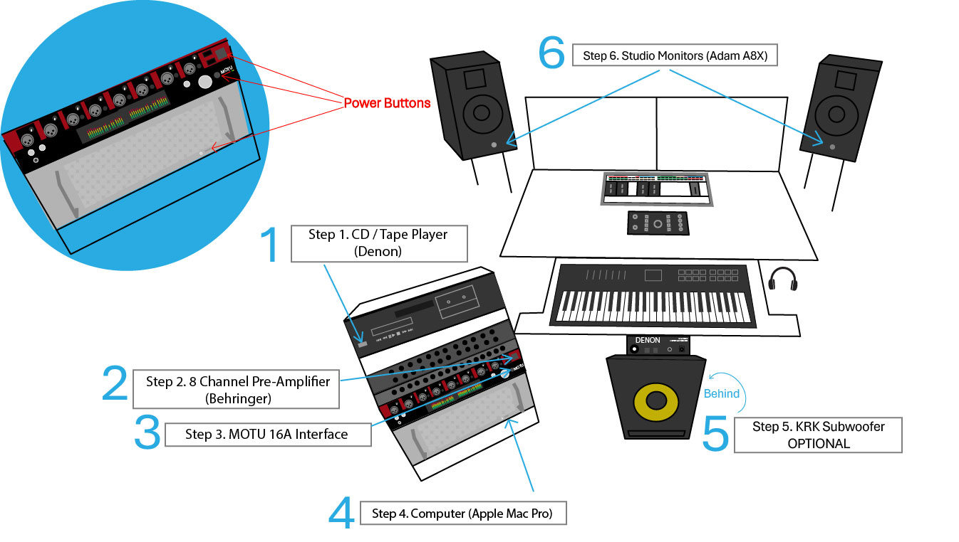
Turn on in sequential order:
- MOTU 16A Audio Interface
- Denon CD/ Tape player (Optional)
- 8 Channel Pre-Amplifier Behringer (ADA8200)
- Mac Pro
- KRK Subwoofer (Optional)
- Adam A8X Monitors
---
SHUTDOWN PROCESS
Essentially, this is the reverse order of the startup process. Shut down in sequential order:
- Adam A8X Monitors
- KRK Subwoofer (Optional)
- Mac Pro
- 8 Channel Pre-Amplifier Behringer (ADA8200)
- Denon CD/ Tape player (Optional)
- MOTU 16A Audio Interface
Care must be taken at all times when powering equipment up and down.
This order protects the speakers from voltage spikes during powering on and also ensures the software and computer recognise the connected equipment.

Frequently Asked Questions
Below you can find a list of frequently asked questions.
If you are still experiencing difficulties, please email us on appliedcreativity@slq.qld.gov.au or ask The Edge reception to contact one of the Applied Creativity team to come and assist if during business hours.
- Can we bring other people in to record that haven’t been inducted?
Yes, as long an inducted State Library member books the spaces, you can bring up to 6 people into The Edge Recording studio without overcrowding, and up to 10 total people at absolute maximum. ​
- Can I bring drums in to record?
Yes​
- Can I plug my laptop in and record directly to my own computer?
No not at this stage, however We are currently looking into this option for the future. ​
- When will I be able to book after the induction?
Please allow 48 hours for your induction to be processed. ​
- Can I use the Recording studio if I have gone over my weekly booking limit?
Yes, if the studio is available, you can ask The Edge reception for access to the studio. They will check that you have completed your induction and will let you into the space. ​
- Is the room completely soundproof?
Unfortunately, the room impedes sound very well, but doesn't completely nullify it outside of the room. Likewise, loud noise can bleed into the room. ​

Recording studio Information
The Edge Recording studio is a near professional environment for recording, editing and mixing sound. People use it for recording and mixing multitrack music recordings, recording interviews and podcasts.

Digital Audio Workstation

Hardware
- 2020 Apple Mac Pro
- MOTU 16A Audio Interferface
- Ableton Push 2
- Native Instruments Maschine
- RODE Caster Pro II
- Korg Triton Taktile Keyboard
- Denon CD/ Tape player

DAW Software
- Pro Tools 2020
- Ableton Live Suite 12
- Logic Pro X
- Reaper
- Izotope RX 7 Standard
- Garage Band
- Fruity Loops Studio Producer Edition
- Audacity

Virtual Instruments and Plug-ins
- CueMix Pro - Digital IO patchbay
- Native Instruments Komplete 12 Ultimate
- Slate Digital All Access pass (subscription)
- Plugin Alliance Mega Bundle (subscription)
- UAD Spark Plugins (subscription)
- Izotope Music Production Suite 3

Monitoring
- Audient Nero Monitor controller
- Adam A8X Nearfield Monitors
- KRK S10 active subwoofer
- Sennheiser HD 280 pro headphones
- Denon DN-200BR Bluetooth Receiver

Pre-Amplifiers
- JLM Audio 99v
- JLM Audo NV500
- JLM Audio TG500
- Behringer ADA8200 Microphone/Line Preamplifier (8 Channel)

Hardware Compressors
- JLM Audio LA500A
- JLM Audio FC500A

Analogue Synthesisers
- Behringer MonoPoly
- Moog Grandmother

Microphones
Brand | Model | Type | Usage | info
Shure | SM7b | cardioid dynamic (x2) | Vocal | website
Neumann | TLM193 | cardioid condensor | Vocal | website
Neumann | TLM107 | multi-pattern condensor | Vocal | website
AKG | C414 XLII | Matched Pair multi-pattern condensor | Vocal, acoustic instruments | website
RODE | Broadcaster | end-address broadcast condenser (x2) | vocal | website
RODE | Podcaster | USB Broadcast condensor (USB with headphone) | vocal | website
RODE | NT 5 | compact 1/2“ cardioid condenser (pair) | acoustic instruments | website
RODE | K2 | variable pattern dual 1” valve condenser | vocal | website
RODE | NT-SF1 | soundfield ambisonic | ambience, VR | website

