Laser Cutter Induction
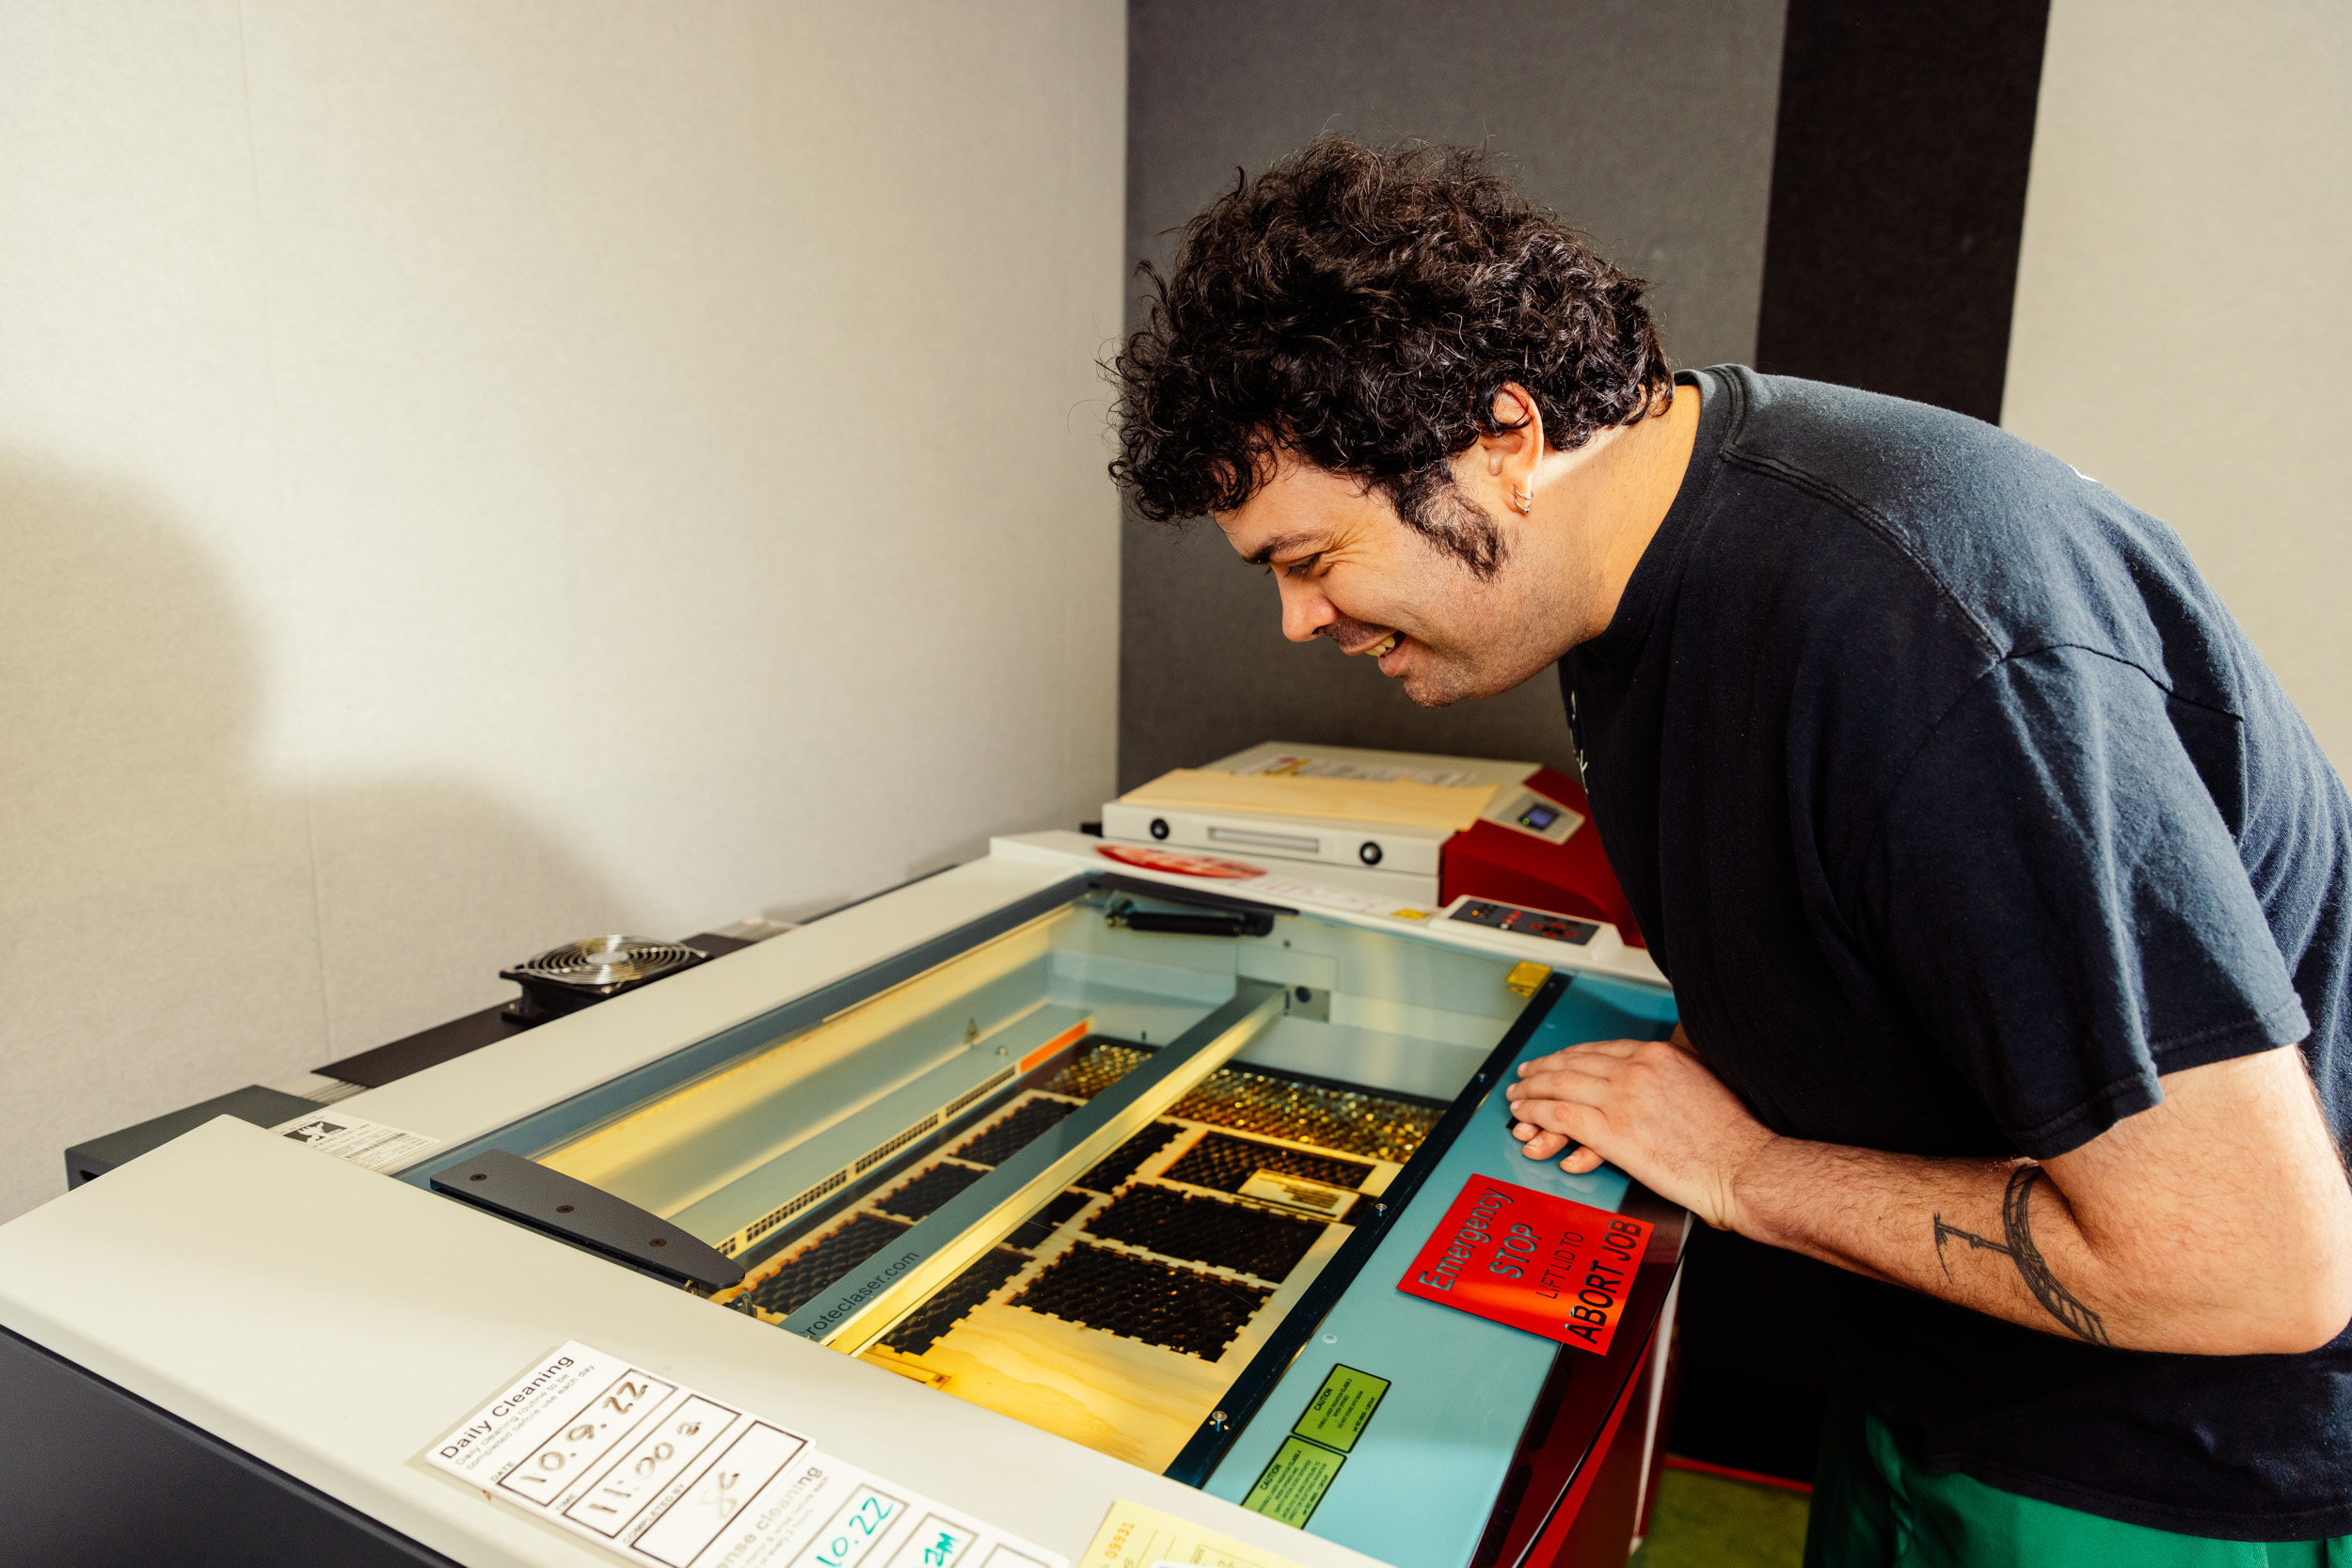

Induction presentation
Our Inductions have been created as slide shows for presentation and documentation purposes. Please feel free to download and use the guide and files as per our CC license in the footnote.
Some pages may link to other online workshops, tutorials or guides created at The Edge, you may require internet to connect and view links.
Admin view
Our Laser cutter induction resource guide

Design Files
Visit the Vector Library for options!
Or learn more about creating your own vectors:
- 101 - Intro to Vector Design with Inkscape
- 101 - Intro to Vector Design with Illustrator
An easy trial cut:
Beetle laser cut

Booking
Once you have completed an induction you can book a laser cutter to use for your projects during Open lab hours;
Have not done the induction yet? keep up to date with the SLQ What's on page for further information:
PLEASE NOTE CLOSED IN SHOES MUST BE WORN AT ALL TIMES IN THE INNOVATION LAB.

Acorn Online Component
Acorn is our database that holds your induction access details. Please enrol into the specific induction you are completing with the SLQ Acorn website. NOTE: This website is only available onsite at SLQ. https://inductions.slq.qld.gov.au/user_login

Additional Resources and Inspiration
Iconic Brisbane Lampshades Workshop
Laser Cutter Ornaments Workshop
Queensland Architecture in Miniature - Mid century modern Workshop
Queensland Architecture in Miniature 2023 Workshop
Paper Boutique Workshop
Christmas Laser Cut Earrings Workshop
Laser Cut, Hand-Bound Books: Crafting the Grumpus' Treasured Tomes
Laser Cutter / Engraver Resources
Information on Laser Materials settings

