Electronics Induction
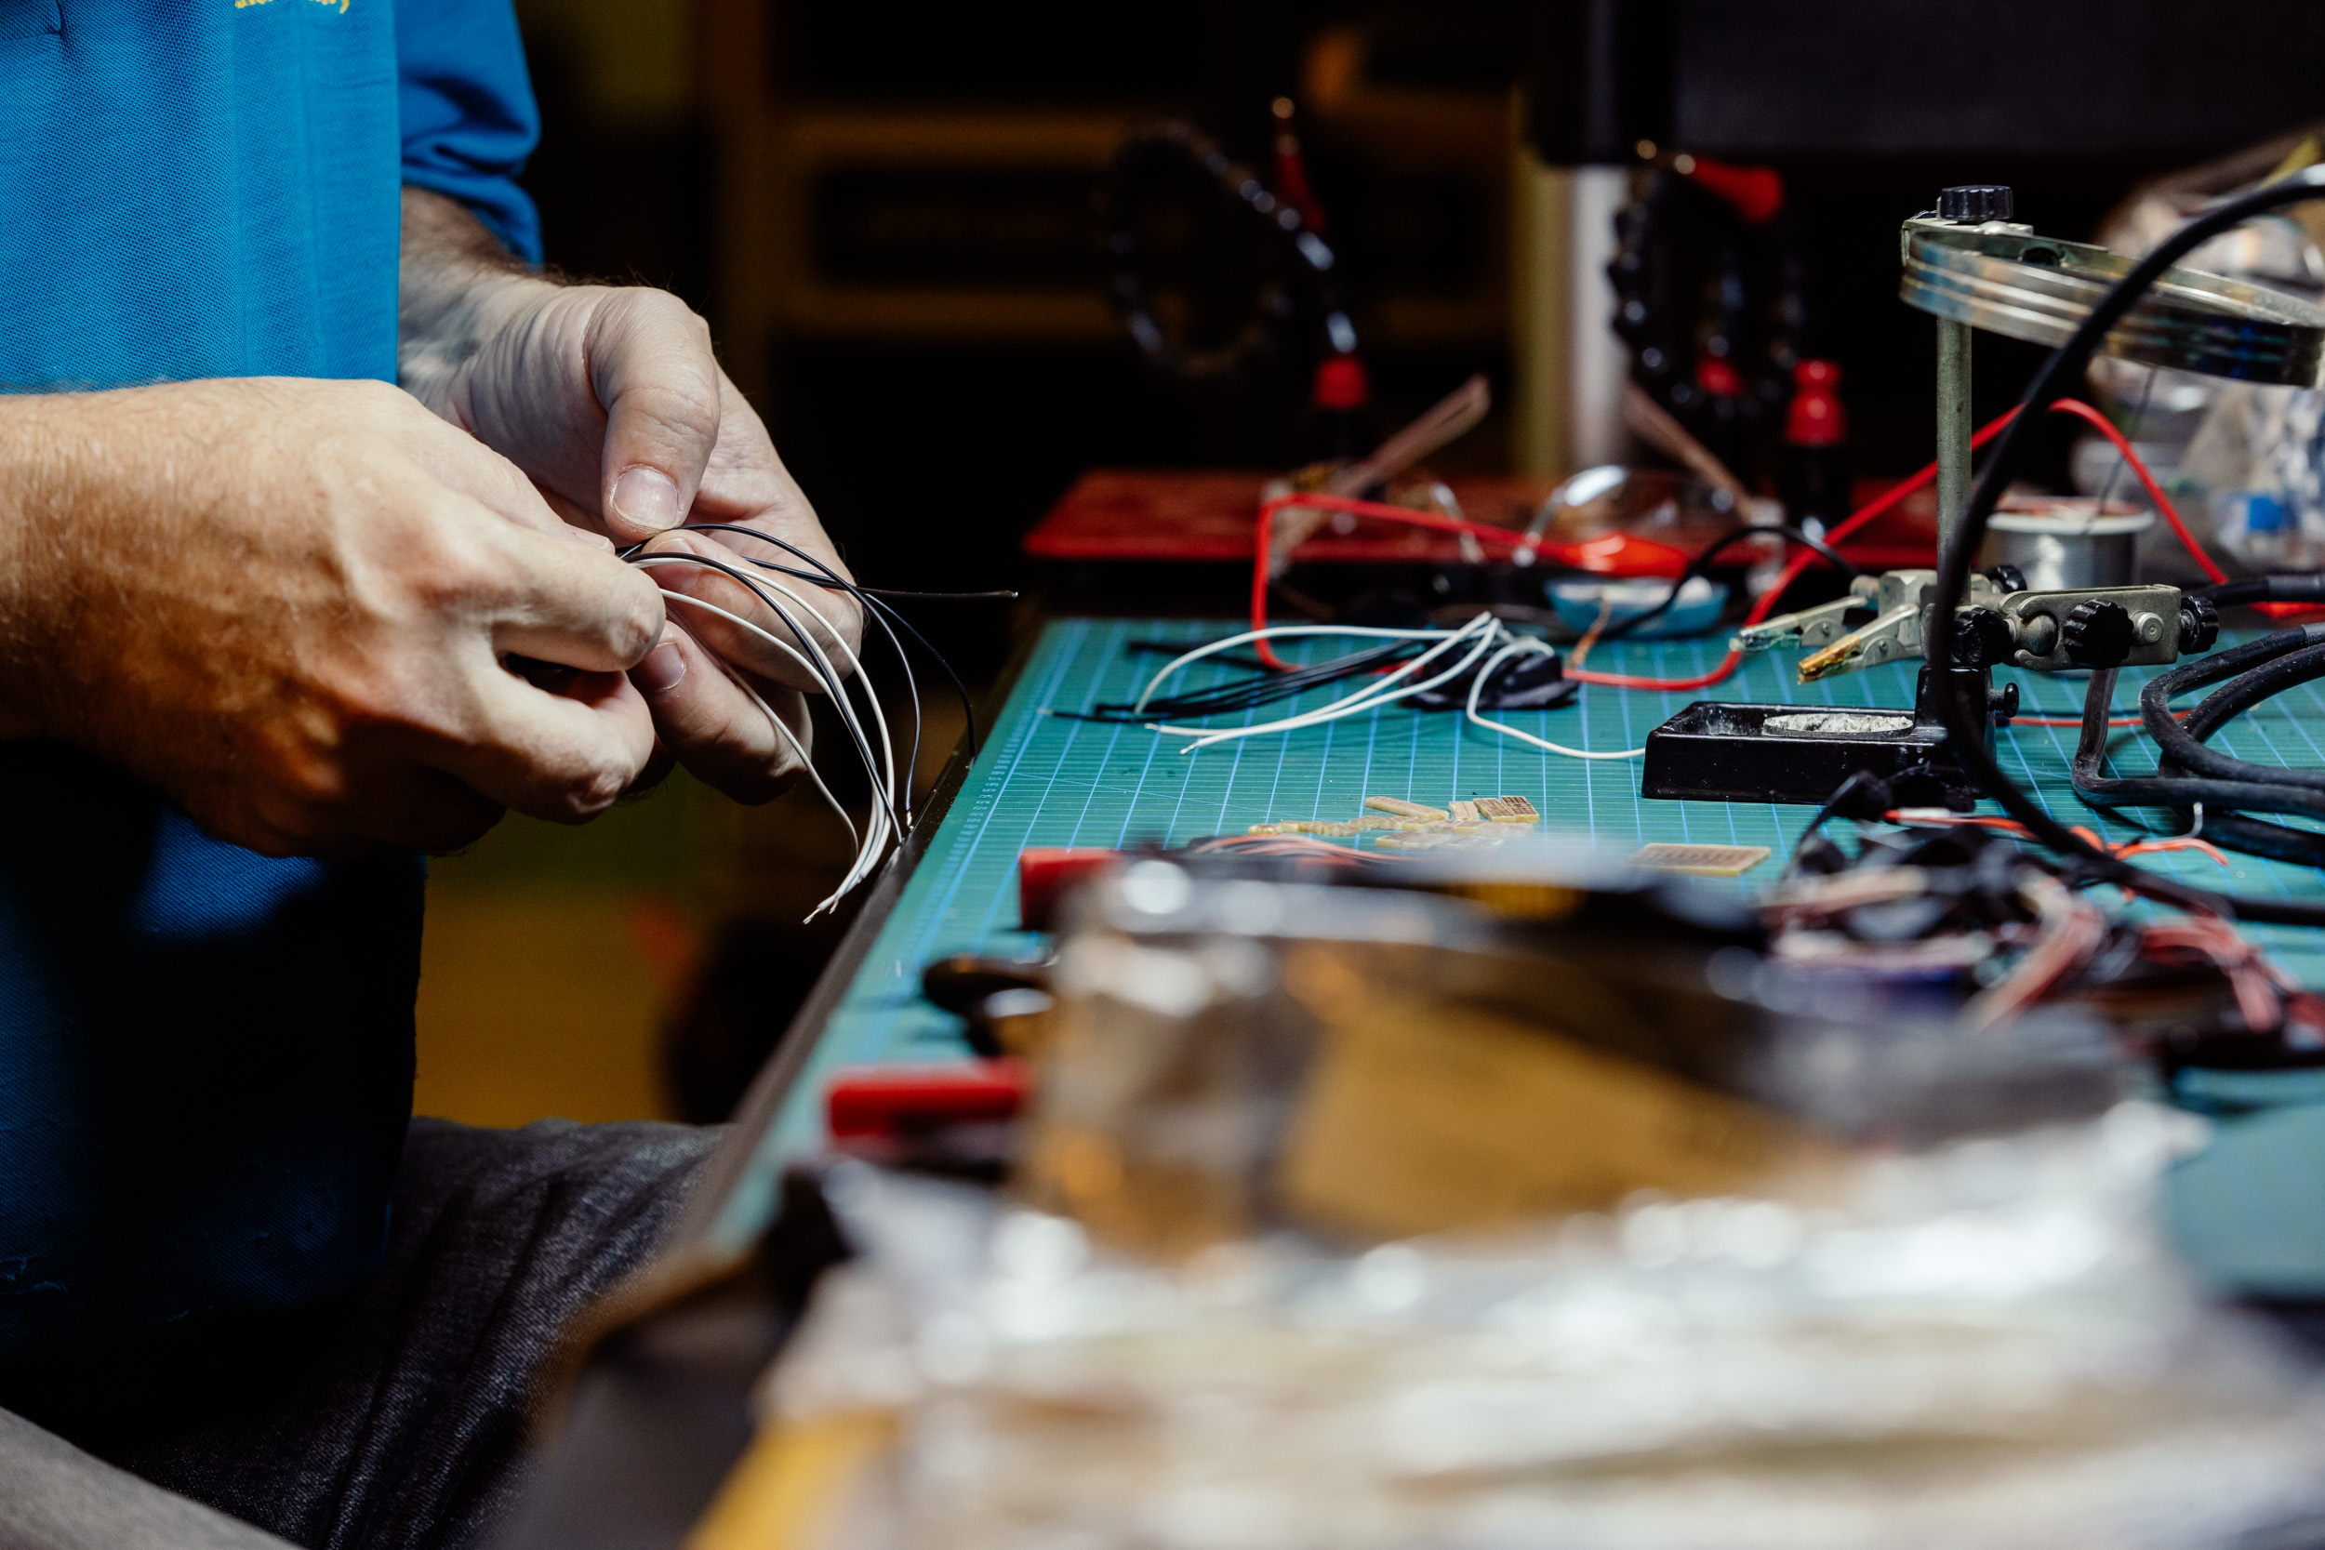

Electronics Induction

Induction presentation
Our Inductions have been created as slide shows for presentation and documentation purposes. Please feel free to download and use the guide and files as per our CC license in the footnote.
Some pages may link to other online workshops, tutorials or guides created at The Edge, you may require internet to connect and view links.
Admin View
Our Electronics Bench induction resource guide

Booking
Once you have completed an induction you can book an electronics bench to use for your projects during Open lab hours;
Have not done the induction yet? keep up to date with the SLQ What's on Page for further information:

Acorn Online Component
Acorn is our database that holds your induction access details. Please enrol into the specific induction you are completing with the SLQ Acorn website. NOTE: This website is only available onsite at SLQ. https://inductions.slq.qld.gov.au/user_login

Additional Resources and Inspiration

Activity
101 - Intro to Arduino Workshop
Table Top Christmas Tree Workshop 2022

Instructional videos & PDFs for equipment
YouTube - How to use a multimeter like a pro! The Ultimate guide
YouTube - How to do SMT Surface Mount Reflow soldering by hand
YouTube - HOW TO SOLDER! (Beginner's Guide)
YouTube - How to ACTUALLY Use an Oscilloscope (Beginner-Friendly Guide!)
Rigol 1000 E series Digital Oscilloscope Quick Start Guide
Instrument Basics: Bench Power Supplies
Rigol DP700 series Bench Power supply Quick Start Guide

