3D printer Induction
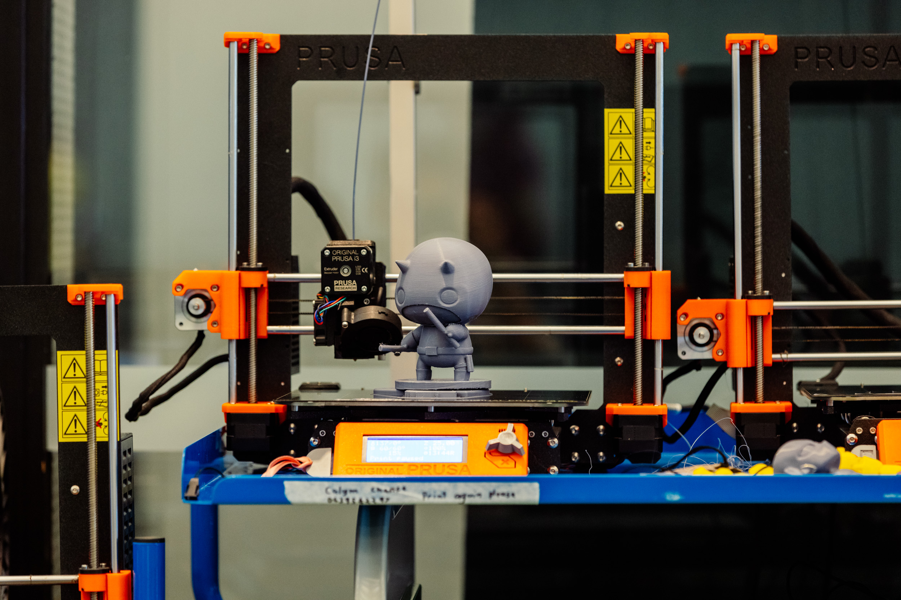

Induction presentation
Our Inductions have been created as slide shows for presentation and documentation purposes. Please feel free to download and use the guide and files as per our CC license in the footnote.
Some pages may link to other online workshops, tutorials or guides created at The Edge, you may require the internet to connect and view links.
Induction Powerpoint - Admin View
3D Printer Induction Slides

Booking
Once you have completed an induction you can book a printer to use for your projects during Open Lan hours
Have not done the induction yet? keep up to date with the SLQ What's on Page for further information:

Acorn Online Component
Acorn is our database that holds your induction access details. You will be enrolled in the specific induction you are completing on the SLQ Acorn website, staff will assist during the induction. NOTE: This website is only available onsite at SLQ. https://inductions.slq.qld.gov.au/user_login

Additional Resources and Inspiration
Info on Prusa Slicer
101 - Intro to 3D Printing
101 - Intro to 3D Modelling Workshop
Printing on the Prusa i3 Mk3s
DIY Action Figures - Jan 2022

