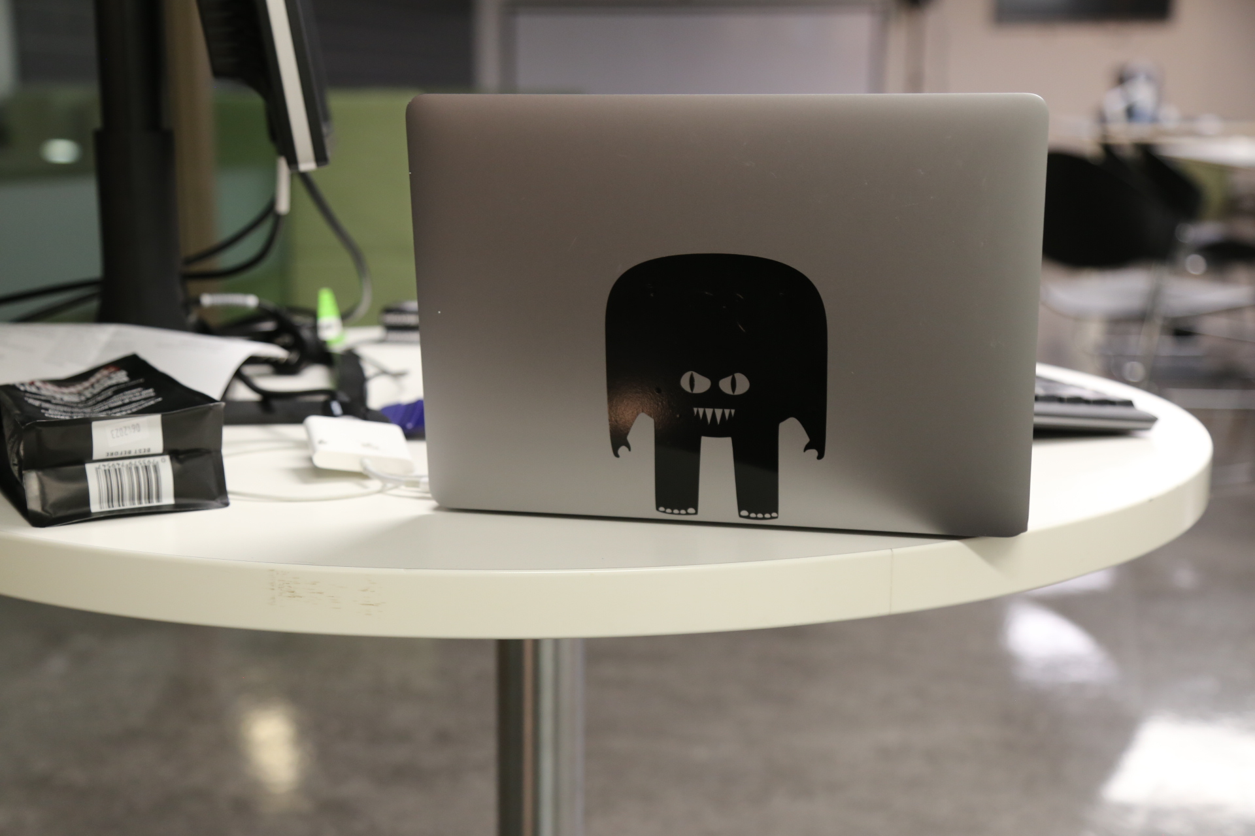

Vinyl Cutting for fun - Self Paced Started Project
Make a sticker for your laptop or smart phone. If you can read a screen, use a mouse and have a bit of patience, we can teach you the basic skills you need to layout, cut and apply a vinyl sign, just like the pros. Your first sticker is free. After that it's about $15/metre or you can bring in your own material. Checkout these examples.

So... Your Mission if you Choose to accept it

Step 1
Find a nice simple image ( preferably black and white) on the internet (usually if you google your favourite animal/character/go to thing with “silhouette”you get a good result) or draw something with a fat black marker.

Step 2
Download the image or take a photo of your drawing with your phone and open it in your favourite vector drawing program ( Adobe Illustrator, CorelDraw or Inkscape which is free and there's a tutorial here)

Step 3
Trace your image using the pen tool or Autotrace function

Step 4
Add some text* if you like or a border round the outside if you like (a border round the outside makes it easier during the weeding stage).
*Remember if you write something you need to convert it from text to an outline before you cut it.

Step 5
Cut that Badboy. Instructions for doing this over here

Step 6
Weeding is the process of removing the unwanted parts (negative space) of the vinyl. Its the main reason frankly, you'd pay someone else to do this work because its the part that takes time and patience.
Its also the point of the process where you will be punished if you have been over ambitious with the scale of your project and will wreck your work if you rush. This is where we refer you to the first instruction in Step 1 “Find a nice simple image ”
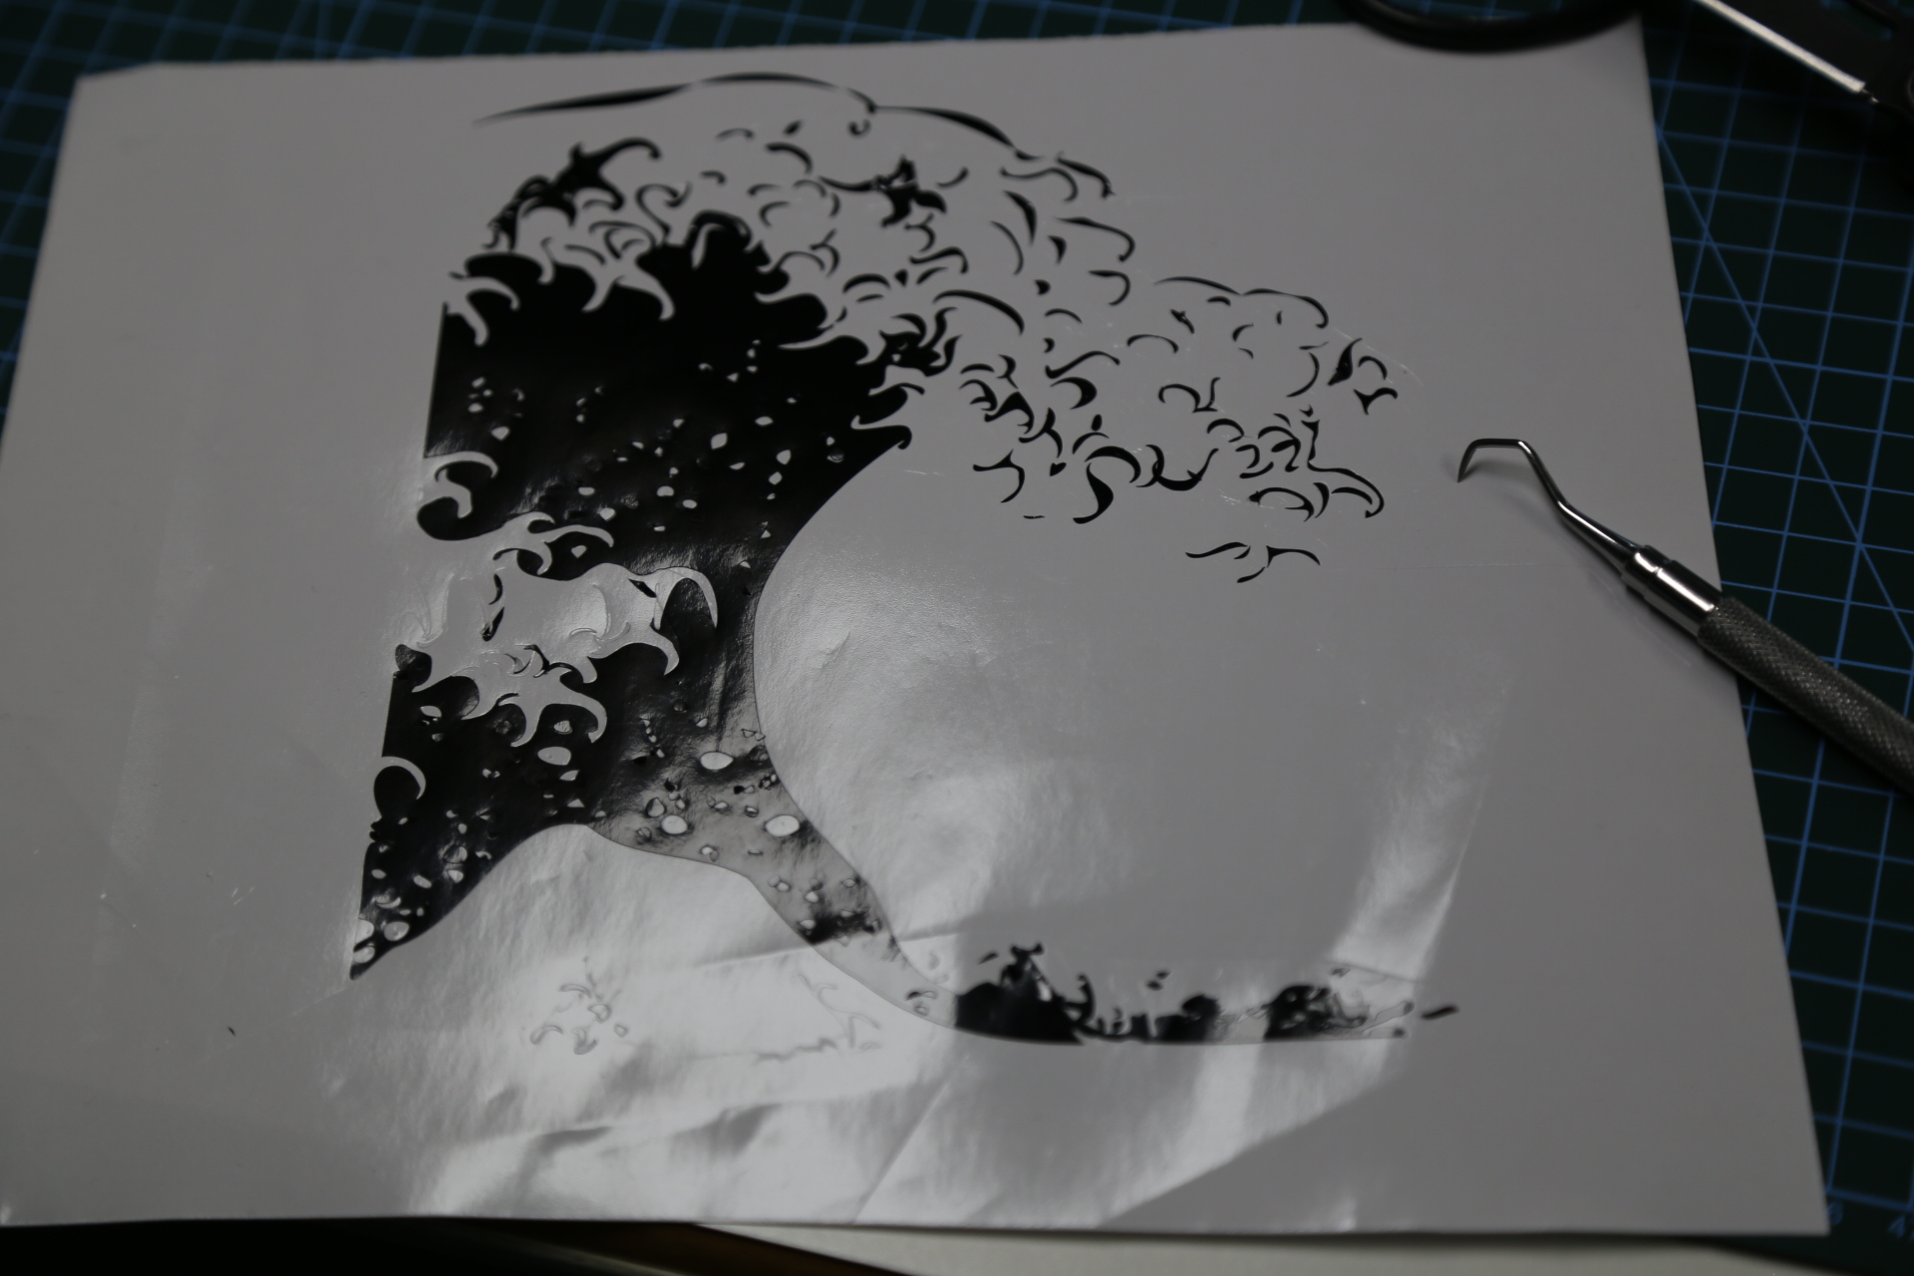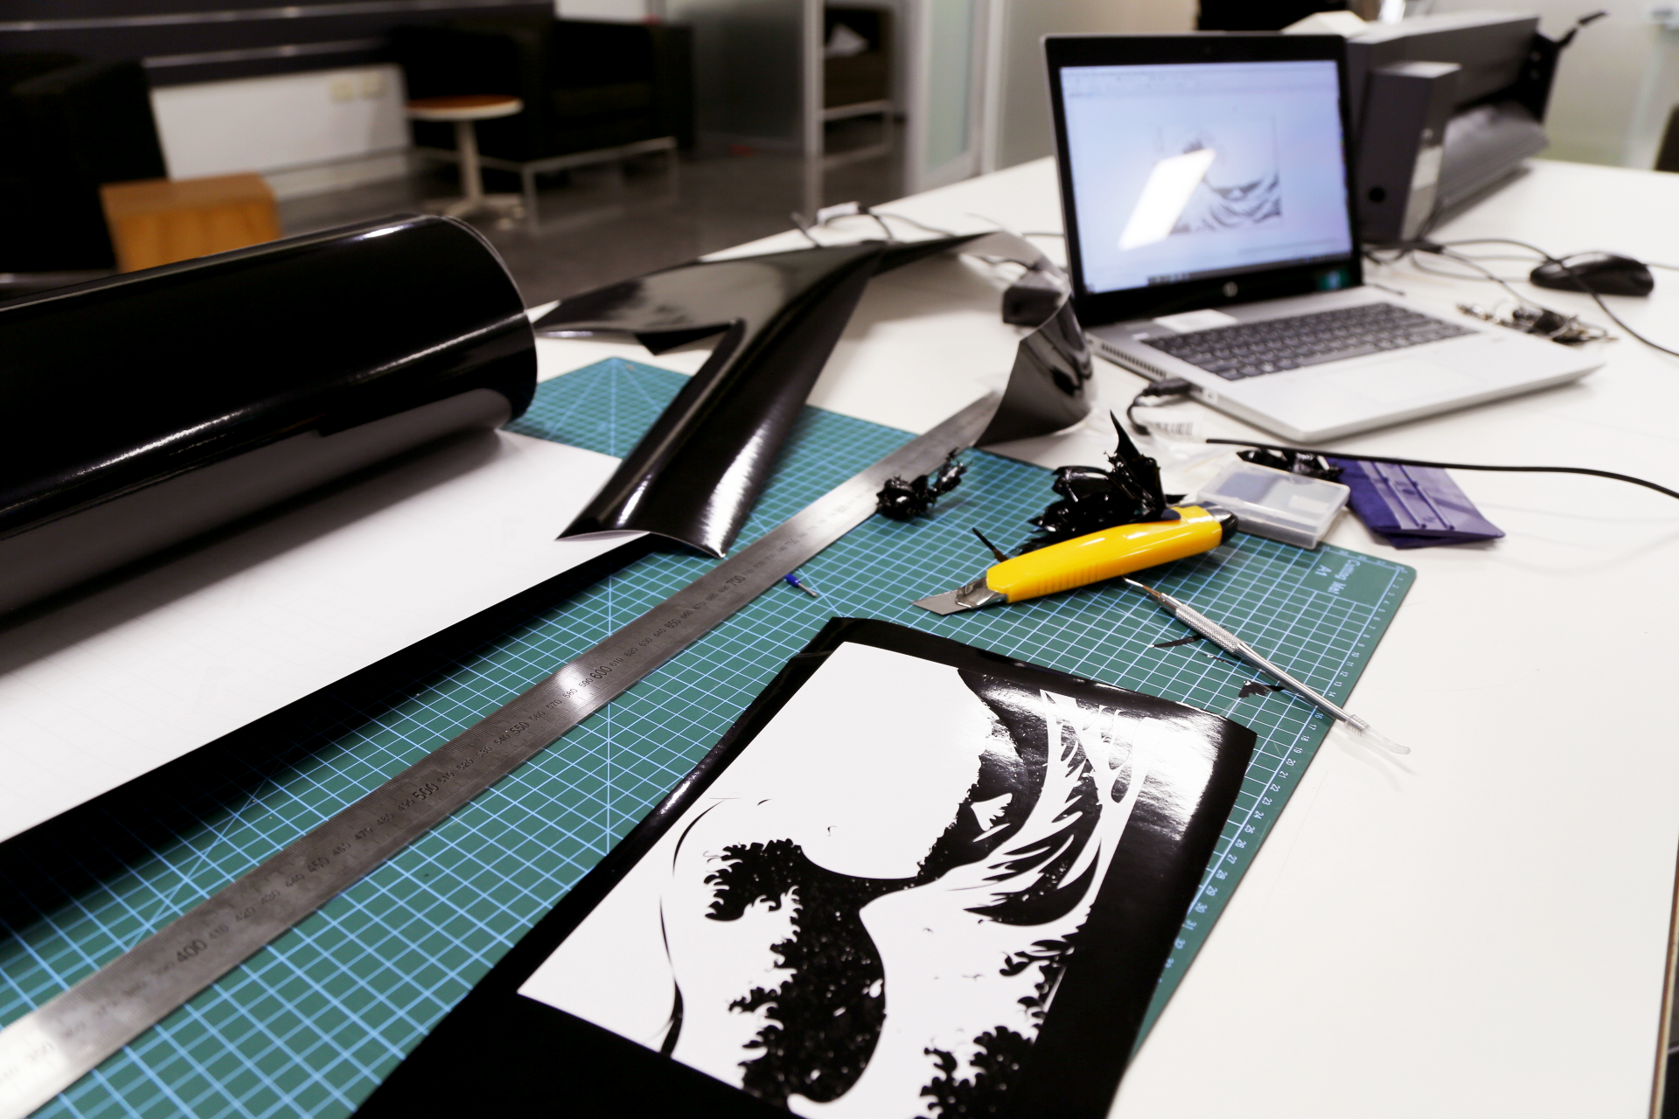
I persisted with this Hokusai “Great Wave” with three tries and it eventually beat me when i finally go one applied but I'd stuck it on upside-down... i nearly cried.
Step 1 “Find a nice simple image ”
Hints for Weeding-
- Use a weeding tool. It makes it a lot easier.
- Work from the top right hand corner across and down. seems to work better.
- Don't be afraid to make a few extra cuts with a utility knife to make the negative space bits that you are weeding small- more manageable.
- Don't be afraid of cutting a second for spare parts if you lose some - its better than tearing your hair out.

Step 7
Apply some applicator tape to your vinyl
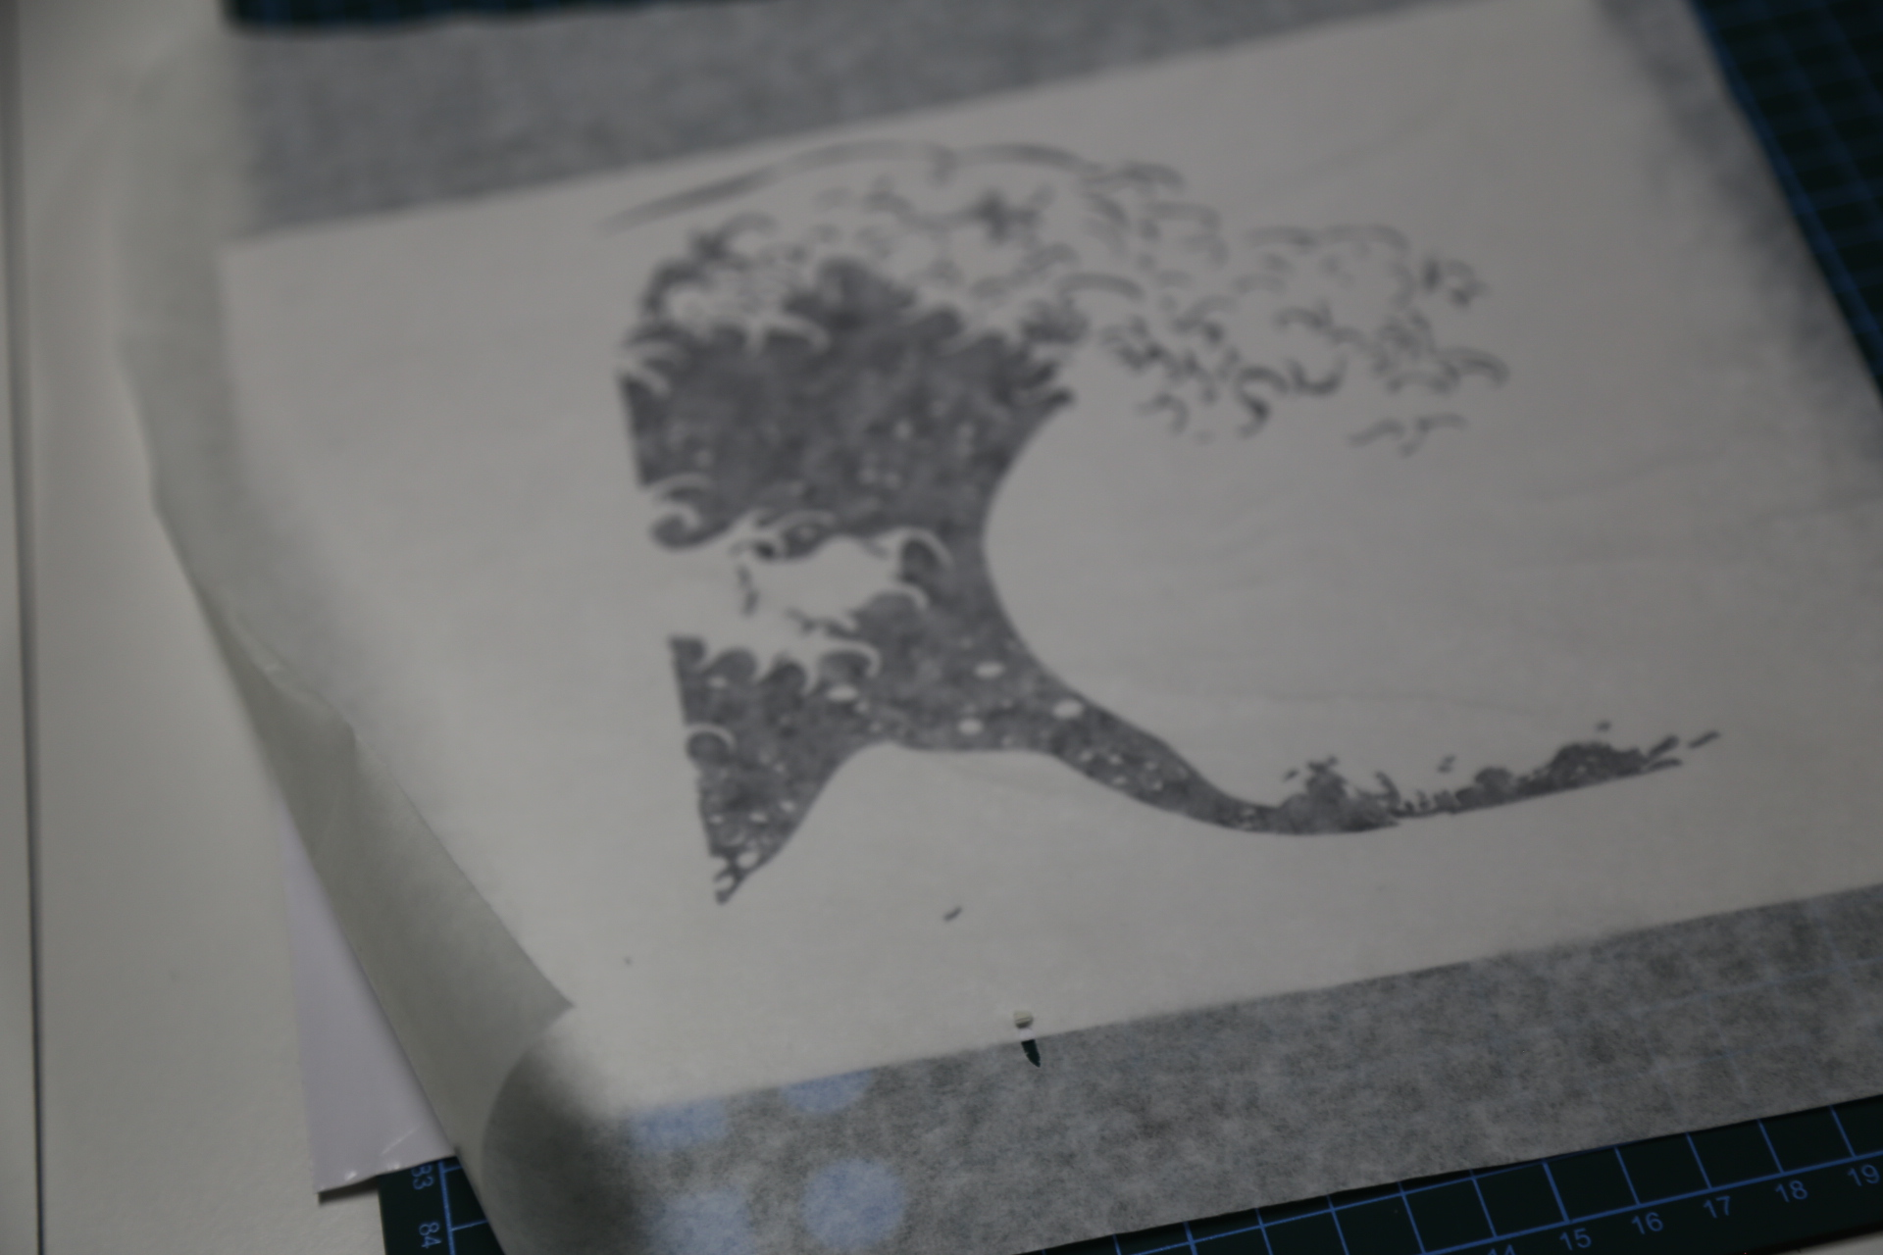
and prep your surface for application. 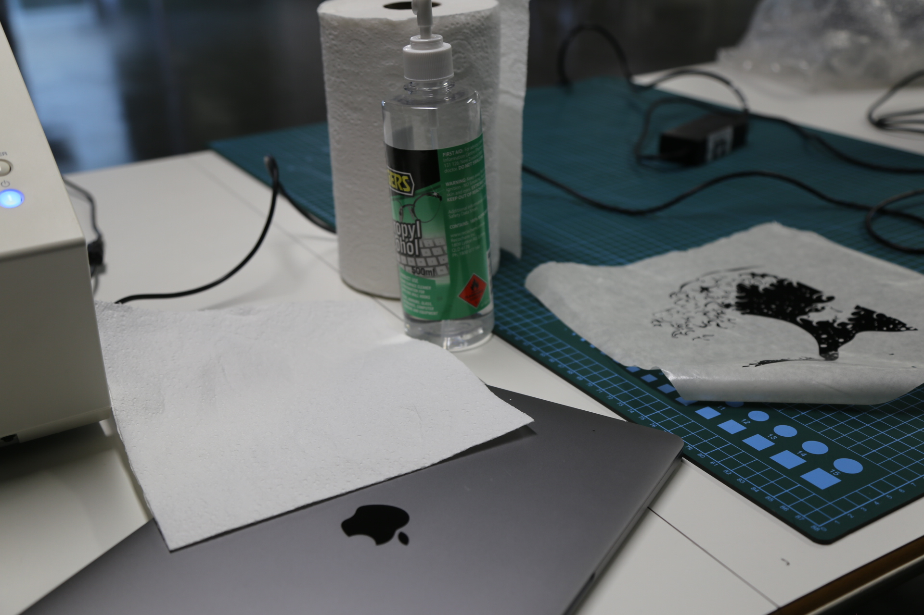

Step 8
Take a deep breath and apply your vinyl.


