IRC Wiki

What is the IRC Wiki?
This IRC Wiki space is provided by State Library Queensland, while the content is created by Isaac Regional Council staff.

Who is the IRC Wiki for?
The IRC Wiki is for Isaac community members, containing resources complementing workshops held in the region.
Also, serving as a tool to share program material with other professionals in public libraries.

Resources
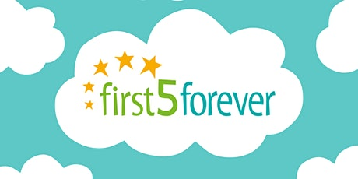  F5F TIPS & MESSAGING | 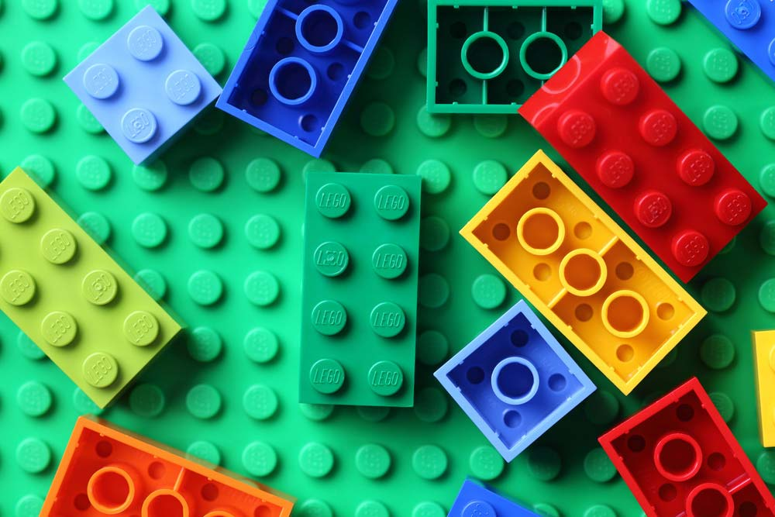  LEGO BUILDER - Program ideas for engaging sessions with Lego for the ages 6+.
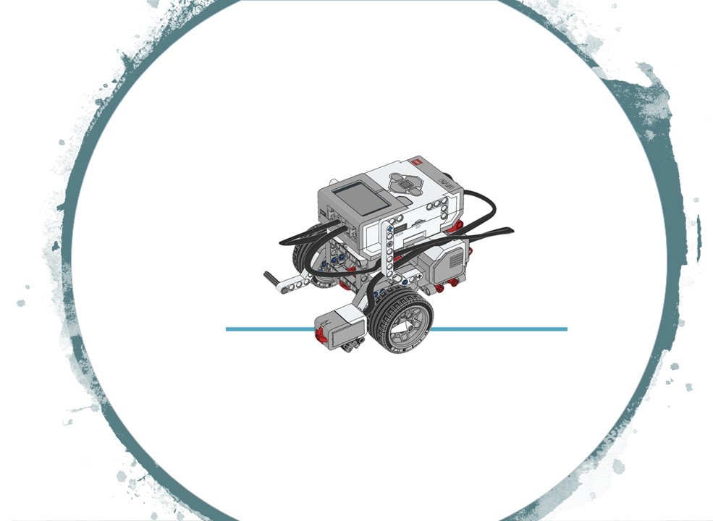  LEGO ROBOTICS - The Lego Robotics workshops with EV3 and Mindstorms. | 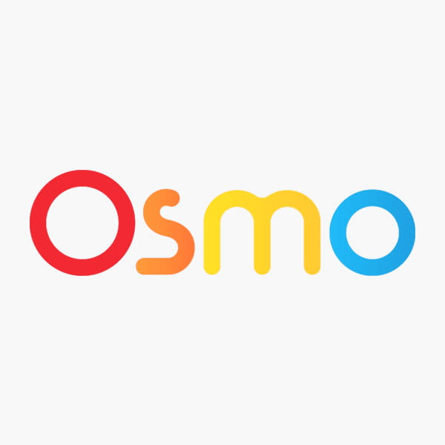  OSMO - Program ideas for engaging sessions with Osmo's for the ages 6+.
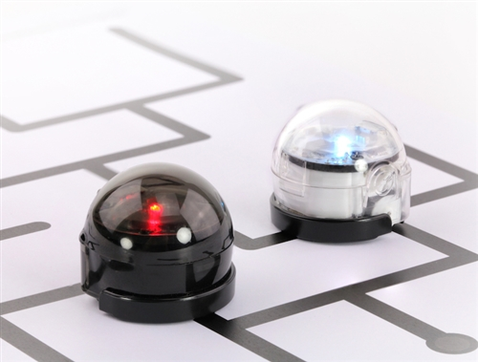  OZOBOT - Program ideas for engaging sessions with Ozobots for the ages 9+. | 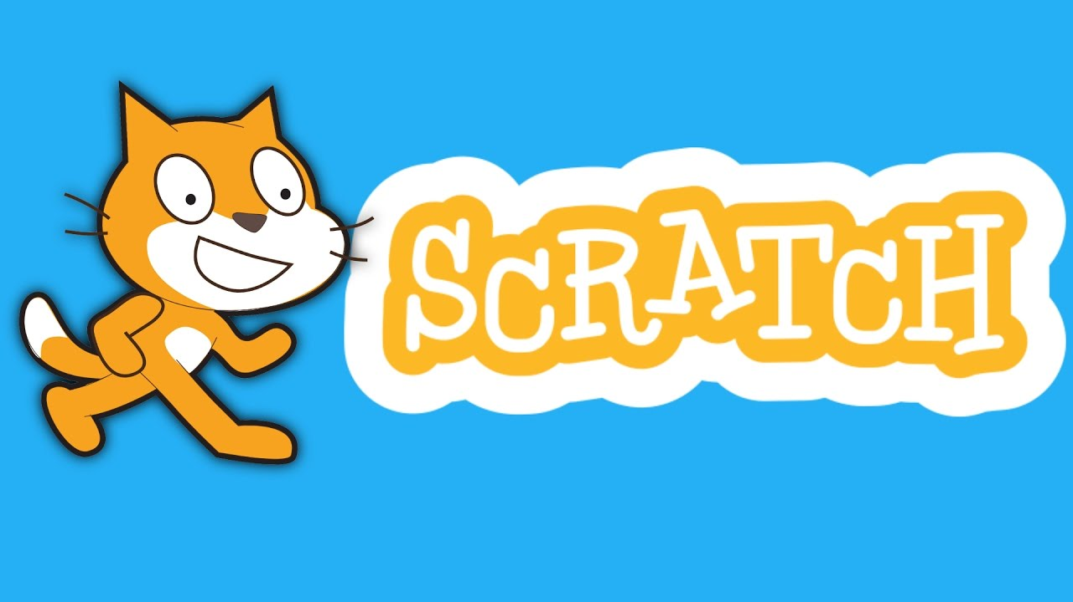  SCRATCH - Program ideas for engaging sessions with Scratch for the ages 9+ including the use of Makey Makey's. | 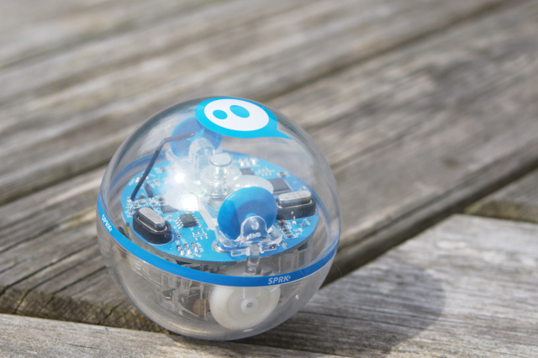  SPHERO - Program ideas for engaging sessions with Sphero's for the ages 9+. | 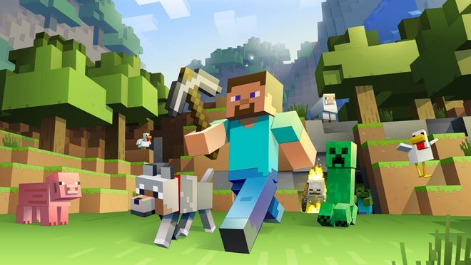  MINECRAFT - This is a site for our Isaac Master Builders.

Workshops
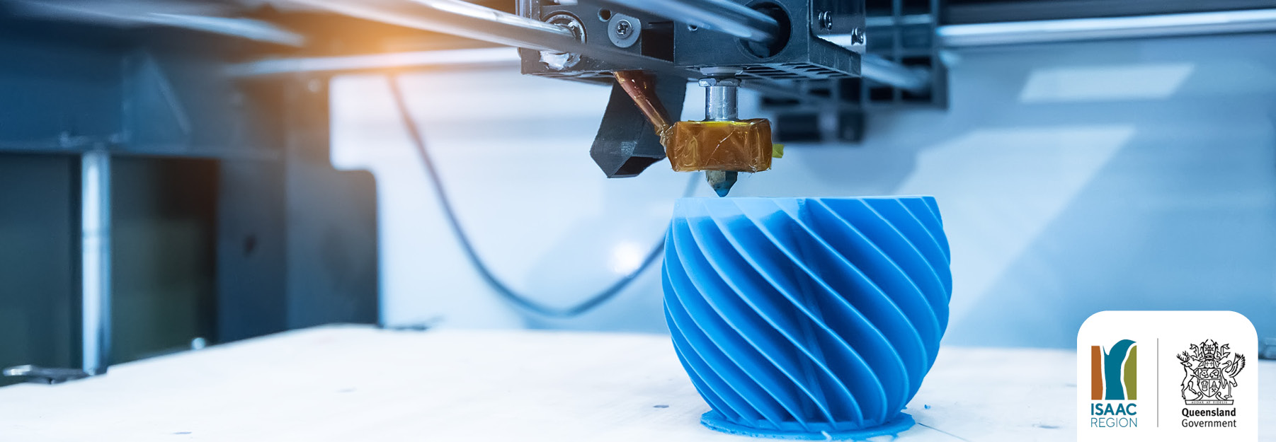  3D PRINTING WORKSHOP - Here you find material complementing the 3D printing workshop touring the Isaac Region. | 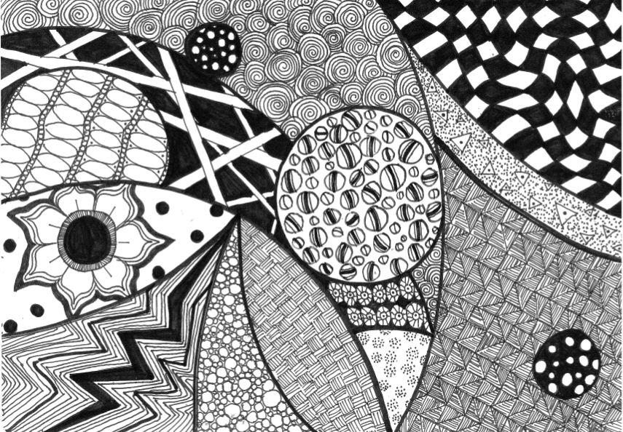  ZENTANGLES TUTORIAL - Here you'll find a tutorial video and resources to create your very own zentangles artwork.
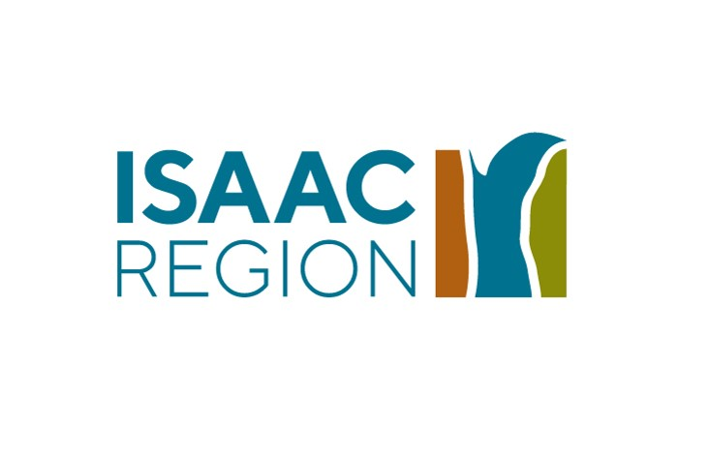
~~HERO-IMAGE ~~

