SCRATCH PROGRAM'S
On this page you will find a variety of information to get you started on your journey with Coding using Scratch. This online platform is a great way to introduce creative thinking into your digital programming and coding adventures.
For more information visit the Scratch page on SLQ Wiki.

Creating a Scratch account
Open your internet browser (explorer, chrome, safari etc) and go to the Scratch website below;
https://scratch.mit.edu/
- Once you are on this page you will see a Join Scratch button in the top right hand corner.
- Follow the prompts to create your account.

Saving and downloading a project to your computer
- CLICK: File
- CLICK: Save to your computer
  - Make sure to download a .sb3 file
  - If your file does not say .sb3 at the end just type it in yourself > Test.sb3
- CLICK: Download from your computer
  - Go to the location your file has been saved too
  - Click on your file
  - Click open
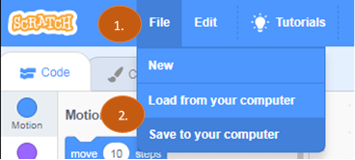

Resources
The following links will lead you to a variety of Scratch Programming ideas. Feel free to give them a go and use them as a starting point to develop your own Scratch coding.
- Scratch Programming ideas
- Hide and Seek with Gobo
- Music Cards
- Animate a character
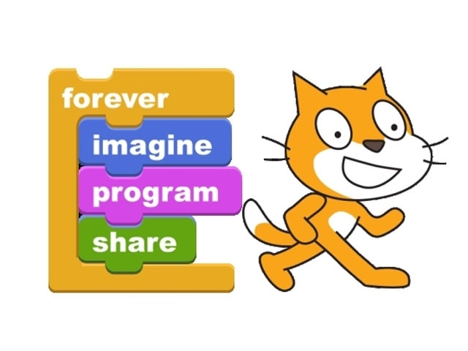
~~HERO-IMAGE ~~
Back to Scratch

