MINECRAFT FEEDBACK

General Information
Hello Everyone, this page is for the first Minecraft Master Builder program participants. We would like to hear from you what you think of the program and any tips you can give us to make it better in the future. Thank you for your help.

Questions for inspiration
- Did you learn something new about Minecraft?
- How did you like to code in Minecraft to create buildings faster, or create shops and quests?
- Was there something missing from the sessions you would have liked to see?
- Was the Isaac program staff helpful? And could you get easily in touch for help?
- What do you think we could do better, for even more fantastic sessions?
Please leave your feedback in the provided discussion forum. See above questions for inspiration. Please read our Comment Policy before commenting.
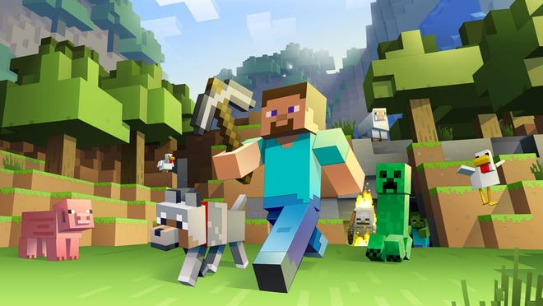
~~HERO-IMAGE ~~
Back to the Minecraft page

