MINECRAFT

General Information
Isaac Regional Council's programming team is currently in the process of developing a town within the SLQ's Minecraft server. Programming in the space is currently being undertaken with a select group of several young people, who have been identified as 'Minecraft Master Builders'. These master builders, along with IRC staff, will continue to build the town space and develop challenges to launch to the wider Isaac Community in Term 4 of 2021.
The Isaac Master builders are held to a code of conduct when entering the Minecraft space. The code of conduct from both SLQ, as well as additional material, is listed below.
- QLD Minecraft Rules - SLQ
- Please remember to be respectful to one another while online. And always feel free to interact with each other in the chat box. Let your team mates know how great you think their builds are and feel free to explore the structures and creations that everyone has constructed.
- We all know how much time and effort is put in to crafting a building or structure. Please do not destroy or alter anything that one of the other master Builders is in the process of creating or has finished creating.
- If you begin a project, please remain with that project until you have completed it and been given the 'completed' tick in the building tasks table. This way we don't end up with random structures appearing throughout the space that leave others unsure on what their purpose is.
- If you would like to try something out creatively that may not fit in with the theme of the town please utilise the 'creative area' on the outskirts of town (Large walled off area).
- Please keep in mind that this is meant to be a 'Cohesive' space. We would like one town where everything works well with one another so before starting your build please make sure to view your allocated task page and think about how you might like to construct your build and what materials you might like to use.

Resources
- Previous Master Builders please leave a message on our Feedback Page to help us improve and grow the program. Thank you!
- Please follow the link to register yourself as a player on the required Minecraft server. SLQ Minecraft Server - Drustcraft
To register please click on the register button as seen in the image. 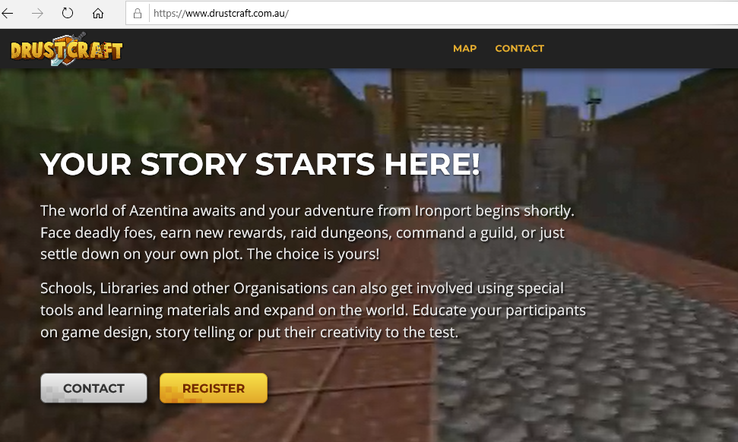
Once you click on this you will then be taken to the page in the image below. This gives you the server address and linking code to enter in your Minecraft application. You will need to enter this information as a new server in Multiplayer mode. 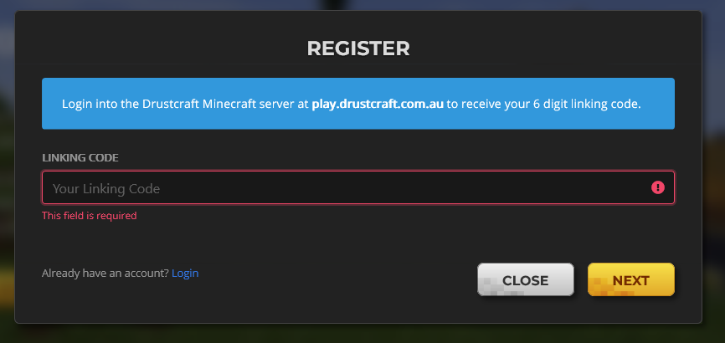
In the following section you will find a number of resources to aid in your Minecraft journey. Please explore them at your leisure.
- SLQ Minecraft Map
- WorldEdit Wiki
- WorldEdit Cheatsheet - Region
- WorldEdit Cheatsheet - Selection
- Block Tags
- Block States
In the table below are the commands we used in the first three Master Builder session - everything about builder tools. You can find many more listed at the links above.
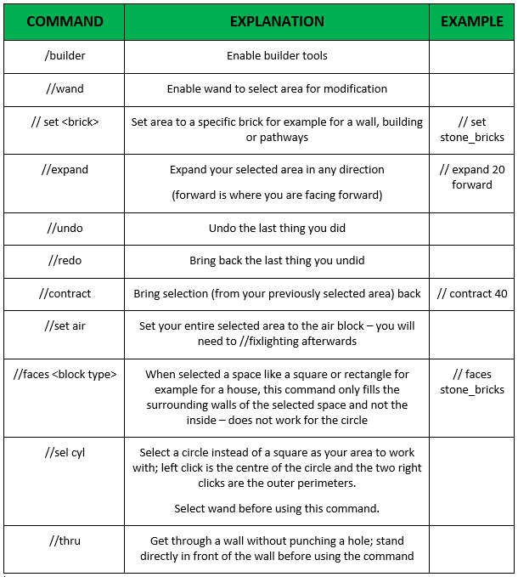
In the table below are the commands we used in the second three Master Builder sessions - everything about NPC's, Shop's and Quest's. You can find many more listed at the links above.
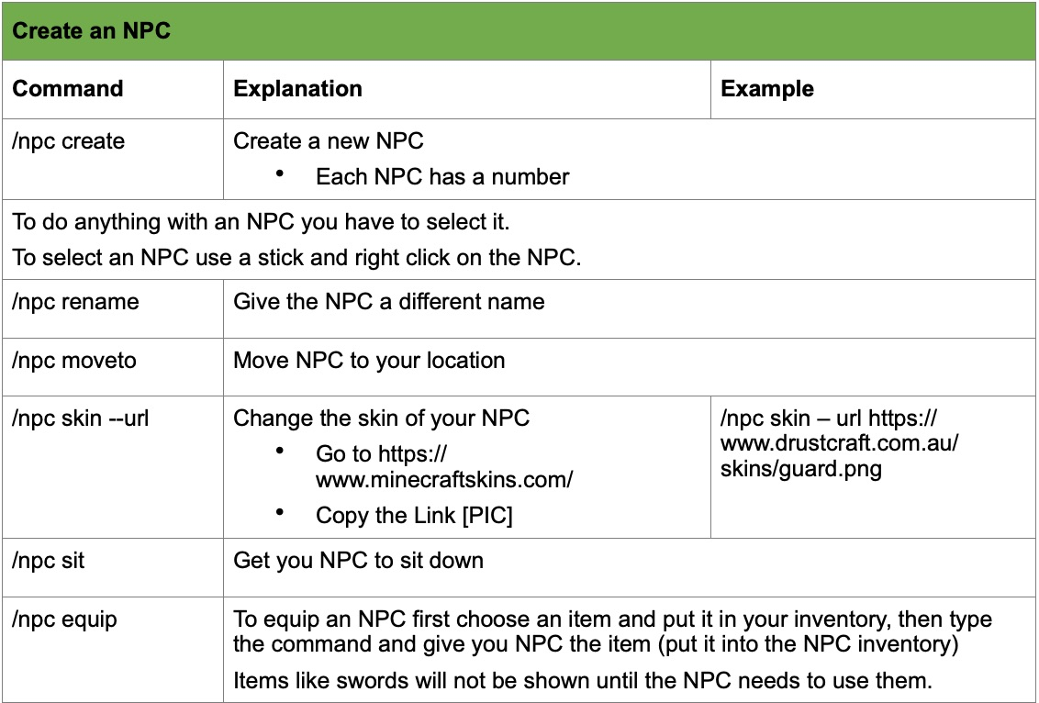
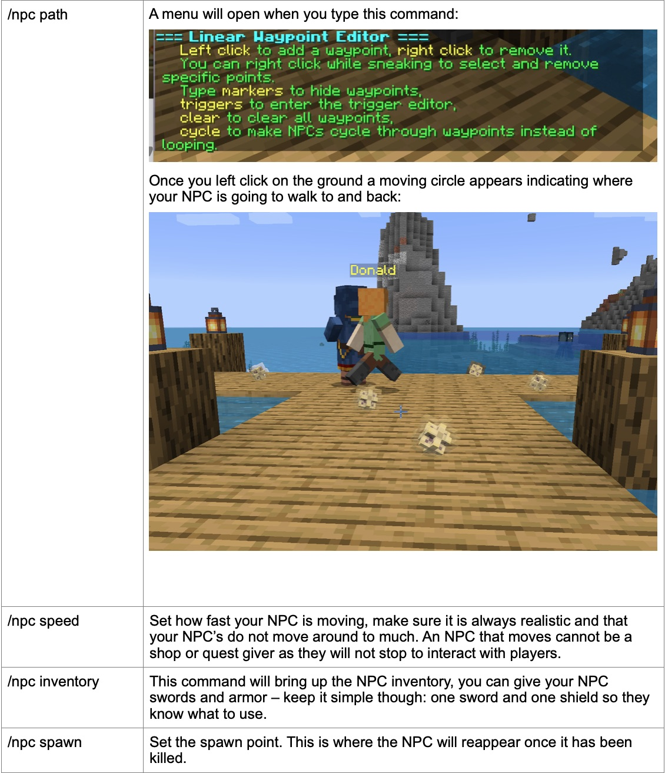
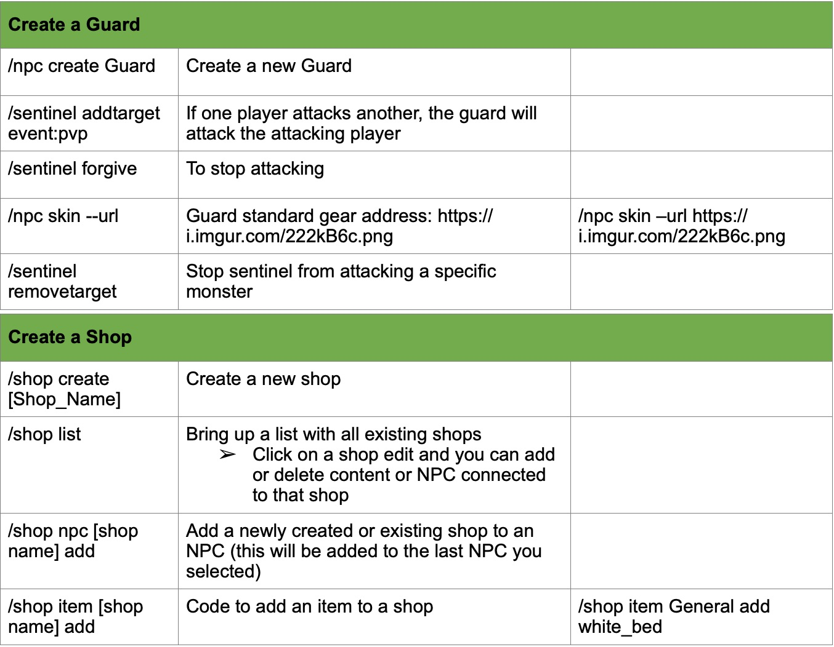
- Quests coming soon

Upcoming Sessions

Previous Sessions
- Friday 9th June: Let's design some custom skins for our towns people.
- Thursday 8th June: Will give time to finish the work form the day before. - There is never enough time for building.
- * Wednesday 7th June: Reimagine your buildings in a new world - let James from SLQ guide you as you make final tweaks.
- Wednesday 14th April: We will take some time and talk about current and missing buildings, go over the Wiki, missing NPC's and quest's. Tune in to have your say in what need's to be done and what Isaac town is supposed to look like.
- Friday 9th April: This session will be the last of the three Master Builder sessions for these school holidays (April 2021). James from SLQ will teach us how to create quests. We will play through all of our new quests, explore the previously created houses without builder mode, NPC and shops. Please follow the Skype meeting link which will be sent to you via Email. Homework for session three is to finish your NPC's (giving them skins, placing them around town and ensure they have a spawn point); ensure there is enough lighting in the town and enough guards; finish your buildings using the guide below. Please let us know if you have got any questions in the Q/A section. Happy Building!
- Thursday 6th April: We will learn how to create shops with the NPC around town, how to add items and NPC's to shops. Make sure you know which items you want available for the players to complete quests we will create in our next session.
- Wednesday 7th April: James from SLQ will dive into NPC's and Quests. Make sure your buildings are complete as we will need them to place NPC's around the town. James will show us how to create NPC's and how to give NPC items, spawn points and skins.
- Monday 15th March: In this session we would like you to focus on finishing off your current builds. After watching the below video please go to the Builder Tasks table below and have a look over your individual task pages. Once you have done this we would like to see you make your way in to the Minecraft space and develop your builds to the outlines listed in these task pages. Once you feel happy that you have completed these projects please let the Isaac Staff know via the below Q&A Section.
Video: Master Builder Session - March Video

Builder Tasks
The below table is dedicated to the building tasks currently underway in our town on the SLQ Minecraft server. Please click on the tasks below for more information regarding your individual builds.
TASK NAME | MINECRAFT USERNAME | STILL TO COMPLETE (As of 3/06/21)
Guard Towers | Kbird | Landscaping (look at the possibility of adding trees, bamboo, grass, flowers etc.)
Shop | Kbird | Landscaping/Pathways
Campsite | Kbird
Library | Ojemoji123 | Landscaping/Pathways. See building page - Inspiration pics (less blocklike)
Zoo | Ojemoji123 & ArmyBunny22 | Landscaping/Pathways. See building page - Inspiration pics (less blocklike). Is this space animal friendly?
Pet Shop | NotedSoup489865 | Landscaping/Pathways. Hole in ground?
Village Houses (All) | All MB participants | Please remember that these are the houses NPC's live in. Keep in mind what size these houses may have been in the time period we are aiming for.
Bridge | QueenofFaerie95 (Flynn)
Blacksmith | QueenofFaerie95 (Flynn) | Landscaping/Pathways. Indoors to reflect more of a blacksmith shop.
Community Centre | MoranbahCoal | Building to be completed. Landscaping/Pathways.
Bank | ArmyBunny22
Temple | seraphina_pekala | Pathway
Underground Catacombs | seraphina_pekala | More pathways and areas to break blocks
Tavern | seraphina_pekala | Pathway
Barn & Fields | QueenofFaerie95 (Codie)
Tree | QueenofFaerie95 (Codie)

NPC's - Shops - Quest's
The below table is dedicated to the NPCs, Shops and Quests in Isaac Town.
Guards:
- Functions should include: Protect against Mobs & PvP
- Have in their inventory a sword and a shield
- Have a spawn point and one path point to come back to after fighting/dying
- All guards should wear the same uniform: /npc skin --url https://i.imgur.com/222kB6c.png
NPC's | Function | COMPLETED
(15) Plotmaster
(19) Luna - Temple Priestes | Quest 7 Find Dion; Quest 17 Protect Luna
(20) Dion - Luna's son | Quest 7 Find Dion
Guards | See below | Incomplete
(90) Michael - Storyteller | Shop: Cartographer
(91) Bob the Manager
(92) Bob
(93) Gareth
(94) Clerk Sapphire | Shop:
(96) Mary - Stefan's wife | Shop: General
(97) Olvu
(98) Stefan - Mary's Husband
(99) Harald
(101) Dylan
(102) Rase | Shop: Warrior, Miner | Issue: Players cannot get to Rase
(103) Sergent Tyler
(134) Pub Owner Richard
(135) Flinty | Shop: 'Farm Supplies'
(136) Librarian Prachi | Shop
(137) Melissa | Shop
(139) Sally | “I am all sold out”
(144) Trainer Zane
(145) Jade
(147) Cynthia

If you have any questions relating to the Minecraft Master Builder program outlined above, please direct them to the section below. Please read our Comment Policy before commenting.
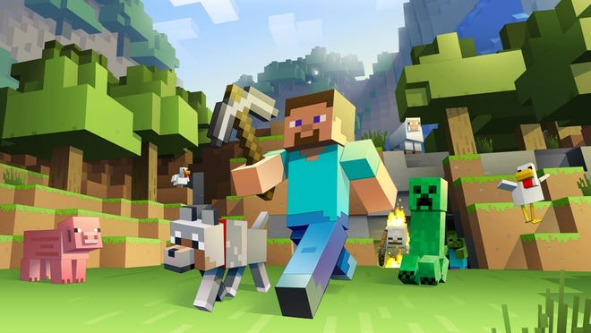
~~HERO-IMAGE ~~
Back to IRC Wiki

