BANK

General Information
The bank is the space in town where players can go to store items from their inventory, including plot deeds that they might own. This is a very important space and as such should have good levels of security.
When you are creating these spaces it is important to keep in mind the following questions:
- What sort of people come here/use this space (Minecraft characters & NPC's)?
- What is the aim of the building? What is it used for? Why?
- What time period would this building have been created?
- What sort of materials would have been used during this time? What materials suit the aim of the building?
- How can you develop this build so that it seems it has been there for a long time?

Task Outline
This area provides a brief outline on the space you have been selected to create. The components that you must complete as part of this task are listed below:
- Building - Please ensure this is completed both inside and out. Think about each block you place and make sure it is in line with the information provided to you on the Minecraft Wiki landing page as well as your individual task pages.
- Pathway - Pathways are an important part of your creation. Please make sure that when you create a pathway you first explore the surrounding area and identify what other pathways you may be joining up with. Your pathway should flow seamlessly in to these other pathways - think materials and width. Another important aspect to your pathways is shape. We ask that you please try to make the pathways flow more with the natural environment instead of have them just be straight with sharp corners.
- Landscape - A very important part of your build is the landscaping. Landscaping helps to establish your creation in to the environment and have it appear as though it has been there for quite some time which is something we definitely want considering our town is very 'Old'. We would like you to make sure that you have 'landscaped' 20 block in all directions from your buildings. This could be building up or lowering the ground levels, planting trees,plants or flowers, or even adding in ponds or very small structures.
Once you believe you have completed the outlined tasks please let us know in the Q&A section on the Minecraft wiki page. Once we have seen that all areas of your task outline have been completed we will put a tick in the completed column of the building task table.

Inspiration
The below images are in line with the 'Medieval/Viking' theme we are trying to continue throughout the Isaac Minecraft space. Please take note that these images are only here to provide you with inspiration for your build. We would still love for you to bring your own creativity to your build all while keeping in mind the cohesive space we hope to create for the Isaac Community to use in future Minecraft programming.
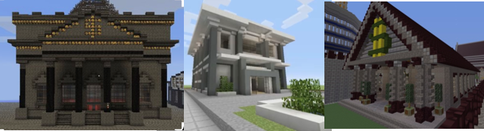
Back to Minecraft

