Floor Piano
Using the Makey Makey and Scratch, we are able to create our very own Floor Piano and combine the wonders of tech and coding in a way that allows us to have fun and get physical.
To create your very own floor piano, follow the links below that provide you with all of the information you will need to get started:
- How to - Floor Piano set up
- Scratch coding for Makey Makey floor piano

As you can see in the image below, the Programming team in the Isaac Region created our very own floor piano. This was an easy to follow project and required only a small amount of materials, as discussed in the 'How to - Floor Piano set up' link above. We enjoyed creating the piano but the real fun started when we connected the Makey Makey to the Scratch Program and began making sweet sweet music!
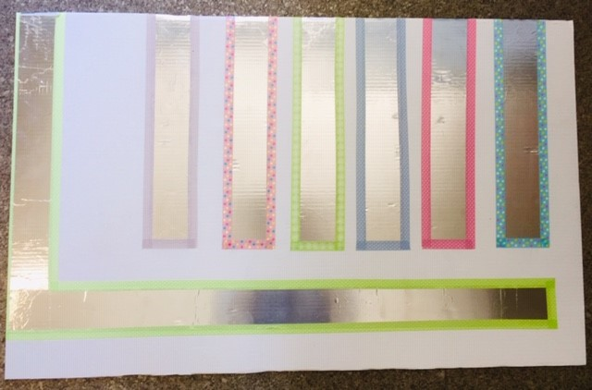
Back to Makey Makey page

