MAKEY MAKEY
This great tech resource works alongside Scratch and is perfect to use with Scratch Program's that you have created yourself, as well as with pre-existing Scratch Program's found on the website.

Resources
These resources provide you with information on the set up of your Makey Makey as well as give you some great ideas on the sort of amazing things that can be created using this tech. The sky is the limit!
- First time set up
- Existing Scratch program's using Makey Makey
- Makey Makey Programming Ideas
- Floor Piano

Tips
- The Makey Makey's are perfect for those people who may be new to coding and not yet have the confidence to create a program from beginning to end. This resource can be creative and fun for all ages despite whether or not the coding is developed by you personally or if you piggy back off of another Scratch program written by someone else.
- In order for the Makey Makey to work you must always be connected to earth in some way. It is easiest doing this with either your barefoot or hand but a connection can also be established if you are wearing socks. You can even be connected to earth by holding someone else's hand while they are touching it.
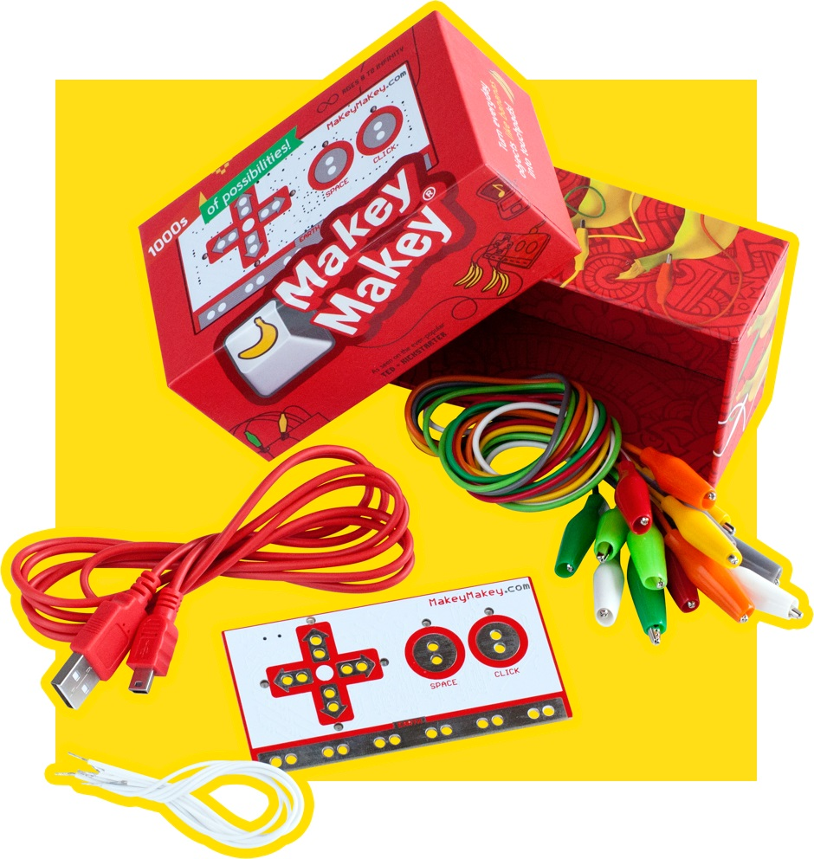
~~HERO-IMAGE ~~
Back to Scratch

