STAFF CORNER

Staff Resources
- Online information on the Lego League: https://firstaustralia.org/programs/first-lego-league/
- Lego Robotics Newsletter
- Expectations on Parents and Participants
- Example Email to Mentors

2019 Staff Training
Library staff members received training on the 20th of February. What follows is an overview of discussion topics and material.
Have a look at the First Lego League Webinar on EV3 and Mindstorms. Feel free to utilize the videos for session preparation as well as throughout your sessions.
IMPORTANT: ENSURE THAT THE BATTERY OF YOUR EV3 IS FULLY CHARGED AT THE START OF EACH SESSION, AS THE BATTERY VOLTAGE WILL CHANGE THE CHARACTERISTICS OF THE MOTOR.
Control Panel
In the Lego Mindstorms EV3 software you will find a control panel divided into three sections.
HINT: While your EV3 is connected to the computer, it won't turn off.
Files:
- Conection Tab
- Settings Tab
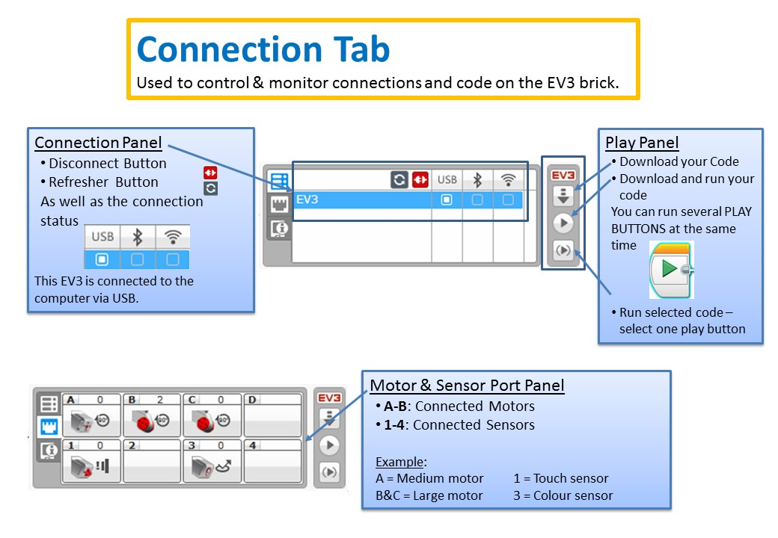
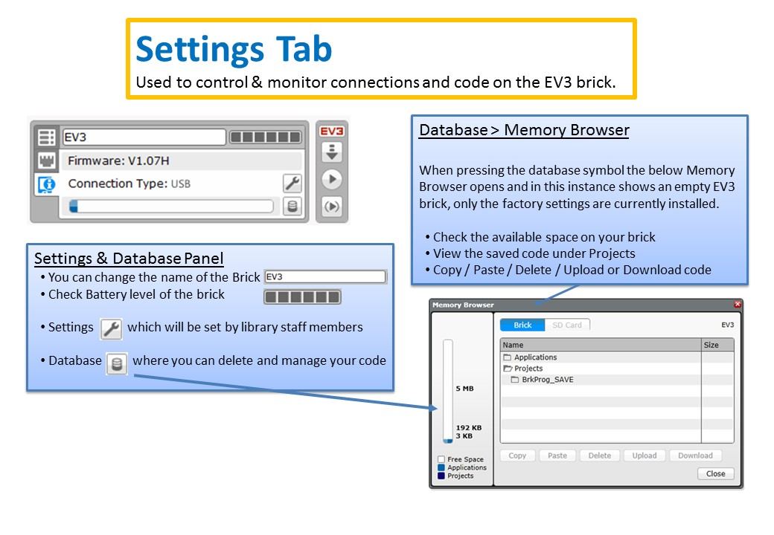
Naming Conventions and Folder Structure
File: Control Panel
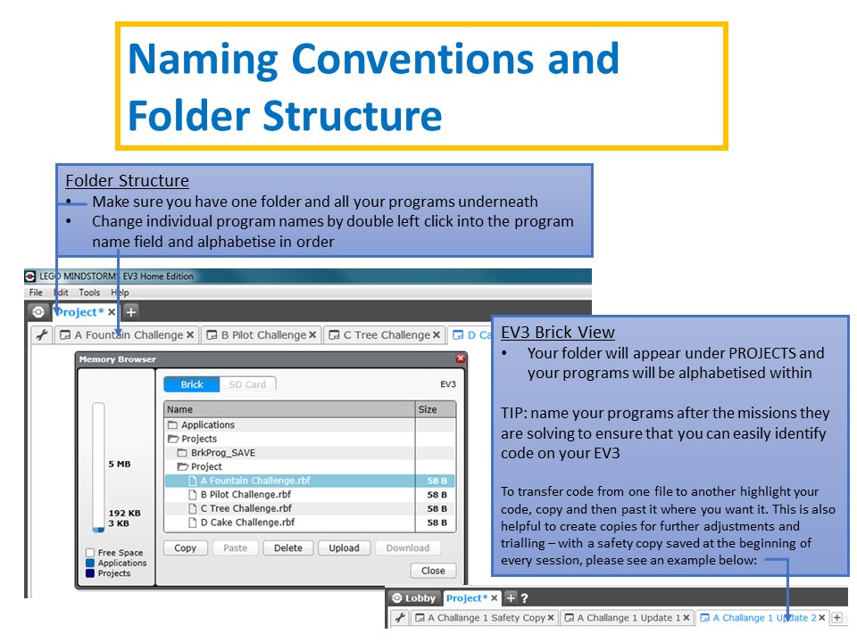
Lego Robotics Mat
- Set-up & Pack-up
  - Create a tub where each challenge piece has it's place and a picture of the correct pack-up is taped to the bottom and top of the tub.
  - Make sure each team member has a role to play in the set-up of the table.
  - Ensure that the table set up is clear to all team members and a printed copy of the correct table set up is available at all times.
- Lining up the robot
  - The lining up of the robot is one of the most crucial tasks when tackling a Lego robotics challenge, choose therefore one or two points on the mat as the designated start point.
  - Ensure that all team members know the designated start points and use them for their code
  - The challenge mat cannot be altered to show starting points but you can use Lego in the base to make it easier for the team.
  - Challenge mats will be cut at the beginning of the 10 week program so do not use the back of the table as an indicator, depending on the table you use during the Tech Fest those line ups will not work.
Session Management
Time Management
Throughout the ten week program each library will hold one two hour session each week and if possible two further four hour sessions closer to the Tech Fest for concentrated work on individual challenge tasks.
It is important that the structure outlined in the 10 week overview is followed as closely as possible to ensure that all teams have the same chance at completing as many challenges as possible. Keep in mind that we try for 4 - 5 challenges for the Tech Fest, otherwise you might not be able to run all challenges you have solved within the 2.5 minutes allocated.
Break your sessions up into workstations and rotate team members as needed. In the 10 week overview you will see that each session is at least broken into two parts or workstations to allow for a change.
Behavior Management
Ensure that your team takes breaks. If your team members are fatigued they will not be able to perform or behave. This can be anything from a 10 minute snack time to a 30 minute outdoor break, depending on the length of your session.
Behavior management plays an important part and is the responsibility of the library staff and parent. Follow library policies and your own common sense when calling your team member to order. Below two approaches that worked well last year in Moranbah.
Timeout Cards:
- the Timeout Card is given to participants who do not follow the core values and thereby disrespect either the library space, resources, staff, mentors or team members
- The parent and participant will use that time to review the core values and team member responsibilities
- cb_ev3_timeout-card.pptx
Leadership Points:
- One Leadership point is awarded by each mentor each session for exceptional demonstration of core values and teamwork
- The library staff keeps a running tally of the leadership points
- The team member with the most leadership points will run the EV3 on the competition day
- The next runner up can have also an equally important task and so on
Leadership Points are to reward behavior and to encourage the participants to review the core values regularly.
Teamwork
Establish little working groups that can be swapped regularly to encourage your team members to help and work with each other. Follow the core values and establish an atmosphere where the team members first consult with each other on a problem before asking an adult. Also make sure that problems are tackled and resolved as a team and not as an answer from an adult.
Tech Fest Preparation
- Ensure that you are starting with the run-through as outlined in the 10 week overview, these are crucial to ensure that the team understands what will happen on the Tech Fest day and can prepare.
- Clean the code with your team and take your teams code with you to the Tech Fest to ensure nothing is missing.
- Charge your EV3, the EV3 runs slower when the battery is nearly empty.
- Make sure everyone is clear about their role on the day and has prepared their team/individual introduction
Motor or Action Blocks
Files:
- Large Motor Block
- Medium Motor Block
- Tank Motor Block
- Steering Motor Block
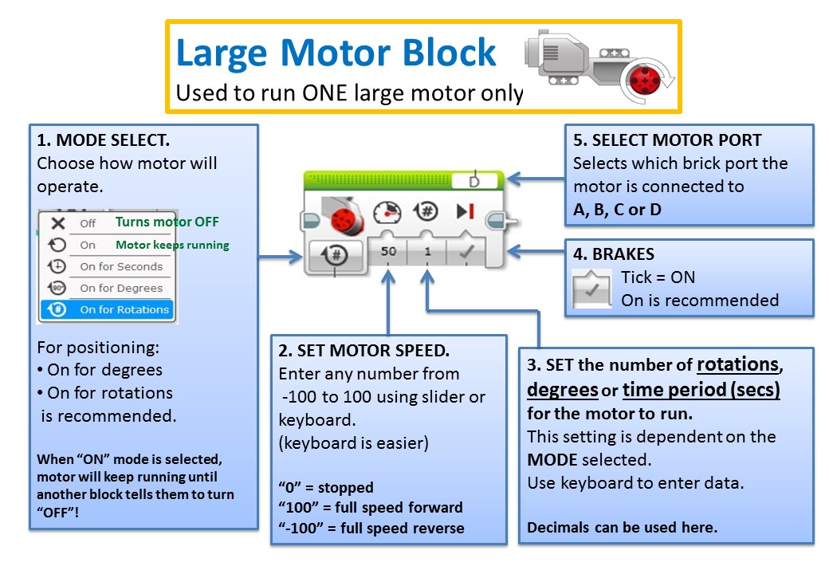
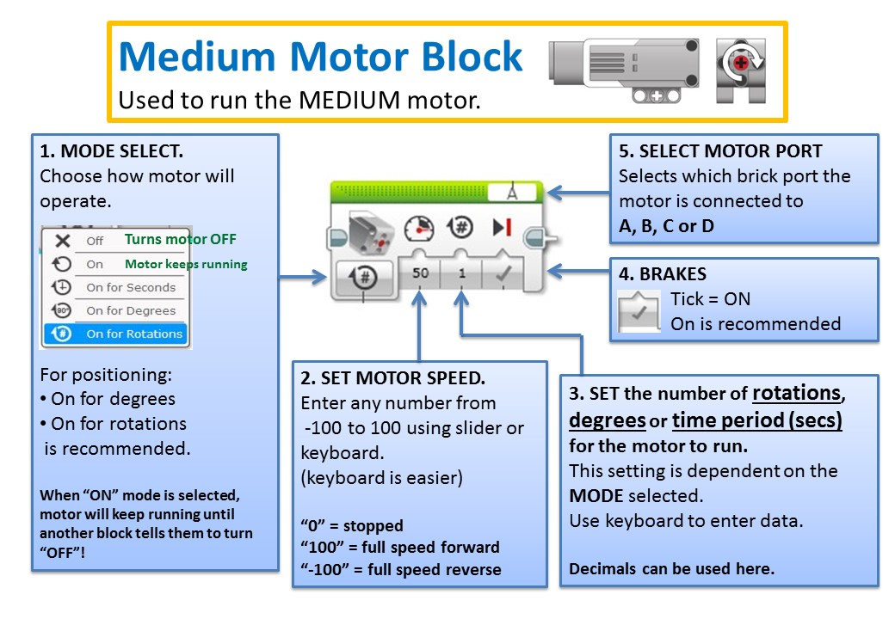
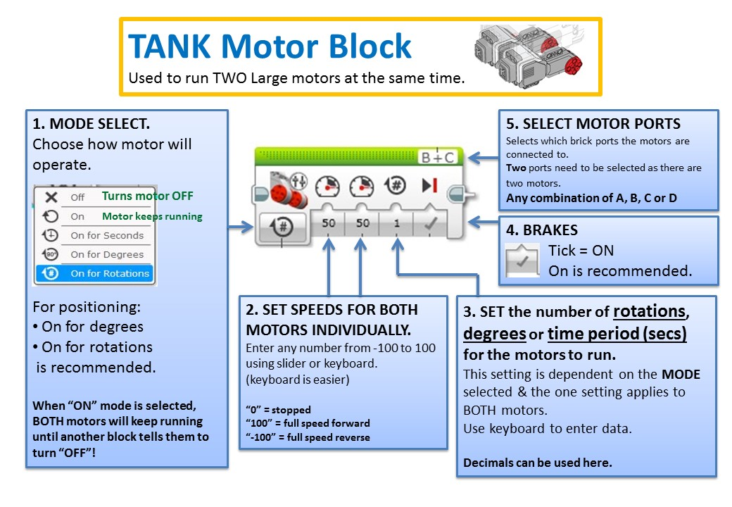
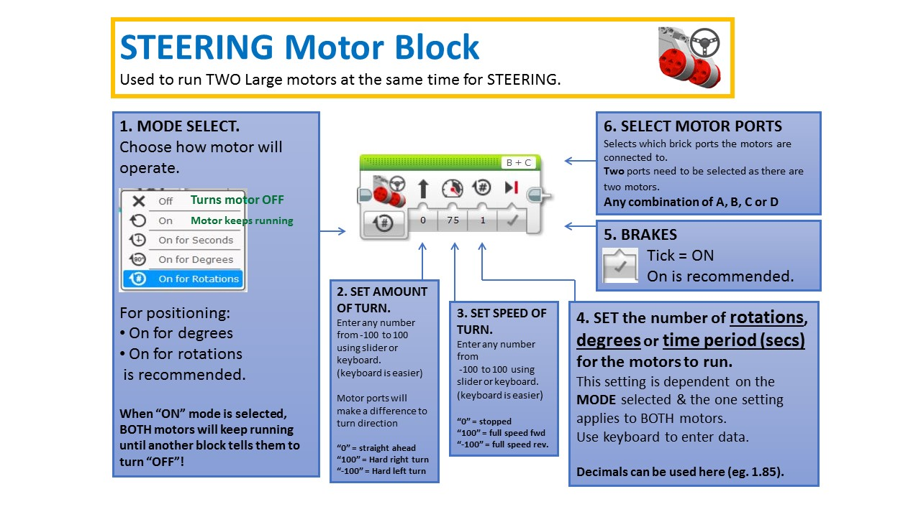
Motor Blocks Handy Hints
- ALWAYS ensure the battery is fully charged. Battery state WILL affect motor speed & power.
- ALWAYS ensure that the large motors have their gears “preloaded” to ensure “backlash” doesn’t cause the robot to skew on start up.
- Consider adding a small delay at the start of sequence (code, program, etc) to allow the robot operator to get their hand clear after pressing the “go” button.
- Moving slowly when completing a challenge will enhance accuracy. Once task is completed, return to base as fast as possible. Accuracy isn’t required for return.
- When using forks or other attachments, use code to “settle” the attachment on the ground before raising to required position. This will improve the “repeatability” of the action.
- Consider “gearing” the medium motor to increase torque & accuracy.
- ALWAYS ensure the battery is fully charged. Battery state WILL affect motor speed & power.
- ALWAYS ensure the battery is fully charged. Battery state WILL affect motor speed & power.
Flow Control/Sensor Blocks
- Start Block
- Wait Block:
  - Time Delay Block
  - Colour Sensor Block
  - Ultrasonic Sensor Block
  - Touch Sensor Block
- Single Loop Block
- Double Loop Block
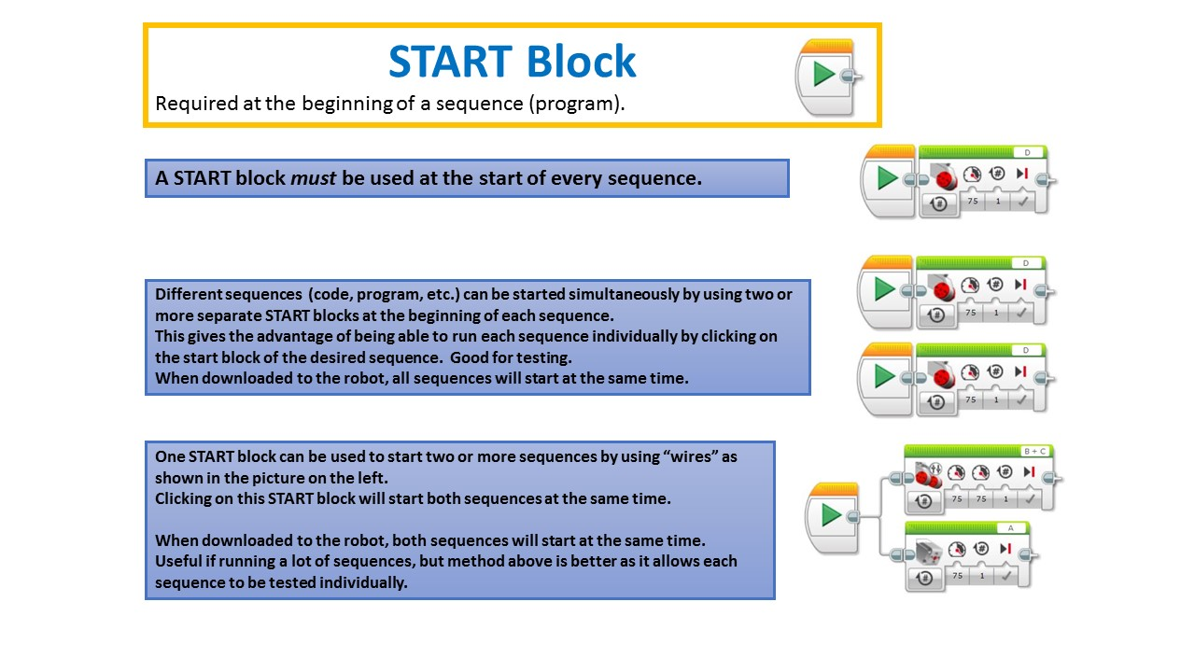
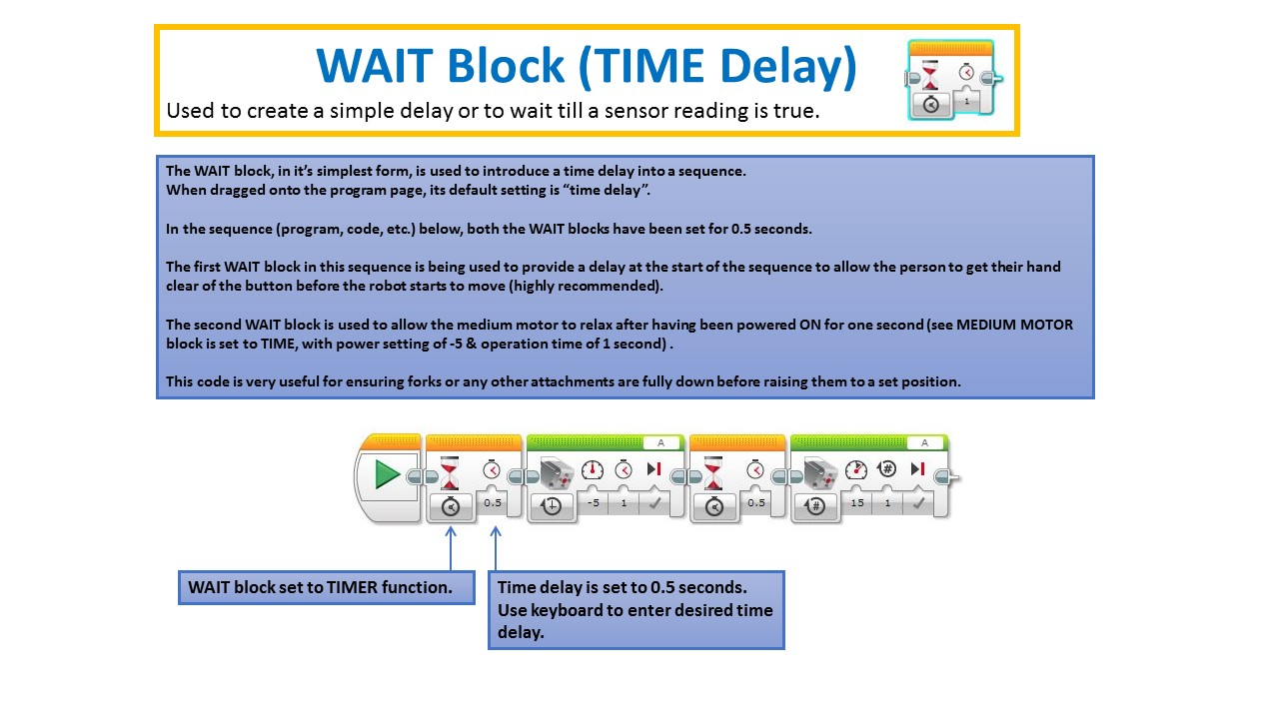
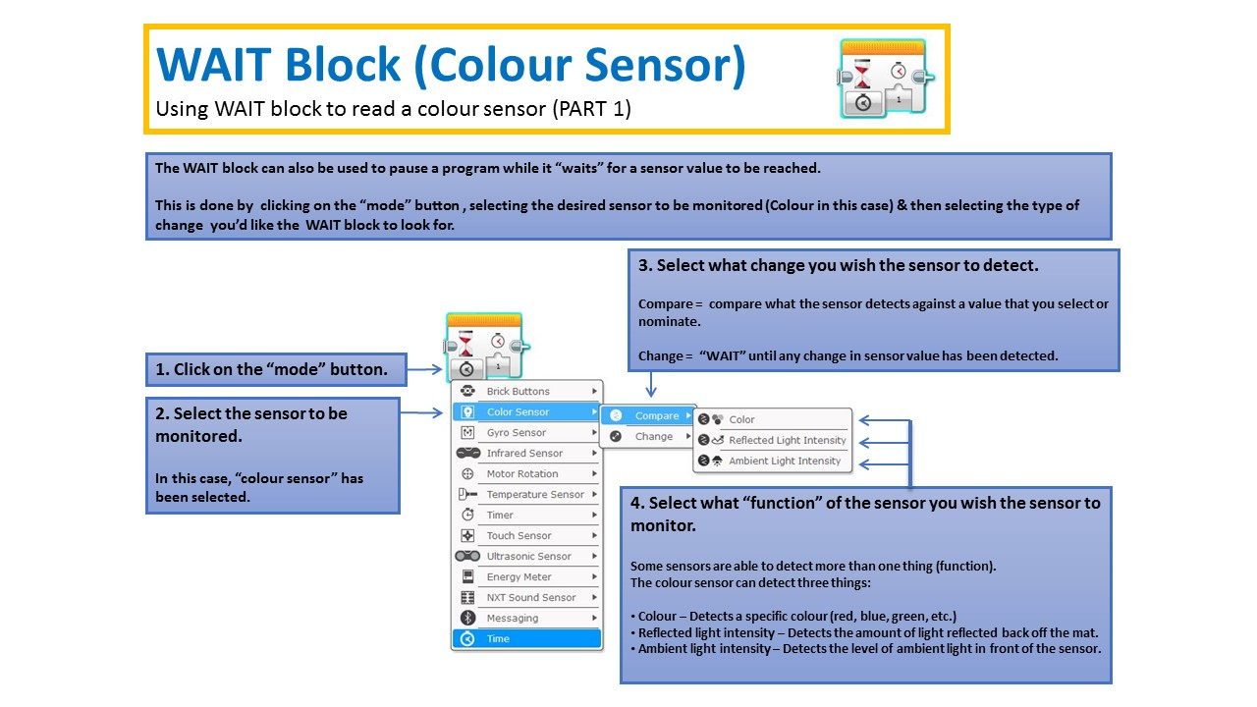
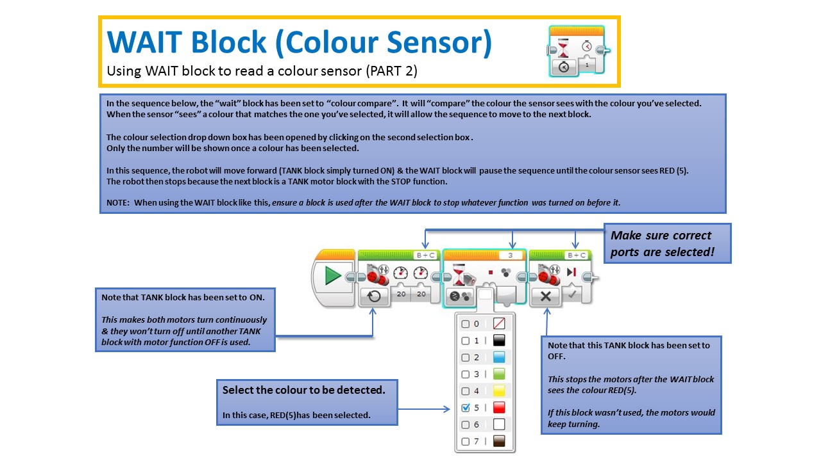
Colour Sensor Handy Hints
- Check sensor ports are correct by using the “PORT VIEW” in Mindstorms. This information will only be available or be updated when the robot is plugged into the computer.
- When the robot is connected to the computer, the “PORT VIEW” will show what the sensor is reading. This is handy to determine what colour the sensor is “seeing”.
- No two COLOUR sensors will read exactly the same, so if using two at the same time, be prepared for discrepancies between the two.
- Colour sensors will detect colours on a “picture” or shaded background. This can cause false triggering when travelling over areas that are not distinct colours.

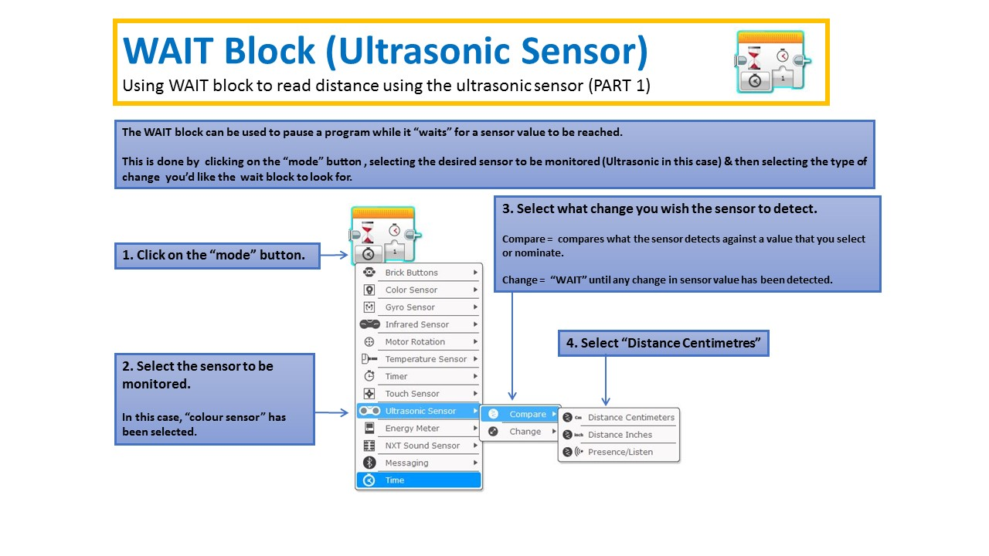
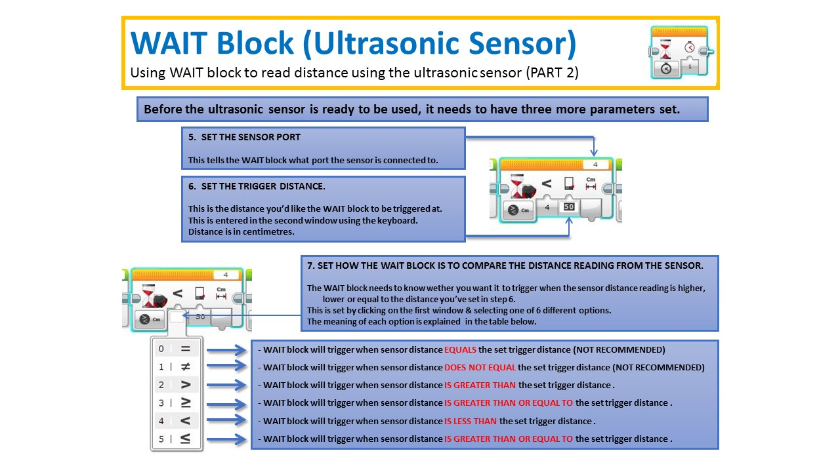
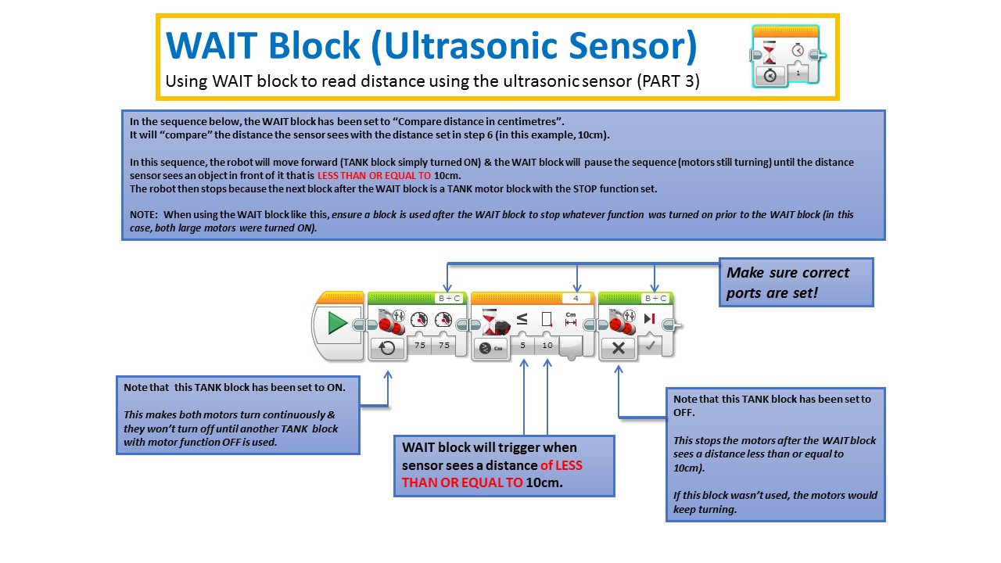
Ultrasonic Sensor Handy Hints
- Check sensor ports are correct by using the “PORT VIEW” in Mindstorms. This information will only be available or be updated when the robot is plugged into the computer.
- When the robot is connected to the computer, the “PORT VIEW” will also show what the sensor is reading. This is handy to determine what distance the sensor is “seeing”.
- The Ultrasonic sensor will struggle to read reliably if the surface in front of it is too small or is sharply angled. This is because the ultrasonic sound wave will bounce off at an angle rather than being reflected back to the sensor.
- Using “greater than or equal to” or “less than or equal to” is highly recommended as it means the wait block will react even if a count of two or more is skipped between sensor readings.
- When using the ultrasonic sensor, moving the robot slowly will result in better accuracy.
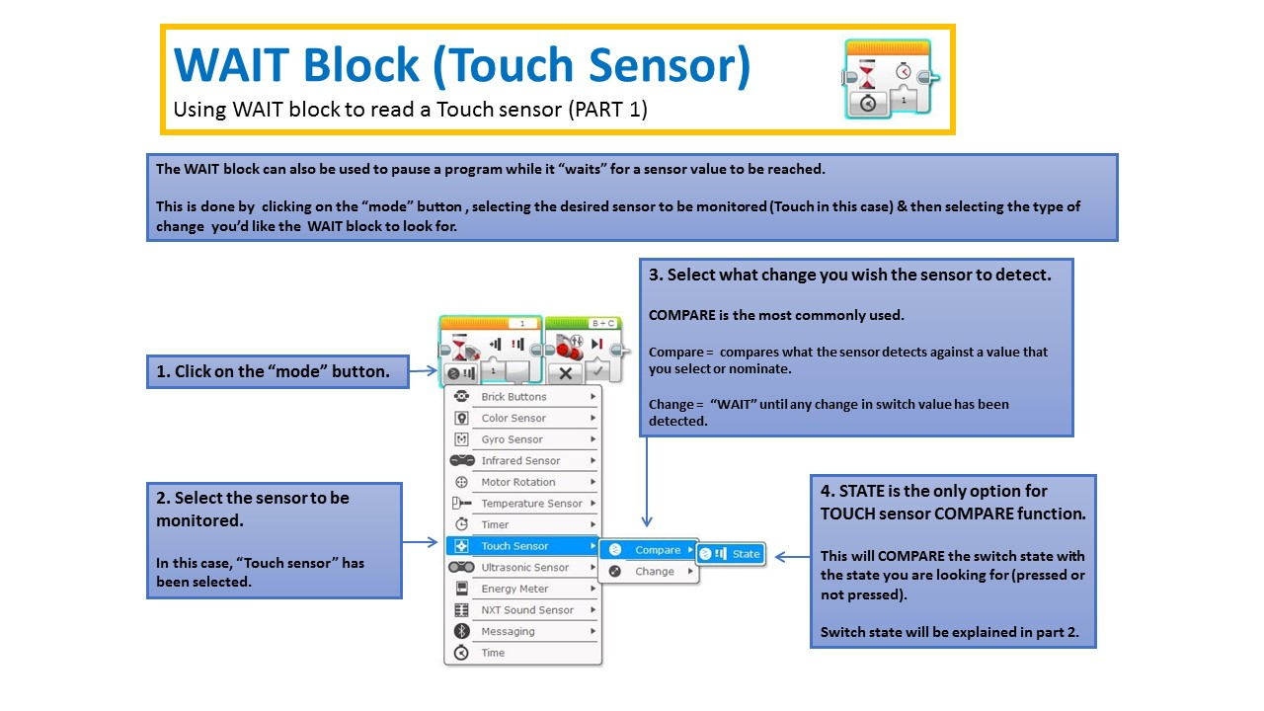
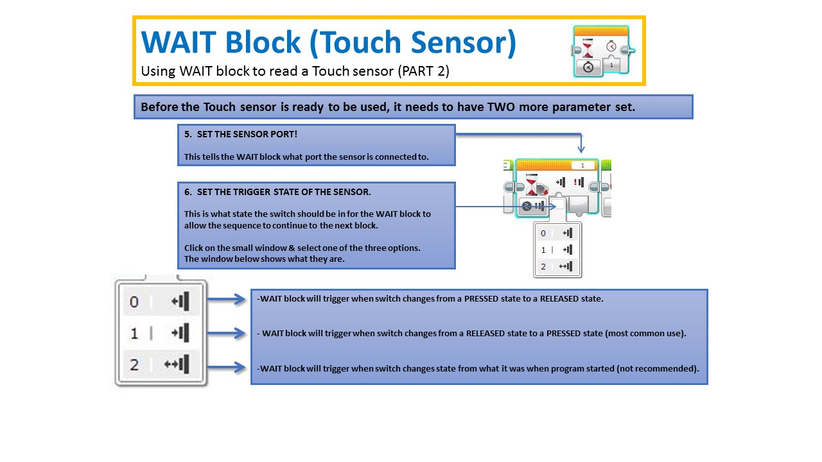
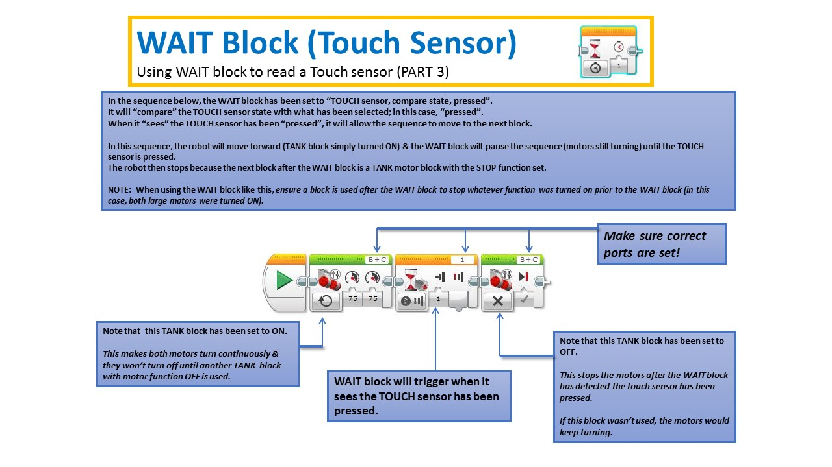
Touch Sensor Handy Hints
- Check sensor ports are correct by using the “PORT VIEW” in Mindstorms. This information will only be available or be updated when the robot is plugged into the computer.
- When the robot is connected to the computer, the “PORT VIEW” will also show what the sensor is reading. This is handy to determine what state the sensor is in (pressed or released).
- The TOUCH sensors do require some pressure to activate. Make sure the frame being used to hold the sensor is sturdy enough to not “flex” when pressure is applied. Too much flex will provide unreliable actuation of the sensor.
- Because pressure needs to be applied to activate the sensor, ensure that the robot can apply enough pressure without spinning the wheels or being “skewed” off at an angle.
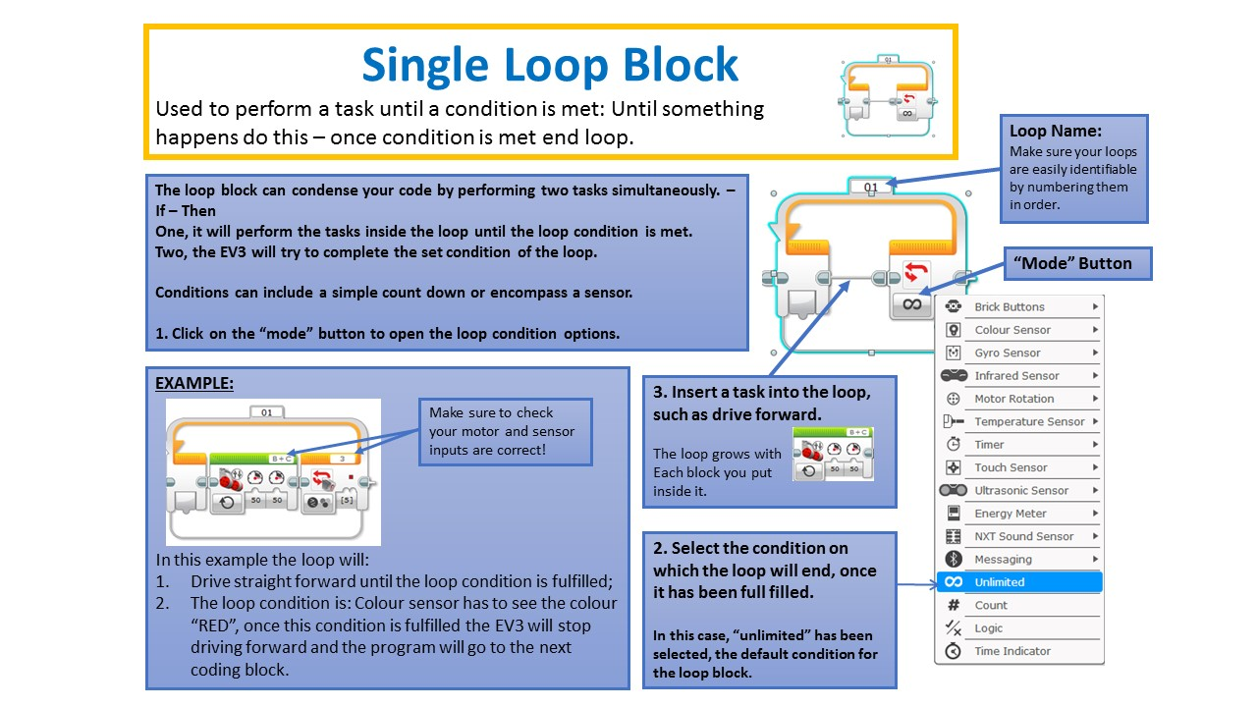
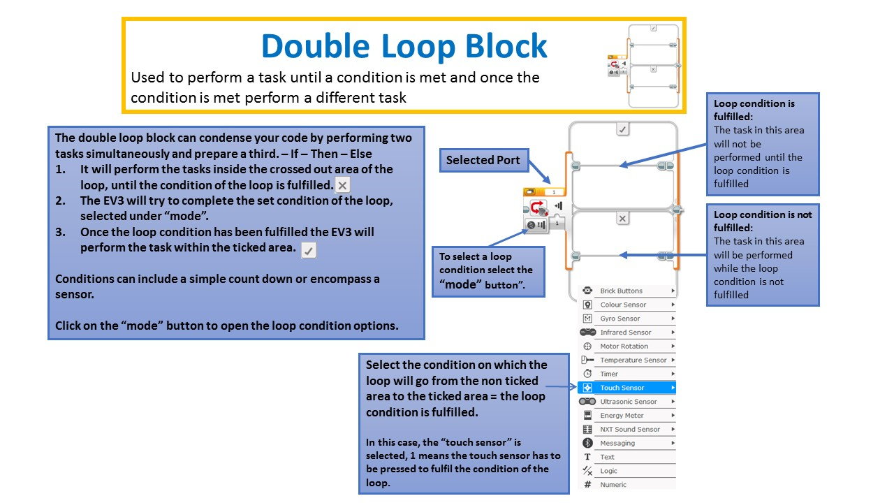
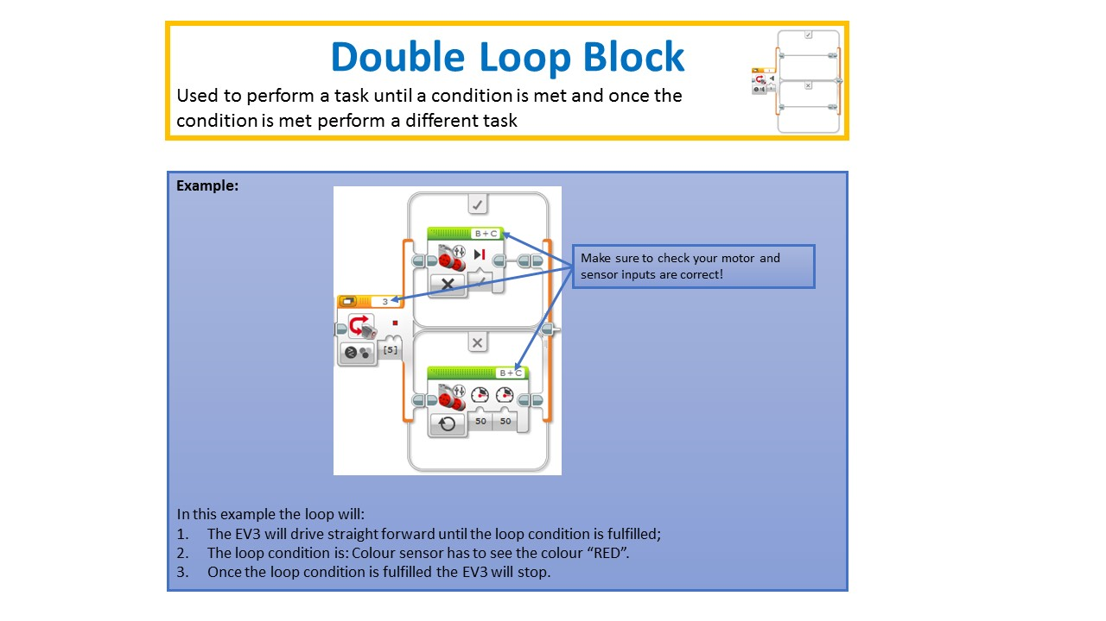

Mentor Training
The following will be discussed during the mentor training.
- Naming conventions and folder structure
- Introduction to the coding blocks by the cheat sheets - with robot
  - Coding with the cheat sheets and a EV3 robot
  - Play Button
  - Motor Blocks
    - Gear train
    - Medium motor gearing
  - Time Delay
    - Setting ground zero for lifting operations
    - Half-second delay after start
  - Touch Sensor
  - Colour Sensor
  - Ultrasonic Sensor
  - Control Panel
  - Loop Blocks
- Connection Panel
  - Connecting Robot
  - Port view
  - Memory & Settings view
  - Don't Press Update on the robot during a session - it will take a very long time.
- How to program the robot - USB only
- Mat
  - Positioning
  - Cutting of the mat
- Homework options (self paced introduction at home)
  - knowing the blocks
  - how to set ports correctly
  - how to read a block
  - first problem solving experience in Mindstorms
- Core Values and how to get the participants to find solutions themselves:
  - Have the team member read the code back to you
  - Have the team member write out what the robot is supposed to achieve

Training Resources
- Mentor Training Print Out
- Challenge guide with point system
- Field set up guide
- Core Values
- 10 Week Program
- Score Sheet
- Challenge Updates
- Robot Game
- Rotations Overview
Back to Lego Robotics

