HERE LIES THE ENTRY FOR AN IMAGINED THING
This is a thing imagined by Michelle, aged 10, on Friday December 3
The full name of this thing is: CatBeast
It can be found in: In a galaxy far far away
It is known that: It is very fluffy and shiny
This thing has three important features: crystals, sparkles, and soft fur

An image of CatBeast can be found here:
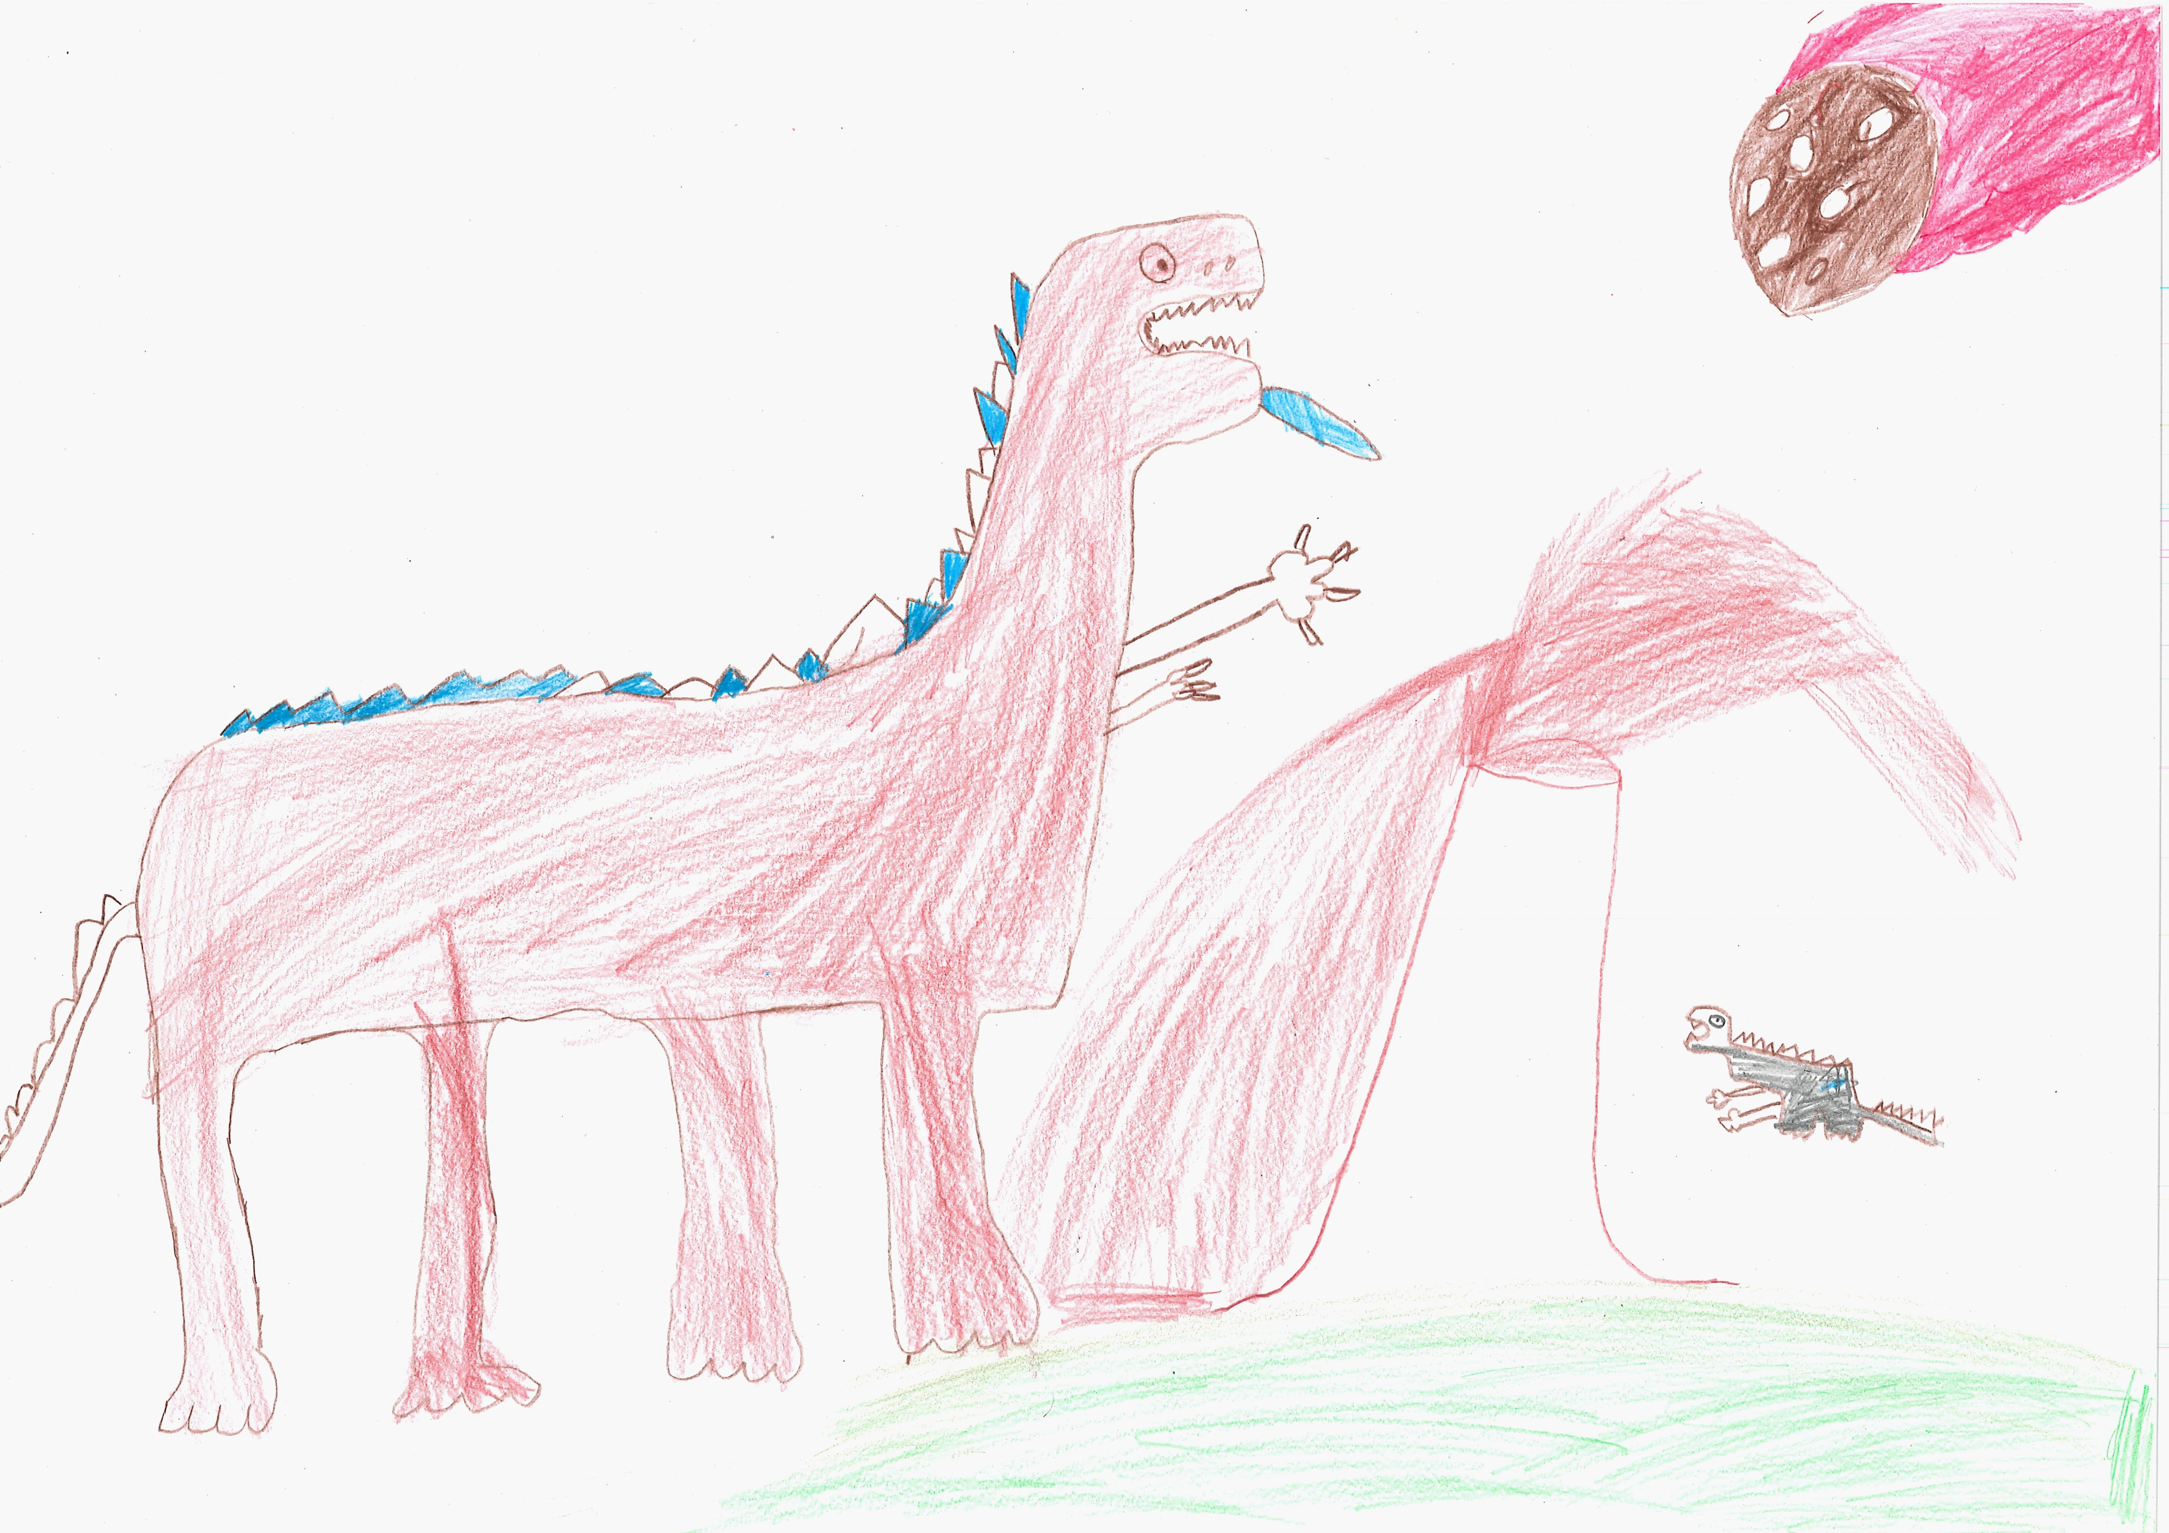400

A recording CatBeast can be found here:
upload_your_audio_file400

This is the unique QR code for this Imagined Thing. Right click it to save then share it, so you and others can find your way back to here to this point of The Well.

IT IS KNOWN! HUZZAH FOR THE GREAT & GRAND RUMPUS!

