The Making of the Rumpus
Making of the Great & Grand Rumpus

Overview
So you want to build a magical world of cardboard? The Great & Grand Rumpus is a collaboration of cardboard, creativity and community. It incorporates the ideas of children remixed into designs and made 'things' by community.
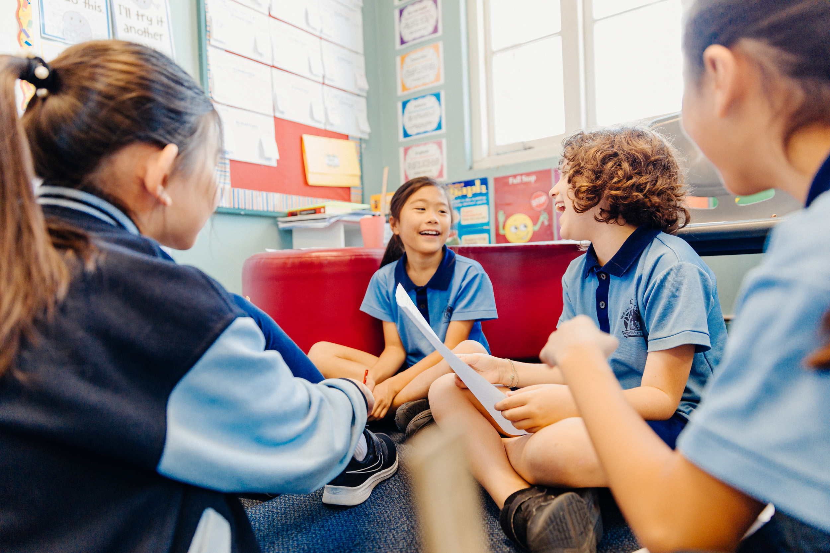
The key idea is these ideas are submitted into a collection titled 'The Well', where community can select and create from. It demonstrates the imagination of children and adults alike, the importance of wonder, creative thinking and applied creative and technical skills and how playing with the box is sometimes more fun than what was inside.
This framework provides you with a base structure to create your own adventure, which is intended to be adaptable to your needs, your opportunities and limitations. We encourage you to share you own process through this Wiki, to ask questions, share and enjoy.
If you decide to create, make sure you are having fun.

Objectives
The objectives are up to you. However, through this process of engagement, the program will enable:
- Experimentation with ideas
- Problem solving, knowledge building, and skills development
- Cultural participation, creation and self-expression
- Social interaction and collaboration across generations
- Engaging with story and making activities that inspire a love of words and creation.
- Community led fabrication
- Access to creative resources, collections and digital technologies
- Showcase the work that children, young people and community users are creating through programs
- Documented process of community engagement that can be used by public libraries.
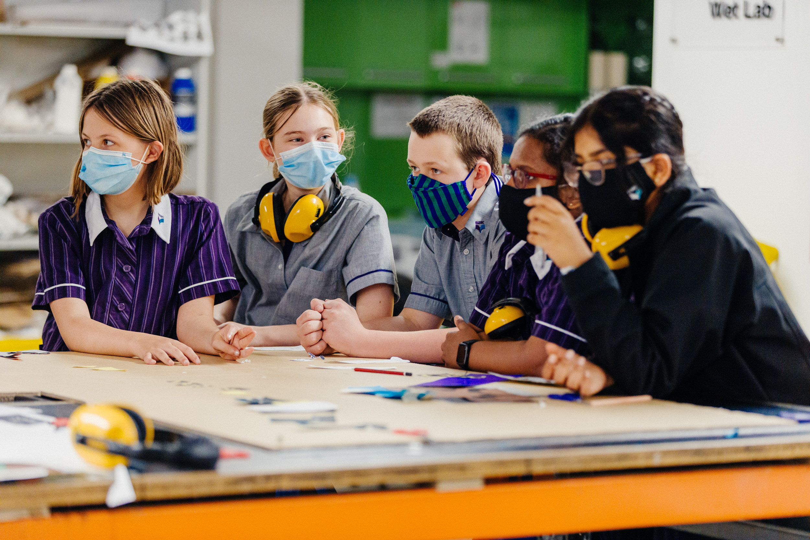
For your own objectives, to help you consider what these may be, think about what you would like to achieve, what is the value to community, skills you want to cultivate, what technology is available to you, how many groups or numbers of people you would like to involved.
For example, you may be seeking to collect 100 Imagined Things, create 20 Designed Things, and actually make 3 Made Things. You may want to spend time developing your imaginary concept, so perhaps you end up with far more Designed Things than Imagined.
If you want to focus on cultivating design skills, for example, this could be a good way at looking at various ways of prototyping.

Deliverables
The intention is that you will complete with:
- a catalogue of Imagined Things
- a collection of Designed Things
- a collection of Made Things
Imagined Things are a catalogue of ideas collected from children. These may be drawings, audio recordings, or any form that you can capture.
Designed Things are designs in format suited and/or selected by community. This may be in the form of 2D drawings, hand sketching, model making or maquettes, digital concepts using Photoshop, dioramas and more.
Made Things are intended to be sculptures made out of cardboard. They can be as large or as small as you like, but we think the bigger, the better! You may want to complement your Made Things with digital projections, lighting and augmented reality, such as Snapchat lenses.

Budget
Again, this is variable. Consider the price of cardboard, glue, glue guns, LED lighting strips, straws and dough, paper, colouring in pencils, human time to create. You may also need to consider how you will access design software, and if you will be using any other media to create your experience.
When completing The Great & Grand Rumpus in 2021, the price of cardboard and hot glue rose, so the price of materials can also change throughout production and is worth considering.
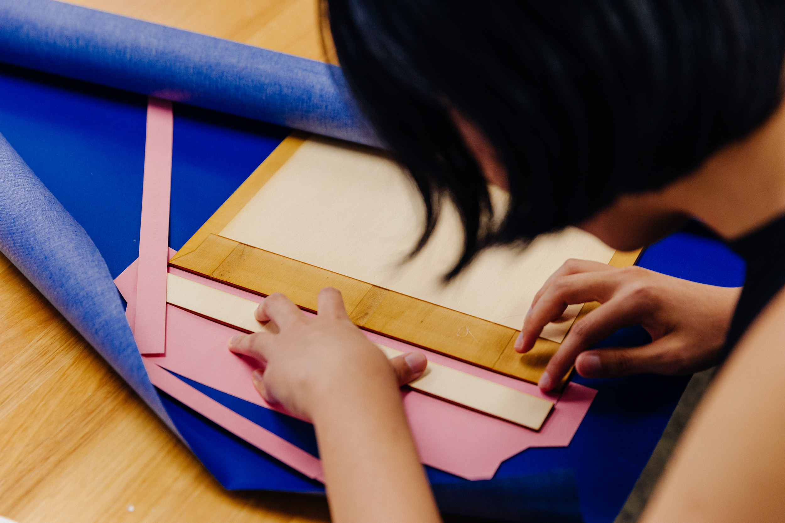

Timeline
These stages may happen concurrently, and you can manage their timeline using a GANTT chart, or technology to assist you with this.
The Great & Grand Rumpus has broken down into ideation (through Well capturing sessions), design-prototyping and final fabrication. This was different for each sculpture. Depending on the size, materials and quantity of sculptures, you may need to factor in more or less time.

Community Engagement Profile

Staff
Investigate staff skills to contribute to the project. These may skills outside of their usual job, and hobbies, interests that could create embellishments to the project. For example, The Great & Grand Rumpus features a series of books, handmade by community and housing The Well ideas. This concept was introduced by a staff member who had made their own handbound and laser cut book.

Students
Students may be willing to contribute their skills, through creative thinking, applied creative disciplines, engineering, fabrication, design and more. Alongside, Educators and Teachers may be willing to contribute, or collaborate through engaging their classroom, or through university with unit/coursework. These partnerships are best to be negotiated early and prior to the commencement of their starting terms or semester, with session plans outlined. Sometimes permission forms are required, and these are an additional consideration.

Volunteers / Community
Community can be involved in various stages, and there is opportunity to leverage already established partnerships. You may want to consider running a regular meetup, for example The Great & Grand Rumpus hosted a 'Saturday Arvo Crew'. This was an invitation to an engaged group of Makers, Creatives and Tech-Lovers. Structured workshops are another option, so that less confident people, who are still willing to be involved in creative community have the opportunity to learn and connect.

Audience
If you are planning on exhibiting your final work, it is recommended that you position to an audience. Positioning is a strategy used to establish an image of a product or service in a customer/audience member mind.
For example, The Great & Grand Rumpus is targeted at children and families and the maker-creative community - so there are two audiences. Therefore, positioning will occur in two ways, through different use of language and imagery when communicating to both of these audiences, and when design and making decisions occur.

Workshop Engagements
State Library of Queensland ran many types of workshops to engage with community. This included primary school, high-school and universities. We have included some session plans to demonstrate workshop deliveries.
School and University programs undertaken during the Great & Grand Rumpus session plans.
Brisbane South State Secondary College - 6 week program bsssc_grumpus_workshop_session_plans_all_v.05_211215_6_week_program.pdf
Queensland College of Art - Design Students - Southbank & Gold Coast Campus - 7 week program qca_grumpus_workshop_session_plans_all_v.07_211215_7_week_program.pdf
Queensland University of Technology - Creative Industries Students - Kelvin Grove Campus - 10 week program qut_grumpus_workshop_session_plans_all_v.03_211215_10_week_program.pdf

