Spirits of the Rumpus Wild
This is how the Spirits of the Grumpus came to life!
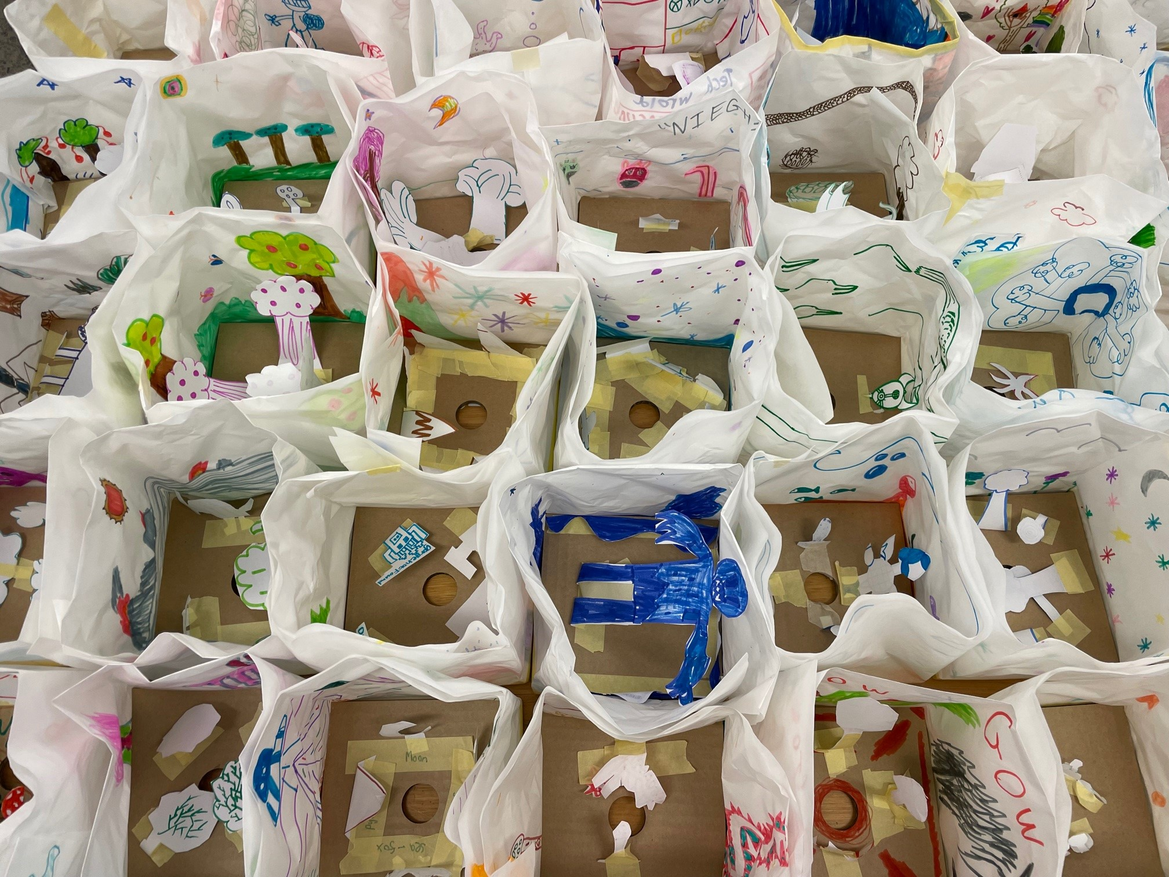
Spirits of the Rumpus Wild are small paper based sculptures inspired by stories and items drawn from The Well. Focused on light, shadow and shadow play, the sculptures are internally illuminated and installed alongside the collaborative large sculptures as a field of floating, glowing sculptures in the gallery space. Each sculpture comprises of three parts, a lantern, lighting components and stand/base.
Over 200 lanterns where hand drawn and put together by primary school children.
The lanterns were then mounted and fitted with LED lighting components designed by Edge volunteers and staff, specifically using the lighting boards designed by Byron Crowe;
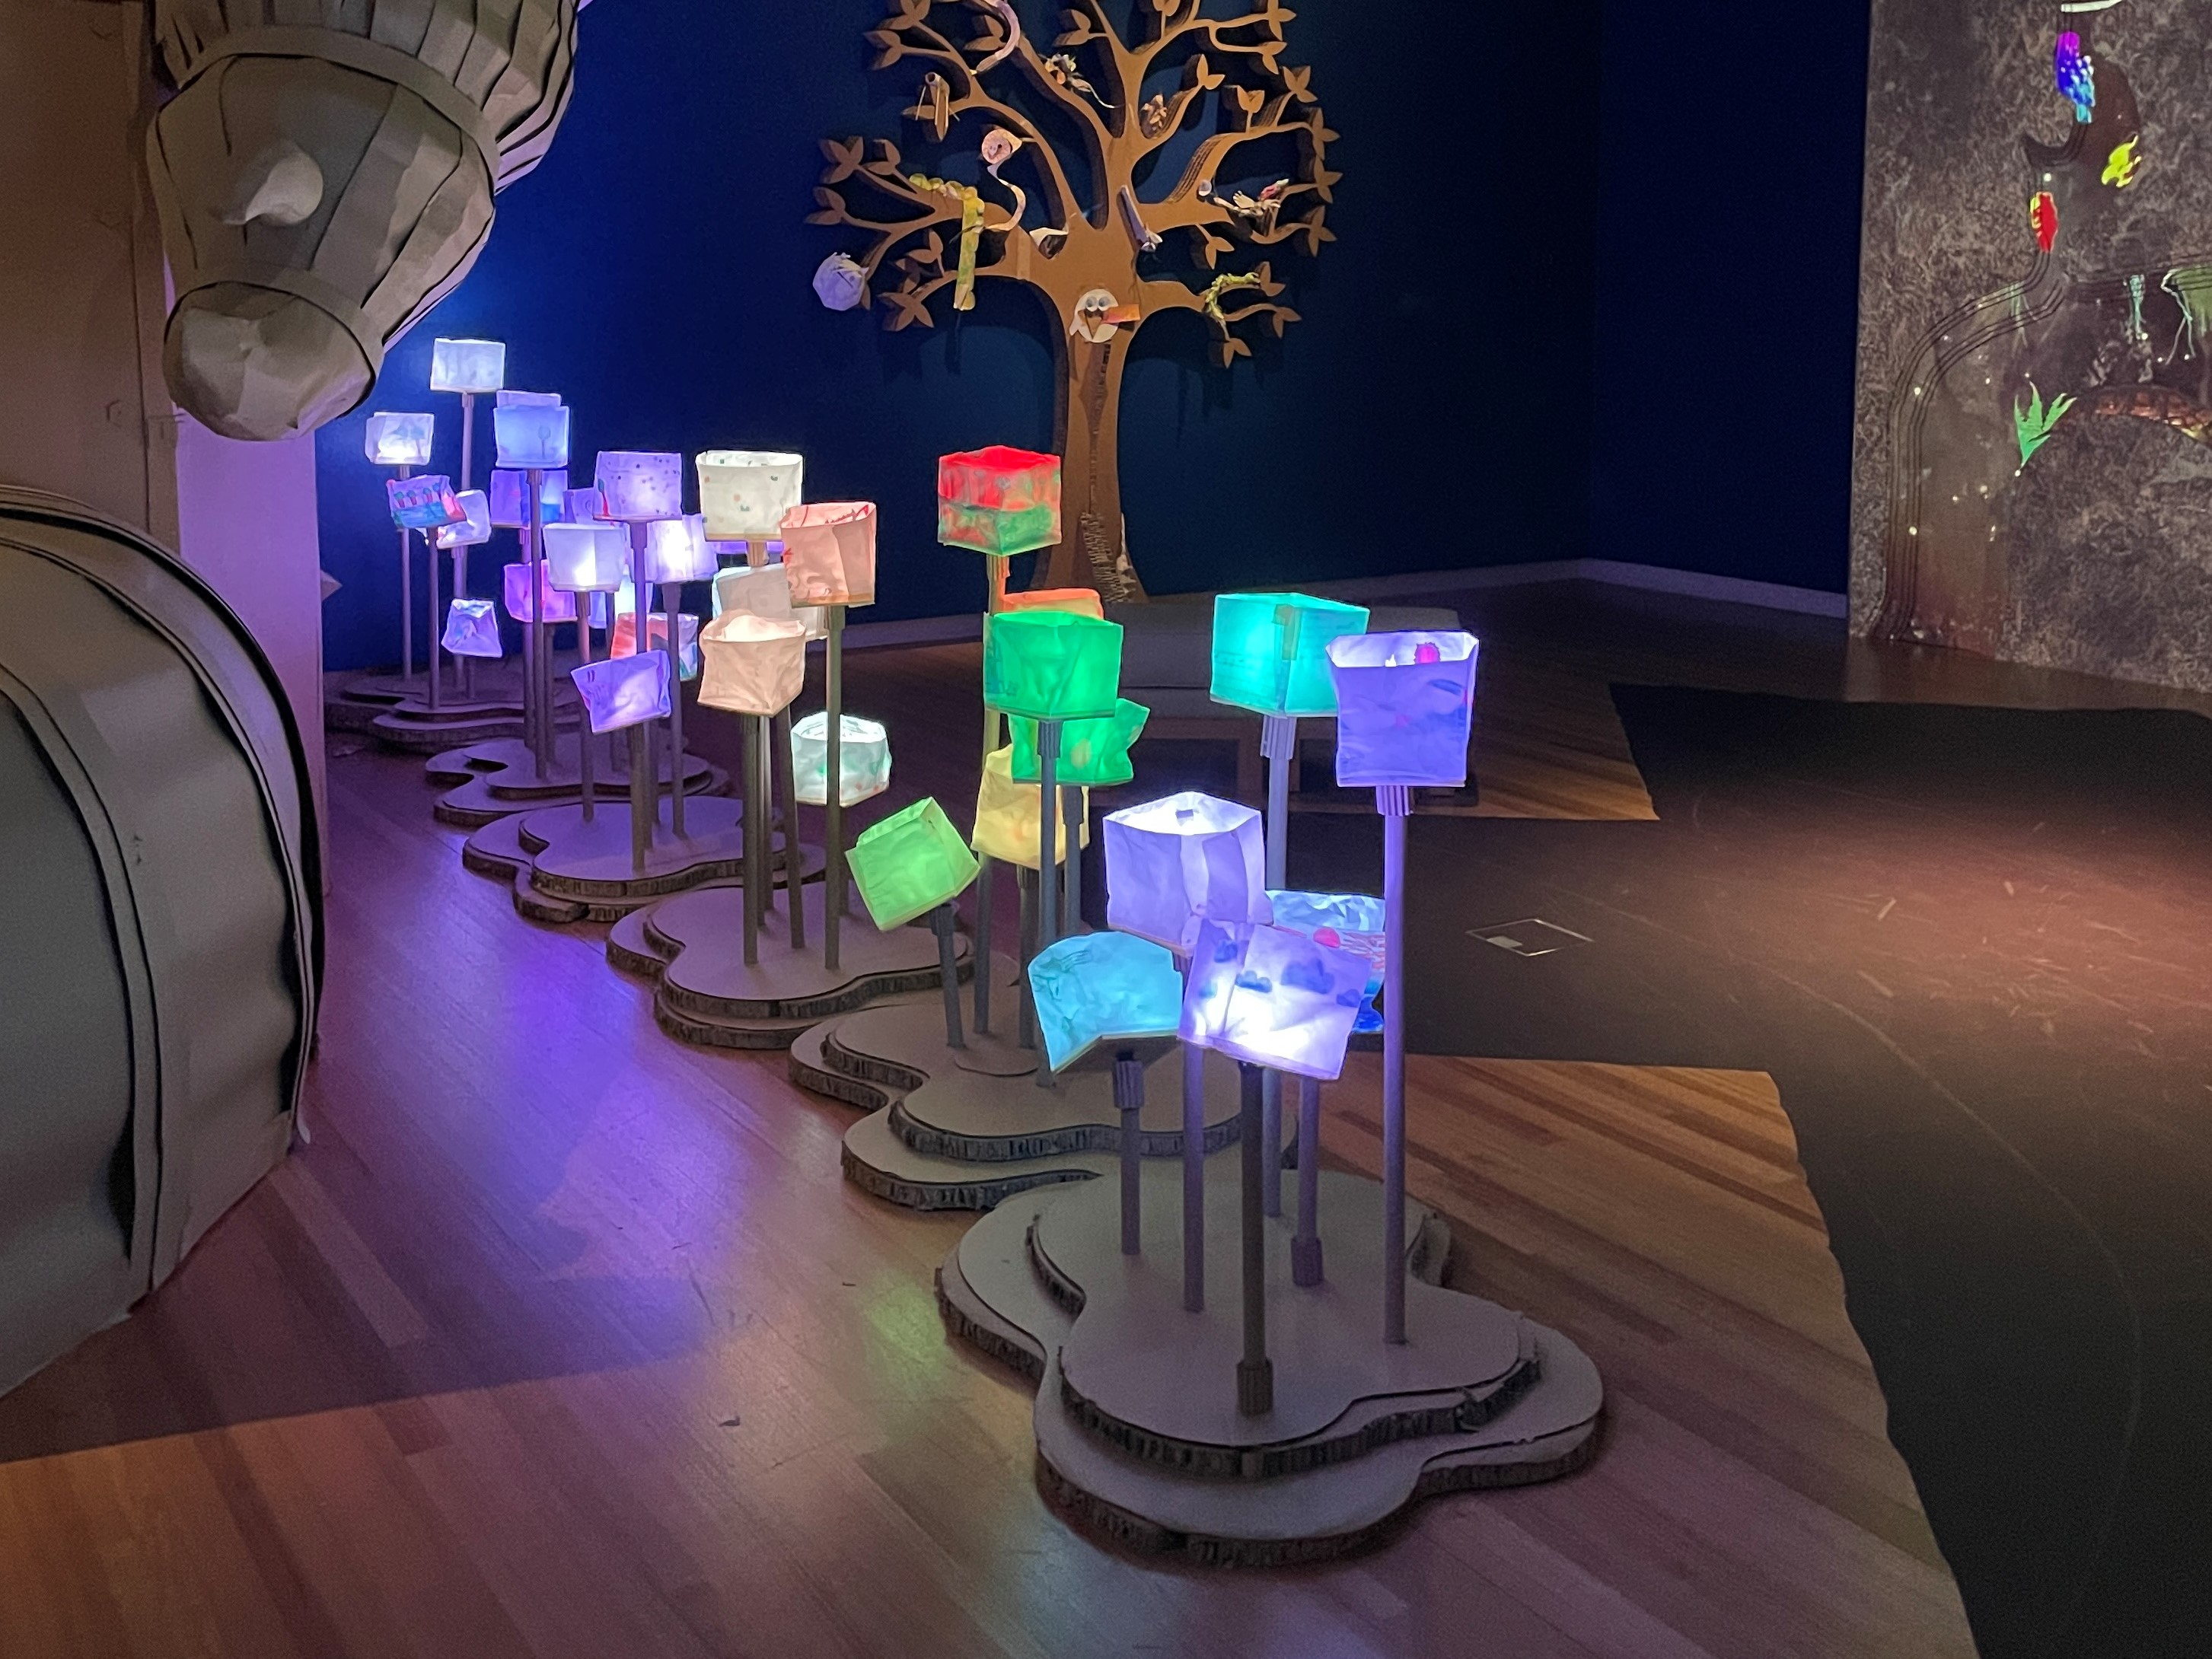
Addressable Scalable LED lighting Platform
Grumpus Lighting Components

