No Name Rocu
This is the story of how the No Name Rocu came to life!

No Name Rocu
No Name Rocu was inspired by two Imagined Things from The Well, No Name and Rocu!
No name is a thing imagined by Andrew, aged 12 years, on Thursday July 8
The full name of this thing is: No name
It can be found in: Swedish wilderness
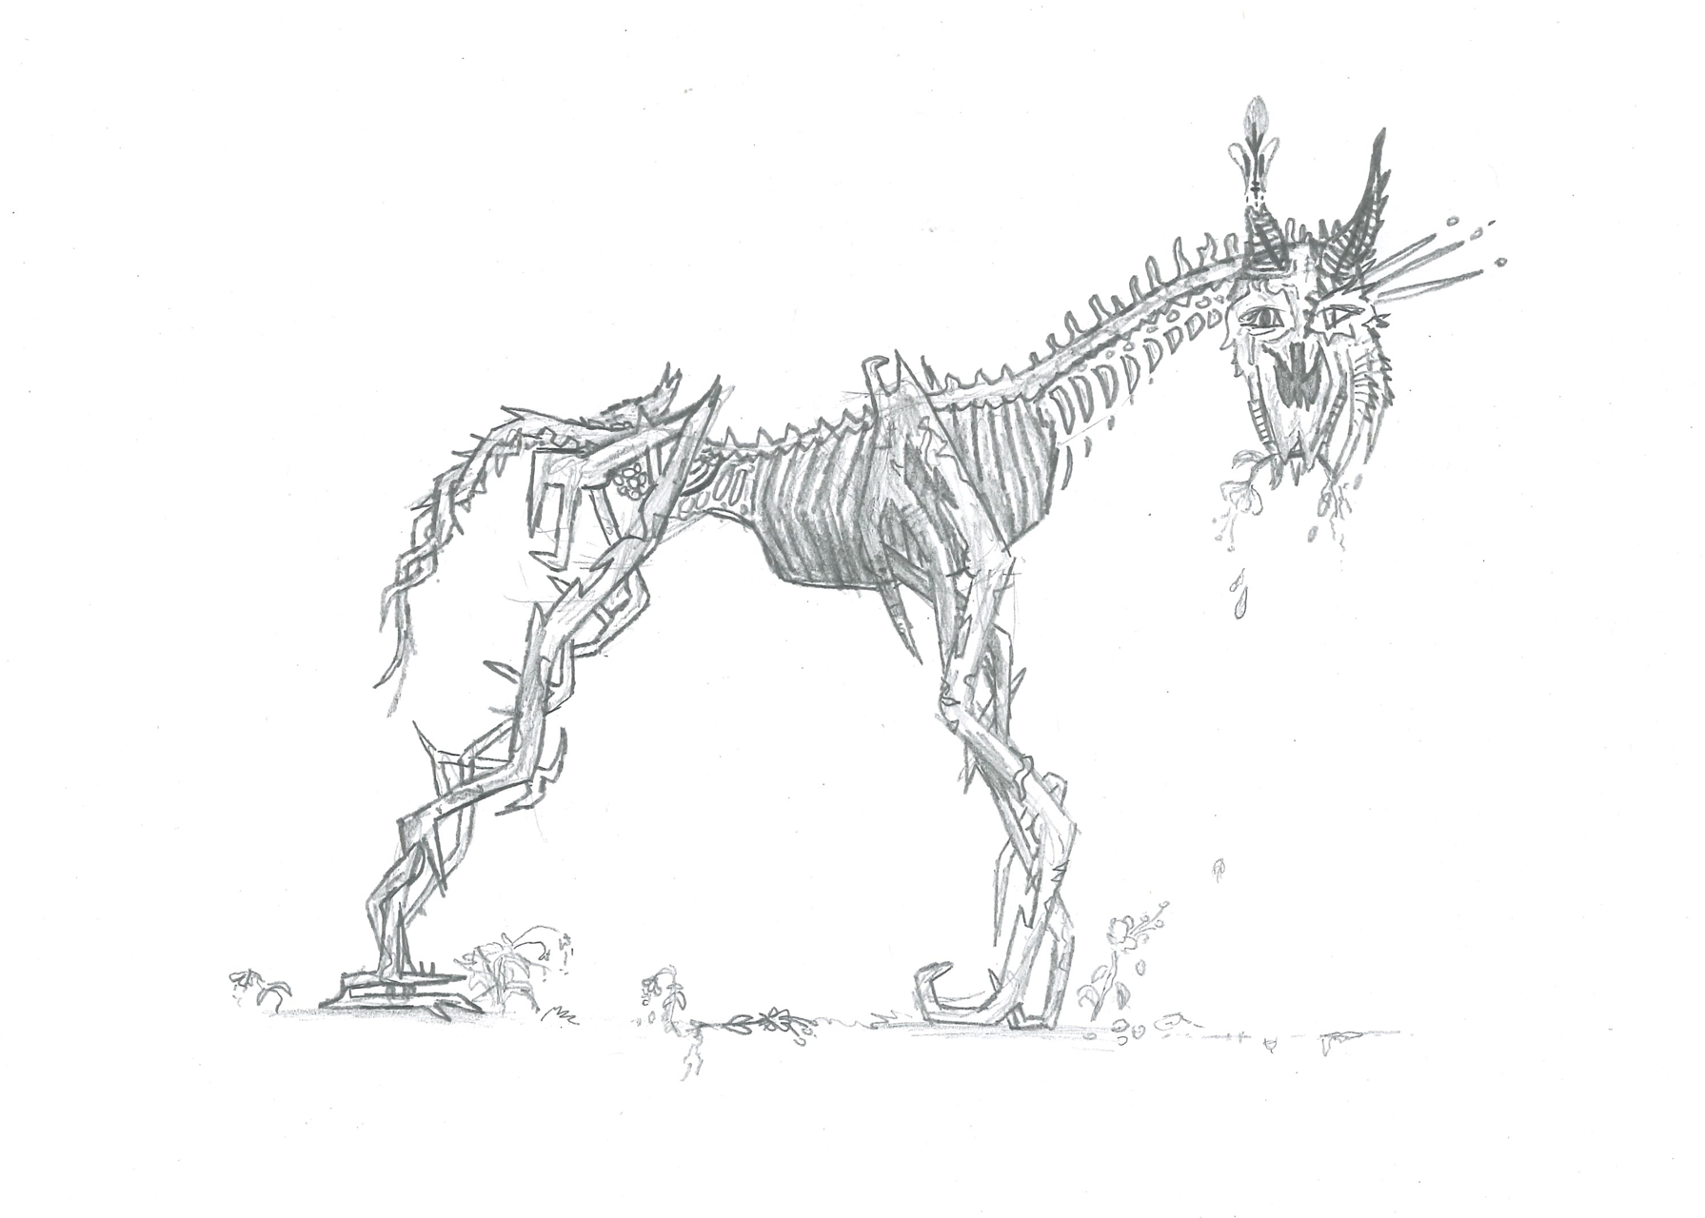
ROCU is a thing imagined by Bronte, aged 12 years
The full name of this thing is: ROCU
It can be found in: A logged forest
It is known that: The skeleton is all that is left of him after the loss of his forest. He is concerned by anger of his loss but is sad - regrets his actions. Rocu has the power to create but needs a strong reason for doing so.
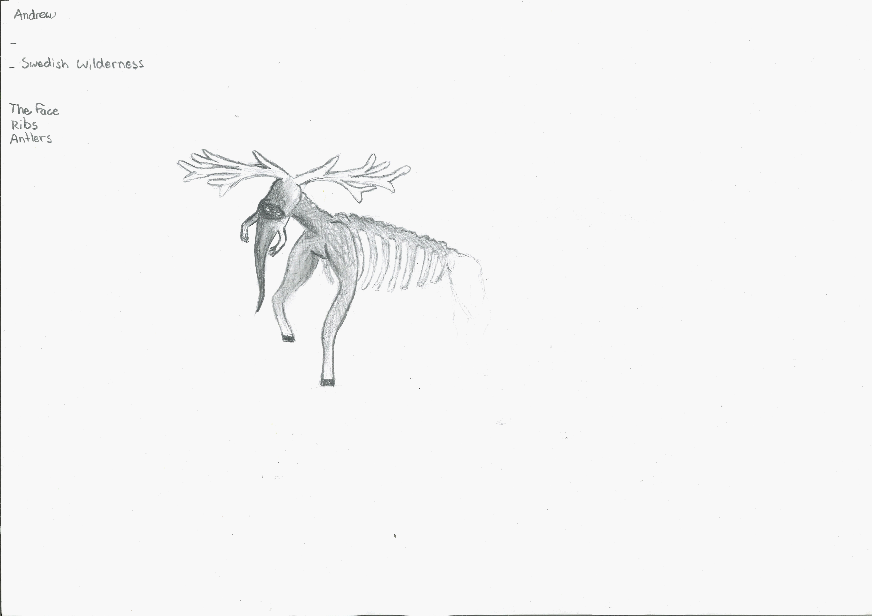

Designed
Designed By:
Saturday Afternoon Open Lab Crew
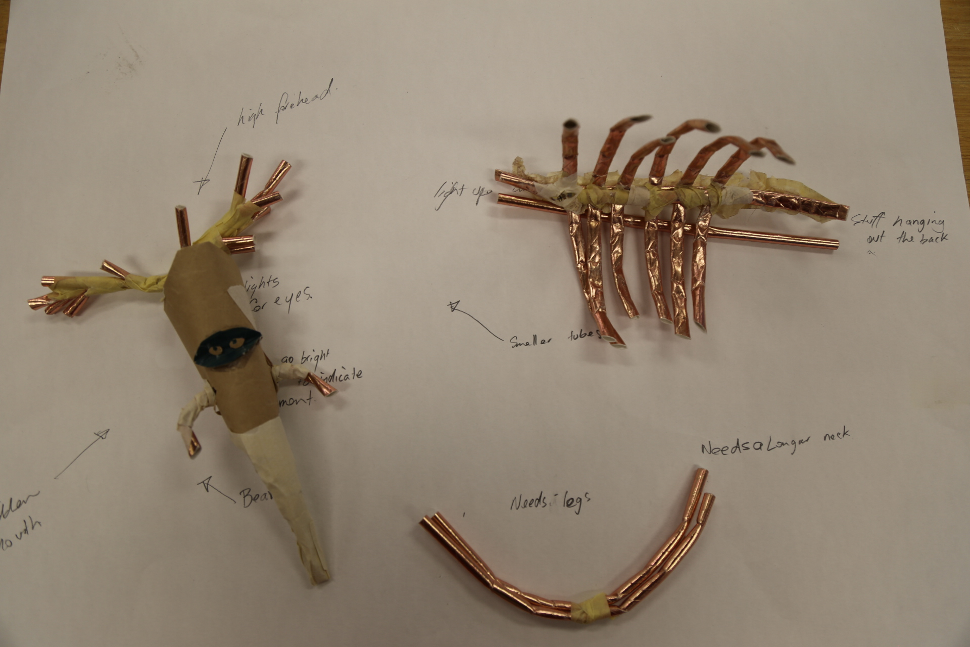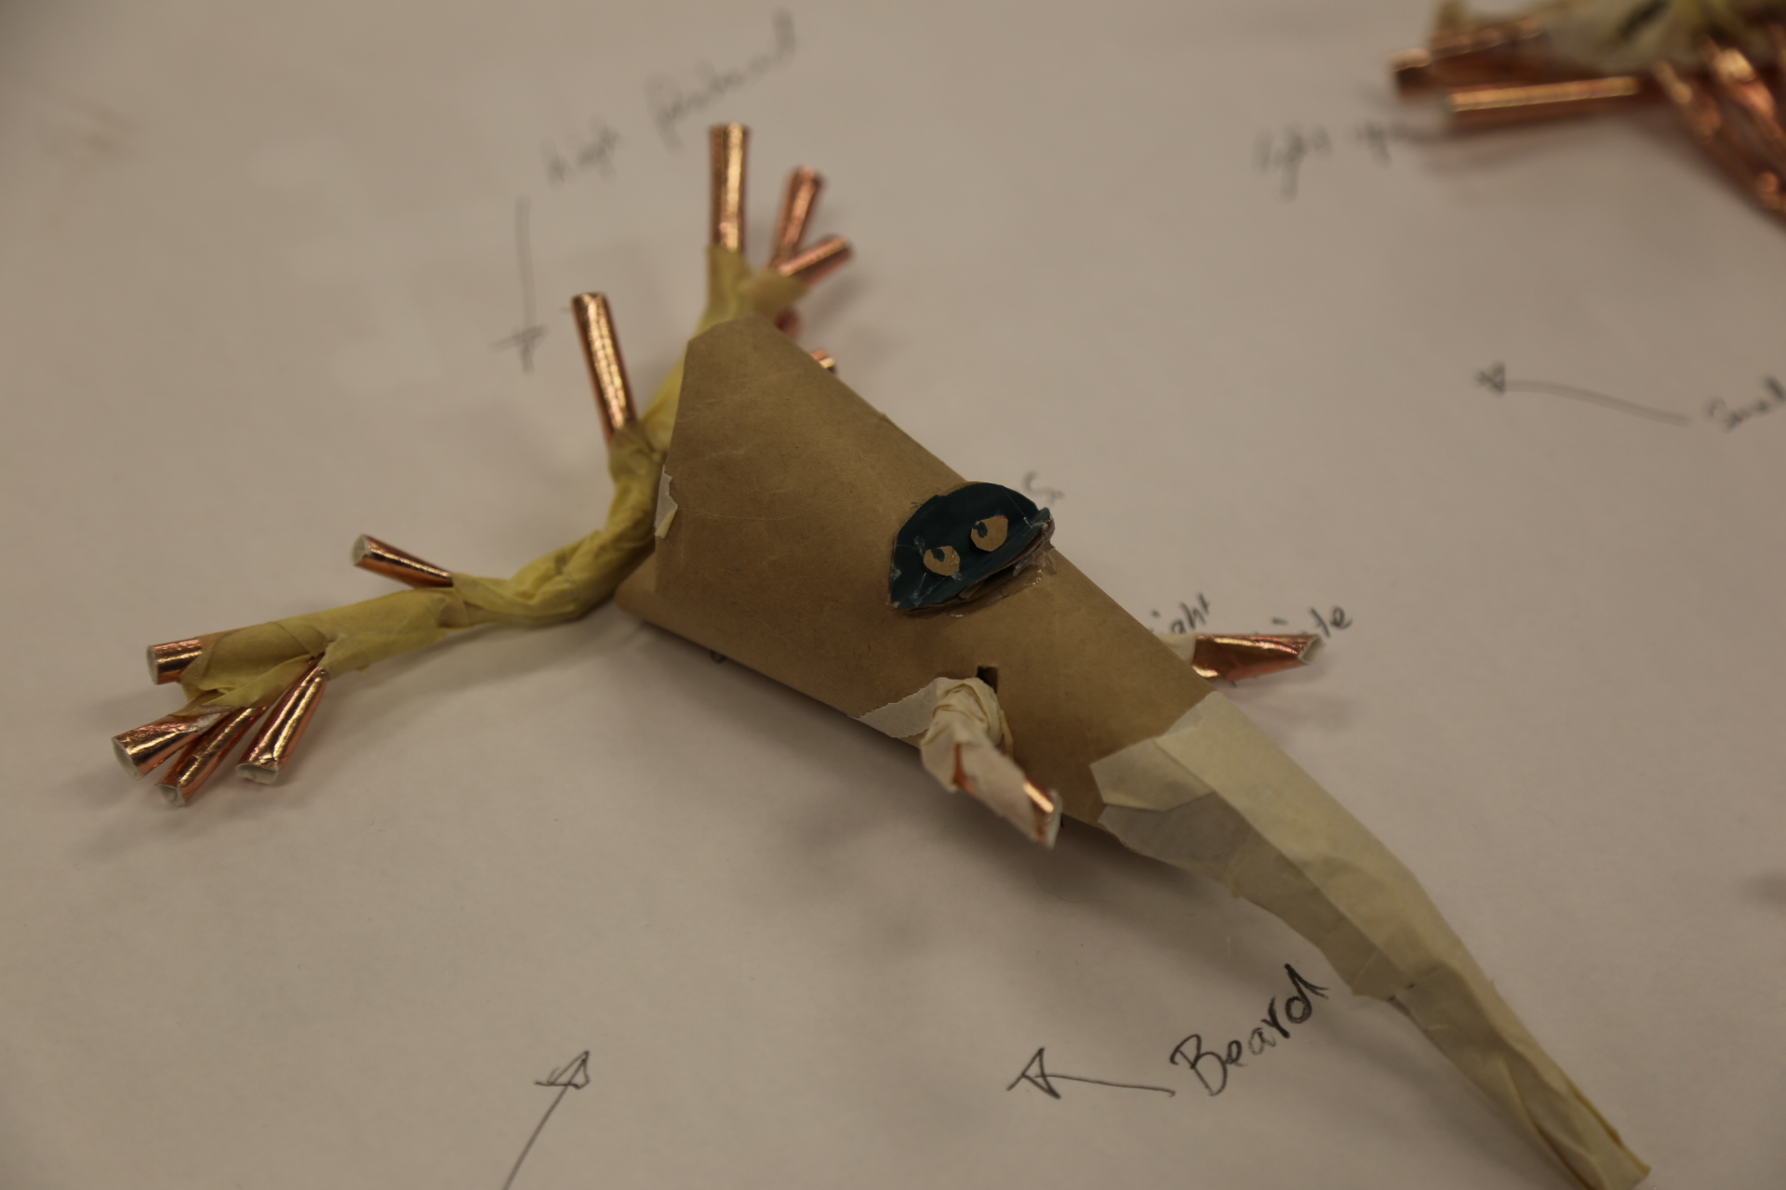
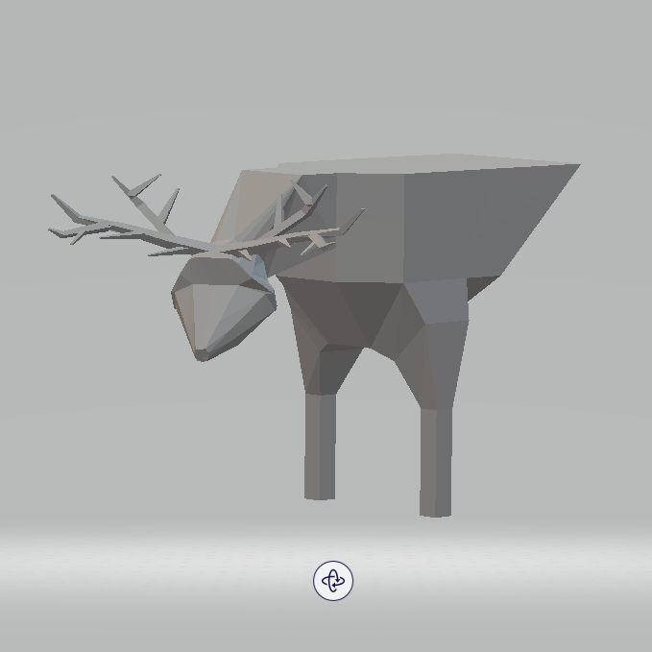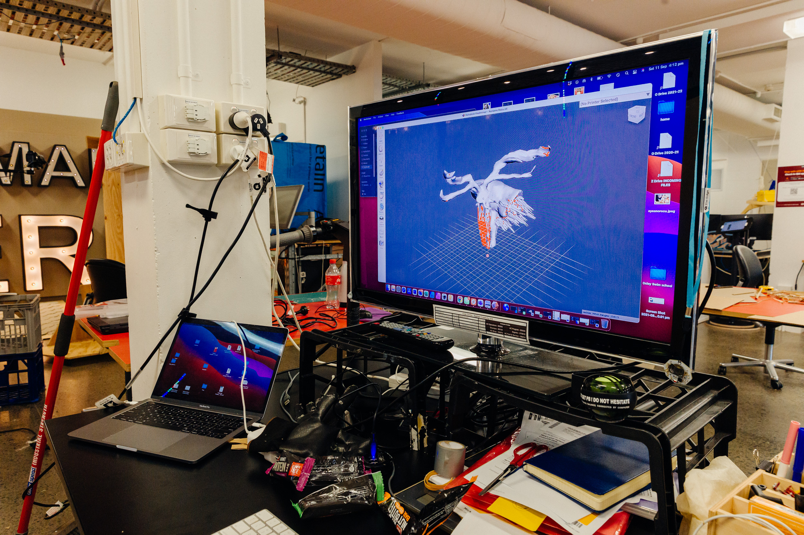

Made
Made By:
Saturday Afternoon Open Lab Crew & Applied Creativity


