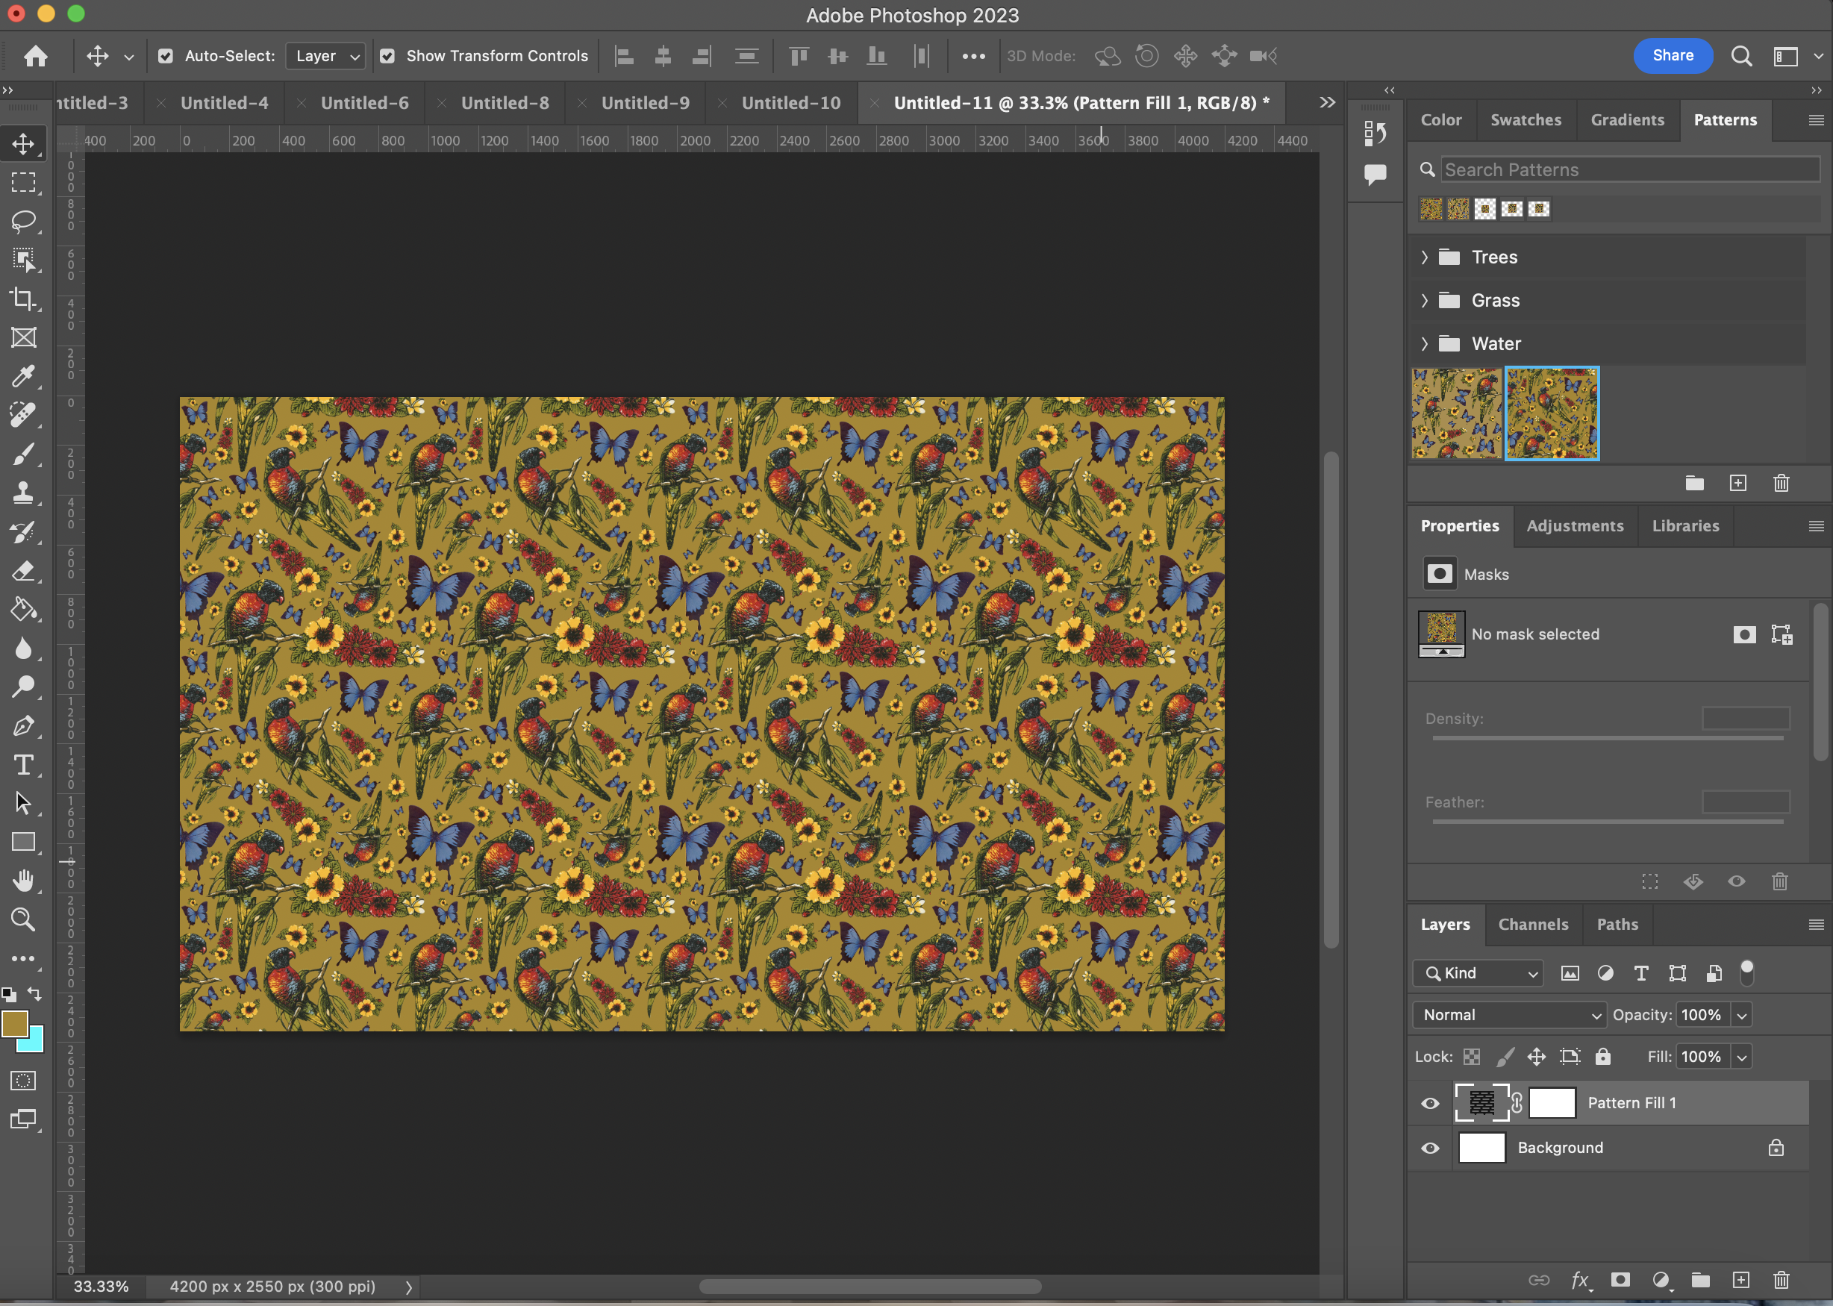

Creating a seamless pattern in Photoshop
An Edge activity guide
July 2024, Ellie Dumigan

Acknowledgement
We acknowledge Aboriginal and Torres Strait Islander peoples and their continuing connection to land and as custodians of stories for millennia. We respectfully acknowledge the land on which we all meet today, and pay our respects to elders past, present and emerging.

Summary
Creating a seamless pattern in Photoshop. There are two ways to create a seamless pattern that create a slightly different effect.

Skills Introduced
- Basic photoshop skills
- Creating a seamless pattern with an illustration
- How to export this pattern

Way One - Using the offset method
This method is quick and easy and utilises the offset tool.

Step 1
When creating a seamless pattern in Photoshop, you can use drawings or cut-out snippets from photos to achieve your desired effect. We used cut-out icons from some State Library of Queensland collection illustrations for this example.

Catalogue references:
- One Search - Tea Towels
- Tea Towels Exhibition
- One Search - Queenslander Newspaper
When picking an image from the collection to use, just be sure to check the Conditions of use section and ensure you don't breach copyright. You can also learn about copyright here.

Icon files for downloading:
Most copyright for these files is personal or study use.
- One Parrot
- Group of Parrots
- More Parrots
- Flowers
- Waytail Birdie
- Yellow Flower
Queenslander Icons - Out of Copyright
- Unordered List Item

Step 2
Create a square canvas (this is the easiest way to create a pattern tile); I used 1000 x 1000 pixels for the size and 300 DPI or pixels per inch for the resolution.
Pull in the vectors or artwork you will be using to create your pattern. You can also create the pattern using your drawings and just draw them in real time to fill up the space. It is easier to work with all the different elements on different layers so keep this in mind when drawing.

Step 3 - Design the pattern
Lay out the elements until you are happy with the design and then merge all the layers.
Then go to Filter - Other - Offest, and automatically photoshop will make this half of your canvas, ensure this number is correct for both the horizontal and vertical (for our example the number displayed should be 500), and ensure wrap around is selected and then hit okay, The offset will move the design 500 pixels (or whatever half of your canvas is) to the right and then 500 pixels down. Once this is done the outer sides of the canvas will be repeatable, however, sometimes gaps might appear in the middle of the design.
Fill in these gaps with other elements until you are happy with the layout of the design. Once you are happy with the design merge these new layers.

Step 4 - Saving the pattern
Now it is time to save this as a pattern! To do this, go to Edit - Define Pattern and give the pattern a name, then click on ok.

Step 5 - Test the pattern!
Once you have saved this as a pattern it is time to test it! Open a new doc that is much larger than the original pattern title. Go to Edit, Fill, Pattern and click on your newly created pattern! It will fill the background of the canvas, you can now zoom in to check the seamlessness.
Your pattern can also be found in the sidebar, under the patterns category.

Way Two- Using the cut-and-paste method
This way is a little bit harder and relies on using rulers to help you align the elements, but does give a seamless look.

Step 1
Import your elements and organise them, best to have them on all separate layers as it will be easier to move them around.

Step 2 - Creating a frame
Create a square outline on a new layer using the rectangular marquee tool. You can set the tool to be an automatic size up in the top toolbar section, and choose a size that would make it a perfect square; for this example, we are using 1000 px by 1000 px.

Step 3
Fill this square with a plain colour using the paint bucket tool. We will use this rectangular block to arrange as a guide to create the repeating pattern.

Step 4 - Creating the pattern
Move your design elements around this rectangle until you are happy with the layout and design. You can allow them to hang off the edges of the shape but you will need to leave a space for them to loop back around.
To achieve this, cut and paste using the rectangular tool where the design element sits over the edge of the frame. Paste the design back into the canvas (Command + V on Mac and Ctrl + V on Windows) and position it on the other side of the shape, but exactly opposite the piece you cut out.
You can drag in rulers to help you better align the elements. Drag rulers in by clicking on the ruler on the side next to the Photoshop toolbar to bring out a vertical ruler and click on the top ruler to bring down a horizontal ruler.
Move these rulers to the middle of the design element to help you line up the other half of the design element on the other side. You can nudge the element by tapping your keyboard's up and down arrow keys.

Step 5 - Saving the pattern
Now, it is time to save this as a pattern! To do this, go to Edit—Define Pattern, give the pattern a name, and click on OK.
Test the pattern in the same way as you tested the other pattern from before, open a new doc that is much larger than the original pattern title. Go to Edit, Fill, Pattern and click on your newly created pattern! It will fill the background of the canvas; you can now zoom in to check the seamlessness.

Final Step - Accessing these patterns
To use the patterns you have created using either method you will need to go to the right-hand sidebar and you should see the option - Patterns under Gradients, clicking on this will open your saved patterns library.
If you can not see the sidebar click the down arrow in the right hand corner and ensure essentials is selected from the drop down menu. 

