Machine start and verify basic operation
- Ensure work space is clear of tools, etc.
- To activate the machine, 'STOP' button needs to be lit up green, if this is not the case, turn red knob clockwise(direction arrows) until it pops up.
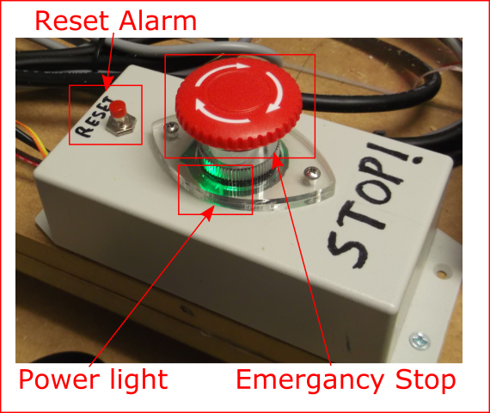
- Open or switch to Candle(Machine control software). 
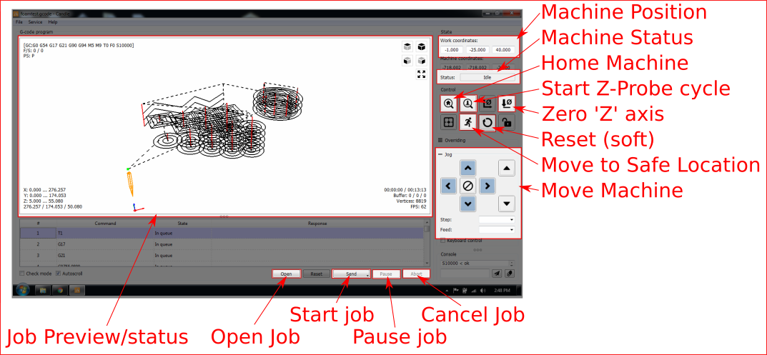
- Verify 'Machine Status' does NOT say 'Not Connected' ('Alarm' or 'Idle' is OK), if not contact Supervisor.
Good:  Bad: 
- Press 'Reset' above the Emergency Stop button. 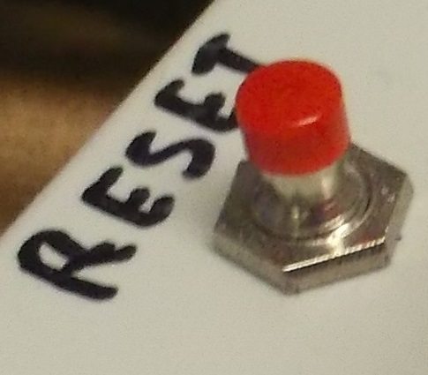
- Press 'Home' Machine will move to find end stops. 
- Status should flash green 'Home' then display 'Idle', if not or if the machine makes grinding noises, doesn't home or has other problems contact Supervisor.
Good: Bad:

