X-Carve User Guide and Operations

Basics
~~REVEAL~~

Safety

Basics
- Don't put hands in machine.
It hurts to have fingers cut off.
- Wear clothes.
It'd distracting to other users and against policy.
- No loose clothing or long hair
That really was a nice tshirt or scalp...
- Don't cut anything you don't own.
Think about how you would feel if it was your thing.

Required PPE
- Hearing protection
It's a better story to loose it at a rock concert than operating this machine
- Eye protection
The replacement ones are awful. It's not worth it.
- Covered Shoes
Something you should be wearing anyway.

Optional
- Respirator
Looks scary and protects your lungs.
- All over body condom
You can never be too safe.

Material Recommendations

Best
- Soft plastics
  - HDPE
  - LDPE
- foams.
  - Dence Polystyrene
  - Light weight polystyrene
  - Expanded PVC
- Cork.

Noisy
- Hard plastics
  - Acrylic
- Wood
  - Plywood
  - Pine

Avoid
- Solid PVC (Tends to clog bits)
- Leather (Fibrous. Cuts but clogs bits. Stinks.)
Tooling and cutting speeds

Operations

Machine start and verify basic operation
- Ensure work space is clear of tools, etc.
- To activate the machine, 'STOP' button needs to be lit up green, if this is not the case, turn red knob clockwise(direction arrows) until it pops up.
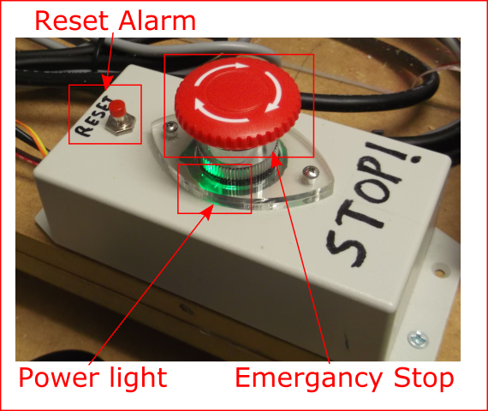
- Open or switch to Candle(Machine control software). 
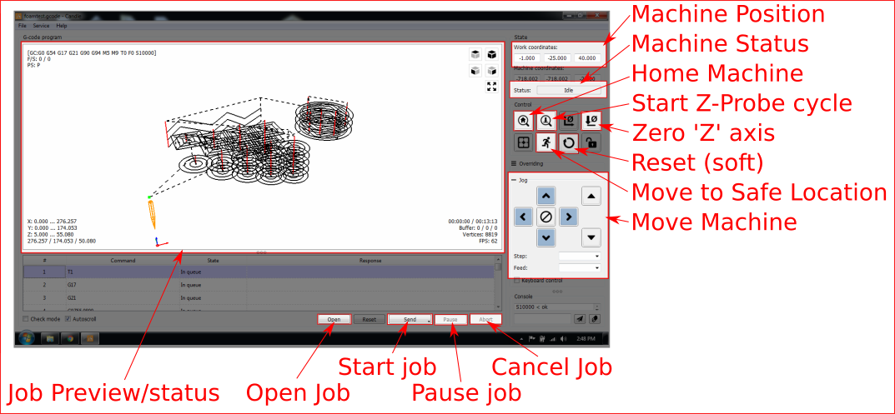
- Verify 'Machine Status' does NOT say 'Not Connected' ('Alarm' or 'Idle' is OK), if not contact Supervisor.
Good:  Bad: 
- Press 'Reset' above the Emergency Stop button. 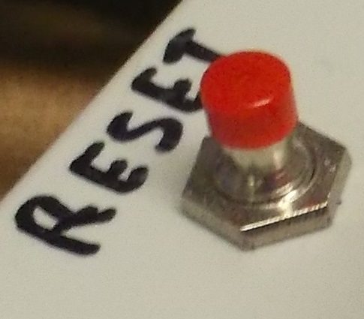
- Press 'Home' Machine will move to find end stops. 
- Status should flash green 'Home' then display 'Idle', if not or if the machine makes grinding noises, doesn't home or has other problems contact Supervisor.
Good: Bad:
Installing and change of tooling
Loading and running a job
Post-use shutdown

