UP! Mini SmoothWare upgrade
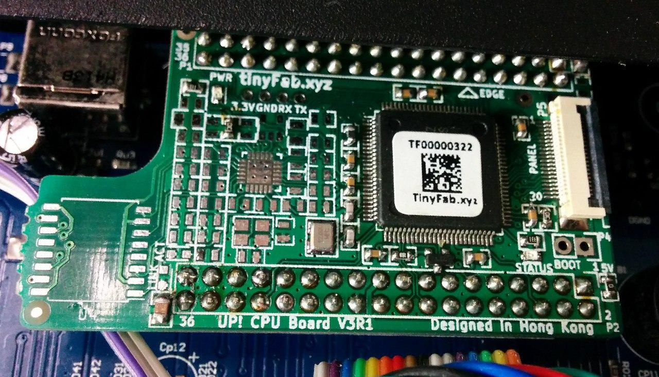

Summary
Upgrade the original non-functional UP! Minis to a new CPU board that supports SmoothWare.
This series of printers has a fault that distroys the original CPU board over time, rendering the machine non-functional.
A board is made by tinyfab.xyz to replace the original and allow open firmware.

Photos
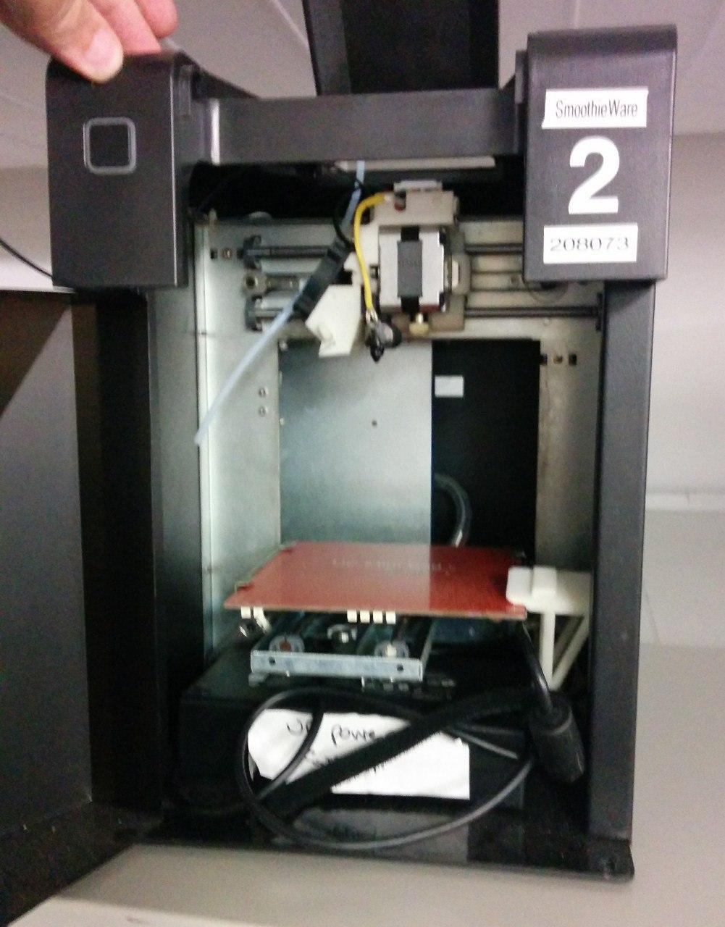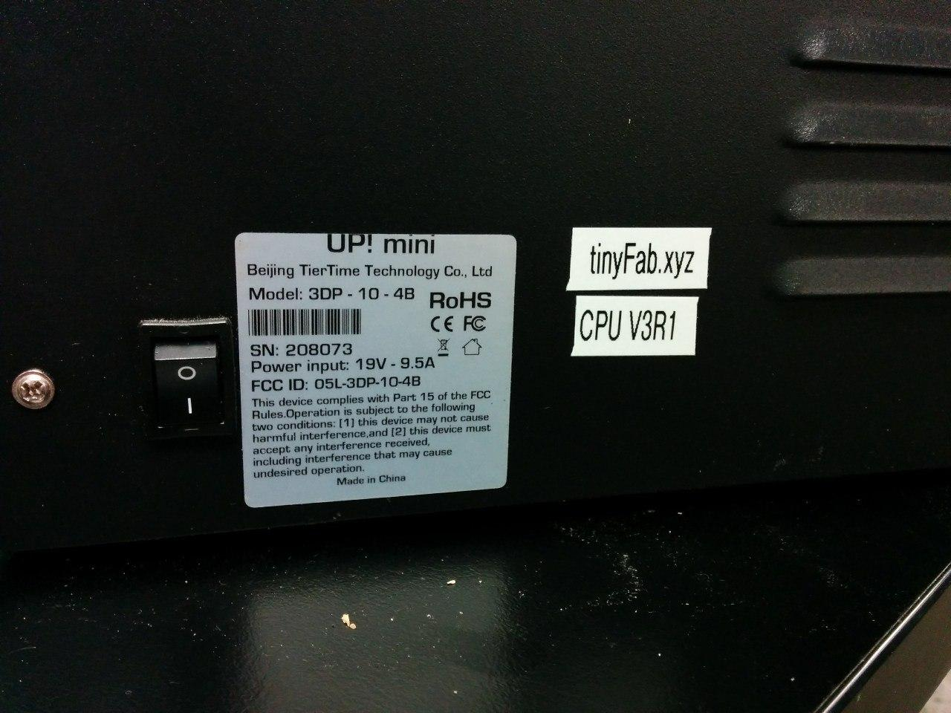

Links
Primary links:
- https://www.tinyfab.xyz/cpu-support
- https://www.thingiverse.com/thing:1655144
- http://www.geoffwilliams.me.uk/3d_printing/up3d_gcode_upgrade
- https://github.com/tinyfab/Smoothieware
Secondary:
- https://www.google.com/search?tbm=isch&q=up!+cpu+board+tinyfab
- https://www.ebay.com/itm/USB-ONLY-GCODE-CPU-for-Tiertime-UP-plus-mini-cetus-3D-printer-by-tinyfab-/222439745965

Notes
getting started guide
https://drive.google.com/file/d/0BxnykIRpb264OUFSVnZoWVVzblU/view?pref=2&pli=1
Please save the config file to the sd card in the printer, the printer will appear as a removable drive when plug in to a PC.
Cetus, Up mini, UP plus 1/2 configuration file
https://drive.google.com/open?id=0BxnykIRpb264MFRhR2YydENKLWM
Currently heated bed control is through g42/g43 to switch on/switch off, we need to put this control in as part of the “up mini” slicer settings

