Display Trolley
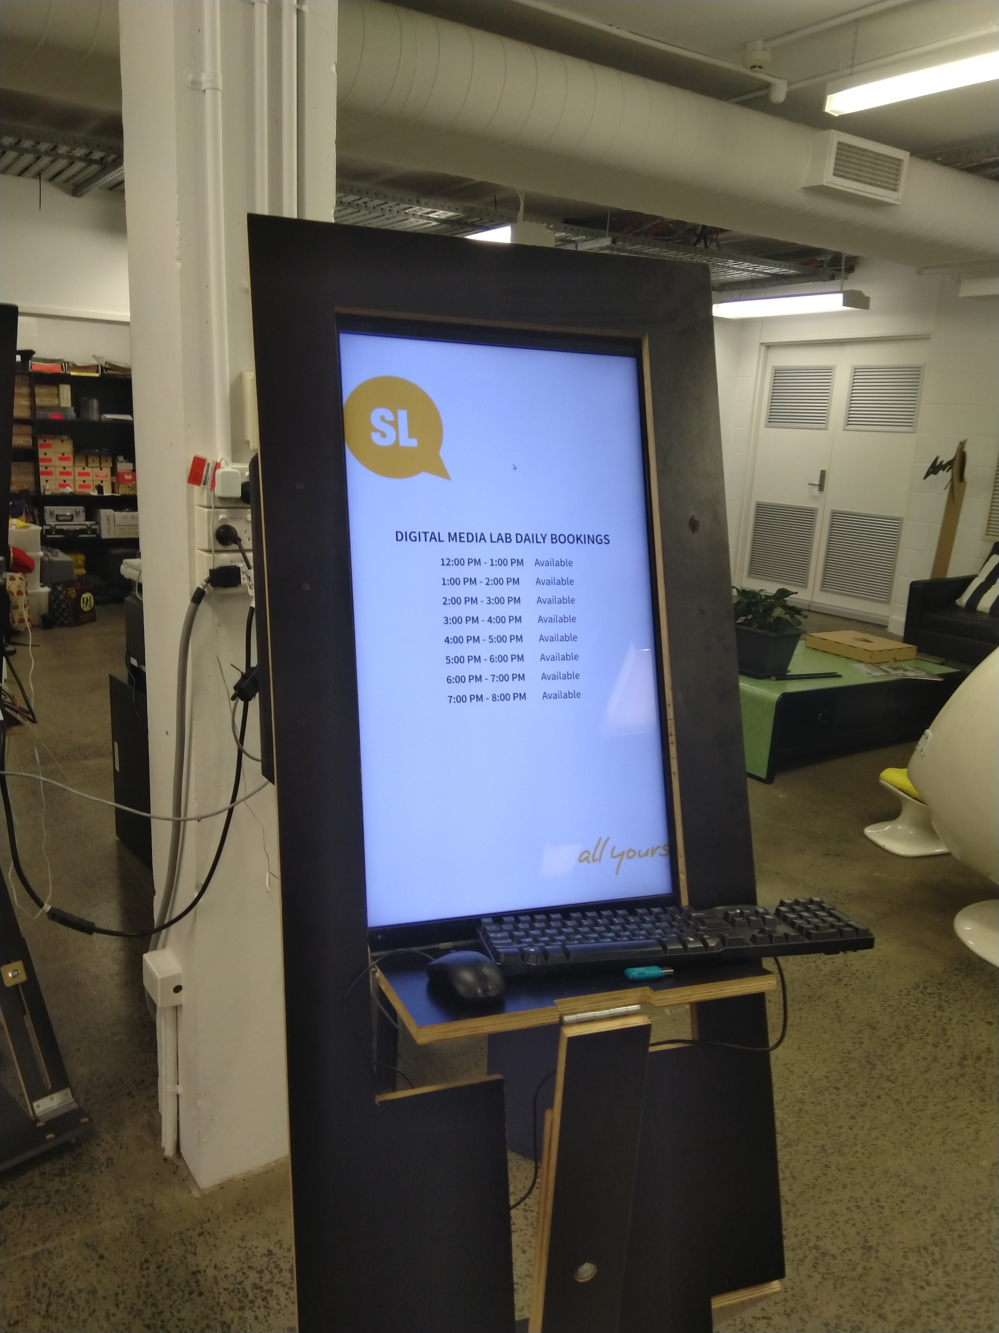
https://cdn.thingiverse.com/renders/32/d5/81/03/61/edf996d3cb009b7ef8e75062155fb9f5_preview_featured.jpg
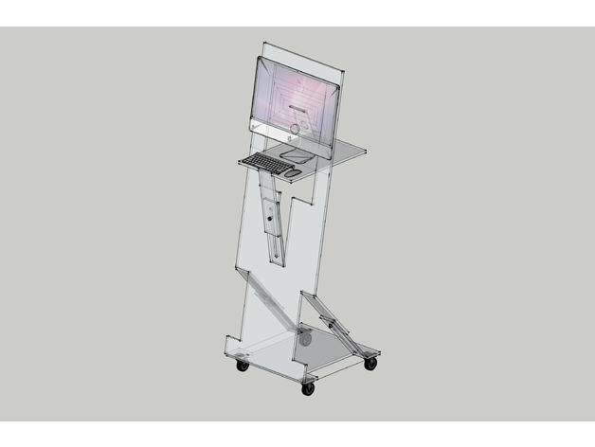

Intro
Aim is to develop a Display Trolley for Advisory notices etc. ...
!st prototype was made in house from sheets of cardboard - the following document is a 'how to' procedure to make this.

Materials
List the materials used, with dimensions, and quantities.

Maquette
* 3mm fluted cardboard ( 120×240 mm )
* Masking tape
* 2mm screw - 3 of

Full Size Trolley
List of items to complete 2 full trolleys :
* 15mm sheet Ply ( 1200×2400 mm ) - 1 of
* Door Hinges ( 100×50 mm ) - 12 of
* Center Pivot Hinge ( 57×15 mm ) - 4 of
* Castor Wheels ( 75 mm ) - 8 of
* Screws to suit ...
* M12 nut & bolt + washers - 6 sets

Tools
(List all the tools you used to complete the project, from #1 Philips screwdrivers, to the CNC machine)
* Screw driver

Instructions
(This is where you put the step-by-step photos showing how to carry out your project, as well as an explanation in words. Rename the steps as you like, use italics or bold for emphasis.
Don't forget to include design files for CNC, laser cutting or 3D printing but remember they need to be zipped before uploading to the Wiki (it is also useful if they are in a transferable format, .svg rather than .ai, for example)).

Step One:

Step Two:

Step Three:

Step Four:
etc

Development notes
Mick wanted some 'furniture' to enable use of old screens for display purpose ...
- Idea was further developed for a portable platform for displays ...
- Design is to fit within a 1200x2400mm ply sheet ...
- Use Standard fittings available from Bunnings ...

Feedback
(Here you can put any suggestions from users that you have not yet implemented, and mention any unforeseen difficulties encountered in operation or construction)

References
This were you put external links, if they have not appeared in the Instructions.

Files
This is where you put files for laser cutting, Excel sheets of suppliers etc..
display_trolley.zip

Links
- https://www.thingiverse.com/thing:3056861
- https://www.aliexpress.com/item/Stainless-Steel-Pivot-Hinges-for-Cabinets-Windows-Connect-Folding-Free-Shipping/32804416600.html

Project Progress
Basic prototype development in progress ...

Log of works
- Prototype done ...
- Drawn up a draft layout ... Aug 2018.
- Make 1:5 scale Maquette ...
- Find Center Pivot Hinge ... Sept 2018.

Project Table
Project | Percent Complete | Project Lead | Status | Budget Req | Budget Approved | Next Major Milestone | Subsequent Milestones to complete
Display Trolley | 30% | Andrew | First Draft | $100 ? | $ ? | Approved concept ? | Complete CAD drawings & Assembly procedure

