Arduino ADC based touch sensor
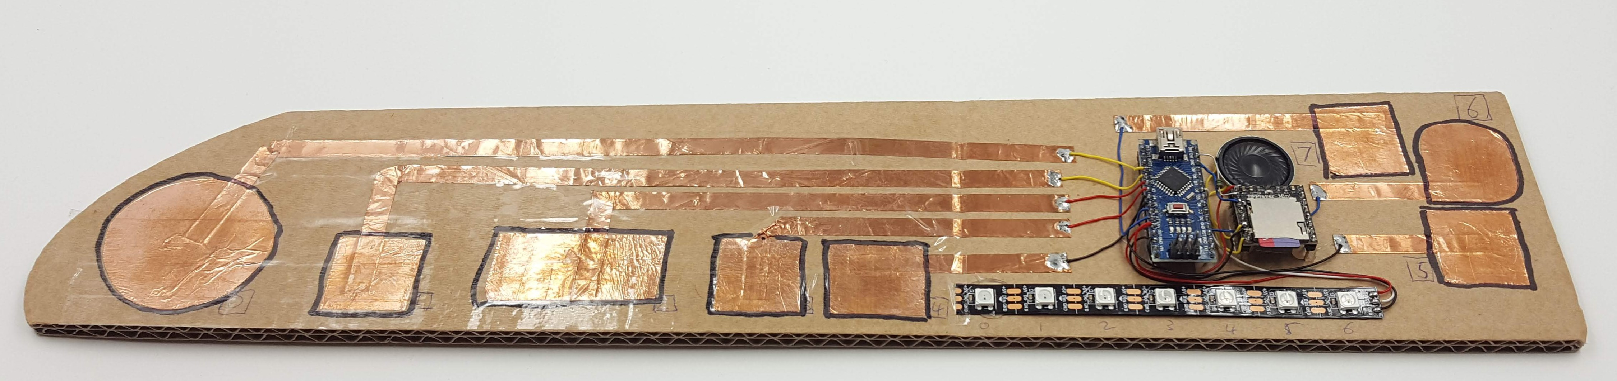

Summary
Using the Arduino's built in ADC(Analog to Digital Converters) along with libraries originally based on Atmel's QTouch technology to create 'free' capacitive touch sensors using either zero or ultra low(I you include copper tape and a resistor or two) cost capacitive touch sensors that can work as bare copper, covered with tape or through 1.5mm acrylic.

Materials
- Arduino Nano (Though any AVR based Arduino works)
- Copper tape/foil
- Wire
- Substrate: Cardboard or laser cut acrylic.
- 1k resistors. (Optional but recommended)
- MP3 player module. (Optional)
- Neopixel strip (optional)

Tools
- One Byron
- Time
(List all the tools you used to complete the project, from #1 Philips screwdrivers, to the CNC machine)

Progress to date

Proof of concept
Cardboard base, roughly cut contacts made from wide and narrow self adhesive copper tape then covered with packing tape.
Electronics hot glued in place and everything soldered together quickly.
Neopixel strip and MP3 player are for feedback.
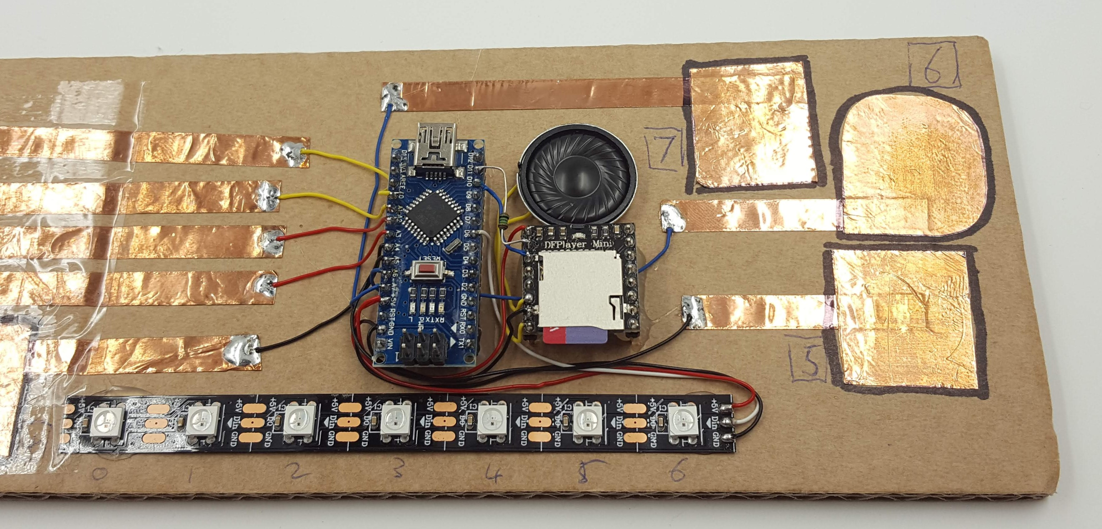

Demonstration board
Laser cut version. Copper tape on back of 1.5mm acrylic. 3mm acrylic frame and back.
MP3 player, 3 neopixels for status, two neopixels for backlight illumination under each pad.
Hot glue. Solder.
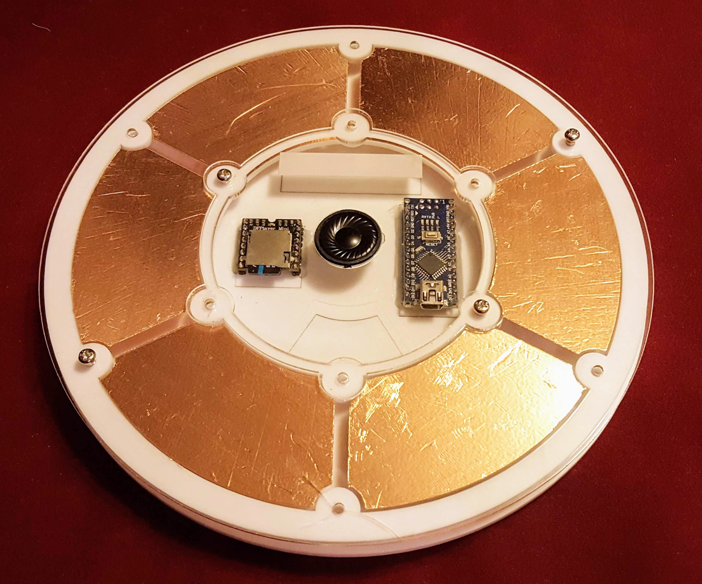

Instructions
(This is where you put the step-by-step photos showing how to carry out your project, as well as an explanation in words. Rename the steps as you like, use italics or bold for emphasis.
Don't forget to include design files for CNC, laser cutting or 3D printing but remember they need to be zipped before uploading to the Wiki (it is also useful if they are in a transferable format, .svg rather than .ai, for example)).

Step One:

Step Two:

Step Three:

Step Four:
etc

Development notes
(This is where you can put ideas that you tried, but which did not work (and why))

Feedback
(Here you can put any suggestions from users that you have not yet implemented, and mention any unforeseen difficulties encountered in operation or construction)

References
ADC Touch:
- http://playground.arduino.cc/Code/ADCTouch
- https://github.com/jgeisler0303/QTouchADCArduino
MP3 player:
- https://www.dfrobot.com/wiki/index.php/DFPlayer_Mini_SKU:DFR0299#Connection_Diagram
- https://github.com/DFRobot/DFRobotDFPlayerMini
- https://www.dfrobot.com/blog-277.html
- https://www.dfrobot.com/wiki/index.php/DFPlayer_Mini_SKU:DFR0299#Sample_code_.22FullFunction.22.2C_including_all_the_functions._Please_read_the_comments_and_documents_in_detail

Files
This is where you put files for laser cutting, Excel sheets of suppliers etc..

Project Progress
Project | Percent Complete | Project Lead | Status | Budget Req | Budget Approved | Next Major Milestone | Subsequent Milestones to complete
Test Page | 90% | Byron | Play with | $0

