Rotocaster
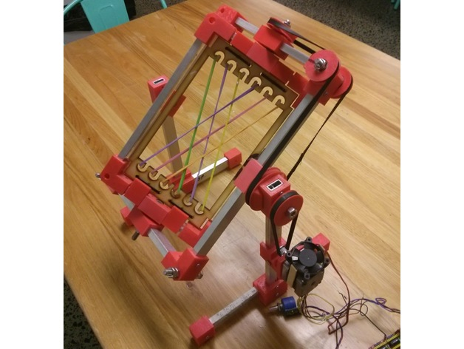
This project was developed by Byron & The Hack evening team as a Hack the Evening project at The Edge in 2017.
More information can be found at https://www.thingiverse.com/thing:2027135

Intro
The rotocaster is a device that allows hollow objects to be moulded from quick setting liquid materials such as polyurethane, silicone or chocolate.
Using a two part mould, slow-setting liquid material is added, the mould clamped together, and then placed in between the network of rubber bands seen. When switched on, the frames simultaneously rotate slowly in perpendicular directions, coating the inside of the mould with the material as it sets. If the quantities are chosen correctly, a hollow object is formed with the external face matching the mould used (wall thickness will depend on the amount of material added to the mould).
This device was used in a workshop making hollow chocolate Easter eggs during 2017.
Moulds were made using the Vacuum Former.

Materials
List the materials you used, with dimensions, and quantities.
* ( TBA )

Tools
(List all the tools you used to complete the project, from #1 Philips screwdrivers, to the CNC machine)
* Screw driver

Instructions
(This is where you put the step-by-step photos showing how to carry out your project, as well as an explanation in words. Rename the steps as you like, use italics or bold for emphasis.
Don't forget to include design files for CNC, laser cutting or 3D printing but remember they need to be zipped before uploading to the Wiki (it is also useful if they are in a transferable format, .svg rather than .ai, for example)).

Step One:

Step Two:

Step Three:

Step Four:
etc.

Development notes
(This is where you can put ideas that you tried, but which did not work & and why)

Feedback
(Here you can put any suggestions from users that you have not yet implemented, and mention any unforeseen difficulties encountered in operation or construction)

References
This were you put external links, if they have not appeared in the Instructions.

Files
rotocaster_rotomolder_made_from_common_parts.zip

Links
- https://www.thingiverse.com/thing:2027135

Project Progress
Basic prototype development complete ...

Log of works
* Prototype done ...
* March 2017 : Assembled & Working ...

Project Table
Project | Percent Complete | Project Lead | Status | Budget Req | Budget Approved | Next Major Milestone | Subsequent Milestones to complete
Rotocaster | 90% | Byron | First Draft | $0

