Portable Spray Booth
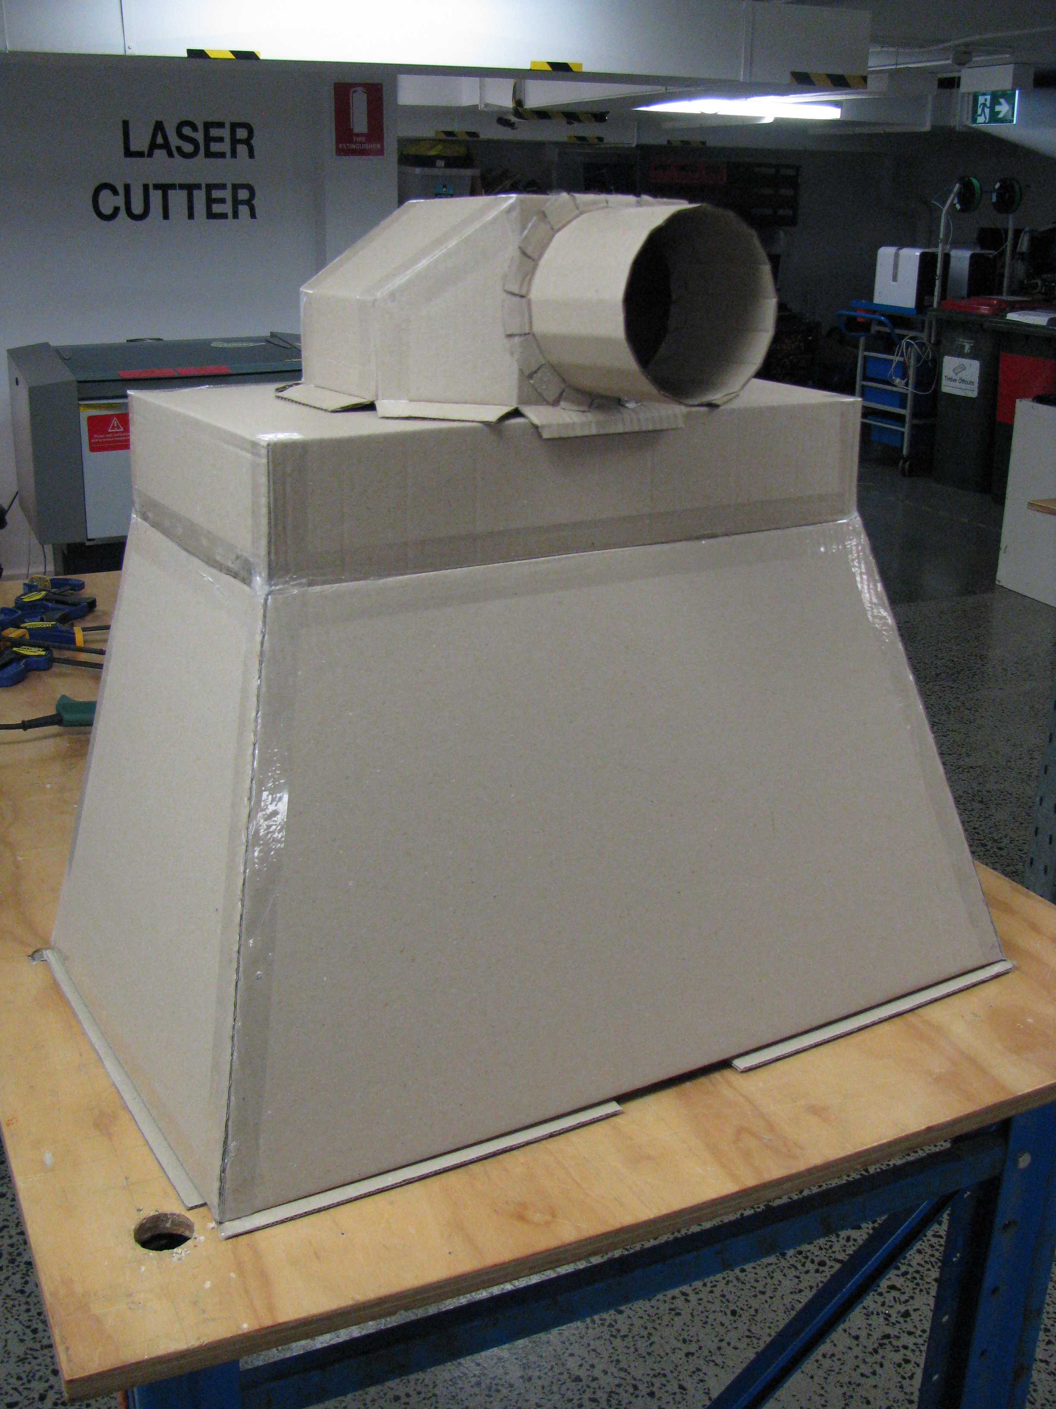

Intro
Aim was to develop a basic spray booth to enable small scale painting of PC boards etc. ...
!st prototype was made in house from sheets of cardboard - the following document is a how to procedure to make this.

Materials
List the materials you used, with dimensions, and quantities.
* 3mm fluted cardboard - 450mm x 600mm ( 7 sheets of )
* hot glue
* masking tape

Tools
(List all the tools you used to complete the project, from #1 Philips screwdrivers, to the CNC machine)

Instructions
(This is where you put the step-by-step photos showing how to carry out your project, as well as an explanation in words. Rename the steps as you like, use italics or bold for emphasis.
Don't forget to include design files for CNC, laser cutting or 3D printing but remember they need to be zipped before uploading to the Wiki (it is also useful if they are in a transferable format, .svg rather than .ai, for example)).

Step One:

Step Two:

Step Three:

Step Four:
etc

Development notes
(This is where you can put ideas that you tried, but which did not work (and why))

Feedback
(Here you can put any suggestions from users that you have not yet implemented, and mention any unforeseen difficulties encountered in operation or construction)

References
This were you put external links like LED generator, if they have not appeared in the Instructions.

Files
This is where you put files for laser cutting, Excel sheets of suppliers etc..

Links
- https://www.thingiverse.com/thing:2776341

Project Progress
Basic prototype development complete ...

Log of works
- Prototype done ...
- Added light & fan ...
- Cut files added ...

Project Table
Project | Percent Complete | Project Lead | Status | Budget Req | Budget Approved | Next Major Milestone | Subsequent Milestones to complete
Portable Spray Booth | 99% | Andrew | Ready to go | $0

