Line Robot
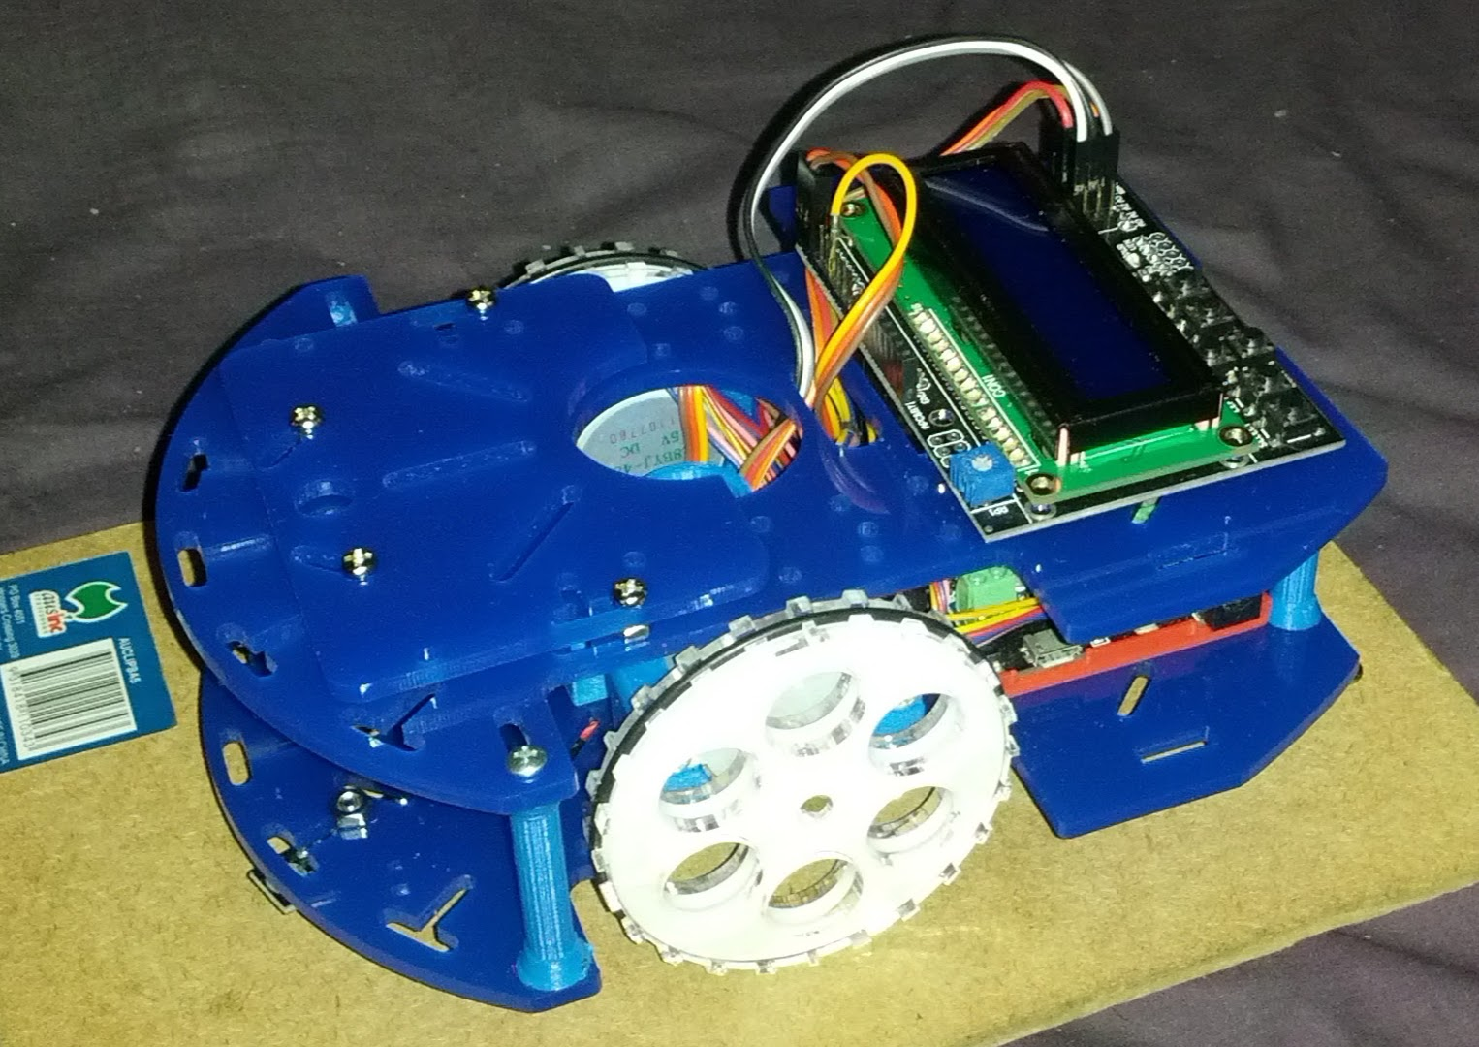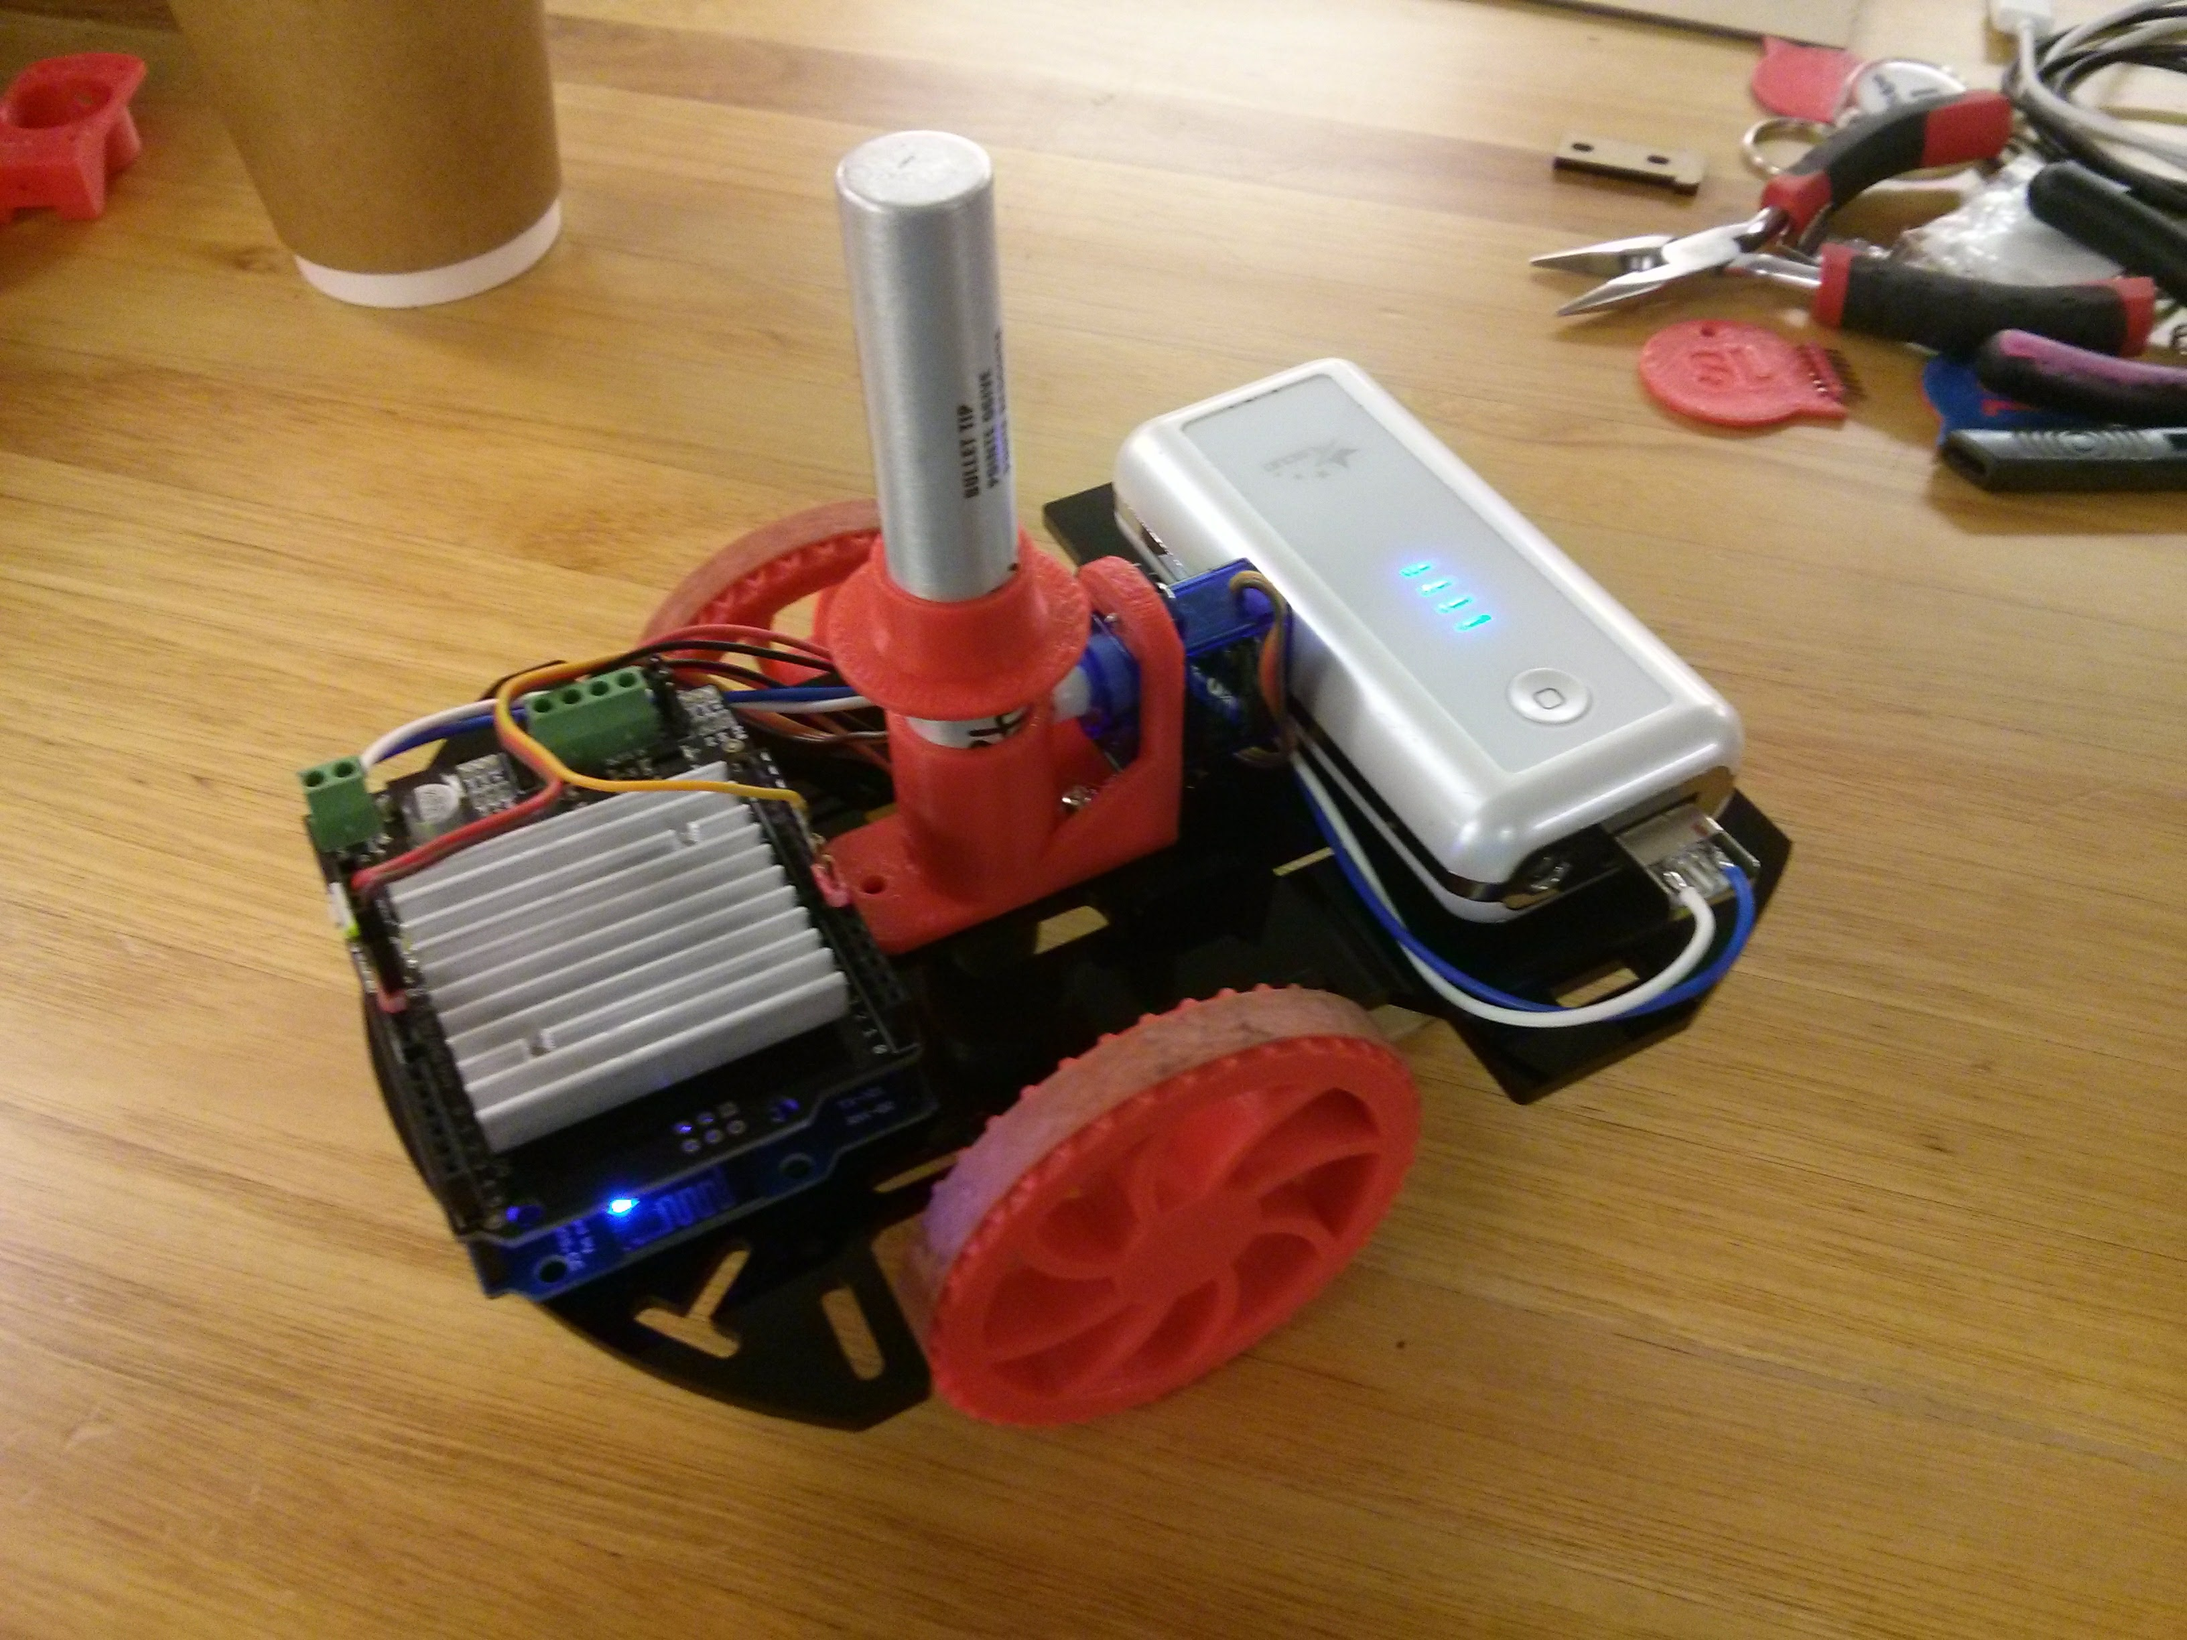

Summary

Modular education robot platform.
The robot is built around a simple 3mm laser cut acrylic frame with 3d printed attachments and parts. It can be assembled as a full featured, voice controlled, internet connected device down to a simple line following robot with price points to match.
Except for the self made parts(3d prints and lasercut) every component has multiple sources and equivalents, allowing the final user to choose between guaranteed parts from a reputable supplier(Genuine Adafruit) or the cheapest possible source(Aliexpress clone parts) and thus trade quality for price to the level where they are comfortable.
Bulk kits can be built up from just the laser cut/3d printed parts, maybe with fastener and a list of electronics with sources as well as complete kits.

The robot is intended to be deployed in one of two ways

As a pre-assembled learning platform
To teach programming, problem solving or similar in either C, MicroPython or Scratch(eventually). Each robot would be pre-built to match the intended language and workshop outcome, this allows organizers to test and debug each robot prior to the workshop, build spares and have a consistent and stable platform and helping the participants to focus on the coding and control side of things rather than using time assembling a standard machine. It also decreases costs due to having a reusable platform that can be on the high end of the price scale.

As a 'robot kit'
The focus of this is to build and test the actual robot platform. Participants would be given a (limited) set of options and encoraged to, stage by stage, build the robot up from a basic motion platform, adding sensors and interface, testing as they go until they have a final machine that can be taken home and learn using. In this style of workshop the testing code would be pre-written and can be simply uploaded to the robots as they progress.
Both of these workshop styles are also intended to feed back into the other one:
- So you built a robot that works? Great! Want to learn how to program it yourself?
- Learn how to program a robot? Great! Want to come back and build one?

Materials

Core Robot
Electronics:
- Arduino.($4-5) Motor shield($5-8). Steppers($5/pair). Batteries($?). = ($20)
- https://www.aliexpress.com/wholesale?catId=0&initiative_id=SB_20170723064316&SearchText=Arduino+uno+r3
- https://www.aliexpress.com/wholesale?catId=0&initiative_id=AS_20170723055351&SearchText=arduino+motor+shield+v2
- https://www.aliexpress.com/wholesale?catId=0&initiative_id=AS_20170723055427&SearchText=28byj-48
Mechanical: (No idea for cost)
- Laser cut: Top and bottom frame. Wheels(?) - Single sheet of acrylic
- 3d print: motor mounts. Pen mount. - Two robots per UP2
- Bits: Nuts/bolts. O-rings. Double sided tape?
Wheels: http://bbs.espressif.com/viewtopic.php?t=1863 https://www.thingiverse.com/thing:862438

Options

Input/output
Options: Each about $5 worth of parts. Pick two?
Screen/keyboard. (Basic robot control? Status display?) https://www.aliexpress.com/wholesale?catId=0&initiative_id=SB_20170723054152&SearchText=Keypad+Shield+Arduino
RGB Ring + button (Status? Prettiness? ) https://www.aliexpress.com/wholesale?catId=0&initiative_id=SB_20170723070849&SearchText=Arduino+button+pcb https://www.aliexpress.com/wholesale?catId=0&initiative_id=SB_20170723070641&SearchText=rgb+ring
One of these:
IR sensors. (Line following. ) Parts: Three(two?) sensors. Nuts/bolts. https://www.aliexpress.com/wholesale?catId=0&initiative_id=SB_20170723064723&SearchText=Arduino+line+sensor (Maybe?): https://www.aliexpress.com/item/Four-Way-Infrared-Tracing-4-Channel-Tracking-Sensor-Module-Transmission-Line-Modules-Obstacle-Avoidance-for-Arduino/32437147325.html? https://www.hackster.io/16336/line-follower-robot-using-arduino-5f5698
Drawing. (Pre-programmed Shapes? Simple program and copy. May need keypad?) https://www.aliexpress.com/wholesale?catId=0&initiative_id=SB_20170723064804&SearchText=servo+sg90
Range finding(Wall following/people avoiding) Parts: One(two?) sensors. Simple bracket. (3d print?). http://www.webondevices.com/arduino-robot-car-obstacle-avoidance/

Other ideas
Cheap single message playback https://www.aliexpress.com/item/ISD1820-recording-module-voice-module-the-voice-board-telediphone-module-board-with-Microphones-Loudspeaker-for-arduino/32768903244.html? Bulky but multiable messages https://www.aliexpress.com/item/2pcs-ISD1700-Series-Voice-Record-Play-ISD1760-Module-For-Arduino-PIC-AVR/32308935869.html?
Pricy but voice commands. https://www.aliexpress.com/wholesale?catId=0&initiative_id=SB_20170726165510&SearchText=Arduino+Voice+Recognition

Tools
Laser cutter for frame and wheels. 3D printer for motor mounts and line drawing Basic hand tools. Final design should only require a screwdriver to assemble.

Progress to date
Basic frame v.3 done. Most 3d printed parts done. Basic electronics tested.

Instructions
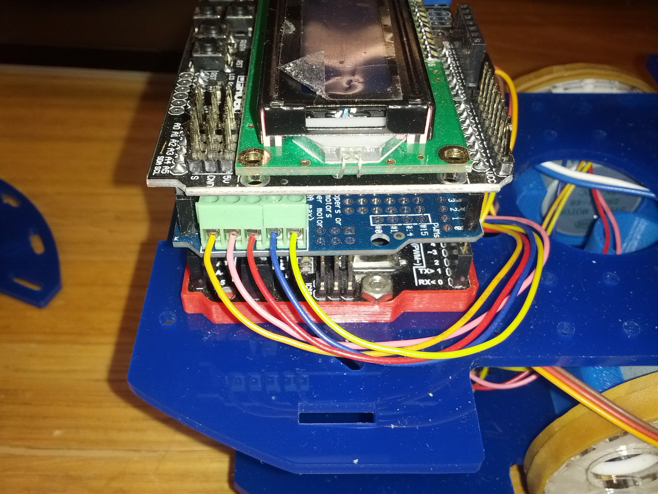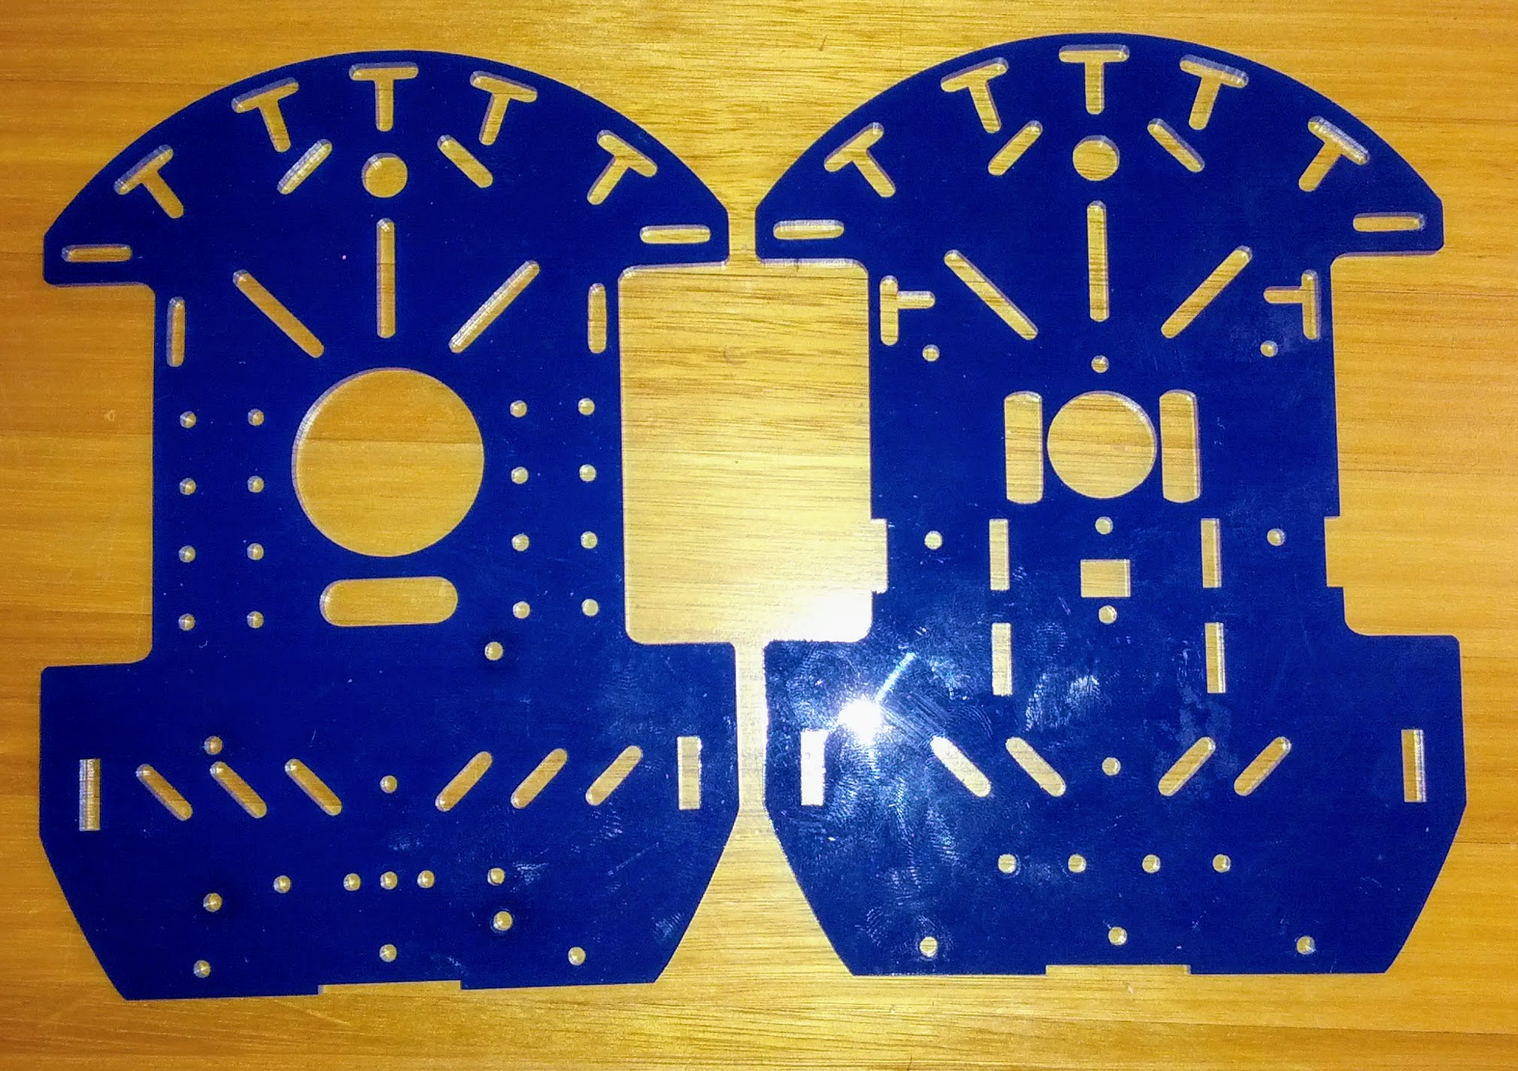

Accessories
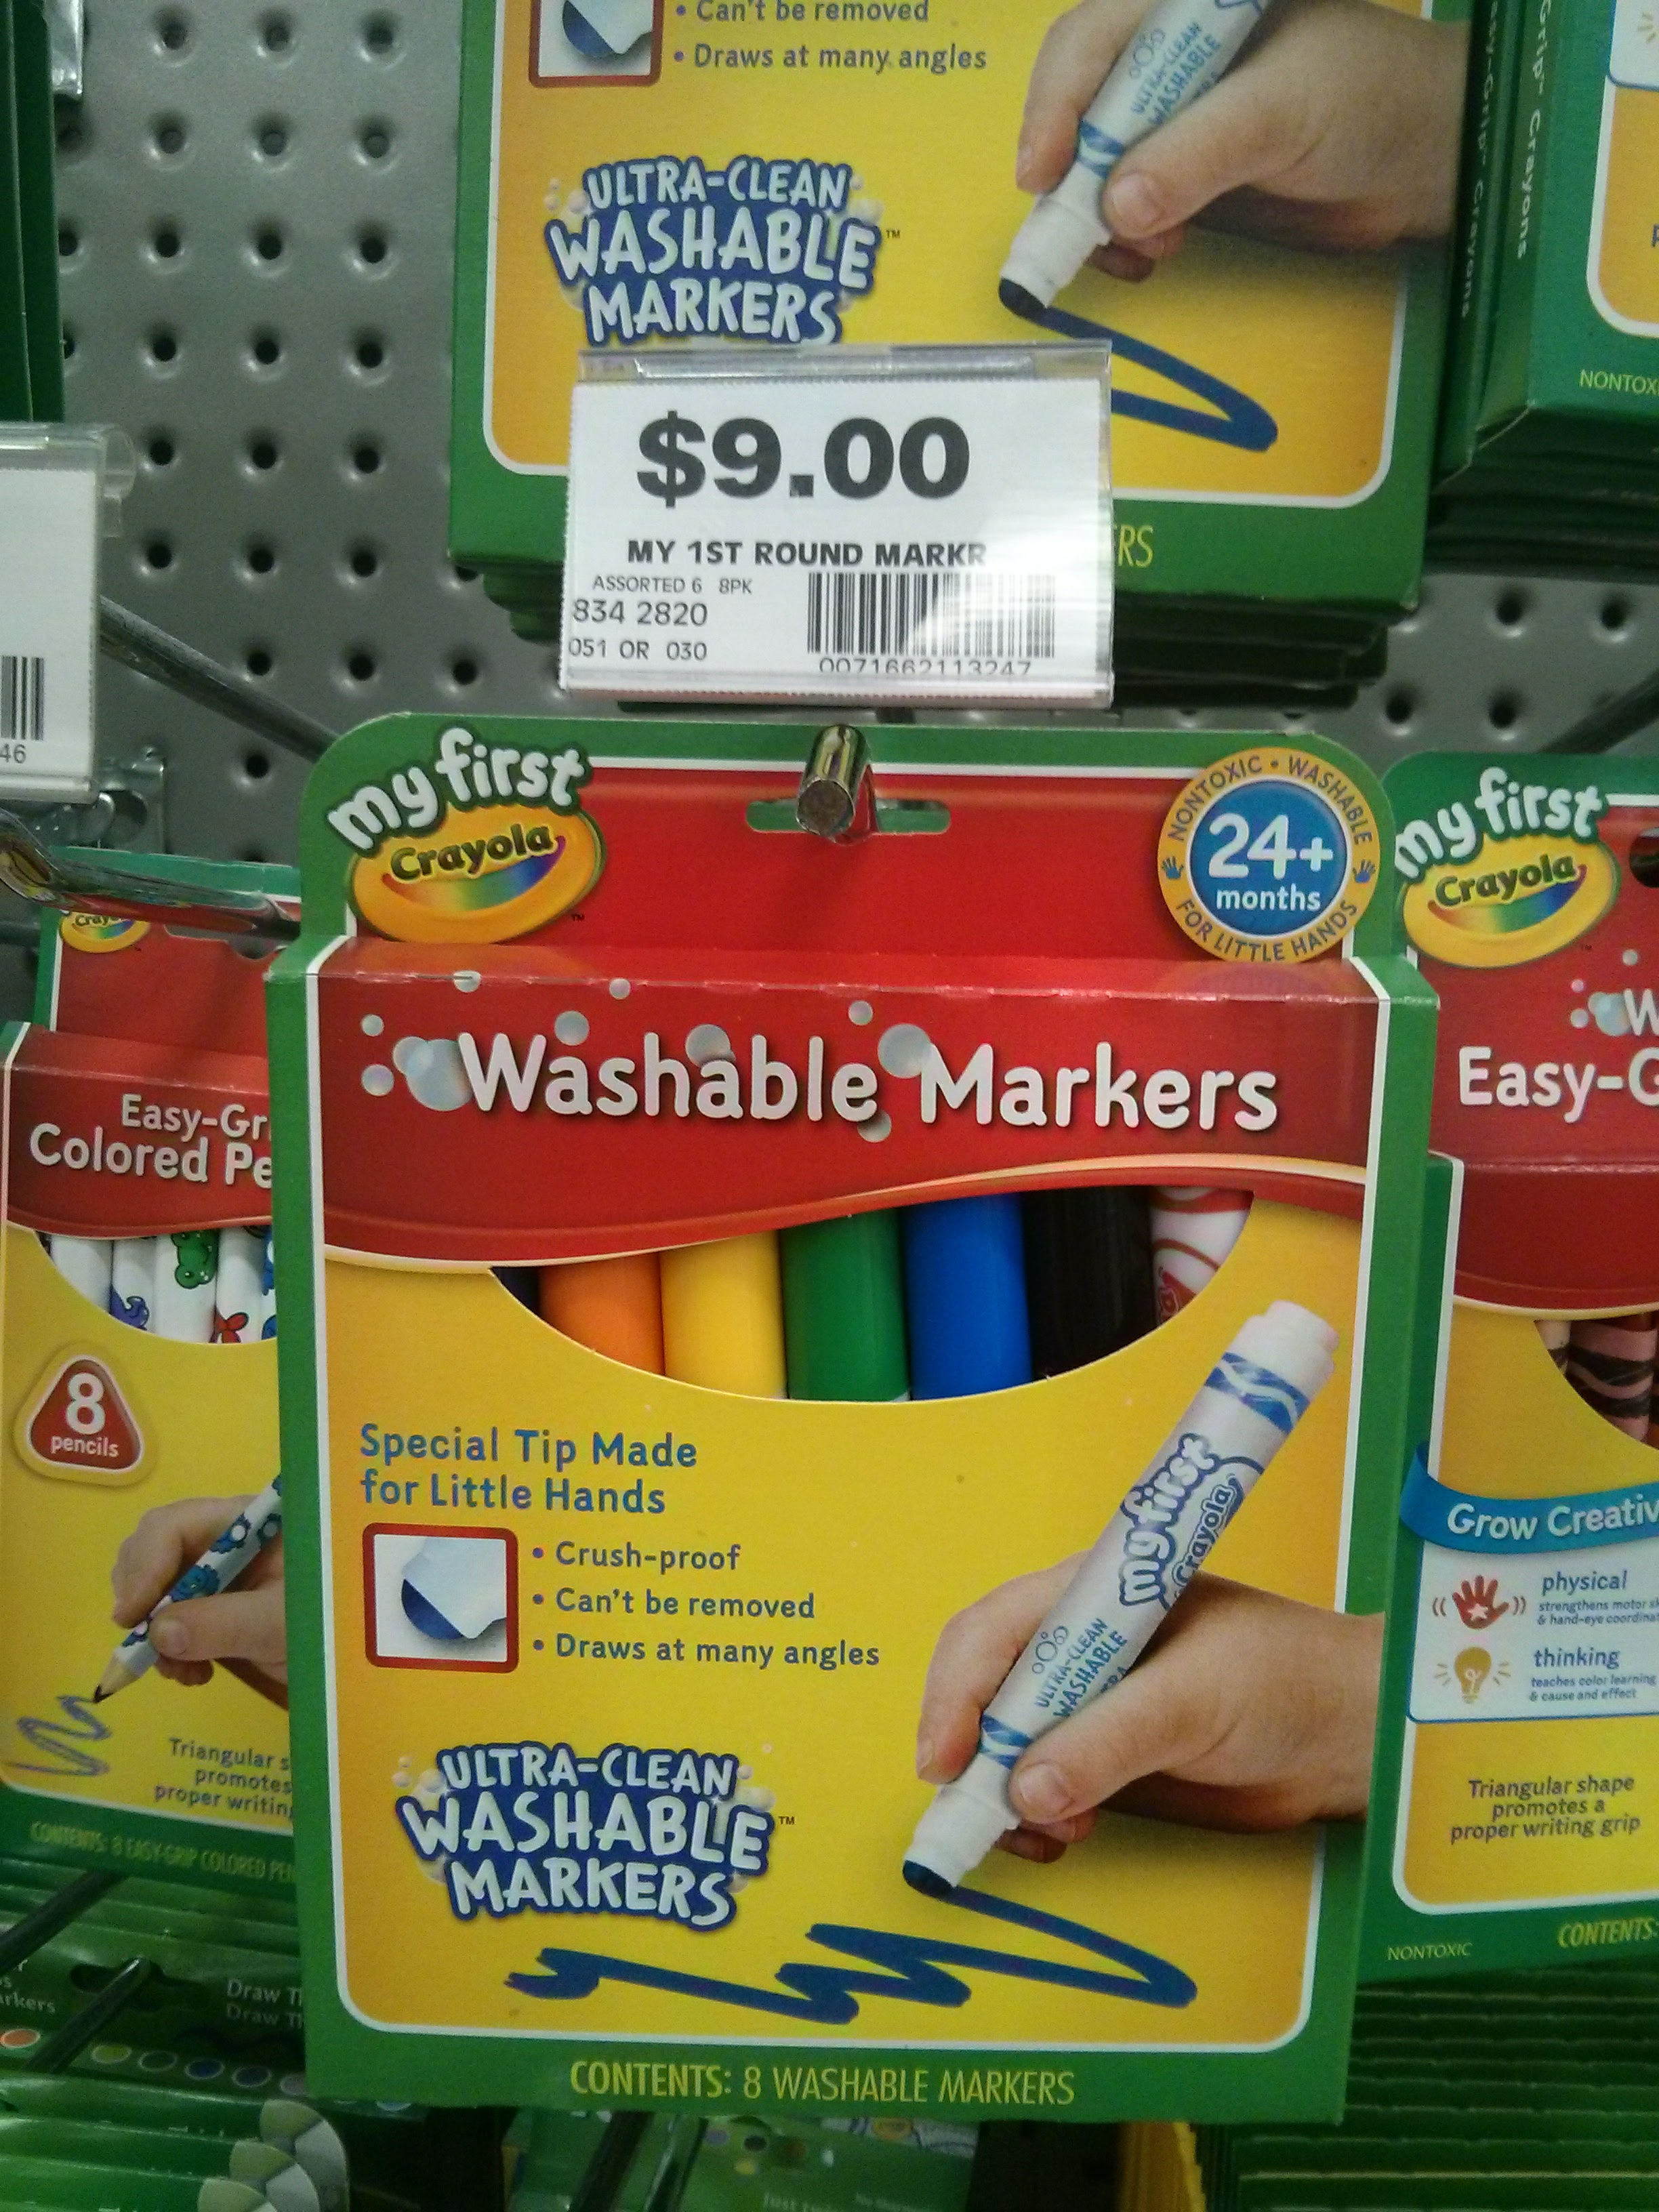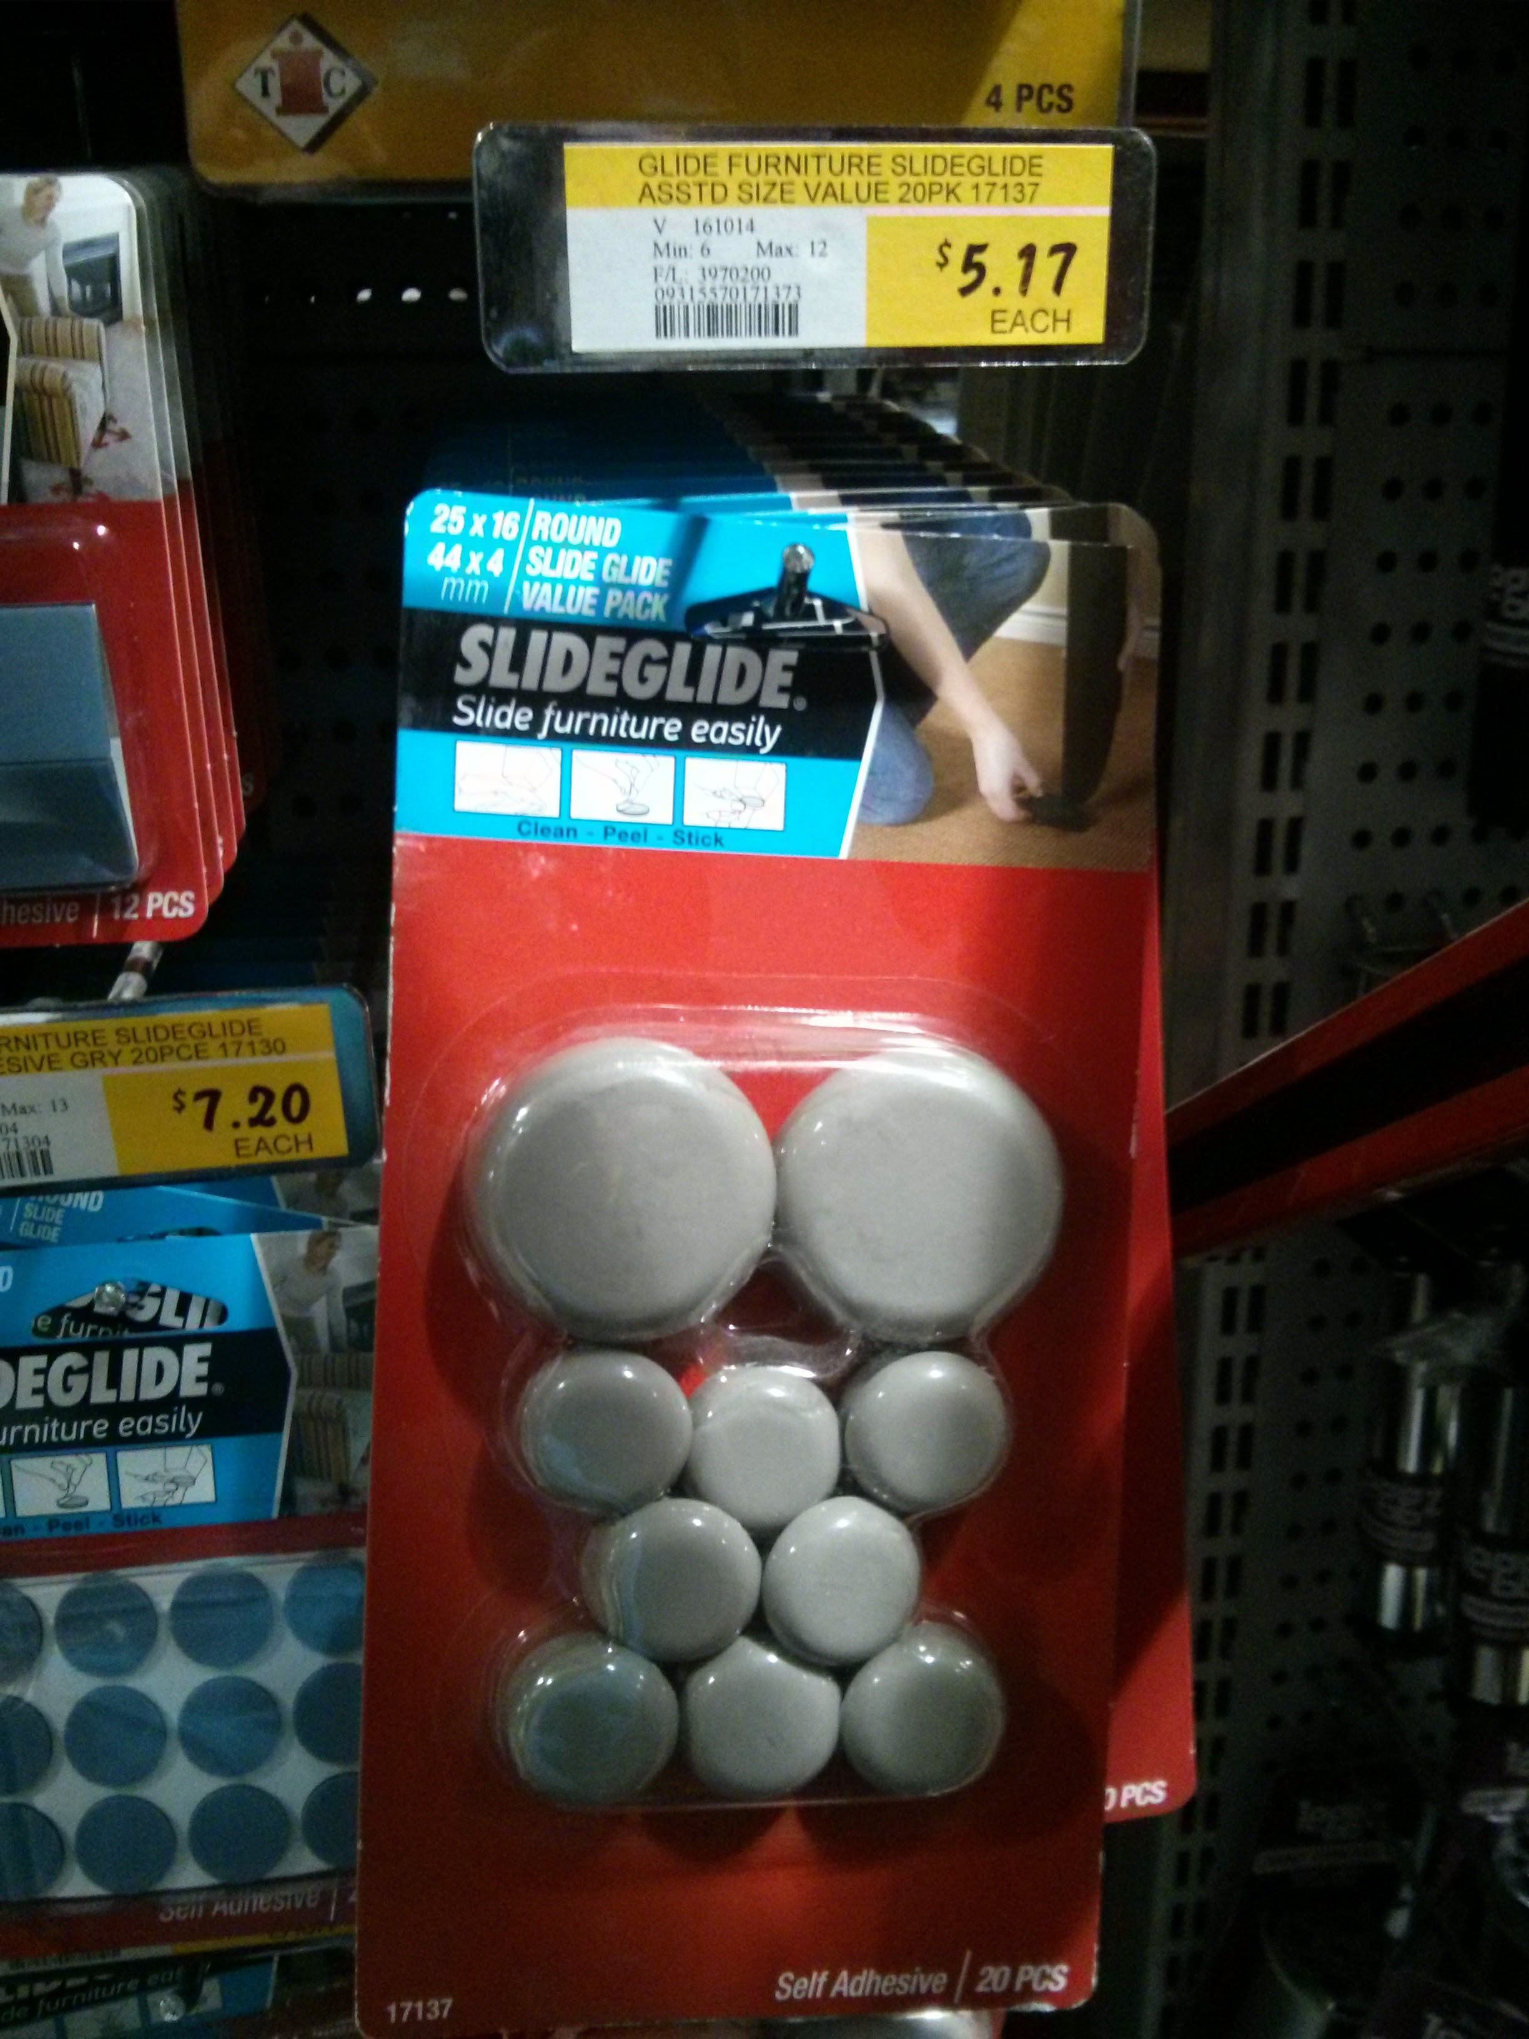

Step One:

Step Two:

Step Three:

Step Four:
etc

Development notes
(This is where you can put ideas that you tried, but which did not work (and why))

Feedback
(Here you can put any suggestions from users that you have not yet implemented, and mention any unforeseen difficulties encountered in operation or construction)

References
This were you put external links like LED generator, if they have not appeared in the Instructions.

Files
redbase3-pdf.pdf

Project Progress
Line Robot | 30% | Byron | Alpha Test Complete | > $50

