Aldi 3d printer

Basics
Aldi's new 'mini' 3D printer Cocoon Create Model Maker: A rebrand of the 'Wanhao i3 Duplicator Mini'
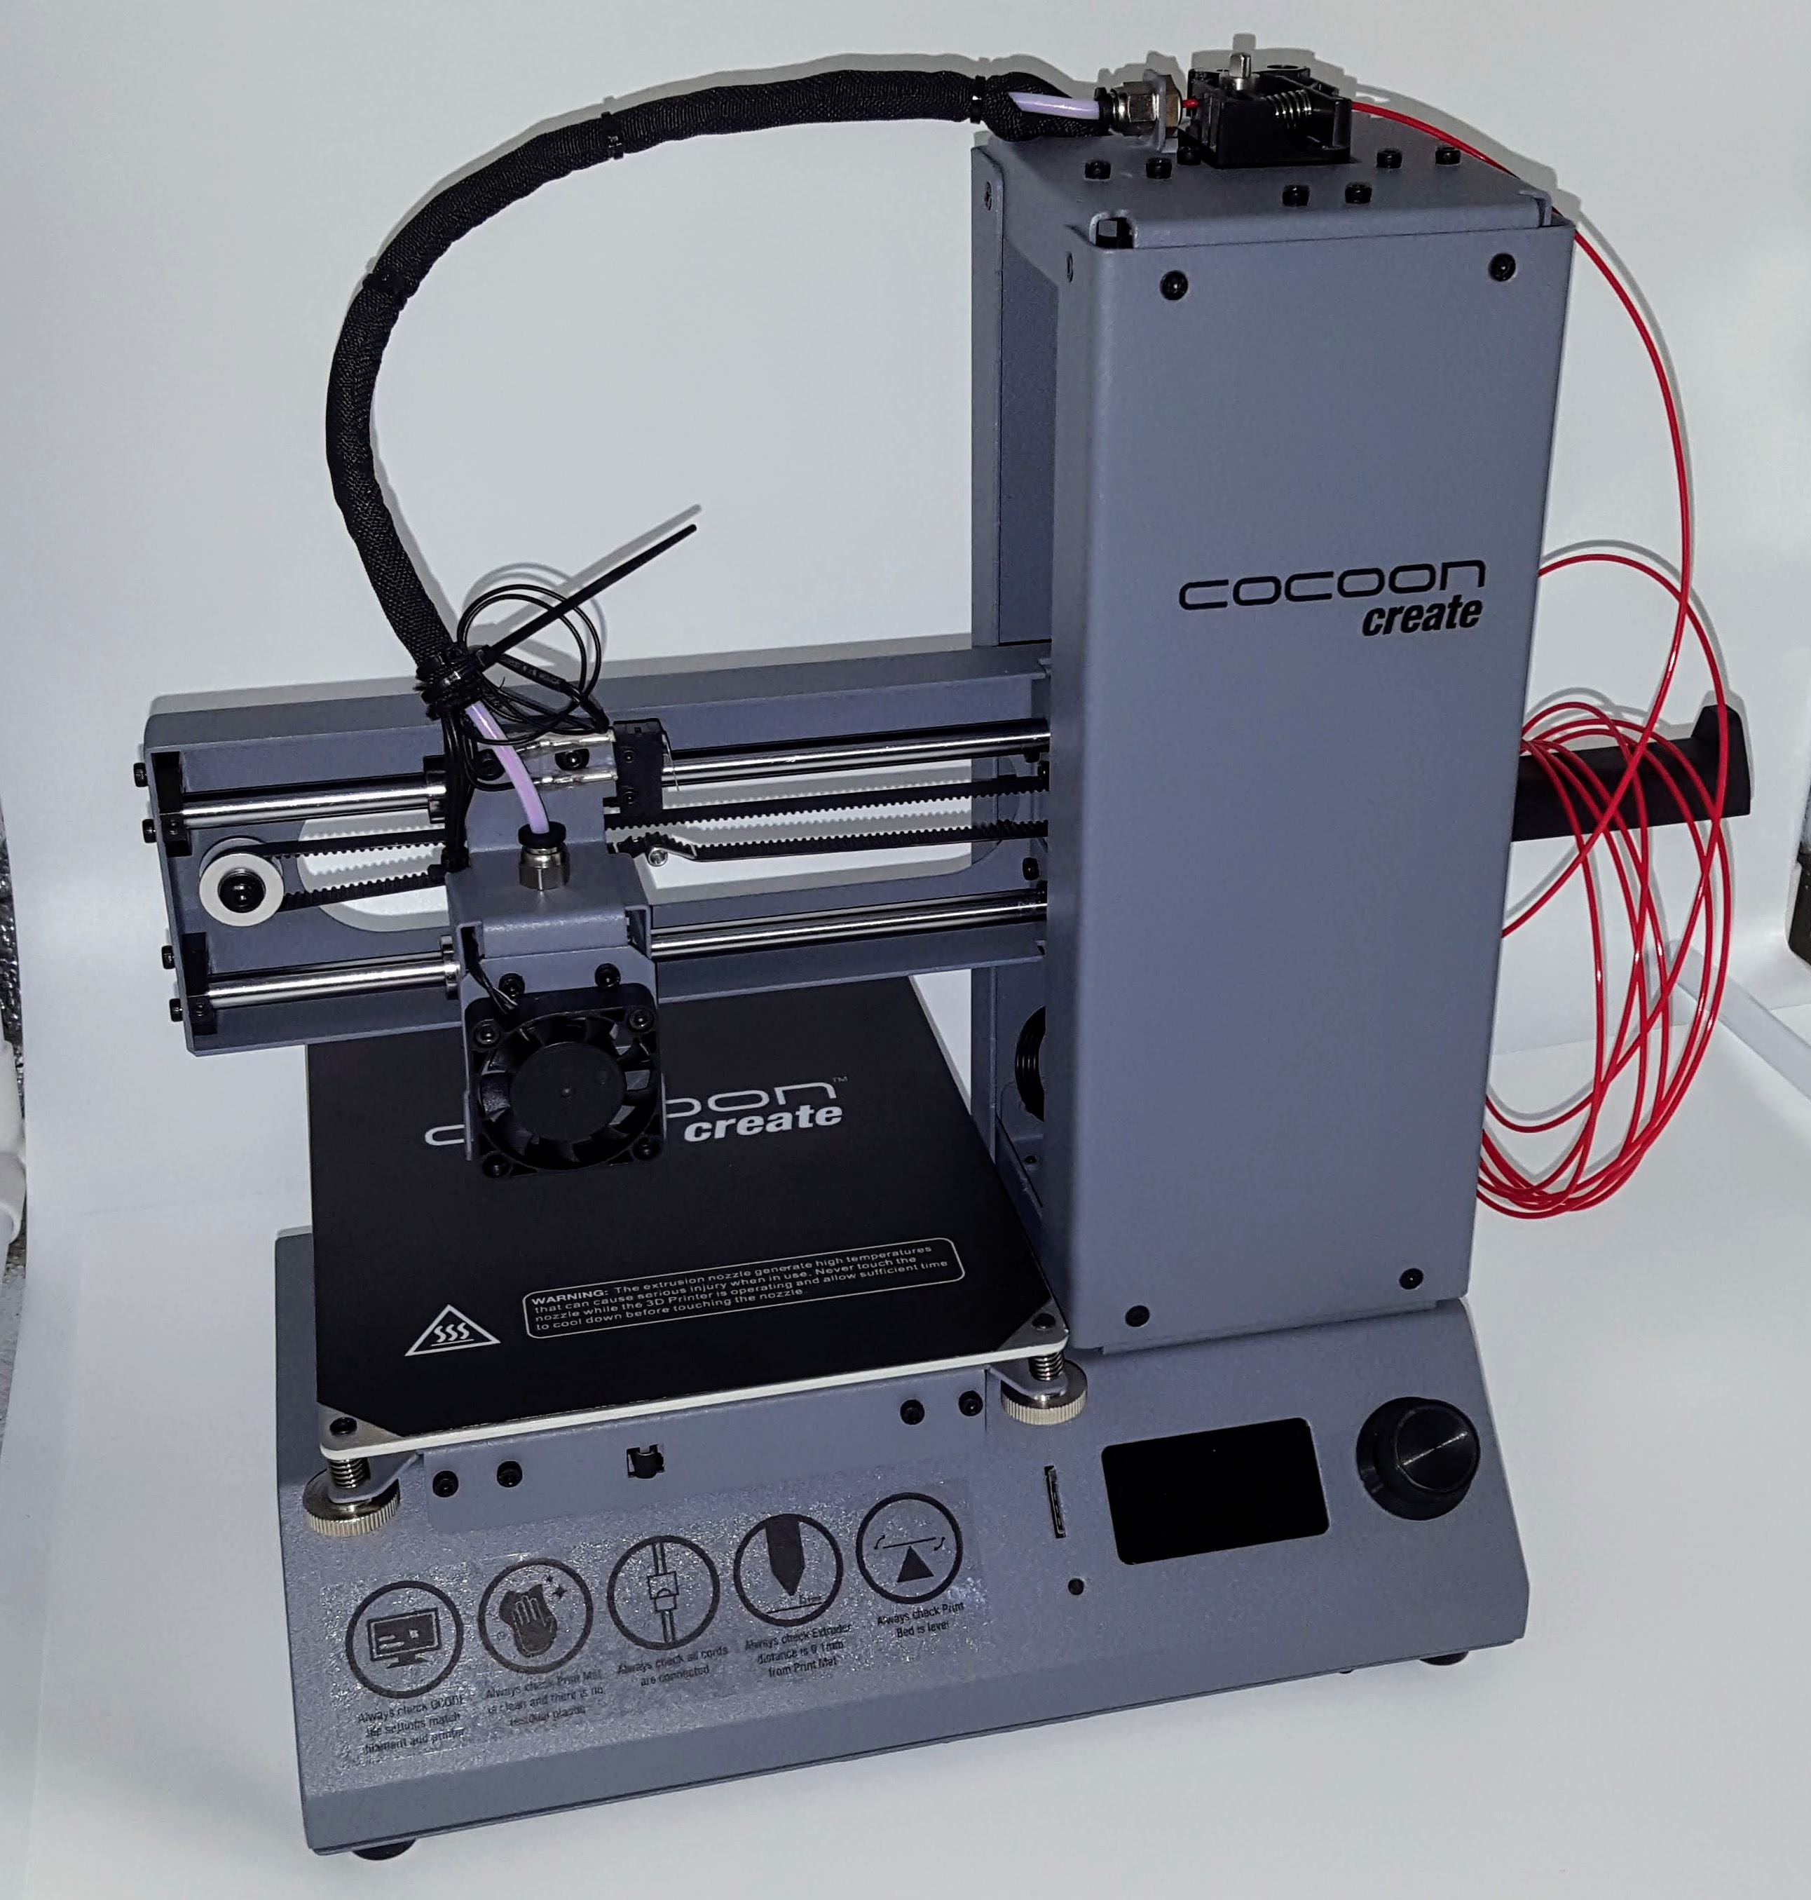

Advantages
- $299 when in stock. Less on clearance. About $350-380 from under the original brand from other online stores:
- * https://www.ebay.com/itm/Wanhao-Duplicator-i3-Mini-3D-Printer-Ships-from-USA-/282697048544
- * https://www.3dprinters4u.com.au/shop/product/39914/WANHAO-I3-MINITHE-ALL-NEW-POCKET-ROCKET-FROM-WANHAO/
- Works out of the box with no assembly Simple setup, well packaged.
- Good manual for hardware setup and test. Comes with enough filament to get started.
- Bed leveling wizard built in and paper to help.
- Quiet printing.
- Metal construction, descent seeming parts
- E3D clone print head! (But with caviet below) So replacement tips and heatbreaks might make a nice upgrade.

Disadvantage
- Minimial software instructions beond a very few 'getting started' pages.
- NO HEATED BED. So can't print ABS. PLA or PETG will be your main materials.
- No dedicated cooling fan, so fine detail can be tricky.
- Due to being a clone, hotend is PTFE lined rather than all metal so print temperature is limited to 140 continuous and 160 for limited times.

Example prints
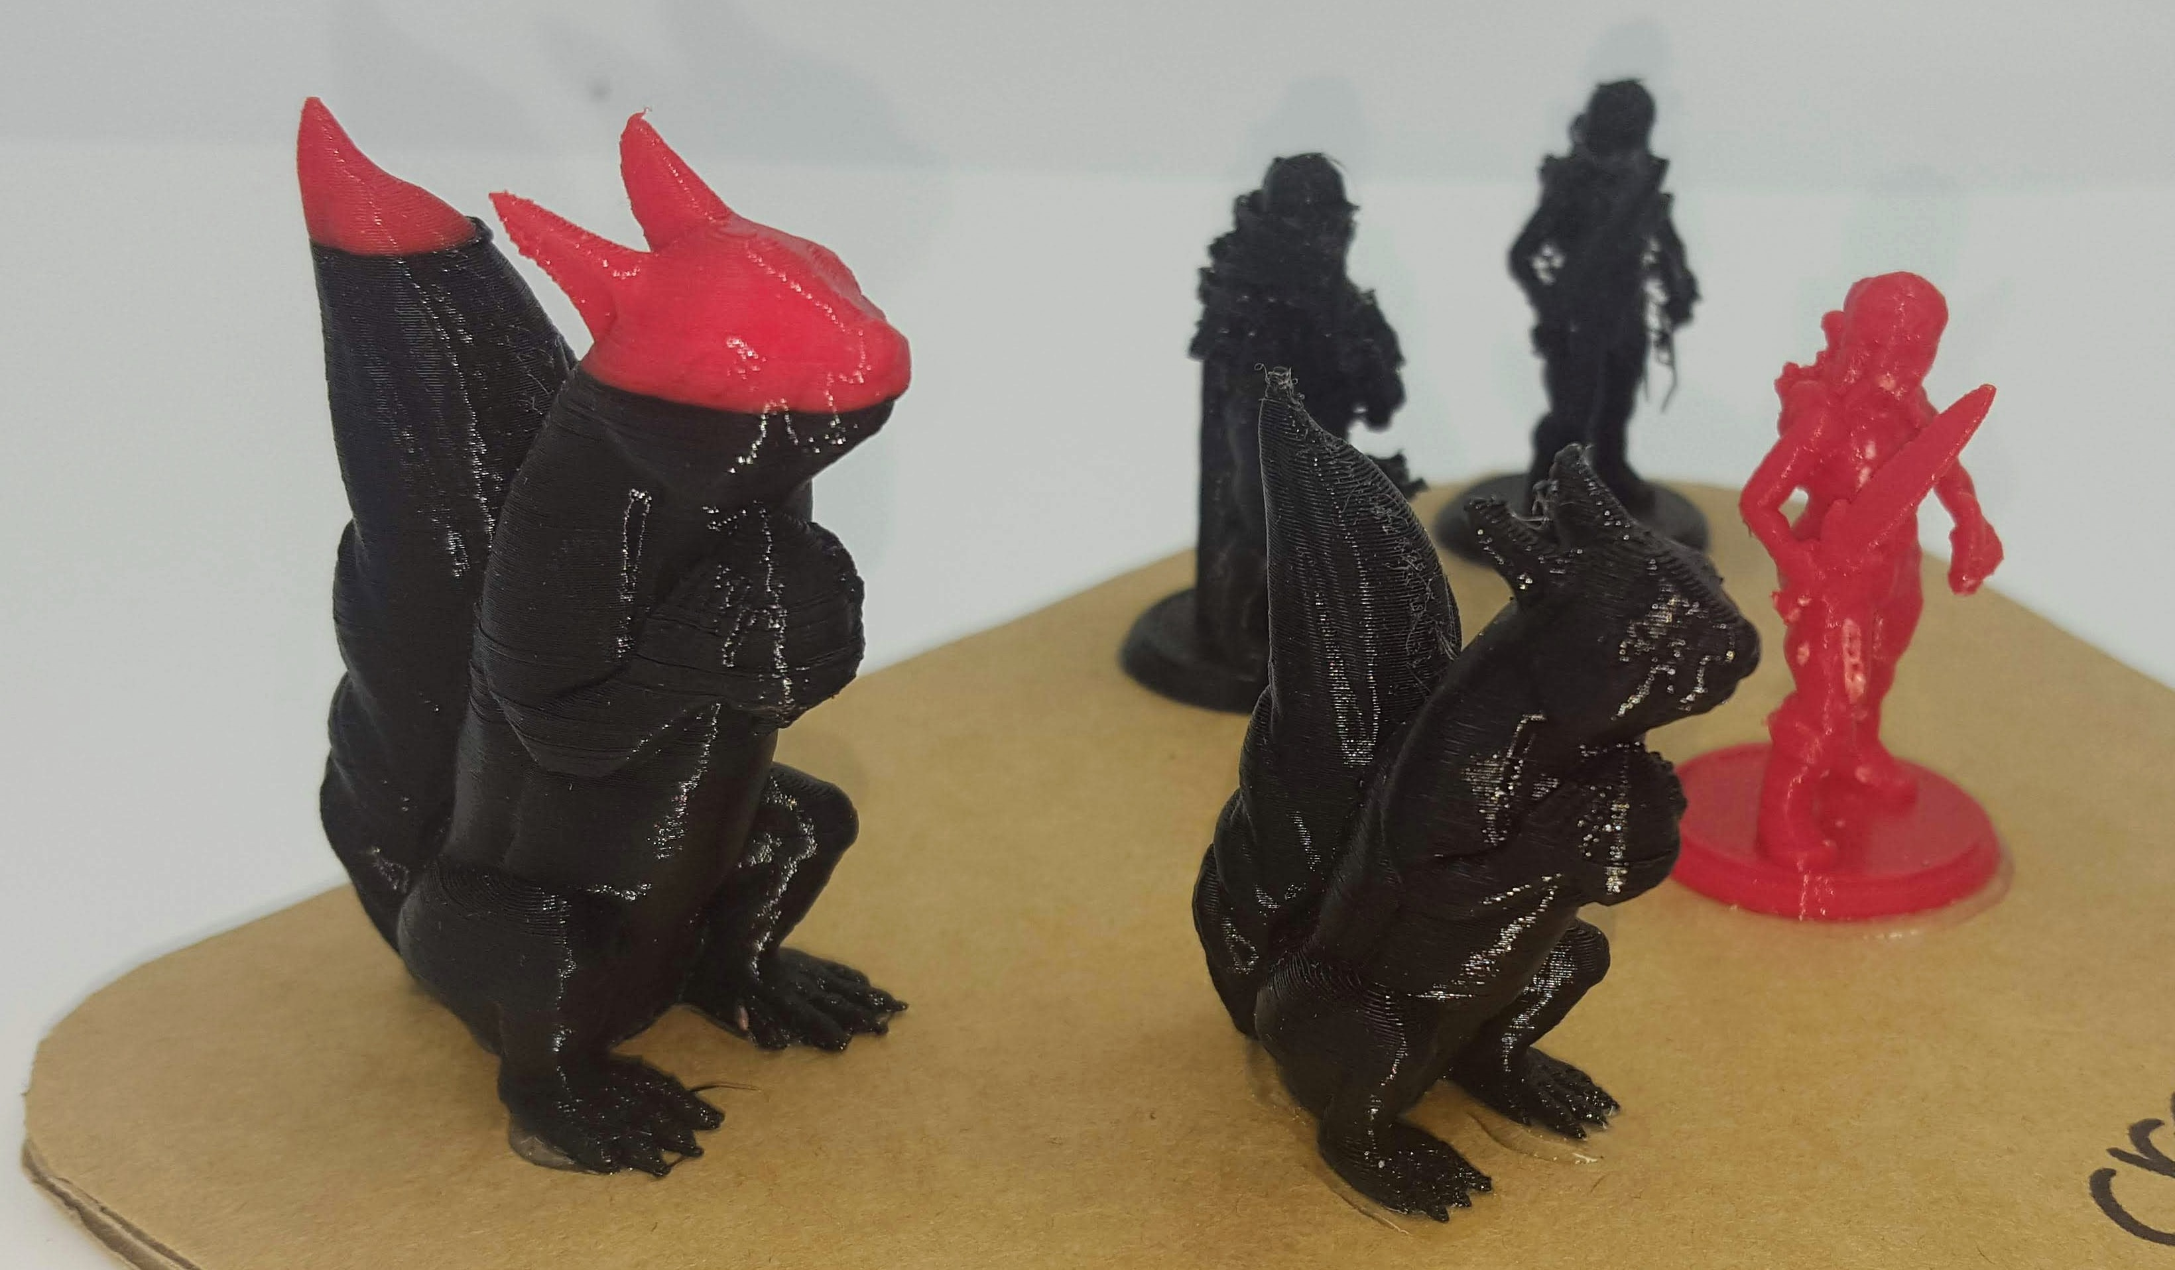

Software
Instead of using cura/slic3r and an SD card, we are trying Matterhacker's 'Matter control' 3d printing software that works over USB.

Settings
Settings and Controls -> Settings -> Printer Switch to 'Basic' to 'Advanced'
- Connection:
  - Baud Rate: 250,000
- Print area:
  - Bed Size: 120×135
  - Print center: 60×65
  - Build Height: 100
- Features:
  - Has Fan
  - Has SD Card
- Extruder:
  - Nozzle Diameter: 0.3mm

Upgrades

Easy
- E3D V6 Brass Nozzles
Replace 0.4 with 0.3mm for finer printing.
- FAN DUCT WANHAO I3 MINI
Requires no modification or parts, uses existing fan but gives no controllable cooling.

Intermediate
- Cocoon Create Model Maker (Wanhao Duplicator i3 Mini) mount with part-cooling fan
Requires minor wiring changes and new parts but allows for a proper controlled cooling fan.

Hard
- Should be possible to upgrade bed to a heated one using cheap parts. This requires 3d printer and electronics knowledge and is not recommended for most users.

