Open Lab

Open Lab
Open lab is located on Level 1 of The Edge, it is State Library’s free and accessible fabrication space for makers and designers to book and use the creative resources available with support from skilled staff. The basement level of the Edge closed after the February 2022 flooding event.
Bookable equipment resources include:
- Two laser cutters
- 3D printers
- Vinyl cutter
- Sewing machines
- Soldering stations
Open lab sessions are Wednesday 12.00pm to 5pm, Thursday 1.30pm to 8.00pm and Saturday 12.00pm to 5.00pm
Please note, equipment bookings are required for all Open lab sessions.
To find out about the latest workshops and inductions keep an eye on the Whats On pages on our website and sign up for The Edge enews here.
There's also a range of drop in activities you can undertake, check them out here.

How can I visit Open Lab?
All up-to-date visitor information is always on the the https://www.slq.qld.gov.au/plan-my-visit/spaces-visit/edge.
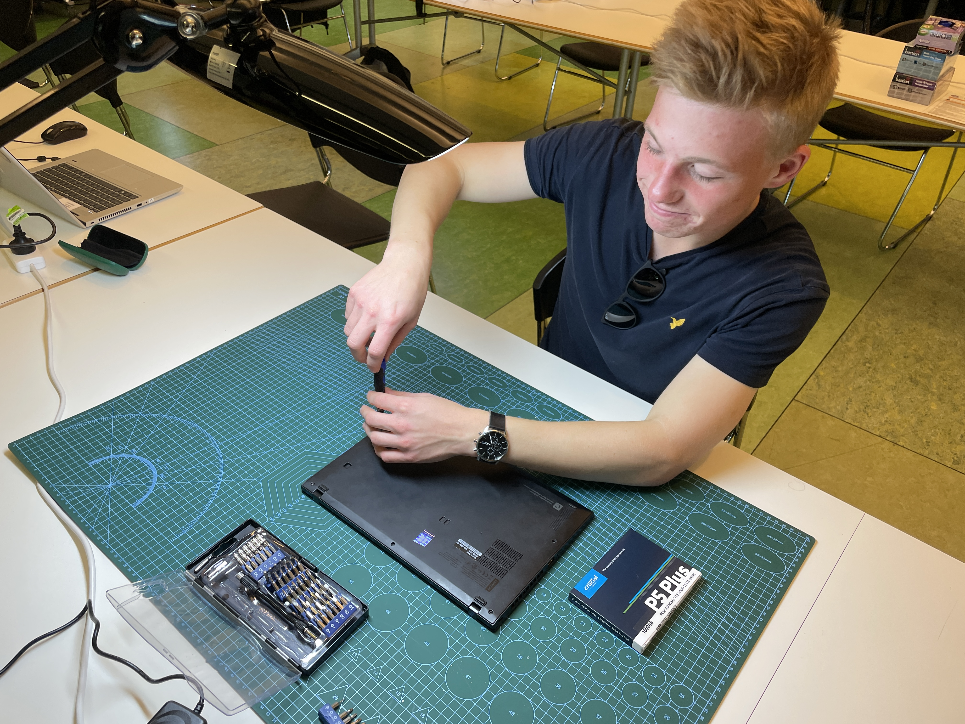

Safe Operating
DML SOP

