~~REVEAL~~

Moveable Walls For APDL
This page documents the making of movable walls for the APDL space.

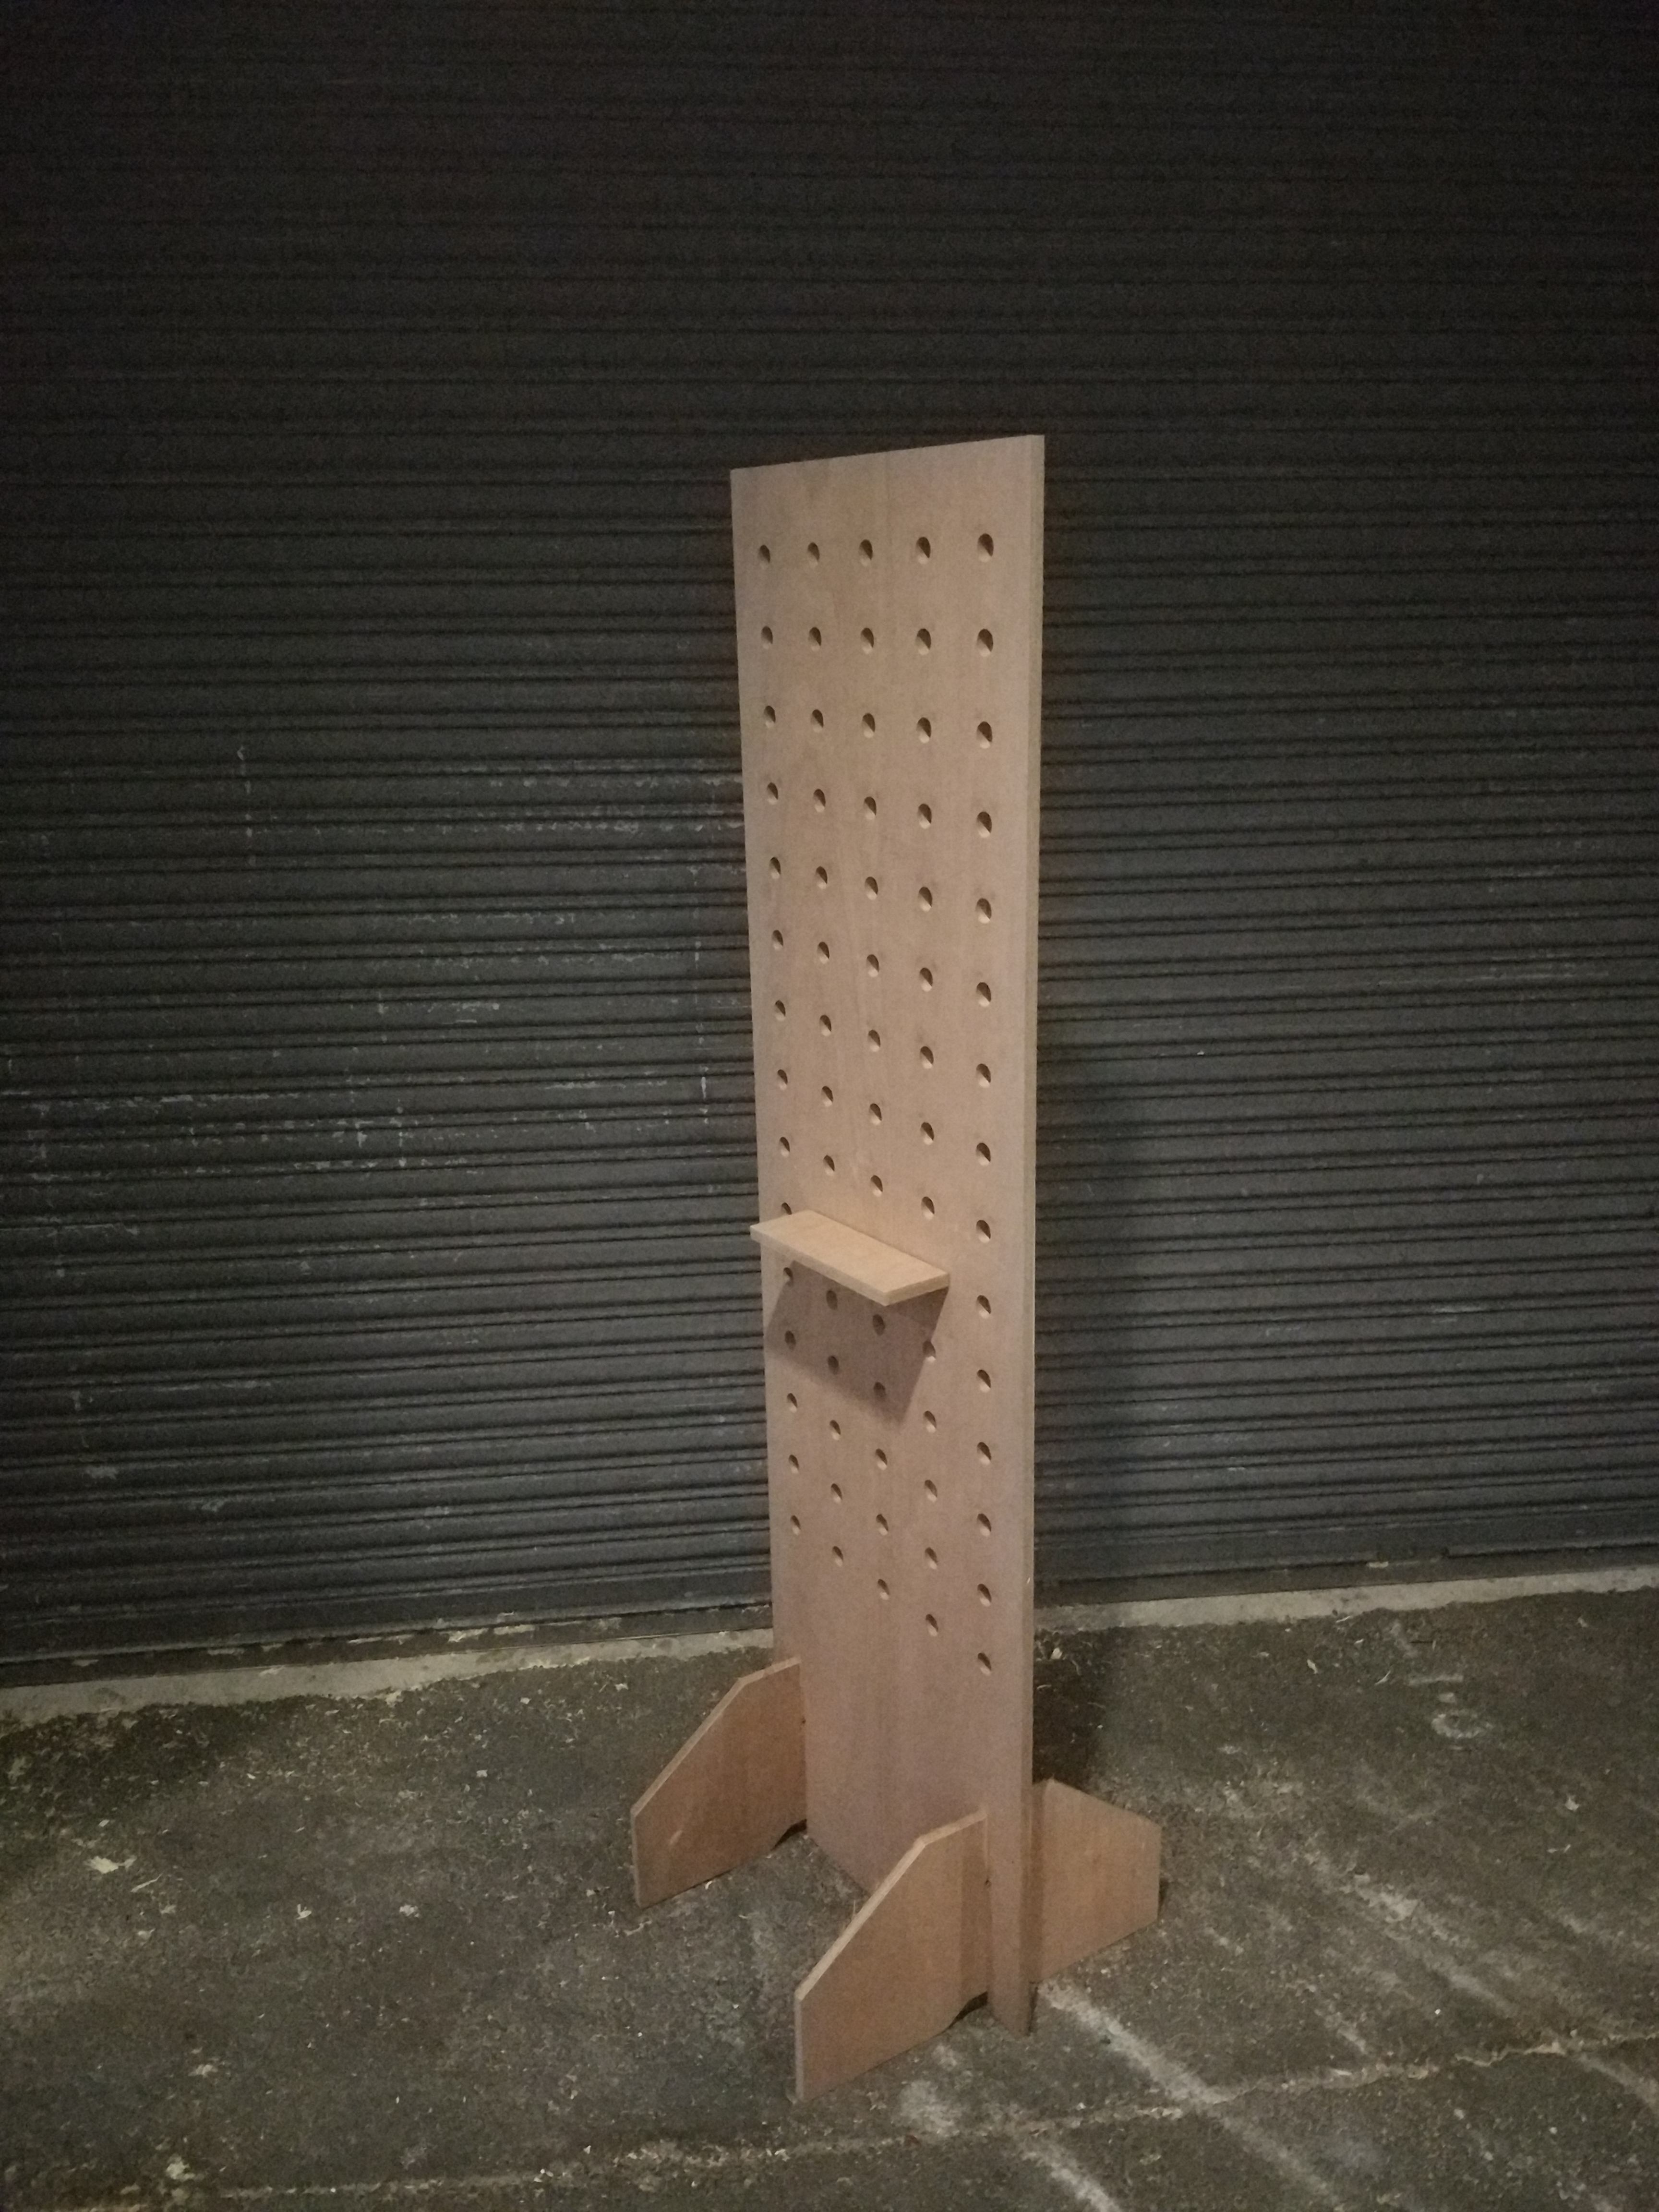

The original communication was: “Adam mentioned that he spoke to you this morning about a design we have been working on for some moveable walls for the APDL space. Please find attached for what we have in an Ai file so far. Let me know if you need it in an alternative format and I am happy to provide.
We would love your feedback on the design and would like to hear about what the process might be for working with you to convert it into a parametric design for cutting on the CNC.”

Design
The design was supplied by Chenoa as a illustrator document and looks like this:
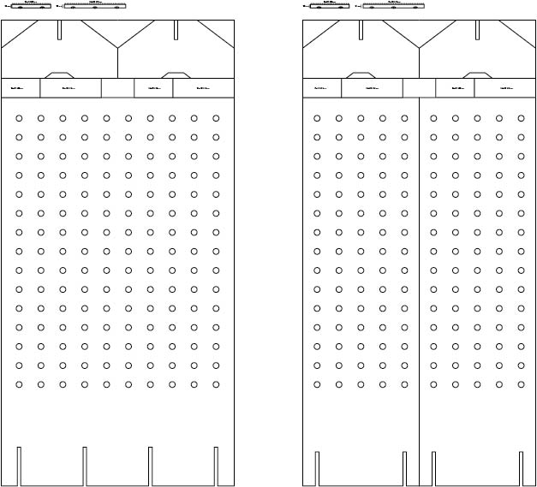
The shelves are supported by dowels that fit into the holes in the wall.

The brief is to turn that file into a parametric design of varying thicknesses for cnc cutting. This will involve;
- Cleaning file for export (most likely in Corel)
- Make first prototype
  - Parametric design on Fusion360,
  - CAM in Enroute
  - test cut on CNC
  - evaluate
- Make 2nd prototype
- Do prouction run.

Design Revision
After discussion with Chenoa, the design will need to be modified. The shelves were originally designed with a groove to fit snug against the dowels. This is not possible using Enroute (the basic version we have) so we've decided on a square groove.

Clean Up
A straight export to DXF from the illustrator file supplied failed (of course). Although both artboards were exported, circles and text where dropped.
The original illustrator file has all the text and markings on the same layer as the shapes to be cut and the designs were spread across two art boards.

To clean this up in Corel;
- Import Illustrator file boards.ai
- Copy 2nd page (artboard in illustrator speech) content into first page
- Create a new layer
- Select all text and dimension indications
- Drag all text and dimensions onto new layer
- Ungroup all parts
- Clean up stray lines
- Combine all curves
- Join all curves (with 0 tolerance)
- Save as Corel Doc boards.cdr
- Export as DXF boards-cleaned.dxf

Prototype One

Parametric Design in Fusion 360
A fully parametric design is one that can be scale and adjusted to suit cutting out of any material, with any tooling, at any size. So the same model could be scaled down to make a 1/10 model out of cardboard on the laser cutter, or scaled up to make walls out of 30mm ply, 3000mm high, with dowels 50mm in diameter.
In practice this level of parametric design is pointless, and not achievable except for simple designs.

There are two parts to this process, that overlap in the work flow. First we need to do is make sure the design is cut-able shapes for the CNC router, and can be assembled when cut. The original design efficiently uses space and cuts and is perfect for a laser - where the cutting edge is practically dimensionless and overlapping shapes are not a serious issue. But a CNC router needs:
- a clearance for the router bit
- accounting for the sheet dimension (shapes must fit inside 2400 - including cuts)
- add dogbones

The next part of process is additions and modifications of the design to make it parametric. In this case I've focused on working parameters for
- dimensions
- Material thickness
- Dowel diameter
- Tool diameter
- tolerances for tooling and material.

Having these parameters available means several other parts of the design need to follow suite. For example, changing the dowel diameter affects the depth of the notches in the shelves.

Parametric Process
This is an abbreviated summary of the process;
- Import DXF
  - This creates two sketches labeled “shapes” and “text and guides”.
- Measure dimensions
- make initial parameters based upon these measurements

Initial Parameters
These are the initial parameters - most of these are entered to check dimensions and don't need to be parametric - but its easier to start with more parameters than needed than add others later. - in this case 'Circle“ is the dowel hole diameter.

Access denied to CSV data

Apply Constraints To Shapes
In this step we constrain the existing shapes so that when we apply parameters they stay at the correct proportions. For example we need to make sure the edges of the wall shape are contrained to right angles or horizontal/vertical, otherwise changing dimensions later one will skew the shape out of a perfect rectangle.

Depending on the precision of the design, this can be as simple as going through and measuring and applying constraints and dimensions. If the design is imprecise then shapes need to be redrawn.
- Apply constrains to design
- If constraints fail - redraw shapes
  - I've re-drawn the circles using a rectangular pattern
  - Redrew the shelves and wall.
- apply parameters to dimensions
- test shapes by changing paramaters
- fix any unconstrained shapes

Make Dogbones
There are a bunch of ways to do this - I've chosen to make dogbones that can be cut on the router pass (as opposed to drilled) to save a bit of time. This means the Router will need to be able to get in and out of the corners, so we need a little smooth arc into our dogbone too 1)

- Draw circle centred on corner where you want the dogbone
- Make an arc ( three point) starting on the edge of the circle and meeting the edge of the notch
- Dimension the arc to start at one bit's length from the corner
- mirror this dogbone to the other side of the cut as needed.
  - to be OCD - you can define the arc starting point on the dogbone in degrees(35).

Make 3D
Now that our shapes are all constrained and parametric, its time to make the parts in 3d. These are really simple shapes, the only complication is the groove that needs to be cut on the bottom of the shelves.

I've chosen to make this using an extrude that is the material thickness minus the depth of the groove and then join the bodies together - but there are many (probably better) ways to do this.
- Make new component 'Wall_half” -this is for the half sheet width wall
- extrude whole shapes to material thickness (make sure you don't extrude the dogbones)
- extrude notch to material thickness minus notch and join (do this in the extrude dialogue)
- Turn each of the bodies into components
- name the components

Assemble the Components
Now its time to put our model together - apart from generating a nice looking preview - this lets us eyeball the fit, and make technical drawings and illustrations later.
- Move the components to the correct orientation
  - Setting a pivot point on a bottom edge
  - Rotate the component into position
- Copy and paste and components you need more than one off (like the feet)
  - If they are to be identical - do a normal copy. This will keep the components linked
- Use the align tool to line up faces - flip and rotate where needed.

What About the Dowels?
The dowels are important to check the look of the shelves - they will not be cut on the router obviously. We will make one, then pattern them out to fill the holes. To make the dowels
- Create a new component
- Make a tube
  - select the wall face as the plane
  - this lets you center the dowel over the circle hole
  - create the circle (diam 30mm)
  - make it the right length long (this is how deep they fit in the shelves + the material thickness)
- Make a rectangular pattern with the dowel body - I've space it to skip a row.

Check the parts and Parameters
I placed the shelves on top on the dowels (using a plane on a tangent to align them) and realized that the notch was not wide enough - its only about half the width needed. So I've gone back the the parameters and used an equation to generate a chord - which is a line across the top of a circle with a given offset from the edge of the circle. Sounds more complicated than it is.

Final Parameters
These are the final parameters used in the model. I've added a few 'slop' numbers - to account for the variation in board thickness and tooling cuts.
Access denied to CSV data

Exporting to DXF
Next we need to get the shapes to cut as DXFs into our CAM software (Enroute). To do this from Fusion360 we make a sketch on the face of the component we want to cut
The only tricky part is making sure that the notches on the bottom of the shelves are included and are made as completed shapes - no breaks so we can make
- Create a sketch on each face to be cut - name it after the face_DXF
- For components with notches to be cut (the shelves)
  - Create a sketch of the top, un-notched fac
  - Edit the sketch and create use the project function to project the notches onto the sketch.
- Export each sketch as a DXF.

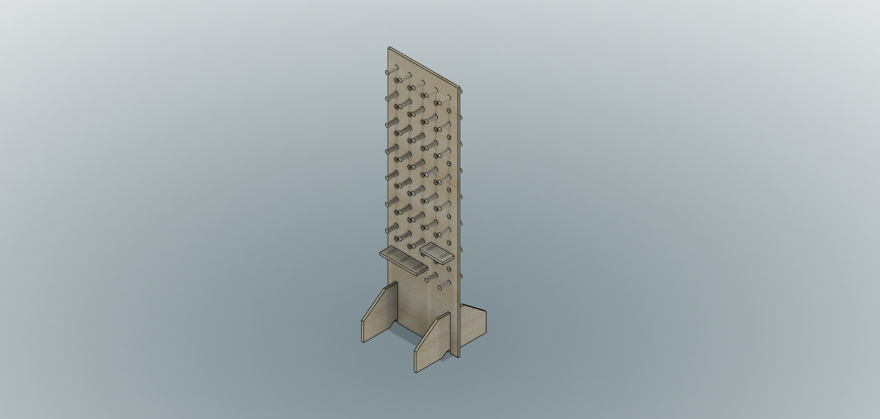
This is what the model looks like.

CAM
We will use Enroute for the CAM;
- Create a new file using the “APDL Walls” template
- Import the foot DXF - add an external router path with;
  - Two passes
    - 17mm depth, 4000 mm/mm feed, 1000 mm/mm plunge, 16000 rpm
- Import the Wall_dxf
  - Select all the circles and add an island fill - APDL_wall_island_fill
  - Check the Feeds and speeds
- Import the Shelf_1_dxf
  - Make a hatch fill for the notches
  - Make an external router for the external shape

The prepped CAM file looks like this:
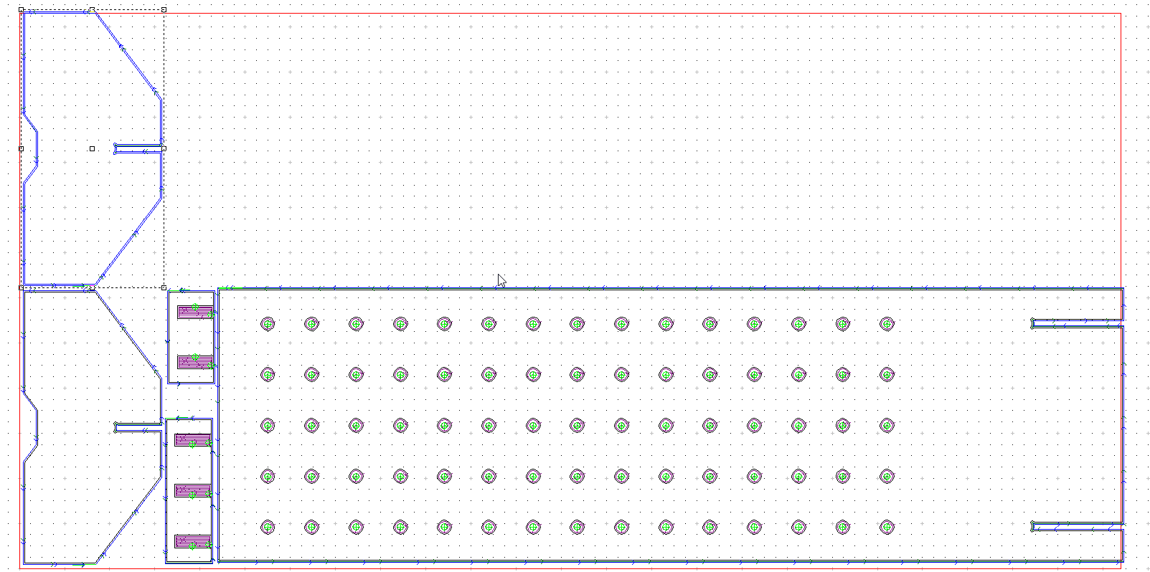

Cutting
The cutting went smoothly - the only is the 9.5mm compression bit should be run at a higher feed rate, the wood was burning while cutting.
The first prototype looks like this.

Prototype Two

Revisions
While the board works as intended, a number of revisions were made by Chenoa and Adam. In this case we made the changes in Fusion, then followed the same export path as for prototype One.

Aesthetic:
- The top of the boards have a tab added to form a link with the indentation in the bottom of the feet.
- A few variation on the feet were tried, Adam wanted to link them visually with the boards. We tried
  - Offset outlines
- Holes in a grid pattern

Functional:
The slop tolerances on the holes and for the material thickness were too high. The ply is high grade AA AB sheets and uniformly 18 mm +/- 1mm, and the dowels are pretty much exactly 30mm.

Cutting
We only cut the legs to test tolerance.

Production
2450x1230x19-9_5_bit.zip

1) You could just do this manually in the CAM software by placing drill points

